B1 / ADFELPS 5

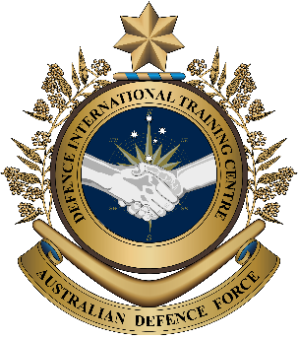

**Military English**

Lesson: Life of a UN Peacekeeping Medic – PART A: Joining the Army – Listening

**Overview:** This is the first of four lessons that teaches vocabulary Medics and Army Nurses use during United Nations (UN) Peacekeeping missions.

**In this lesson, you will:**

* Use listening skills.
* Learn the meaning of new vocabulary and expressions.
* Use new vocabulary and expressions in context.

## Prepare for Listening

1. Work in pairs. You are going to do a role play asking and answering some interview questions. When you finish, swap roles and start the interview again. Try to take notes about your partner.

* Student A: you are the interviewer. Ask student B questions a-d below.

**medic** (n) -   
a person who does medical work in the military – usually a non-commissioned officer

* Student B: student A is going to interview you.

**Interview questions:**

1. When did you join the military, and how old were you?
2. 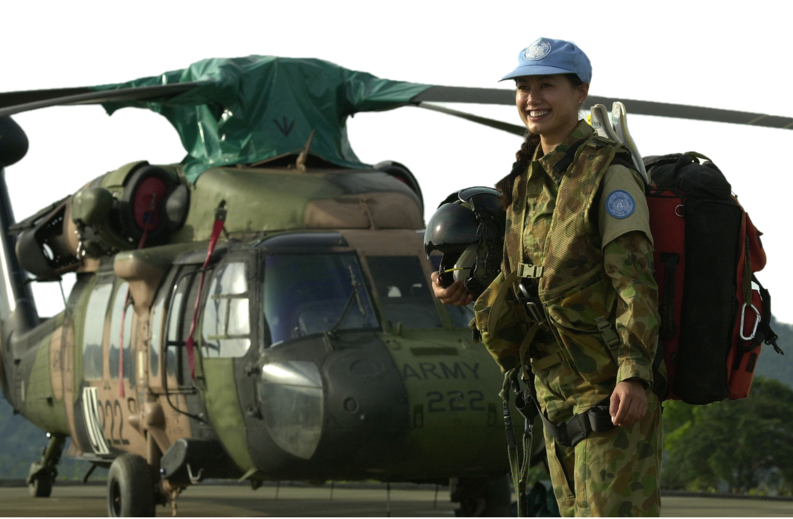Why did you join the military?
3. What was your first job in the military?
4. Would you like to work as a military medic? Why/Why not?

1. Now change your partner. You are going to tell your new partner what you learned from the partner you interviewed in exercise one. Use the Language Box below to help you.

|  |  |
| --- | --- |
| **LANGUAGE  BOX** | * My partner/He/She joined the army in ______. He/She was ___ years old. * He/She joined the military because ______. * His/Her first job in the Army was ______. * He/She would/wouldn’t like to work as a military medic because _____. |

1. Write sentences about the partner you interviewed in exercise one.

* Use the Language Box above to help you.
* When you’re finished, re-read your work and check for mistakes such as spelling, grammar and use of vocabulary.
* Swap your work with another partner. Help your partner improve his/her work and try to find mistakes. Then tell your partner how to improve their work.

## Listening

1. Read the question below. Listen to the opening introduction for the radio program and circle the correct answer.

What is happening in the radio program?

1. A music show
2. An interview
3. A program about wars
4. Read the questions below. Listen to the whole radio interview and answer the questions. Then, work with a partner to compare your answers.
5. What job did Beth Andrews do before she joined the Army?

_________________________________

1. How many other women were training with Beth Andrews?

_________________________________

1. A long time ago, where did Australian army nurses usually work?

_________________________________

## Learning Military Vocabulary

1. The words listed in bold below are important vocabulary and expressions that you should learn to use. Match the vocabulary on the left column with their definitions on the right. Look at the example. Then compare your answers with a partner.

|  |  |  |  |  |  |  |
| --- | --- | --- | --- | --- | --- | --- |
| Table one |  | |  |  | | |
| she put her **life on the line** for her country | |  | | |  | **a. a person who does medical work in the military (usually a non-commissioned officer)** | |
| **UN Peacekeeping Operations** (n) | |  | | |  | 1. to do a job that could kill you | |
| her experience as a **medic** (n) | | **a.** | | |  | 1. something people learn that can be used in a different job | |
| **Army nurse** (n) | |  | | |  | d. when the United Nations sends soldiers to a war zone to help keep peace and security, and to protect the people in the area | |
| a **transferable** skill (n) | |  | | |  | e. a nurse in the army (usually a commissioned officer) | |

|  |  |  |  |
| --- | --- | --- | --- |
| Table two |  |  |  |
| **enlisted** in the Army (v) |  |  | 1. when a UN Peacekeeping force works to keep the peace in a country where there is war |
| we **marched out** with only 32 girls(v) |  |  | 1. working away from a normal workplace or office; usually working in places that are far away or dangerous |
| it was **hard yakka** (n) |  |  | 1. to join the military |
| not expected to do **field work** (n) |  |  | 1. normal work nurses do in a typical hospital |
| we did **general nursing duties** (n) |  |  | 1. when the military sends personnel for a job or operation in another country |
| including being **posted overseas** (v) |  |  | 1. to complete basic military training, or a military course |
| **UN Peacekeeping missions** (n) |  |  | 1. Australian slang: to work hard |

1. Now let’s practice saying the words. Listen and repeat.
2. Below is the transcript for the interview with WO Beth Andrews. Listen to the recording again and write the missing words in the transcript below.

**A:** Good afternoon listeners. Welcome, you are listening to Ben Renolds from Radio Station 4U2, and our program ‘______________________’. Our program is a series of interviews with military veterans who have put their ‘life on the line’ for their country. Today’s interview will be with Warrant Officer Beth Andrews, who is currently serving with the Australian Army as a nurse. In this series of interviews, we are going to talk with her about her experience in UN peacekeeping operations as a ________________________, her various deployments, and her life as a nurse in the modern military.

**A:** Hello Warrant Officer Beth Andrews, thank you for joining our program today.

**B:** Thank you Ben. It is my pleasure to share some of my experiences with your listeners.

**A:** Firstly, please tell us, how did you become an ________________________?

**B:** Well, I’ve always been a very caring person. I became a nurse before I joined the military when I was   
20 years old. Then, when I turned 21, I decided I needed a new adventure to do something more challenging. I was keen to become a nurse assistant in the military and I thought my nursing skills would be easily ________________________. So, I applied for the army and was accepted as a military nurse.

**A:** What was it like to do basic training in the Army?

**B:** When I ________________________, I first went to Kapooka training base. It was pretty scary. I joined with 62 other girls in my platoon for three months of training, and we ________________________ with only 32 girls. It was ________________________! The younger girls with no life experience found it most difficult. I already had a lot of life experience working as a nurse.

**A:** Did you do similar training to male recruits?

**B:** When I joined the army as a nurse, females were not expected to carry weapons or do ________________________. We mainly worked in hospitals and did _____________________________. But this changed in the 1980s and women were expected to do more field work, including being ________________________ onUN Peacekeeping Missions.

**A:** Thank you, it’s been great having you here today. That was WO Beth Andrews speaking for Radio Station 4U2. Until next time.

1. Use words from exercise six to complete the gaps in the text below.

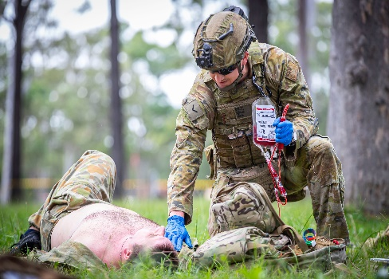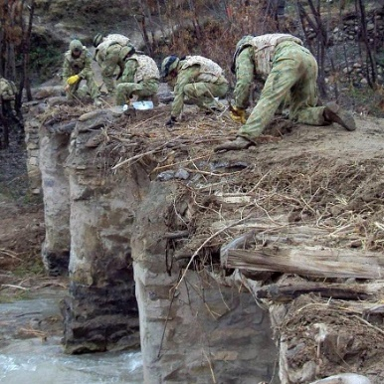Sergeant David Miller was a soldier on a UN peacekeeping ____________________ and he was repairing a bridge in a small village. A landmine exploded near him and he was hurt very badly. An Army __________________, Lance Corporal Ian Chan ran to help him. David’s life was _____________ __________________, so he had to help him quickly. Ian saved his life.

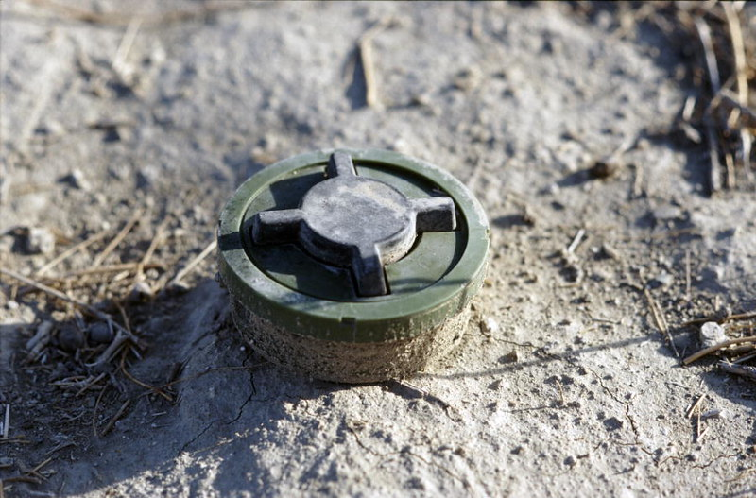Ian _____________________ in the Army because he wanted to help people. He was a brave medic and he was always ready to help people who were hurt or sick, so he was very happy to be __________________ to another country on a peacekeeping ______________________.

When you are an Army medic, you have some useful _________________________ skills. This means that you can use these skills in jobs after you leave the Army. If Ian leaves the Army, he can work in a large hospital in a city.

## Practice

1. Discuss these questions with a partner. Use complete sentences and the words you learned in Exercise 4.
2. Why did you enlist in the military?
3. Have you ever seen a medic helping someone? What happened?
4. Have you ever been posted to another country? Where did you go? If you have never been posted to another country, where would you like to go?
5. What skills have you learnt in the military? Which skills can you use after you leave the military?



## Watch this video about someone who works as an Army nurse:

## Type on YouTube [Army Nurse Rachel Williams](mailto:https://www.youtube.com/watch?v=hzHXyj8TgpI) or scan the QR code 🡪

## For more practice with the words you’ve learned here, scan the QR code.

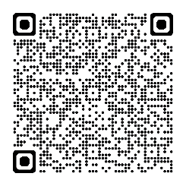

## This lesson links with: Vocabulary Builder – Field Medicine – Part A

© Commonwealth of Australia 2024   
This work is copyright. Apart from any use as permitted under the Copyright Act 1968 (Cth), no part may be reproduced by any process without prior written permission from the Department of Defence.