

**Military English**

Lesson: Demining – Women in the Defence Forces – Reading

**Overview:**  
The topics of this lesson are an important part of peacekeeping: demining and the work being done by women in this area.

**In this lesson, you will:**

* read and find specific information in a text
* read and understand general information in a text
* learn and get practice in the meaning of new words
* learn about word families and practise
* use new words in a conversation

## Prepare for Reading

1. Look at the questions below. If you don’t know the answers, check on the internet.

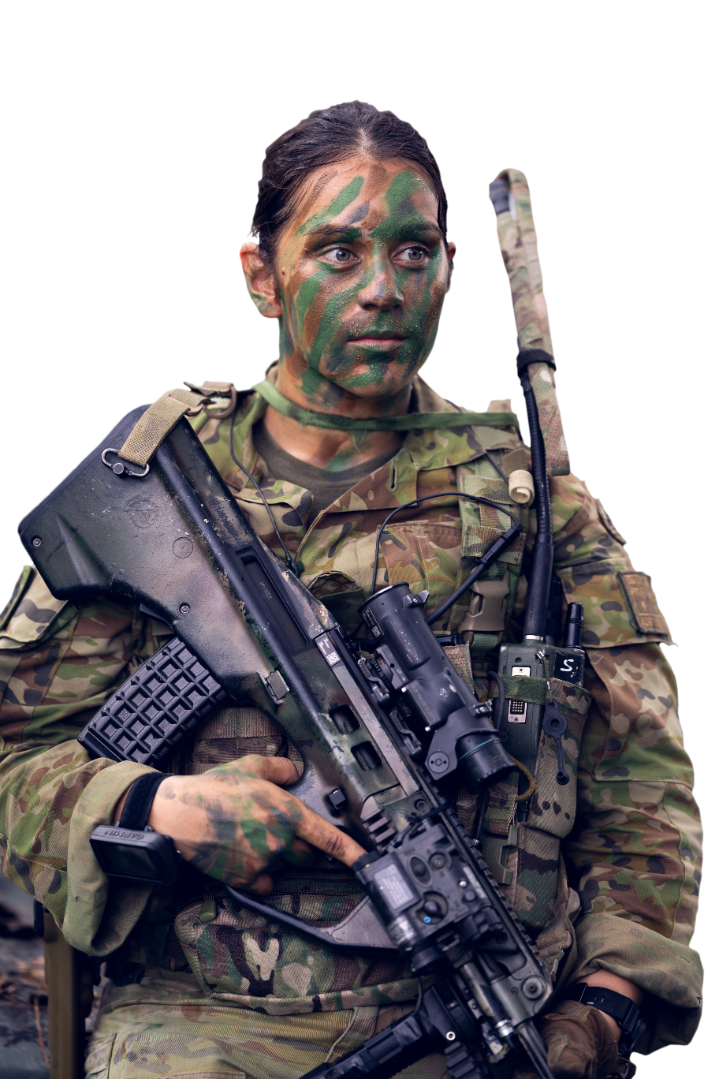Then, work in small groups. Discuss with a partner your answers to the questions. Use the Language Box to help you.

1. How many men and how many women are in your defence force (or in your service), do you know?
2. What jobs or activities do the women in your defence force do? Are they pilots? Are they office workers?
3. Are there jobs or activities that the women in your defence force do not do? Which jobs? Can they be senior officers?

|  |  |
| --- | --- |
| **LANGUAGE  BOX** | 1. The number of men / women in my defence force (or in the Army / Navy / Air Force) is *13 thousand*. 2. They are *pilots and nurses* (name of some of the jobs these women do). 3. They can’t be *infantry soldiers* (name of jobs) in my defence force (or in the Army / Navy / Air Force). |

*LT Samantha May from the 3rd Battalion,   
The Royal Australian Regiment, during Exercise Wantok Warrior in Wewak, Papua New Guinea.*

## Reading

1. Read the text below quickly.

What is important about these numbers? Write a few words for each.

2014 🡪 \_\_\_\_\_\_\_\_\_\_\_\_\_\_\_\_\_\_\_\_\_\_\_\_\_\_\_\_\_\_\_ 2019 🡪 \_\_\_\_\_\_\_\_\_\_\_\_\_\_\_\_\_\_\_\_\_\_\_\_\_\_\_\_\_\_\_

60 🡪 \_\_\_\_\_\_\_\_\_\_\_\_\_\_\_\_\_\_\_\_\_\_\_\_\_\_\_\_\_\_\_\_\_

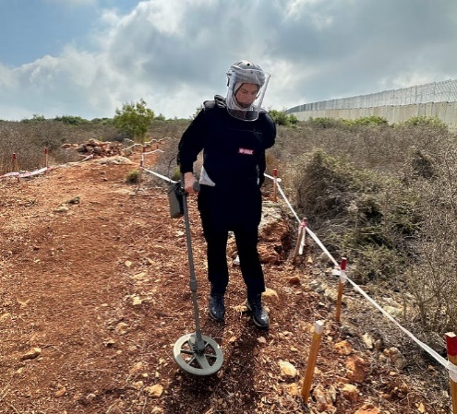It was in 2014, that a UN **peacekeeping mission** finally had a female commander. Major-General Kristen Lund from Norway led the UN’s peacekeeping mission in Cyprus. Now, other work in peacekeeping that women are beginning to do is   
the important task of **demining**.

Demining is the job of clearing land, after war or ‘**post-conflict**’, so that people can return to their homes and get back to a normal life. The only way to clear a **minefield** of landmines is to **deactivate** them one at a time. This is a very slow and dangerous job and accidental **explosions** can happen. Demining is taking place in over 60 countries where landmines or **unexploded ordnance (UXO)** is still a daily problem. In Syria, as well as UXO such as **mortars shells** and **grenades**, ISIS left **improvised explosive devices (IEDs**) everywhere. They are inside cooking pots, mobile phones and even children’s toys.

*Zeina Saleh demining   
a field. Photo: UNIFIL*

Zeina Saleh of the UN Mine Action Service (UNMAS) in south Lebanon is one of the very few women working in demining. In November 2019, Zeina, and six other young women working for UNMAS around the world, received the UN Secretary-General Award for working in **explosive ordnance disposal (EOD)**.

“I am extremely passionate about the work that I do, and I am very happy and proud to be working for UNMAS,” Zeina adds. “Yes, I know that this is an important job, but I have learned how to protect myself and also to protect others.”

*Adapted from:* [*https://unifil.unmissions.org/award-winning-zeina-saleh-defies-gender-norms-clearing-south-lebanon-mines*](https://unifil.unmissions.org/award-winning-zeina-saleh-defies-gender-norms-clearing-south-lebanon-mines)

1. Read the text again and answer the questions. Mark the sentences true or false.
2. Demining is a job for peacetime.

TRUE FALSE

1. Women have done demining for many years.

TRUE FALSE

1. Demining can help people return to the lives they had before the war.

TRUE FALSE

1. Demining is an easy and quick task.

TRUE FALSE

1. There are places that face problems with uncleared mines every day.

TRUE FALSE

1. Landmines are only in farmland.

TRUE FALSE

1. Zeina’s job is to help the UN Secretary General.

TRUE FALSE

1. An important part of Zeina’s job is about making people safe.

TRUE FALSE

## Learning Military Vocabulary

1. The words in bold in the text are important military vocabulary that you should learn to use. Match the military words on the left to their definitions on the right on tables one and two. Look at the example.

|  |  |  |  |
| --- | --- | --- | --- |
| Table one |  |  |  |
| A UN **peacekeeping mission** (n) | **e.** |  | 1. (the time) after a war has finished |
| the important task of **demining** (n) |  |  | 1. Cambodian Minefield | Khao Phra Wihan - temple in Cambodia j… | Flickran area of land or water where a military force lay down explosive mines |
| clearing the land **post-conflict** (n) |  |  | 1. \\d85userdata.dpe.protected.mil.au\ma\marcos.pougy\Downloads\20061109adf8243116_092.jpg\\d85userdata.dpe.protected.mil.au\ma\marcos.pougy\Downloads\20080812adf8239716_019.jpgviolent and sudden blasts of energy with a loud noise, caused by a bomb or other device |
| the only way to clear a **minefield** (n) |  |  | 1. when you take away land mines or other explosive devices from an area of land so that people can return to live in this area |
| **deactivate** one mine at a time (v) |  |  | **e. an operation involving military personnel to help build,   maintain or restore peace and security in an area of conflict** |
| accidental **explosions** can happen (n) |  |  | 1. to make an explosive device safe by taking out the parts that will make it explode |

|  |  |  |  |
| --- | --- | --- | --- |
| Table two |  |  |  |
| **unexploded ordnance (UXO)** is still a daily problem (n) |  |  | 1. small explosive devices that soldiers can throw by hand |
| unexploded **mortar shells** is a problem (n)  *or mortar rounds* |  |  | 1. weapons that did NOT explode when military personnel used them |
| unexploded **grenades** is a daily problem in many countries (n) |  |  | 1. \\d85userdata.dpe.protected.mil.au\ma\marcos.pougy\Downloads\JPAU26JUL03GR029a.jpga bomb or explosive device made ‘by hand’, not in a factory, usually using things that you can find (not specially made) |
| ISIS left many **improvised explosive devices** (**IED**) (n) |  |  | 1. \\d85userdata.dpe.protected.mil.au\ma\marcos.pougy\Downloads\mortar shell.pngthe finding of unexploded devices and then making them safe, and throwing them away |
| working in **explosive ordnance disposal** (**EOD**) (n) |  |  | 1. the ammunition in mortars (small  cannons) |

1. Now let’s practise saying the words. Listen and repeat.

6.1) Word families: in English, many words belong to ‘families’. The family is made from the same ‘base’ word but with something added. We can add something small to the front (to make a different meaning) or the end (to make a new word form). The text in this lesson has a few examples of this.

* Look at the three ‘base’ words **below**. Check the meaning with your teacher.
* Do you know the other family member words for these three ‘base’ words? Read the definition and the grammar rules below, to help you. If you need, look in the reading text again.
* Fill the spaces with the correct spelling of the new word. Look at example ‘a’.

|  |  |  |
| --- | --- | --- |
| **active (adjective)** | **explode (verb)** | **mine (verb or noun)** |
| a. \_\_ \_\_ \_\_ \_\_ \_\_ \_\_ \_\_ \_\_ (v)= to make something active, to make it work  a c t I v a t e | c. \_\_ \_\_ \_\_ \_\_ \_\_ \_\_ \_\_ \_\_ \_\_ (n) = violent and sudden blast of energy with a loud noise, caused by a bomb or other device | f. \_\_ \_\_ \_\_ \_\_ \_\_ \_\_ \_\_ \_\_ (n)  = an explosive device usually put under soil or grass; when someone steps on it, it will explode |
| b. \_\_ \_\_ \_\_ \_\_ \_\_ \_\_ \_\_ \_\_ \_\_ \_\_ (vb) =to make an explosive device safe by taking away the parts that will make it explode | d. \_\_ \_\_ \_\_ \_\_ \_\_ \_\_ \_\_ \_\_ \_\_ \_\_ (adj) = a word to describe a weapon that did NOT explode | g. \_\_ \_\_ \_\_ \_\_ \_\_ \_\_ \_\_ \_\_ \_\_ (n) = an area of land or water where a military force lay down explosive mines  *Don’t use the grammar rules for this word! Look in the text to help you.* |
|  | e. \_\_ \_\_ \_\_ \_\_ \_\_ \_\_ \_\_ \_\_ \_\_ (adj) = a word to describe something that CAN / IS POSSIBLE to explode | h. \_\_ \_\_ \_\_ \_\_ \_\_ \_\_ (v) = when you take away landmines or other explosive devices from an area of land so that people can return to live in this area |

Here are some grammar rules for how we make words in English. Add

* **…ion / …tion** to the end of a word, to make a noun (the name of an idea or a thing).
* **…ate** to a word, to make a verb (an action).
* **…ed** to a word, to get two things: (1) a past tense verb; (2) an adjective (that describes a person who receives the action).
* **…ive** to a word, to make an adjective (a describing word). This can have the meaning of making something possible.
* **de…** to the front of a verb, to change the meaning. The meaning becomes to undo, or the opposite of the action.
* **un…** to a word, to change the meaning. The meaning becomes ‘negative’ or ‘not’.

You cannot add all of these things to all words, so you do need to learn them.

**!**

6.2) At the end of the reading text, Zeina uses the word *‘protect’*. This base word has a large family. Do you know any? Use the grammar rules in exercise 6.1 to see if you can make any word family members. Check with your teacher.

Read the sentences below. Which word from the family needs to go into the gap? (Check in the box below if you need).

*Zeina says she has learned how to* ***protect*** *herself and others.*

* 1. What kind of personal \_\_\_\_\_\_\_\_\_\_\_\_\_ equipment do deminers wear when they go into a minefield?
  2. How can UN Peacekeepers help make people feel \_\_\_\_\_\_\_\_\_\_\_\_\_\_\_ from an enemy?
  3. What \_\_\_\_\_\_\_\_\_\_\_\_\_\_\_\_\_\_\_\_\_ do you need when you practice shooting at a firing range?
  4. When out field, **not** wearing camouflage means you feel \_\_\_\_\_\_\_\_\_\_\_\_\_\_\_ - agree?

|  |
| --- |
| **protect (verb)** |
| protection (n) = the idea of being safe from something, the thing that makes you feel safe |
| protective (adj) = describing something that can make protection possible |
| protected (adj) = describes a person who feels safe |
| unprotected (adj) = describes a thing or a person who does NOT feel safe |

Practice asking and answering the questions with a partner.

1. In the sentences below, the word underlined is used incorrectly. Replace it with a correct word from exercise four. Look at the example.

peacekeeping mission

* 1. I worked for the UN on a ~~minefield~~ in the Ukraine.\_\_\_\_\_\_\_\_\_\_\_\_\_\_\_\_\_\_\_\_\_\_\_\_\_\_\_
  2. We need to grenade this landmine before we can move it. \_\_\_\_\_\_\_\_\_\_\_\_\_\_\_\_\_\_\_\_\_\_\_\_\_\_\_
  3. We didn’t hear any loud post-conflict last night. \_\_\_\_\_\_\_\_\_\_\_\_\_\_\_\_\_\_\_\_\_\_\_\_\_\_\_
  4. There were demining all over the town before the UN arrived to help clean up. \_\_\_\_\_\_\_\_\_\_\_\_\_\_\_\_\_
  5. The UN’s job is to help to build peace in a mortar shell area.\_\_\_\_\_\_\_\_\_\_\_\_\_\_\_\_\_\_\_\_\_\_\_\_\_\_\_
  6. Deminers have to wear special clothing when they enter a EOD. \_\_\_\_\_\_\_\_\_\_\_\_\_\_\_\_\_\_\_\_\_\_\_\_\_\_\_
  7. There is still a lot of land in our country that has demining in it. \_\_\_\_\_\_\_\_\_\_\_\_\_\_\_\_\_\_\_\_\_\_\_\_\_\_\_

## Practice

## Talk to your partners and practise using the vocabulary in this lesson. Discuss the following questions.

1. What are some positives and negatives about ‘demining’?
2. Do you think you can do the job of ‘demining’?
3. What do you think about women doing this job – is this OK? Why / why not?
4. In Ex 1, you found information about what jobs women do in your defence force - do you agree that women **should** do any job in the military / for the U.N? Why / why not?



* For more practice with the words you’ve learned here, scan the QR code for a Quizlet practice activity 🡪
* Watch this video about Zeina Saleh and her award. Type on YouTube: [Award-winning Zeina Saleh defies gender norms in clearing south Lebanon of mines](https://www.youtube.com/watch?v=8wXP5mpGvBs) or scan the QR code.
* This lesson links with 🡪 Vocabulary Builder – Mine clearance;

Lesson – A Day in the Life of a Peacekeeping Officer – Reading

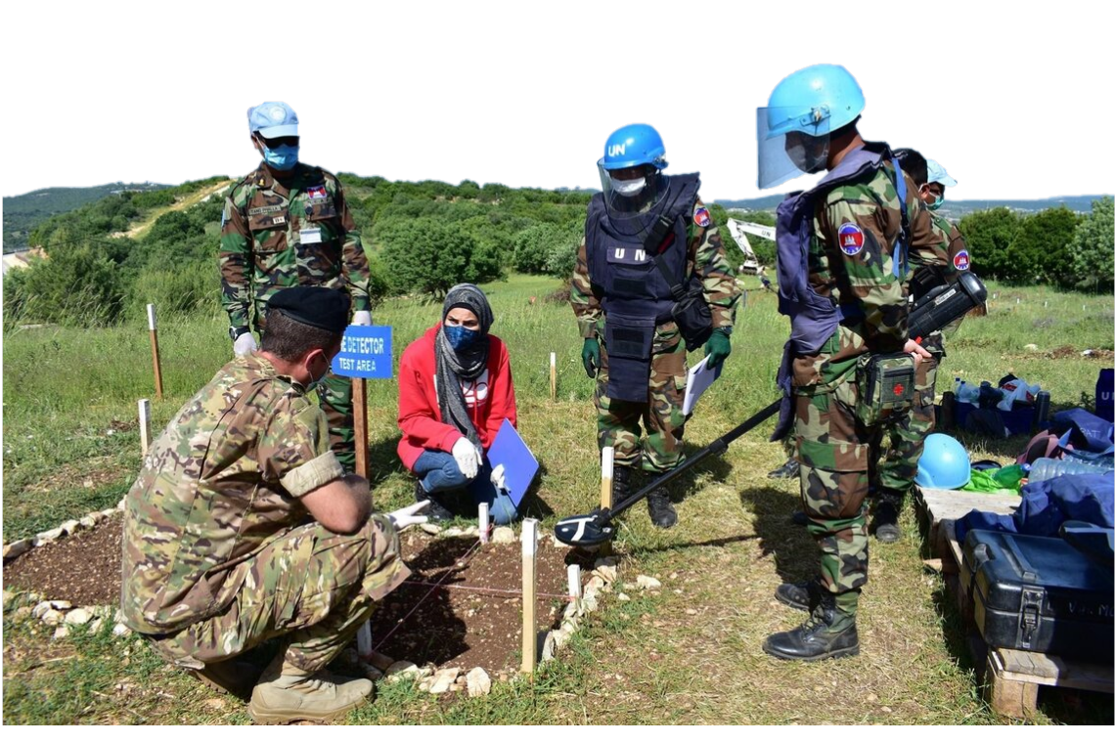

*Below: Ms Zeina Saleh trains deminers from different countries, including the Royal Cambodian Armed Forces (pictured here).   
Photo: UNMAS/  
Omar Diab*

**© Commonwealth of Australia 2024   
This work is copyright. Apart from any use as permitted under the Copyright Act 1968 (Cth), no part may be reproduced by any process without prior written permission from the Department of Defence.**