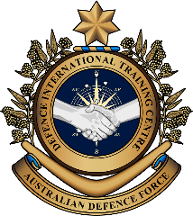

**Military English**

Vocabulary Builder – Parts of a Basic First Aid Kit

**Overview:**  
This worksheet presents vocabulary related to the items of a basic first aid kit.

**In this vocabulary builder, you will:**

* learn and use vocabulary related to a first aid kit in a military context.

1. Label the parts of a basic first aid kit. Match the words in the boxes to the pictures on pages 1 and 2.

scissors // bandage // gauze // splint

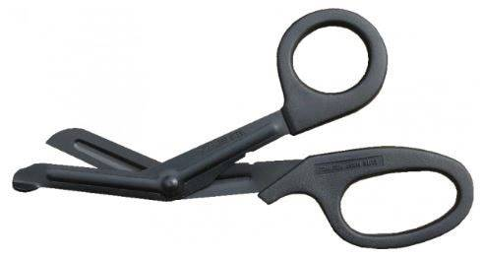

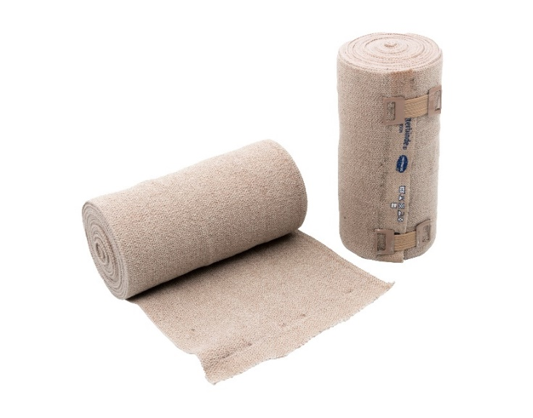

_______________________

**a**

_______________________

**d**

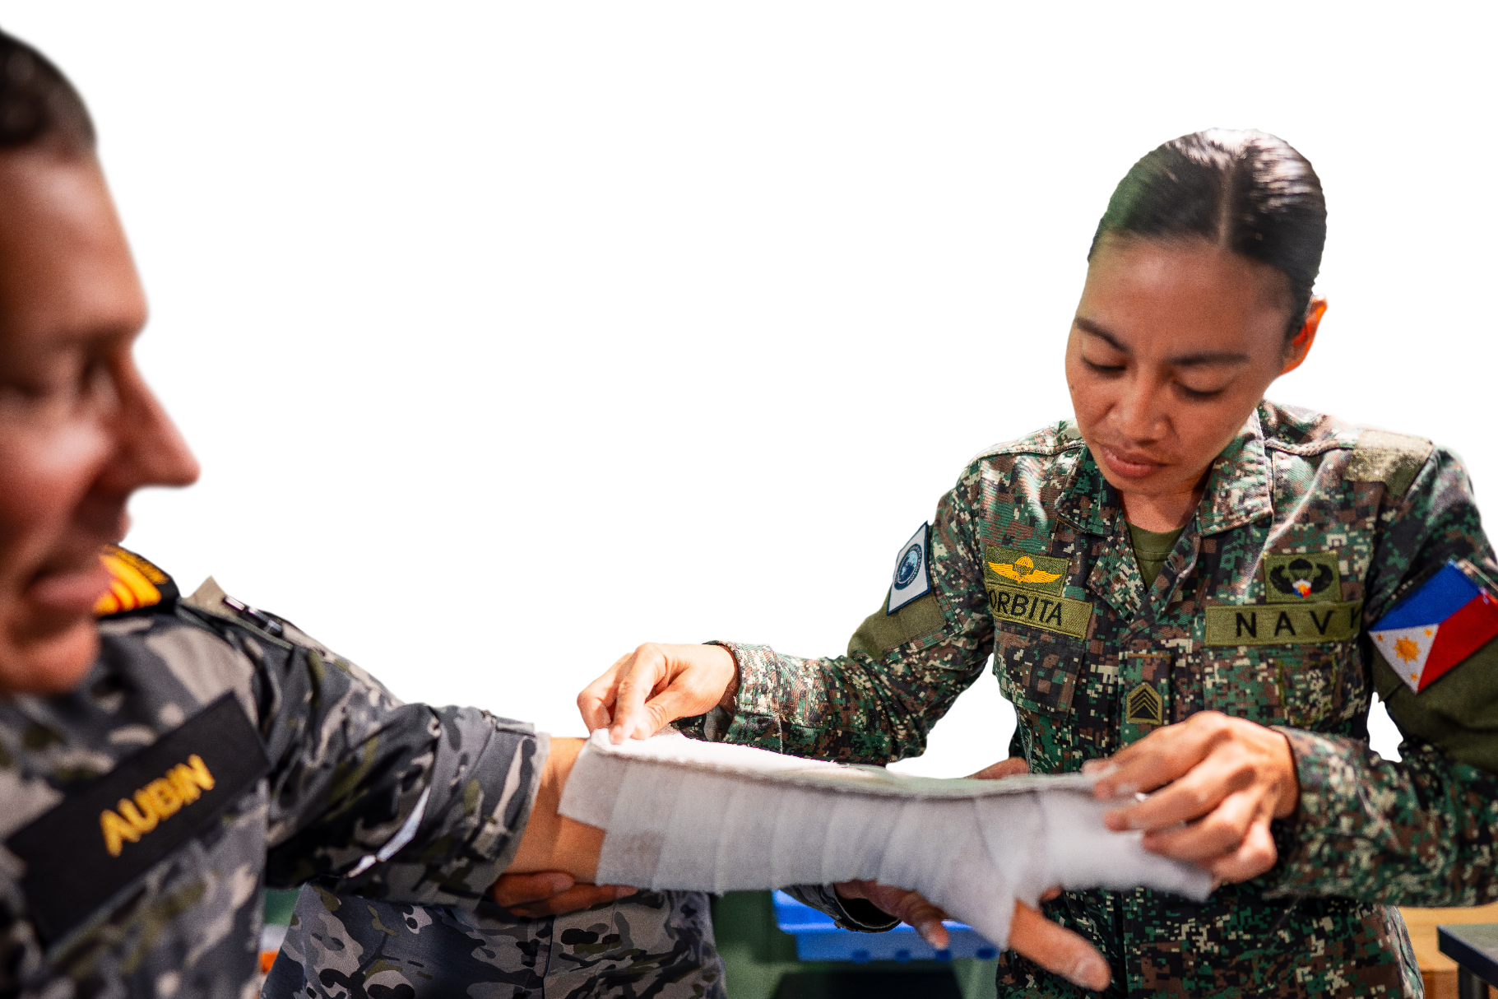

_______________________

**b**

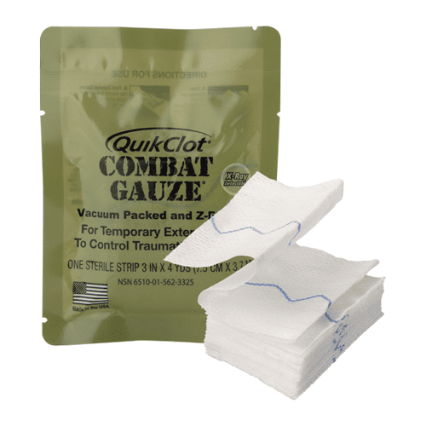

_______________________

**c**

syringe // alcohol wipes // survival blanket // tweezers // eye shield //   
tourniquet // adhesive tape // gloves

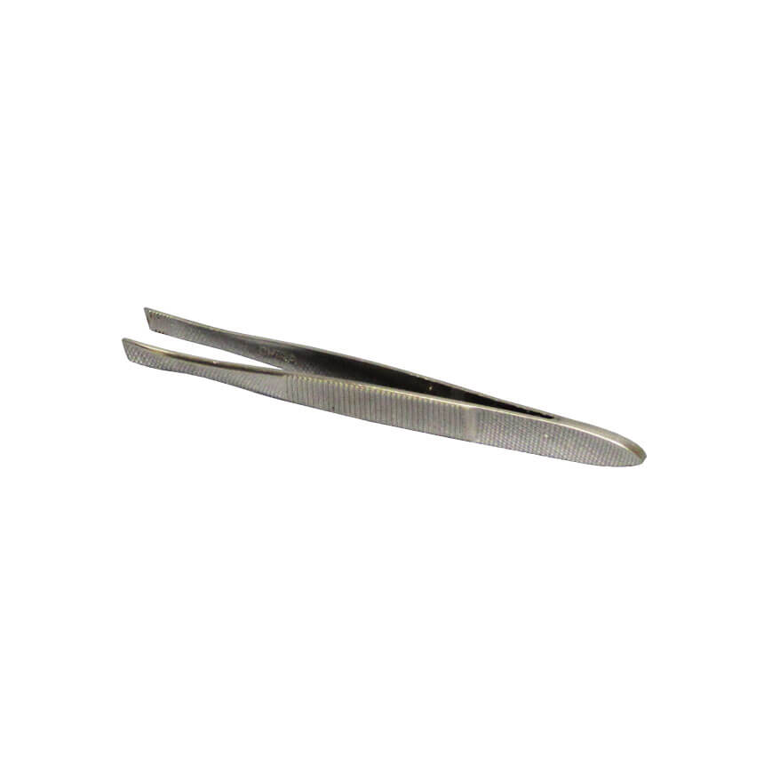

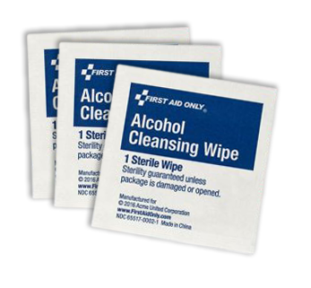

_______________________

**e**

_______________________

**f**

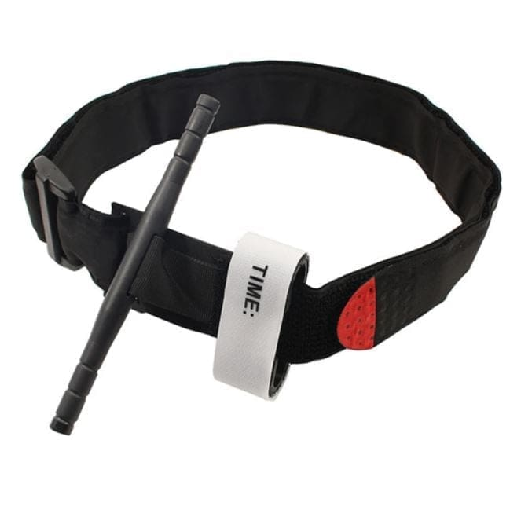

_______________________

**g**

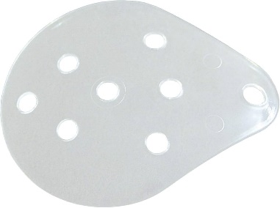

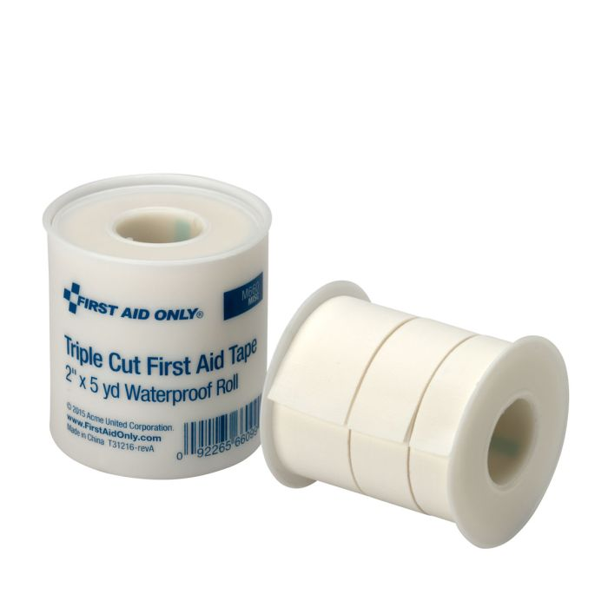

_______________________

**h**

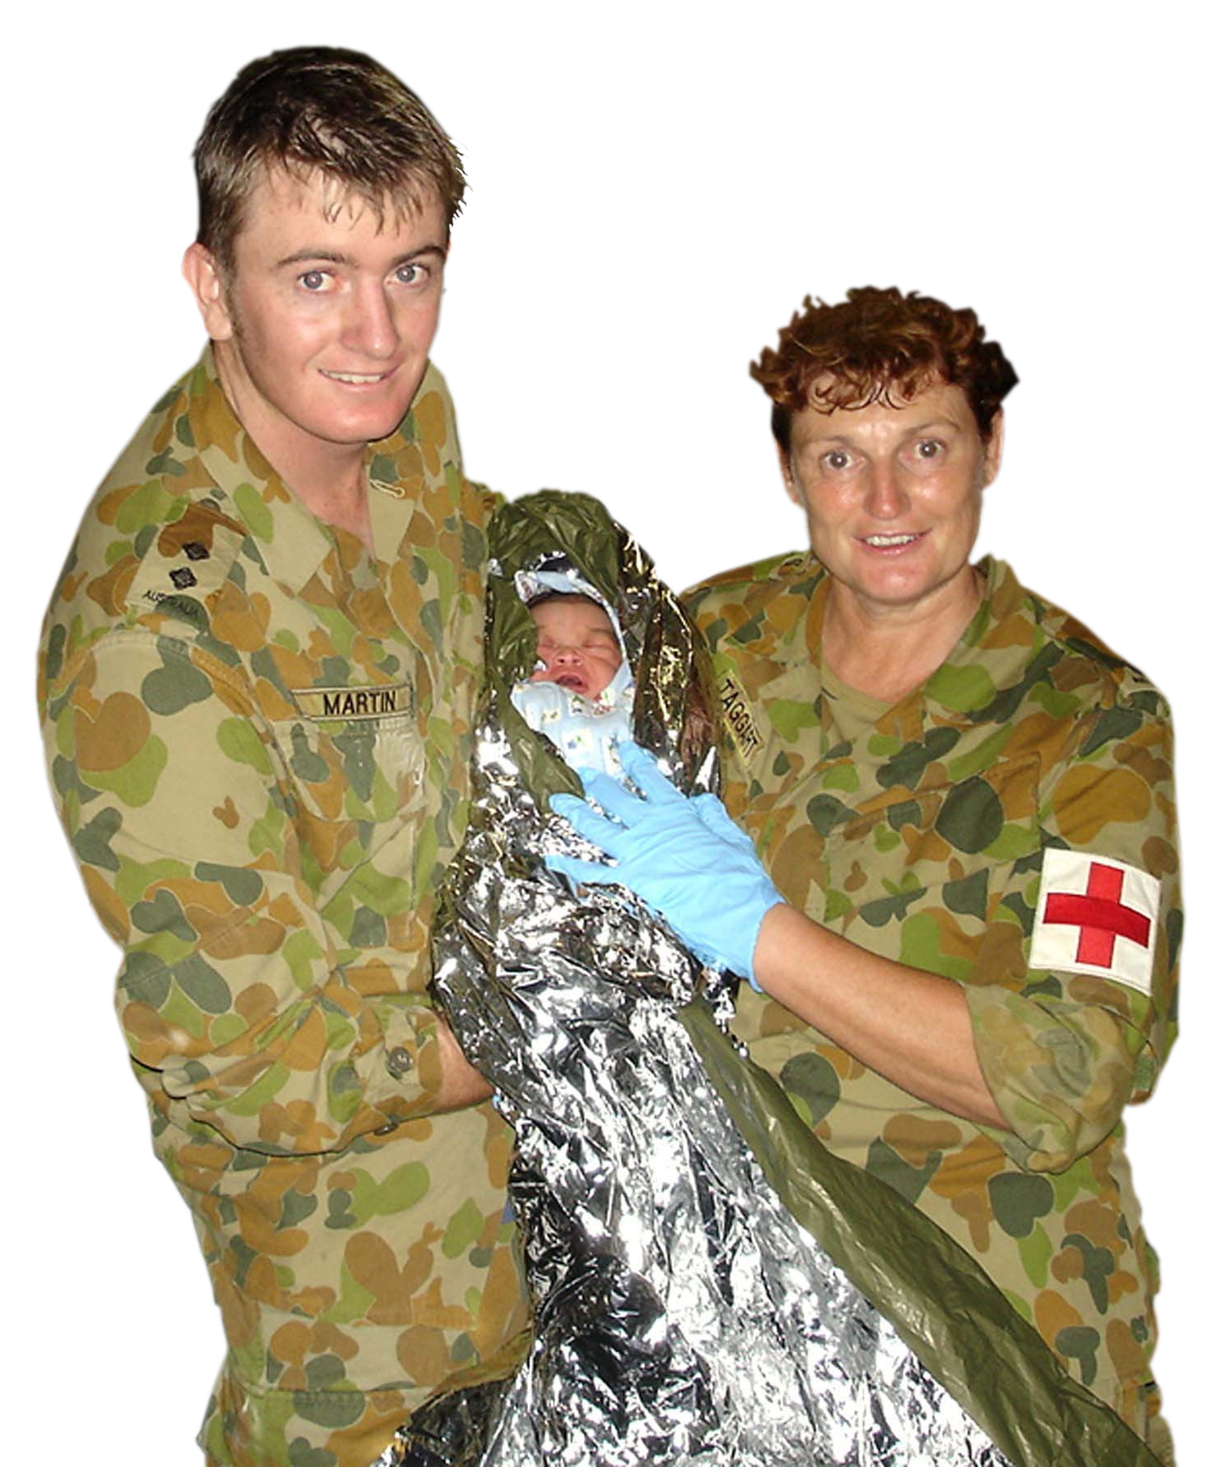

_______________________

**i**

_______________________

**j**

_______________________

**k**



_______________________

**l**

1. Now let’s practise saying the words. Listen and repeat.
2. Do you remember the first aid words you’ve just learned? Play crosswords.

* Read the clues and write the correct words in the spaces.
* 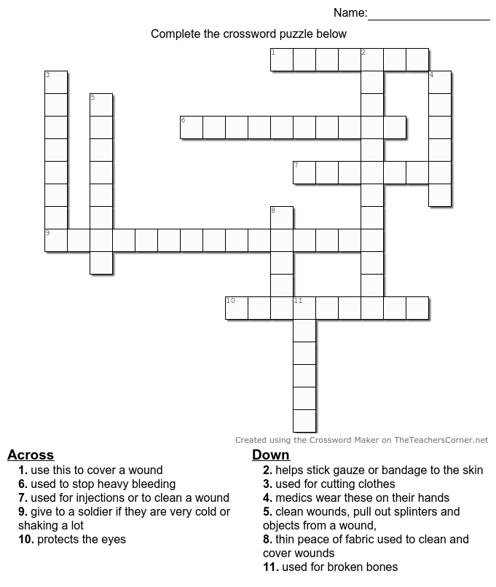Try not to look on pages 1, 2.

DOWN:

2. helps stick gauze or bandage to the skin (8, 4)

3. used for cutting clothes, gauze or bandage

4. medics wear these on their hands

5. use this to pull out splinters, or objects from a wound

8. thin piece of fabric used for covering and cleaning wounds

11. used for broken bones

ACROSS:

1. Use this to cover a wound

6. used to stop heavy bleeding

7. used for injections or to clean   
a wound

9. give it to a soldier if they’re cold or shaking a lot (8, 7)

10. protects the eyes (3, 6)

*numbers in brackets show how many letters in each of the two words*

1. Discuss these questions in groups of 2-3. Use as many of the words you learned in this lesson as you can.
2. Talk about a time when you had to use a first aid kit. What happened? What items did you use?
3. Is it important for every soldier to carry a first aid kit when they’re out in the field? Why?
4. Imagine you don’t have enough room in your webbing for a full first aid kit. You can only fit five items. Which five items of a first aid kit would you choose? Why?

* 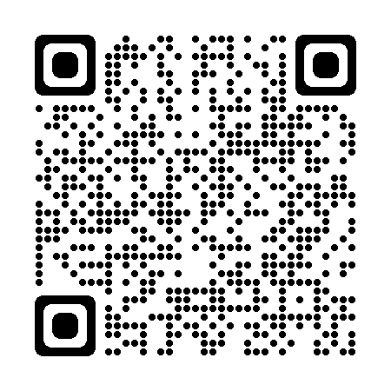Watch a video about Field Medicine. Type on YouTube [Australian Army Medics, Nurses and Doctors conduct simulated casualty drill](https://www.youtube.com/watch?v=4dDEuIGFPgc) or scan the QR code 🡪

Tick the words below that you see / hear in the video.

scissors  bandage  gauze  splint  syringe  
 alcohol wipes  survival blanket  tweezers  eye shield  
 tourniquet  adhesive tape  gloves

* This Vocabulary Builder links with 🡪 Lesson: Life of a UN Peacekeeping Medic – Part A

Lesson: Life of a UN Peacekeeping Medic – Part B

© Commonwealth of Australia 2024  
This work is copyright. Apart from any use as permitted under the Copyright Act 1968 (Cth),   
no part may be reproduced by any process without prior written permission from the Department of Defence.