# 

**Military English**

Lesson: Humanitarian Aid – Reading

**Overview:**  
This lesson covers a humanitarian aid operation conducted by the Australian Defence Force.

**In this lesson, you will:**

* find general and specific information in a text.
* learn the meaning of new words.
* use new words in sentences.
* use new words in a conversation.

## Prepare for Reading

1. Look at the photos below and discuss with a partner:

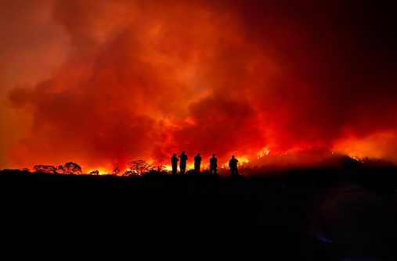What has happened?

What problems might happen next?

Who is in the picture (why)?

What can the military do in this situation?

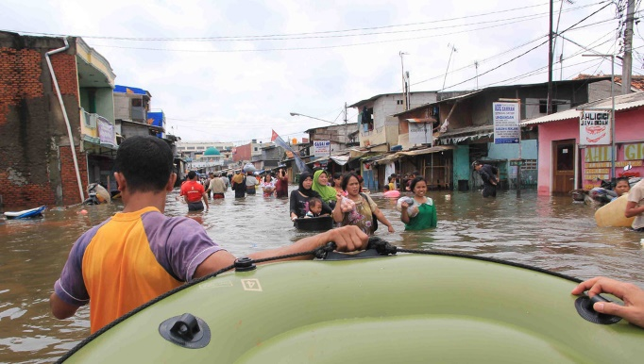

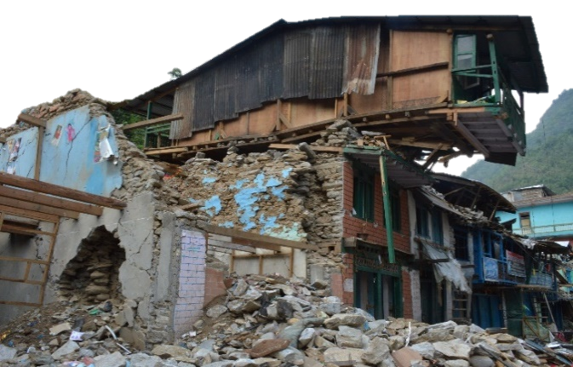

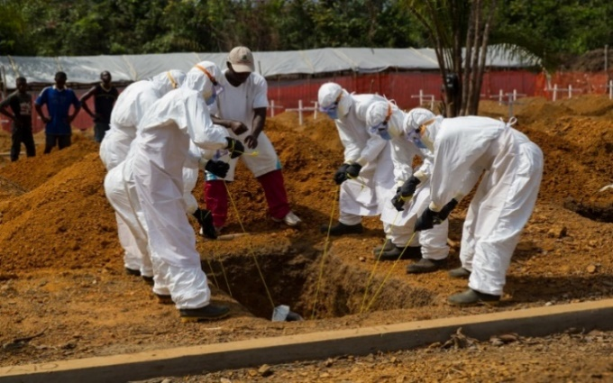

## Reading

1. Read **the heading and the first paragraph** **only** of the article below and answer these questions. Then check your answers with a partner/a group:

Do not use a dictionary yet. You are going to learn the meaning of the words in **bold** in the next exercise.

1. **What** did the ADF (Australian Defence Force) do   
   in this story?

**\* personnel** – people who work for the military. Example: My unit has about 35 personnel.   
Short form: pers

1. **Who** did the ADF help?
2. **Why** did Indonesia need help?

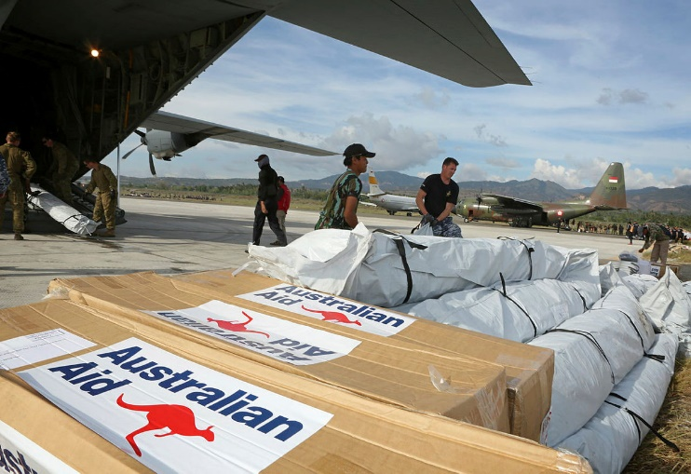**Australian Defence Force Response to Humanitarian Aid Disaster Relief (HADR)**

Australian Defence Force (ADF) personnel*have participated in many Humanitarian Aid Disaster Relief (HADR) missions during natural disasters, both in Australia and in other countries. For example, the ADF assisted Indonesia in **combined** HADR **operations** when earthquakes hit Indonesia’s Central Sulawesi province. The earthquake caused a 3-meter-high tsunami.

The earthquakes, tsunami, and landslides caused a lot of damage and at least 2,227 people died. More than 2,500 others were injured and 113 were missing. This disaster also **destroyed** more than 65,000 houses and **displaced** 211,000 people. The earthquake damaged the airport runway and control tower, and the tsunami damaged the seaport. Therefore, fuel and **humanitarian supplies** could not be delivered to the region. Overall, the earthquake affected 1.5 million people.

The Government of Indonesia, Ministry of Foreign Affairs and National Disaster Management Agency welcomed **foreign humanitarian aid assistance**. The ADF joined 17 other foreign militaries to assist the Government of Indonesia. The ADF **deployed** C-130 Hercules and C-17A Globemaster transport aircraft to deliver humanitarian supplies and equipment from Darwin to Balikpapan. Humanitarian supplies included **tarpaulins**, family **tents**, **generators**, **medicines**, **hygiene kits**, food and watersupplies. These flights also helped to **evacuate** people from disasterareas.

1. Now read the whole text, but quickly!

**Tip: When you see a new word in English, you can:**

* ask a classmate.
* use an English-English dictionary.
* use the sentence to help you guess the meaning.

How many of these can you find?

1. the name of an aircraft type
2. the number of foreign countries that assisted in a combined HADR operation
3. the number of displaced people
4. why fuel supplies could not be delivered
5. the types of humanitarian supplies

## Learning military vocabulary

1. The words in **bold** in the text are important military vocabulary that you should learn to use. Match the military words on the left to their definitions on the right on tables one and two (on the next page).   
   Look at the example.

|  |  |  |  |
| --- | --- | --- | --- |
| Table one |  |  |  |
| The ADF assisted in a **combined** **operation** (n) |  |  | 1. take people away from a dangerous to a safe place |
| The ADF **deployed** aircraft(v) |  |  | 1. **important items that people need for survival during a natural, political or health disaster, such as food, medicines, and water** |
| This disaster **destroyed** more than 65,000 houses (v) |  |  | 1. to send military personnel or equipment to another place |
| **displace** people (v) |  |  | 1. a military operation with forces from two or more different countries. |
| **evacuate** people (v) |  |  | 1. to violently break something, or to attack and end something |
| **humanitarian supplies** could not be delivered(n) | **b** |  | 1. Internally displaced people need more protection: insights from Africa to force people to leave their home or country, e.g. because of war or natural disaster |

‘**Combined Operations**’ versus ‘**Joint Operations**’

A **joint operation** is when more than one service (e.g. air force, navy, and/or army) work together in military operations.

A **combined operation** is when   
the militaries of two or more   
countries work together.

This photo shows the opening   
ceremony of the combined joint   
Exercise Nusa Bhakti AUSINDO 2022   
between Australia and Indonesia.

**Do you know**

**?**

**the difference**

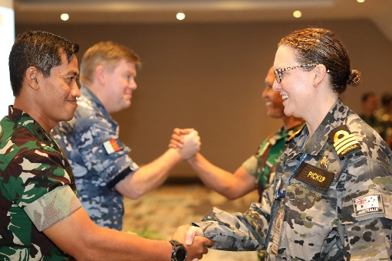

|  |  |  |  |
| --- | --- | --- | --- |
| Table two |  |  |  |
| they welcomed the **foreign humanitarian aid assistance** (n) |  |  | 1. Hygiene Pack Kit for students, elementary. middle school, high schoola package of basic items for keeping  a person’s body clean and healthy |
| supplies included **tarpaulins** (n)  short form - tarp |  |  | 1. Composition of medicine bottles and pills on white backgro… | Flickrdrugs for preventing sickness or disease |
| supplies includeda **tent** (n) |  |  | 1. High Performance Tents | UNICEF Office of Innovationa temporary shelter used in disaster relief |
| supplies included **medicines** (n) |  |  | 1. a petrol machine that makes electricity |
| supplies includeda **generator** (n) |  |  | 1. a large plastic/canvas sheet for protection from the rain and weather |
| supplies included **hygiene kits** (n) |  |  | 1. An agenda for aid and development in the 2022 federal electiona foreign country helping people in another country during a natural disaster |

1. Now let’s practise saying the words in this worksheet. Pay attention to the word stress (strong/weak parts of words. *E.g.**foreign, medicines*). Listen and repeat.
2. Use some of the words from exercise four in the sentences below.
3. One of the most important items of humanitarian supply is __________________ for treating people with illnesses and injuries.
4. Australian military officers worked with officers from several South East Asian countries in _________________humanitarian operations for disaster relief after the tsunami in Indonesia.
5. After a big natural disaster, the military will send _____________ ___________ to people for their basic survival, including food, water, and medicines.
6. Big earthquakes can destroy thousands of houses and ____________ people to areas with no shelter.
7. Military forces from many countries will join together to give ____________ _________________ _______ __________________ as a way of helping people in another country that has experienced a natural disaster.

## Practice

1. Discuss these questions with a partner:
2. Have you ever participated in a humanitarian aid operation? If yes, describe it.
3. Look at the humanitarian aid activities below – which are the most important to you? Why?
   * + delivering food and water
     + delivering medical equipment
     + delivering tents
     + providing education
     + delivering hygiene kits
     + giving blood
4. Do you think participating in a humanitarian aid mission is dangerous? Why/Why not?

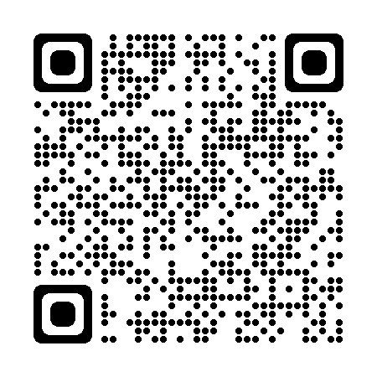

* Watch this video about RAAF C17A Globemaster delivering supplies to a city in Australia. Type on YouTube [RAAF C17A Globemaster delivers essential supplies to Townsville](https://www.youtube.com/watch?v=Q4PzeCnwdsQ&ab_channel=UKMAMSOBA) or scan the QR code:



* For more practice with the words you’ve learned here, scan the QR code.
* This lesson links with 🡪 Vocabulary Builder – Natural disasters;

Lesson – Disaster Relief.

© Commonwealth of Australia 2023  
This work is copyright. Apart from any use as permitted under the Copyright Act 1968 (Cth),   
no part may be reproduced by any process without prior written permission from the Department of Defence.