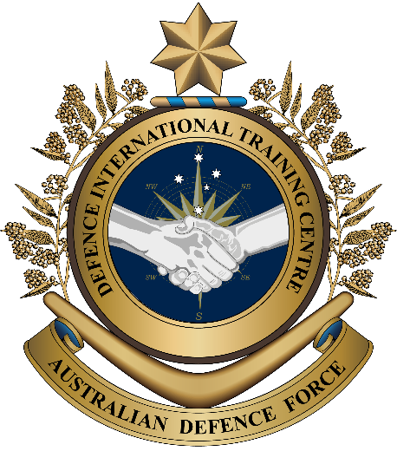

**Military English**

Lesson: Snapshot of the Australian Army - Reading

**Overview:**  
This lesson presents words related to an army.

**In this lesson, you will:**

* read and find specific information in a text
* learn the meaning of words related to an army
* practise pronunciation of new words
* use new words in sentences.

## Prepare for Reading

1. How much do you know about your army? First, match the words to their meanings in the green box below. Then, talk to a partner – do you know the answers to the questions?

**Match the words on the left with their definitions on the right:**

1. vehicle (n)
2. armour (n) / armoured (adj)
3. tank (n)
4. army base (n)
5. a special material in clothes and in military vehicles that protects soldiers from enemy fire
6. a machine with wheels used for moving things and soldiers around
7. a place where soldiers train, work and live

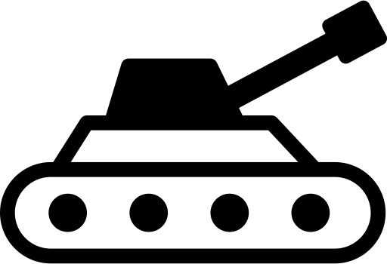

1. How many **tanks** or   
   **armoured vehicles** are there

in your army?

1. What kind of **tanks** or   
   armoured vehicles does  
   your army have?
2. How many **army bases** are   
   there in your country’s army?

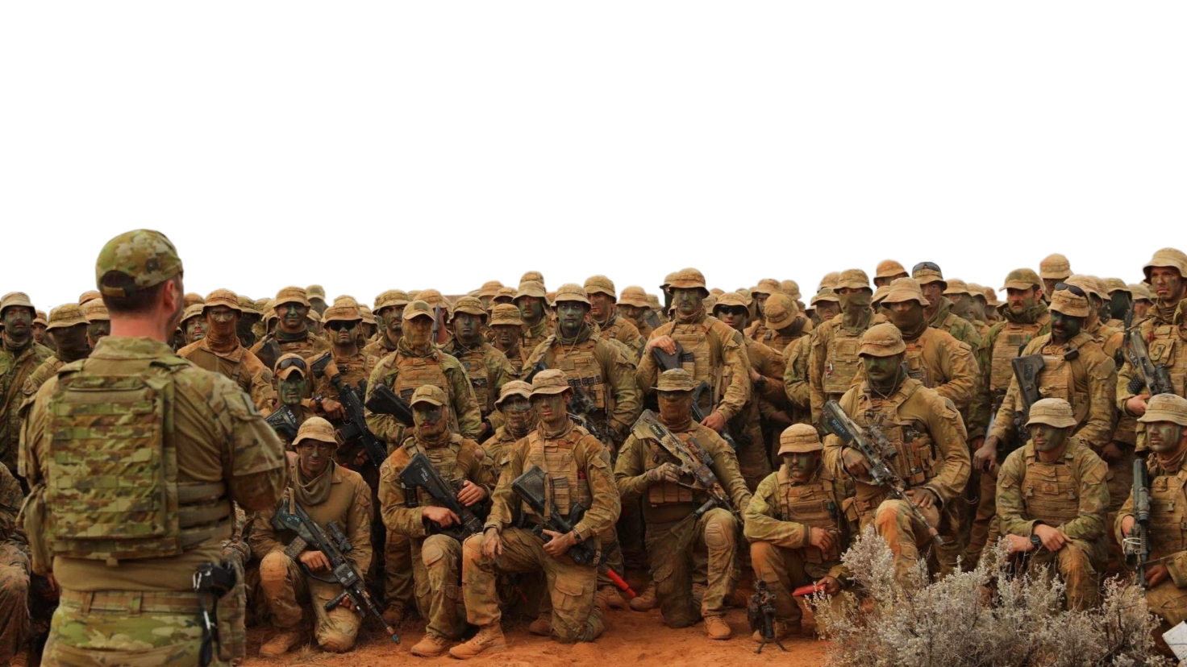

## Reading

1. Before reading the main text, discuss the question below in small groups of 2-3.

Most countries have an army. Why is an army different from an air force and a navy?

1. Read the text quickly and complete the table below with numbers or words.

**Outline of the Australian Army**

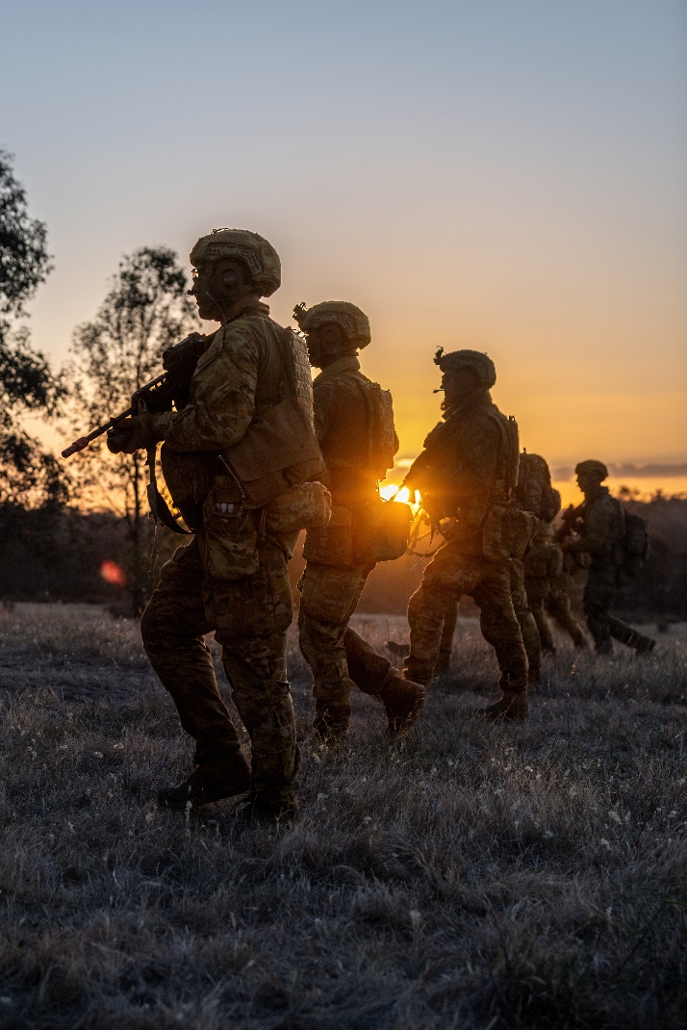15 large bases across Australia

48,500+ **personnel** including 21,000+ **reservists**

14,000 vehicles & aircraft

MAIN MISSIONS

The Army defends Australia’s land and helps to keep peace in other countries, for example:

• supporting international **security** and **counter-terrorism** operations,

• **patrolling** borders,

• conducting **search and rescue** missions,

• supporting **peacekeeping operations**,

• and providing **disaster relief**.

The Army has many kinds of vehicles, including:

**Main Battle Tank** (MBT) 🡪 Used for fighting other tanks and all other vehicles. The Army has 59 M1A1 Abrams tanks.

**Armoured Personnel Carrier** (APC) 🡪 Used for carrying soldiers and equipment into battle. The Army has 430 M113 APCs.

**Combat Reconnaissance Vehicle** (CRV) 🡪 Used for hiding and watching the enemy, and for patrol missions. The Army has 257 ASLAV and 68 Boxer CRVs.

**Infantry Mobility Vehicle** (IMV) 🡪 Used for carrying soldiers on patrol missions. The Army has around 1,000 Bushmaster and 1,000 Hawkei vehicles.

**Military Truck** 🡪Used for carrying personnel, equipment, and supplies. The Army has around 3,500 trucks.

1. _________: number of people in the Australian Army.
2. 430: _____________
3. 68: _______________
4. 3,500: _____________

Australian Army stats:

## Learning military vocabulary

1. The words in **bold** in the text are important military vocabulary that you should learn to use. Match the military words on the left to their definitions on the right. Look at the example.

|  |  |  |  |
| --- | --- | --- | --- |
| Table one |  |  |  |
| military **personnel** wear a uniform(n) |  |  | a. to look for people who are lost and take them somewhere safe |
| **reservists**  are very important to the army (n) | **d.** |  | b. to fight terrorists ( = people who create fear by hurting or killing other people) |
| **security** of the country (n) |  |  | c. people who work in a military service, for example, soldiers and sailors |
| **counter-terrorism** operations(n) |  |  | d. people in the military who work part-time, for example, they might only do military training on weekends |
| soldiers are **patrolling** nearby (v) |  |  | e. when organisations like the UN work to try to stop wars and make places safe for people |
| **search and rescue** missions (n) |  |  | f. something that means safe and protected |
| supporting **peacekeeping operations** (n) |  |  | g. to help people after a natural disaster (e.g. flood, earthquake) by bringing them basic items such as food and water |
| **disaster relief** arrived the day after the tsunami (n) |  |  | h. walking or moving through an area to keep it safe, or to find out what is happening there |

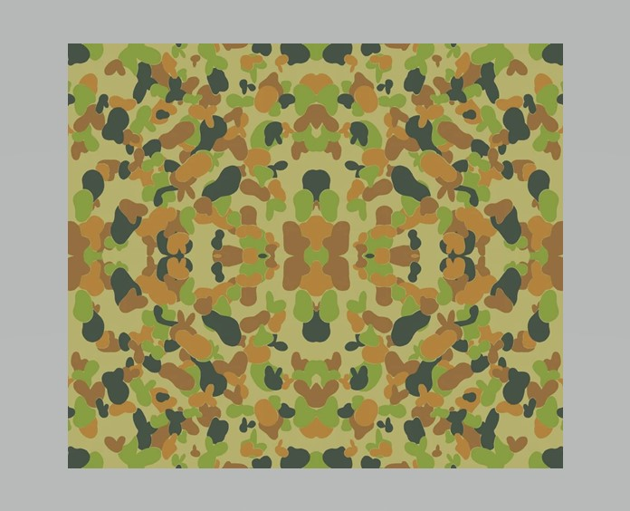

Here are some Australian Army vehicles.

Which one is the Bushmaster? How many trucks do you see?

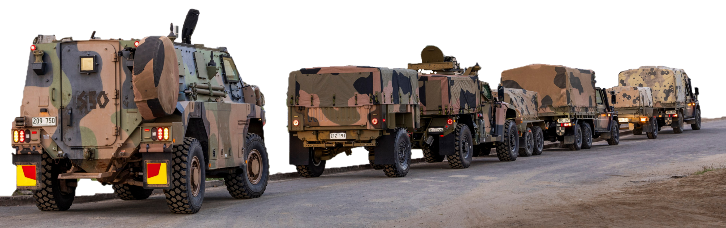

|  |  |  |  |
| --- | --- | --- | --- |
| Table two |  |  |  |
| **Main Battle Tank** |  |  | i. |
| **Armoured Personnel Carrier** |  |  | j. |
| **Combat Reconnaissance Vehicle** |  |  | k. |
| **Infantry Mobility Vehicle** |  |  | l. |
| **Military Truck** |  |  | m. |

1. Let’s practise saying the words. Listen and repeat.
2. Think about the text and the new words in this Lesson. Answer true or false.
3. The Australian Army can help find people if they are lost.
4. A tank is used for moving people and things.
5. Military trucks can move soldiers around.
6. An Armoured Personnel Carrier protects the soldiers inside from enemy fire (e.g. bullets, guns, landmines).
7. A Bushmaster vehicle can quickly move a few soldiers to different places.
8. Military trucks protect the soldiers inside from bullet and gun fire.
9. Now complete these sentences with some of the words from exercises 3 and 4. Use the words in the box below. The first one has been done for you.

reservists

The Australian Army includes personnel who work for the Army everyday (full-time) and 1. ____________(these soldiers don’t work for the Army every day). Personnel work at an 2.___________________. This place is where they train, prepare for missions and sometimes live. The Army uses different 3._______________ vehicles that keep soldiers safe from enemy fire (small and large guns). They also use 4.____________________________________________ to gather information about the enemy. The Army helps in 5.___________________________ operations to find and save people in danger. The Army sends soldiers and equipment to 6.________________________________ to help keep the peace in some parts of the world. Soldiers often go on 7.__________________ to watch and protect important areas. They can be on foot or in vehicles.



armoured // peacekeeping operations // patrol // ~~reservists~~   
combat reconnaissance vehicles // search and rescue // army base

## Practice

1. Discuss these questions with a partner. Use the vocabulary from exercises 3 and 4.
2. Which of the operations below does your army conduct? When do they usually happen?

search and rescue // counter-terrorism // peacekeeping

1. What kinds of missions would be most interesting to do? Why?
2. What kind of army vehicle would you like to use or drive? Why?
3. What types of bases are there in your country? (e.g. army, navy, air force, what do personnel do there, how big they are, etc).

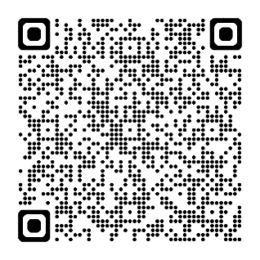

* For more practice with the words you’ve learned here, scan the QR code. →
* For more information about the Royal Australian Army, watch this video.   
  As you watch it, tick the things below that you see in the video.  
  Type on YouTube: [Australian Army - Land Power](https://www.youtube.com/watch?v=9SQVlnzMAlA) or scan the QR code. ↘

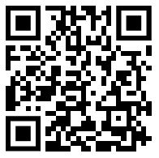 personnel patrolling Main Battle Tank  
Armoured Personnel Carrier Combat Reconnaissance Vehicle  
Infantry Mobility Vehicle Military Truck

* This lesson links with 🡪 Vocabulary Builder: Facilities on an Army Base

Vocabulary Builder: Types of Army Weapons

© Commonwealth of Australia 2024  
This work is copyright. Apart from any use as permitted under the Copyright Act 1968 (Cth),   
no part may be reproduced by any process without prior written permission from the Department of Defence.