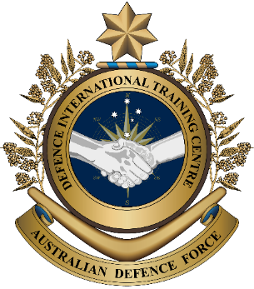

**Military English**

Lesson: Snapshot of the Royal Australian Air Force (RAAF) - Reading

**Overview:**  
This lesson teaches words related to an air force.

**In this lesson, you will:**

* read and find general and specific information in a text
* learn the meaning of words related to an air force
* use new words in sentences and in conversations

## Prepare for Reading

1. Let’s find out how much you know about your air force. Talk to a partner – do you know the answers to the questions?

a. How many aircraft are there in your air force?

an **air force base** (n) – the place where air force personnel work and aircraft stay when they are not flying.

b. What kind of aircraft does your air force have?

c. How many air force bases are there in your country?

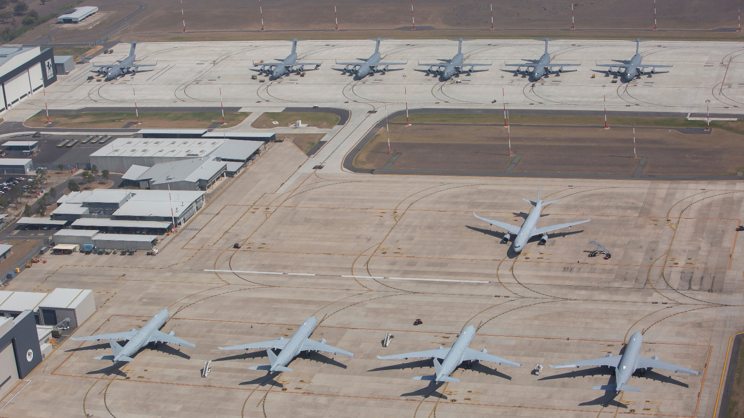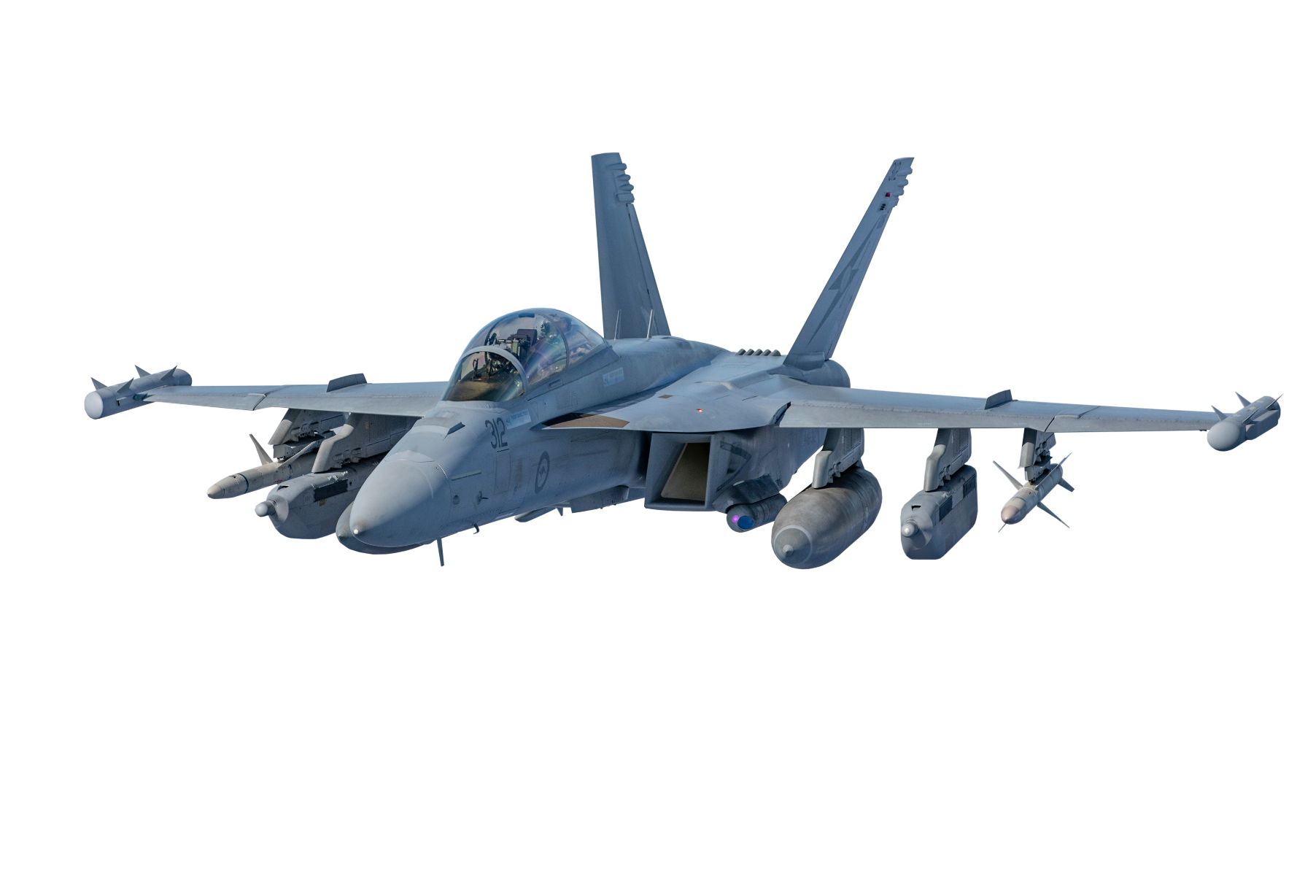

## Reading

1. Before reading the text below, discuss this question in groups.

Many countries have an air force. Why is the air force different from the army and the navy?

1. Read the text quickly and complete the table below with numbers or words.

**Outline of the RAAF**

17 air bases across Australia

21,000+ **personnel** including 6,400 **reservists**

270+aircraft

MAIN MISSIONS:

The RAAF defends Australian air space and assists other countries, for example:

• supporting international **security** and **counter-terrorism** missions,

• guarding **coastlines**,

• conducting **search and rescue** missions,

• supporting **peacekeeping operations**,

• and providing **disaster relief**.

Main aircraft types:

**Fighter aircraft** 🡪 Used for fighting other aircraft. The RAAF has 72 F-35A Lightning 2 fighter aircraft.

**Ground Attack aircraft** 🡪 Used for attacking ground targets, like tanks, trucks, and buildings. Weapons can include bombs and rockets. The RAAF has 24 F/A-18 Super Hornet fighter / ground attack aircraft.

**Maritime** **Patrol aircraft** 🡪 Used for flying around the coastlines and oceans hunting for enemy submarines and ships. The RAAF has 12 P-8A Poseidon Maritime Patrol aircraft.

**Transport aircraft** 🡪 Used for carrying personnel, vehicles, and equipment. Some transport aircraft can carry tanks and helicopters. The RAAF has 8 C-17 Globemaster, 12 C-130 Super Hercules, and 10 C-27J Spartan.

**Trainer aircraft** 🡪 Used for training pilots and crews. The RAAF has 33 BAE Hawk and 46 Pilatus PC-21.

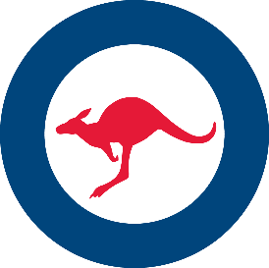

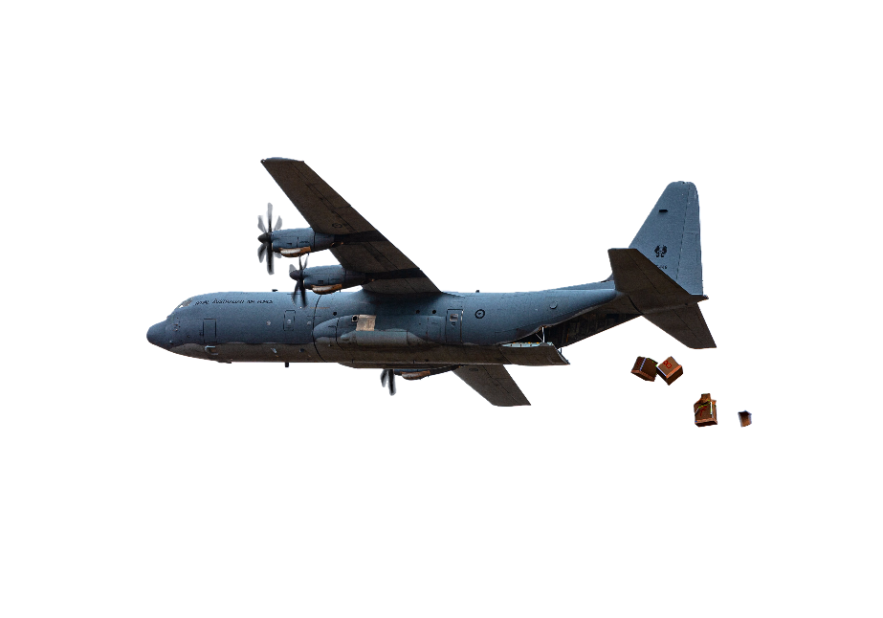

1. _________: number of people in the RAAF.
2. 72: _____________
3. 8: _______________
4. 46: _____________

RAAF stats:

## Learning military vocabulary

1. The words in **bold** in the text are important military vocabulary that you should learn to use. Match the military words on the left to their definitions on the right. Look at the example.

|  |  |  |  |
| --- | --- | --- | --- |
| Table one |  |  |  |
| RAAF **personnel** train for different missions (n) | **c** |  | 1. missions which try to stop wars and make places safe for people |
| a **reservist** (n) |  |  | 1. something that means safe and protected |
| **security** is important at this air base (n) |  |  | **c. people who work in a military service, for example, soldiers   and sailors** |
| some officers are trained in **counter-terrorism** (n) |  |  | 1. a person in the military who works part-time, for example, this person might only do military training on weekends |
| guarding the **coastline** (n) |  |  | 1. to look for people who are in trouble and help them |
| a **search and rescue** mission (n) |  |  | 1. the area between the land and the sea, for example, the line around an island on a map |
| after the war, **peacekeeping operations** made the country safer (n) |  |  | 1. to fight terrorists ( = people who create fear by hurting or killing other people) |

|  |  |  |  |
| --- | --- | --- | --- |
| Table two |  |  |  |
| providing **disaster relief** (n) |  |  | 1. aircraft used to teach a student how to fly |
| this **fighter aircraft** is very fast (n) |  |  | 1. an aircraft which moves heavy things like tanks, helicopters and personnel |
| a **ground attack aircraft** (n) |  |  | 1. to help people after a natural disaster like flood, earthquake, tsunami, etc |
| a **maritime patrol aircraft** (n) |  |  | 1. an aircraft which can shoot down another aircraft |
| a **transport aircraft** (n) |  |  | 1. an aircraft which can look for ships and submarines |
| some **trainer aircraft** are easy to fly (n) |  |  | 1. an aircraft which can attack ground targets such as buildings |

1. Let’s practise saying the words. Listen and repeat.

## Practice

1. Read the text again and think about the words you have learned in this lesson. Answer **true** or **false**.
2. The RAAF can help find people if they are lost.
3. The F-35 Lightning II is used for transporting tanks and trucks.
4. The F/A 18 Super Hornet is a fighter plane and a ground attack plane.
5. The C-130 Hercules is a maritime patrol plane.
6. The Pilatus PC-21 is a training plane.
7. Now complete these sentences with some of the words from exercises 3 and 4.
8. Operation Fiji Assist was a __________________ operation conducted by the RAAF after a cyclone hit Fiji in 2016. The RAAF used some of its ______________________ aircraft to bring basic items such as food and water.
9. The P-8A Poseidon, which is a _______________________________ aircraft, can fly around the _______________________ of Australia searching for submarines and ships. It can also be used for _________________________________ missions if people or ships are lost at sea.
10. Before flying a fighter aircraft, pilots spend many hours practising on a _________________ aircraft.
11. ___________________ don’t get the same amount of training as other air force personnel, but they are ready to join the fight if there is a war.
12. Discuss these questions with a partner. Use the vocabulary from exercises 3 and 4
13. Which of the operations below does your air force conduct? When did they happen?

search and rescue // counter-terrorism // peacekeeping

1. What kinds of missions would be most interesting to do? Why?
2. If you could be a pilot, what kind of aircraft would you like to fly? Why?
3. 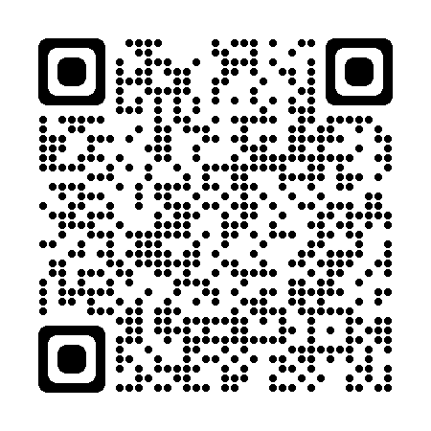What types of bases are there in your country? (e.g. army, navy, air force, what do personnel do there, how big they are, etc).

* For more information about the Royal Australian Air Force, watch this video. →  
  Type on YouTube [F-35s, Hornets and Growlers team up for Exercise Arnhem Thunder](https://www.youtube.com/watch?v=p1KMzMtEh1Q)   
  or scan the QR code below on the right.
* For more practice with the words you’ve learned here, scan the QR code. ↘
* 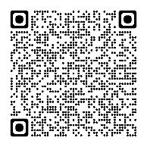This lesson links with 🡪 Lesson – Military Drones;

Vocabulary Builder – Parts of an Aircraft

Vocabulary Builder – Types of a Helicopter

Vocabulary Builder – Ranks in the Royal Australian Air Force

© Commonwealth of Australia 2024  
This work is copyright. Apart from any use as permitted under the Copyright Act 1968 (Cth),   
no part may be reproduced by any process without prior written permission from the Department of Defence.