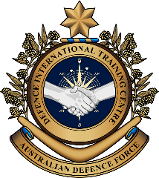

**Military English**

Vocabulary Builder – Parts of a Combat First Aid Kit

**Overview:**  
This worksheet presents vocabulary related to the items of a combat first aid kit.

**In this vocabulary builder, you will:**

* learn and use vocabulary related to a combat first aid kit.

1. Label the parts of a combat first aid kit. Match the words in the boxes to the pictures on pages 1 and 2.

IV fluid // chest seal // naso pharyngeal // giving set

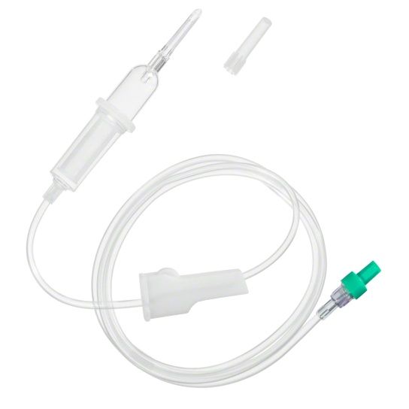

_______________________

**a**

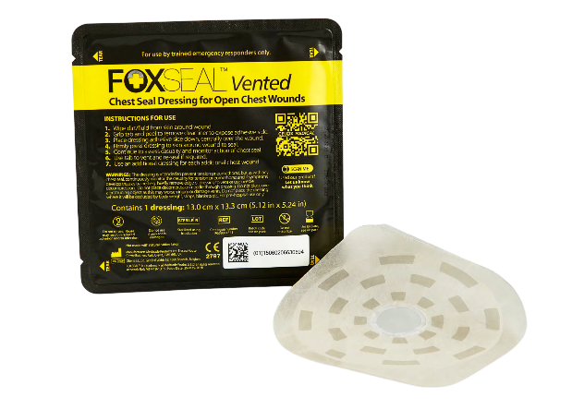

_______________________

**c**

_______________________

**d**

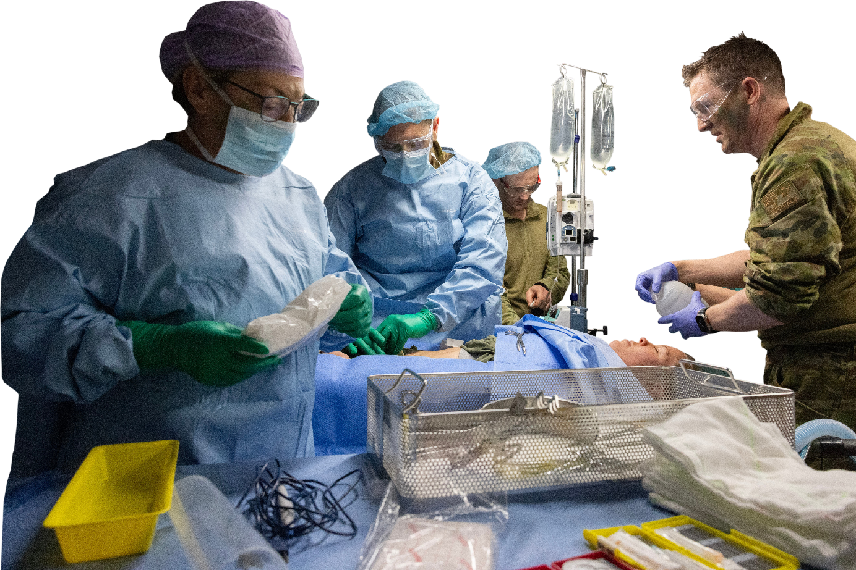

_______________________

**b**

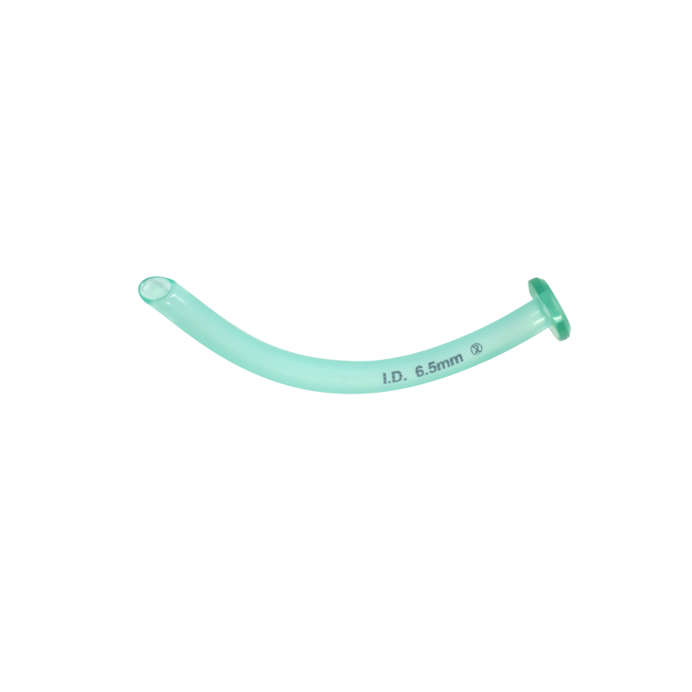

oral pharyngeal // normal saline // oximeter // catheter and needle //   
stethoscope // sharps container // adrenaline ampoule

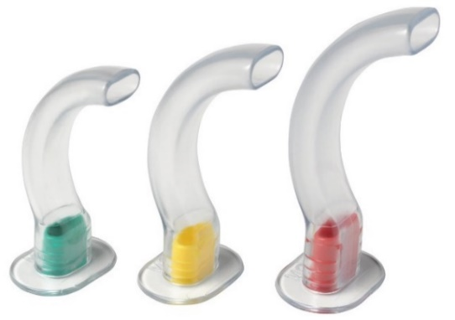

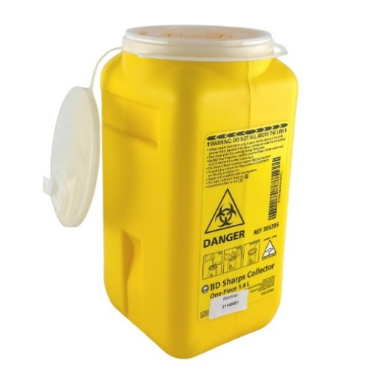

_______________________

**h**

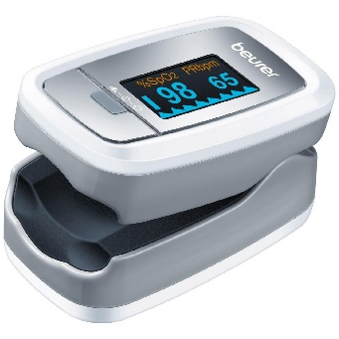

_______________________

**e**

_______________________

**i**

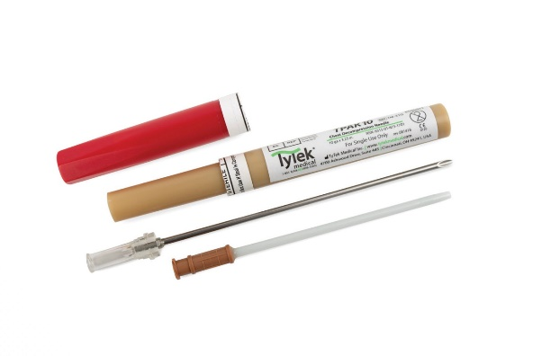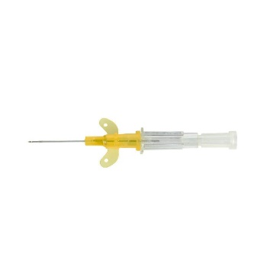

_______________________

**f**

**These can be used for tension pneumothorax (on the left, above) and IV injections (on the right, above).**

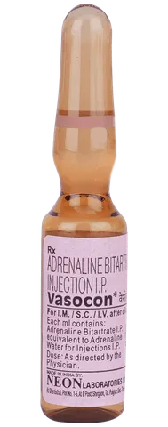

_______________________

**j**

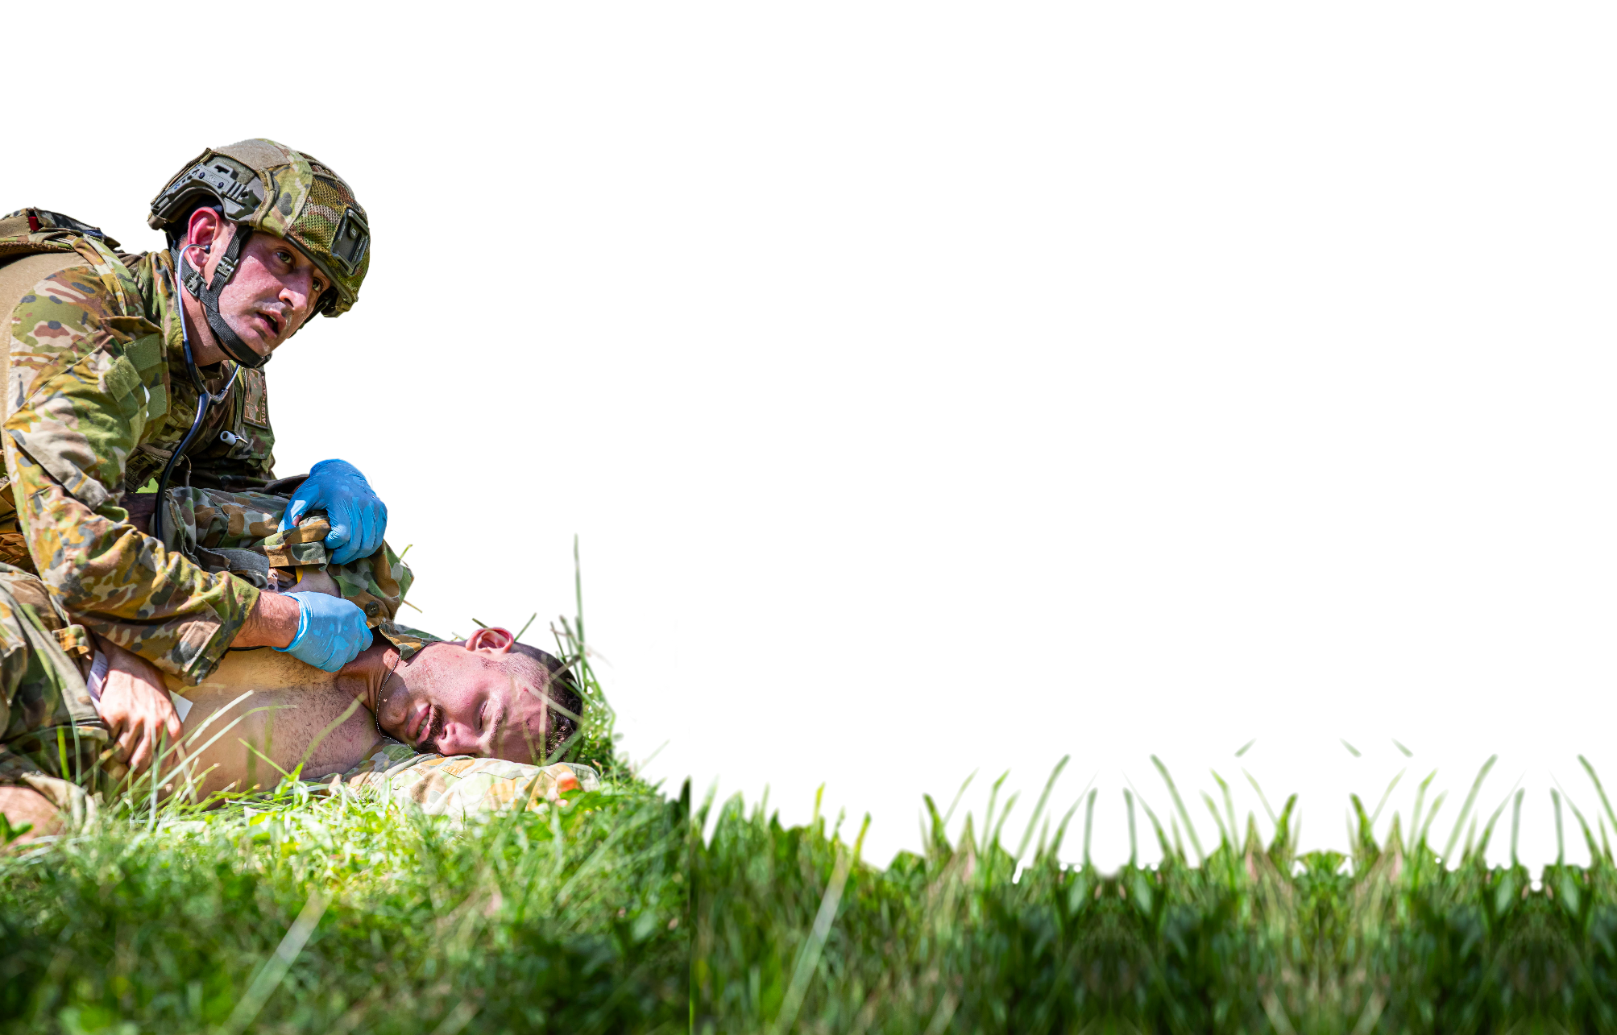

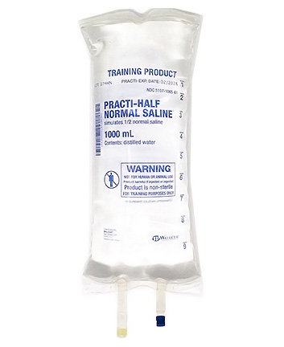

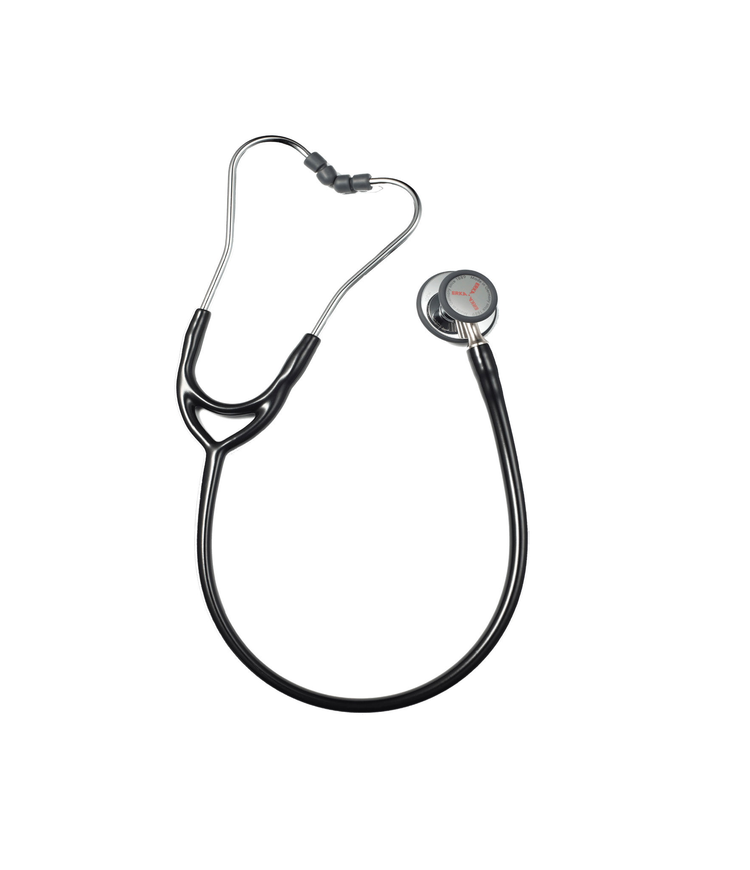

_______________________

**g**

_______________________

**k**

1. Now let’s practise saying the words. Listen and repeat.
2. Sometimes, when we say two words together some of the sounds are difficult to say.

* Listen to this vocabulary item again and notice how the /t/ on chest disappears:

che~~st~~ seal 🡪 /ˈʧesɪəl/

* Now, it’s your turn. Listen to this vocabulary item. Cross out the sound that disappears.

catheter and needle

1. Using the words from the box below, fill in the gaps in the story. Look at exercise 1 for help. The first one is done for you.

IV fluid // oral pharyngeal // oximeter // ~~giving set~~ //

stethoscope // adrenaline ampoule // chest seal

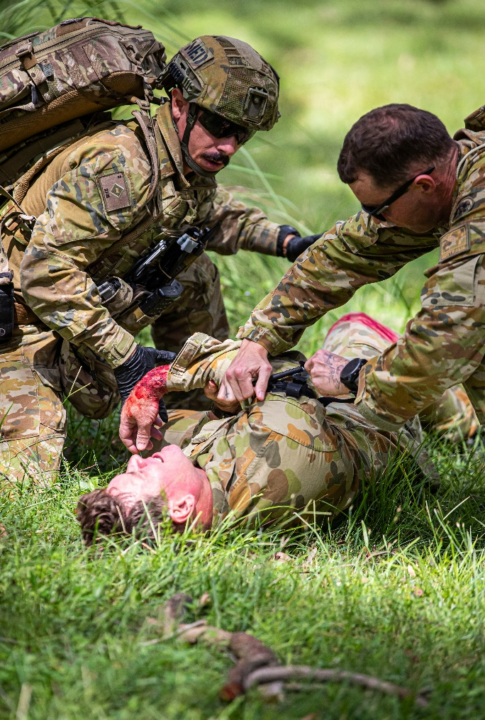During a battle, a soldier was injured in the arm and chest. A medic came to care for him. The medic quickly cleaned the wound on the arm and put a field dressing on it. He then prepared a 1 ____________ with   
2 ________________ to prevent shock. He checked his heartbeat with a 3 ___________________. He then used a 4 __________________________ for the chest injury, to help him breath. He inserted an   
5 ________________________ to keep the soldier's airway open and checked oxygen levels with an   
6 __________________. Finally, the medic had an   
7 ________________________________ ready in case the soldier had a cardiac arrest.

giving set

*Australian Army medics from 2nd Health Battalion provide medical care to a simulated casualty during Exercise Viper Walk 2024.*

1. Discuss these questions in groups of 2-3. Use as many of the words you learned in this lesson   
   as you can.
2. How is a basic first aid kit different from a combat first aid kit?
3. What difficulties do you think soldiers might face when they use their first aid kits in the field?
4. In your military, do you think that medics receive enough training to save a soldier’s life?
5. Which of the items from this lesson can you use?

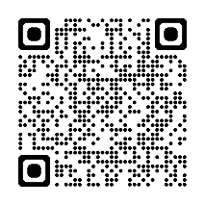

* Watch this short video. Type on YouTube [Providing Immediate Healthcare Support: Maddie's Story](https://www.youtube.com/watch?v=mWYn7ExFlAc) or scan the QR code.

Tick the two words below that you **see** in the video.

IV fluid  chest seal  naso pharyngeal  giving set oral pharyngeal   
 normal saline  oximeter  catheter and needle  stethoscope   
 sharps container  adrenaline ampoule

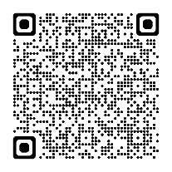

* For more practice with the words you’ve learned here, scan the QR code.
* This Vocabulary Builder links with 🡪 Vocabulary Builder: Parts of a Basic First Aid Kit

Lesson: Life of a UN Peacekeeping Medic - Part C

© Commonwealth of Australia 2024  
This work is copyright. Apart from any use as permitted under the Copyright Act 1968 (Cth),   
no part may be reproduced by any process without prior written permission from the Department of Defence