**Military English**

Lesson: Life of a UN Peacekeeping Medic – PART B: Deployment to Cambodia and Papua New Guinea – Listening

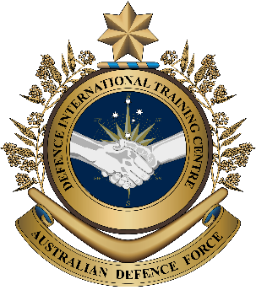

**Overview:** This is the second of four lessons that will teach vocabulary related to being a ‘Medic’ and Army nurse during United Nations (UN) Peacekeeping missions.

**In this lesson, you will:**

* use listening skills.
* learn the meaning of new vocabulary and expressions.
* use new vocabulary and expressions in context.

## Prepare for Listening

1. In pairs, discuss:
2. What do you know about UN peacekeeping operations?
3. Do you know anyone who has deployed on UN Peacekeeping operations? Talk about when, where, how long the deployment was.
4. What are the different jobs of military medics in peacekeeping operations?

to **deploy** (v) – to send soldiers or equipment to a place for   
a mission

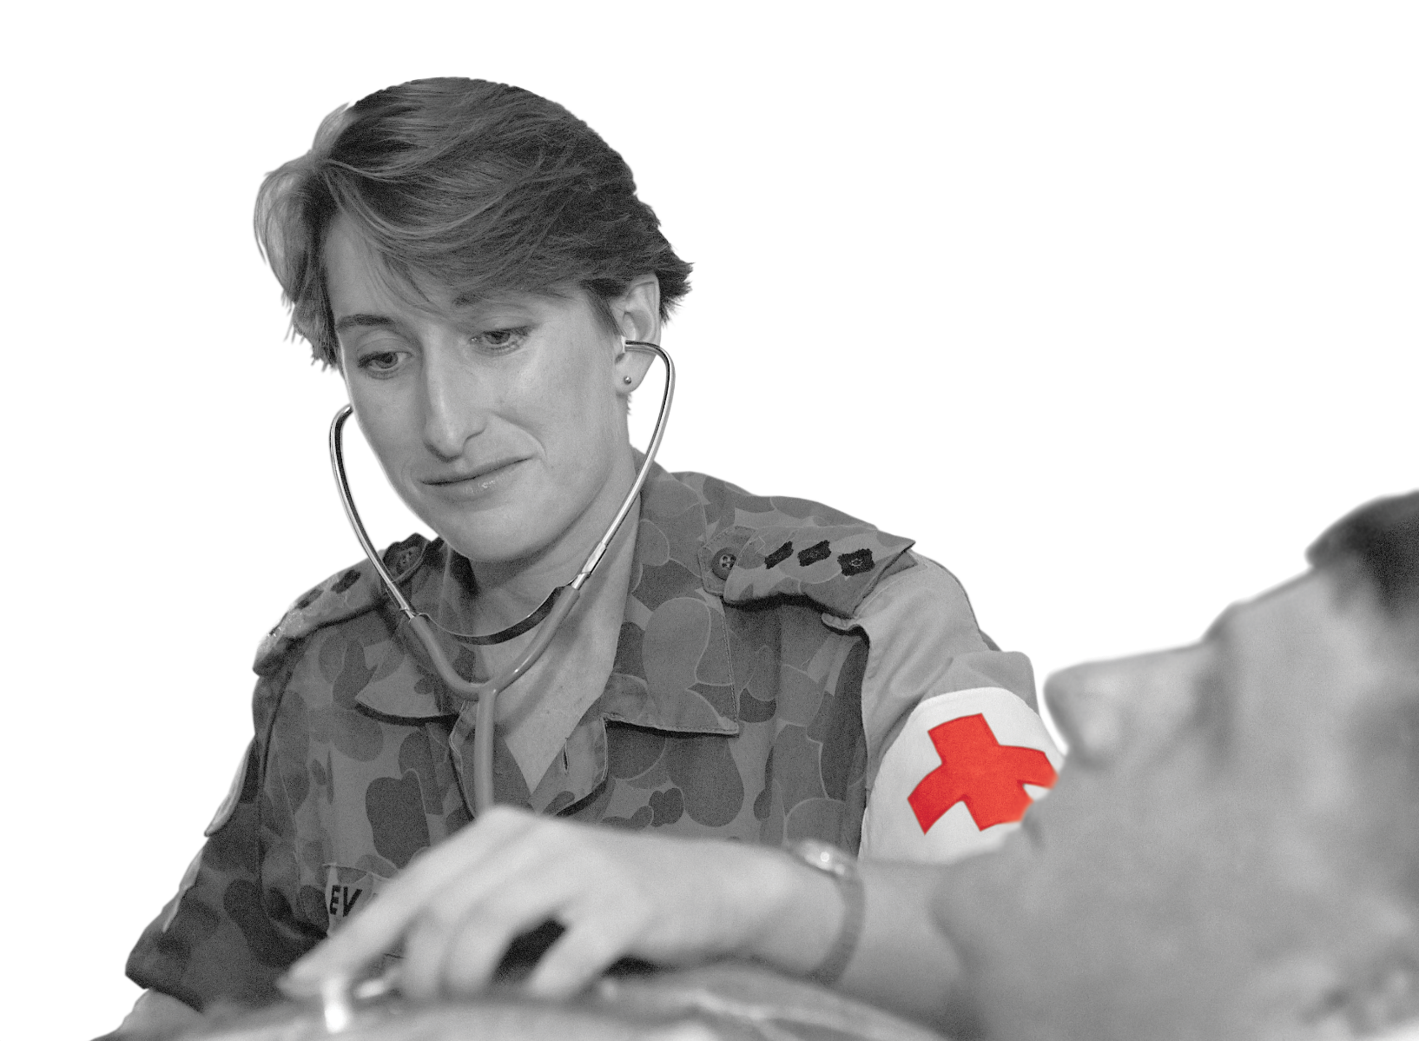

*Captain Susan Evans, Regimental Medical Officer attached to Force Communications Unit, Cambodia, as part of a   
UN Peacekeeping  
 Mission – 1993.*

## Listening – Part 1

1. Listen to the interview and tick the two countries WO1 Beth Mathews deployed to as a medic.

Rwanda Australia Cambodia

Somalia Papua New Guinea (Bougainville)

## Learning Military Vocabulary

1. The words listed in bold below are important vocabulary and expressions that you should learn to use. Match the vocabulary on the left with their definitions on the right. Look at the example.

|  |  |  |  |
| --- | --- | --- | --- |
| Table one |  |  |  |
| how to do **field medical procedures** (n) |  |  | 1. a period, usually in the morning from 0700-0800, for visiting a doctor at a military medical clinic; no appointment is needed | |
| **coalition** of UN Peacekeepers(n) | **d** |  | 1. medical treatments given to patients when they are hurt or injured in combat or operational zones | |
| we started the day with a **sick parade** (n) |  |  | 1. a serious disagreement or argument between groups; sometimes there is fighting | |
| enemy **combatants** were active (n) |  |  | **d. military personnel who are fighting in a war on behalf of their country** | |
| there was a **conflict** (n) |  |  | 1. an armed fighter | |
| it was a problem for **peace and stability** (n) |  |  | 1. personnel who work in hospitals, clinics, or medical facilities | |
| the deployment included **health staff** (n) |  |  | 1. a situation where there is no conflict, violence or war and the government systems work | |

|  |  |  |  |
| --- | --- | --- | --- |
| Table two |  |  |  |
| we treated **injuries** (n) |  |  | 1. people who are injured or harmed from an accident, conflict, disaster, or other dangerous event. |
| **wounds** (n) (bleeding wounds; gunshot wounds; machete wounds) |  |  | 1. practical education and learning that nurses and medics receive in a real medical setting, like hospitals or clinics |
| join the **peace talks** (n) |  |  | 1. a group of soldiers who are part of a larger military force |
| we were receiving those **casualties** (n) |  |  | 1. physical harm or damage to the body caused by an accident, violence, or other external force, e.g. broken bones or gunshot wounds |
| **clinical training** (n) |  |  | 1. injuries to the body where the skin is cut or open and often bleeding |
| a **contingent** of personnel (n) |  |  | 1. discussions or negotiations between groups or countries that are in conflict, with the goal of reaching an agreement to end violence and establish peace |

1. Now let’s practice saying the words. Listen and repeat.

## Listening – Part 2

1. Listen to the interview again and answer the questions below.
2. A person in camouflage uniform standing next to a patient

   Description automatically generatedWhen did Warrant Officer Beth Andrews deploy to in Cambodia?

____________________________________________________

1. What was her first job of the day in Cambodia?

____________________________________________________

1. Why did she need to carry a weapon at the local market?

____________________________________________________

1. When did she deploy to Bougainville?

____________________________________________________

1. Which other countries did Australian personnel deploy to?

____________________________________________________

1. Here is the transcript of the interview. Listen to it and fill in the gaps with the missing words you hear.

**A:** Good afternoon listeners. Welcome back to Radio Station 4U2 and our ongoing interviews with military veterans. In today’s interview we will continue talking with Warrant Officer Beth Andrews, who is currently serving with the Australian Army as a nurse. We are going to talk with her about her experience in UN peacekeeping operations, her various deployments, and life as a nurse in the modern military.

**A:** Hello Warrant Officer Beth Andrews, thank you for joining our program again today.

**B:** Thank you Ben. It is always my pleasure to share some of my experiences with your listeners.

**A:** So to begin, can you tell us, when and where was your first deployment?

**B:** Well, in 1992, I deployed to Cambodia to assist with the UN peacekeeping mission to help re-build the country. Before deploying we did two weeks of training at Portsea in Victoria, Australia. We learned about how to do _____________________________________. I spent most of my time in Siam Riep, Cambodia. There were just 17 personnel in our unit and we were there to support the _____________________________of UN Peacekeepers – approximately 300 personnel.

**A:** What did your typical day look like in Cambodia?

**B:** On a daily basis, we started the day with a _____________________________. Then I would travel with the unit’s cook to the local market for buying fresh fruit and vegetables. We always had to travel in pairs for safety reasons. Everywhere we travelled, we also had to carry our weapons because the Khmer Rouge enemy___________________________were always active in that area.

**A:** Where was your next peacekeeping mission?

**B:** After Cambodia, in September 1994, I was deployed to Bougainville, Papua New Guinea. There was a _________________________ in Bougainville, which was a problem for peace and stability.

**A:** Which forces were deployed to support the UN Peacekeeping mission?

**B:**  The deployment included Army, Navy and Air Force logistics**,** and ___________________________to support UN Peacekeeping discussions in Bougainville.

**A:** As a nurse with this peacekeeping mission, what did a typical day look like?

**B:** As Medics, we treated injuries for both combatants and local people. The _____________________we treated typically included gunshot wounds, machete wounds for people who had come from villages in the area to join the ____________________________. Combatants were shooting people at local military check-points and we were also receiving those casualties. I was a corporal on this deployment and I felt like I had learned a lot through my military training and ____________________ and medical training in Australia. This helped me to control my emotions and just do my best job possible.

**A:** Apart from Cambodia and Bougainville, were Australian Medics involved in other peace keeping missions?

**B:** After Bougainville, the ADF had a _______________________ of personnel deployed to Somalia and Rwanda for peacekeeping operations.

**A:** Thank you, it’s been great having you here today. That was Warrant Officer Beth Andrews speaking for Radio Station 4U2. Until next time.

## Practice

1. Work with a partner. Describe the pictures below.

* Use as many of the words from this lesson as you can.
* Use full sentences.
* Look at the example.

She is a nurse. She’s treating patients at sick parade. Maybe the patient has an injury. I don’t think he’s a casualty.

a.

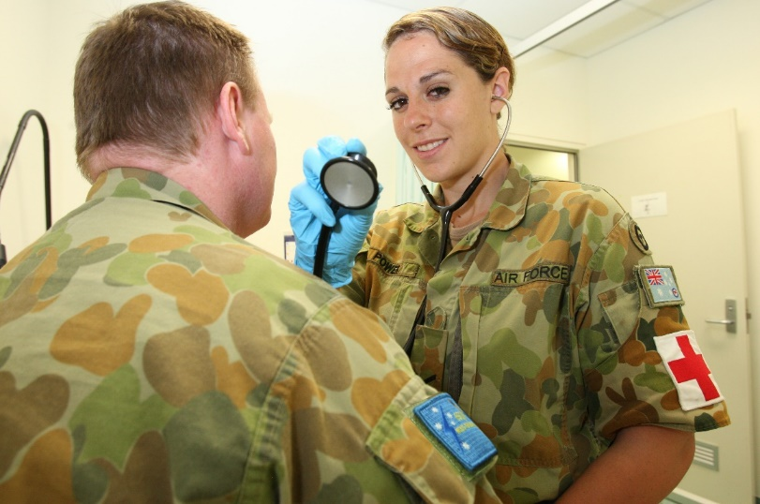

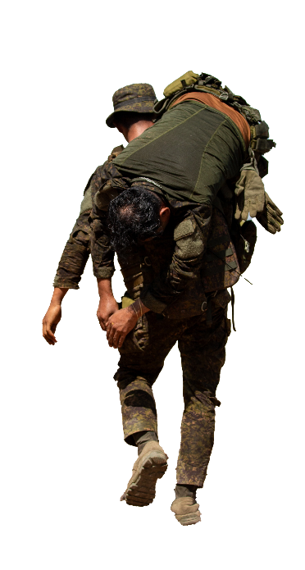

c.

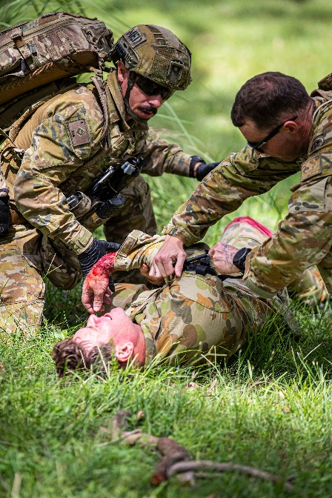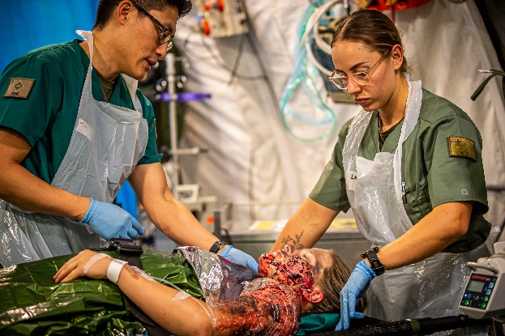

d.

b.

1. In a group, discuss the challenges medics face in UN peacekeeping missions.

* If you have been on a UN Peacekeeping mission, talk about which challenges you faced.
* If you haven’t been on an UN Peacekeeping, talk about which challenges medics would face.
* Use the prompts below to help you.

I have been on a UN Peacekeeping mission and some of the challenges I faced / had were…

I haven’t been on a UN Peacekeeping mission but I think one / some of the biggest challenges would be…

## You will watch a video about a medical contingent deploying on a U.N. peacekeeping mission. Type on YouTube [Thank you Serbia: UN Peacekeeping Service & Sacrifice](https://www.youtube.com/watch?v=W1FvSTLmiU4) or scan the QR code.

## Answer these questions as you watch:

1. What kind of medical procedures do they do?
2. What was a big challenge for the medical team?
3. How does LTCOL Mladenovic feel about being on a Peacekeeping deployment?

## For more practice with the words you’ve learned here, scan the QR code.

© Commonwealth of Australia 2024   
This work is copyright. Apart from any use as permitted under the Copyright Act 1968 (Cth), no part may be reproduced by any process without prior written permission from the Department of Defence.