

**Military English**

Vocabulary Builder – Mapping

**Overview:**  
This worksheet lists vocabulary for reading parts of a map and navigation.

**In this vocabulary builder, you will:**

* learn and use vocabulary related to reading maps and navigating

1. Label the parts of a map. Write the words from the box in the spaces below. Do the same on page 2.
2. _________________________
3. _________________________
4. 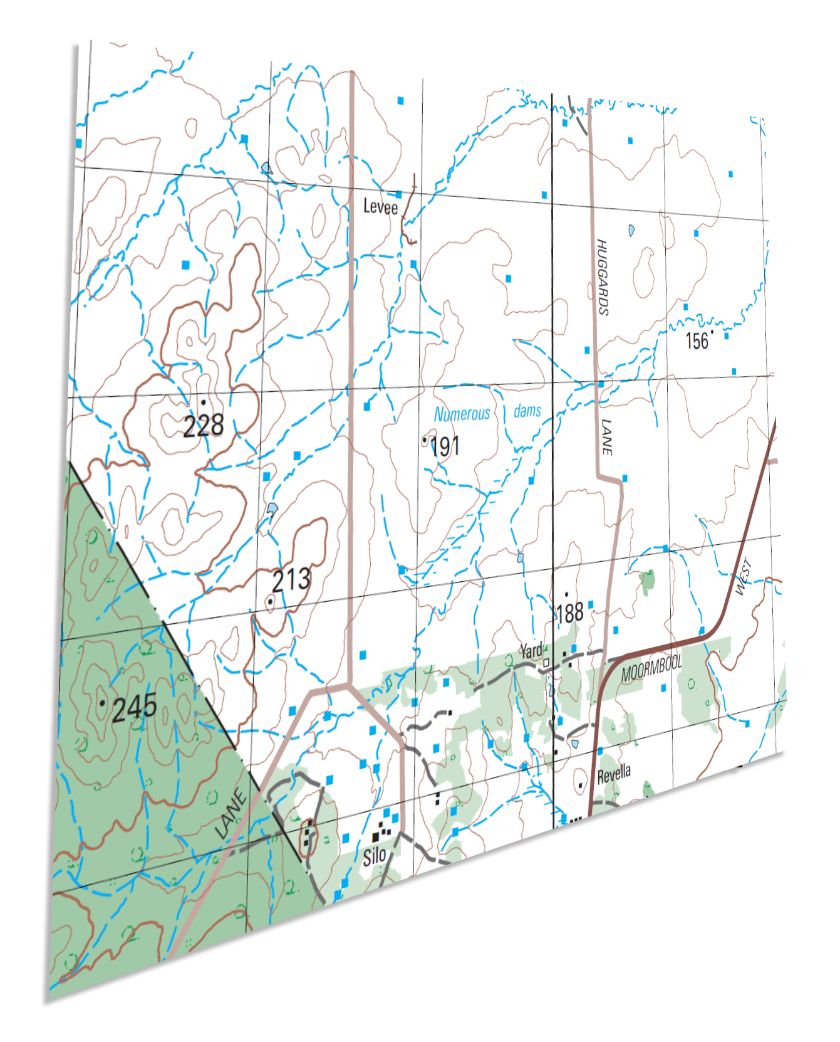_________________________
5. _________________________
6. _________________________
7. _________________________

route // contour lines // grid // distance // elevation // grid line

**f**

**e**

**c**

**a**

**b**

**✘**

**1.3km**

**d**

1. _________________________
2. _________________________
3. _________________________
4. _________________________
5. _________________________

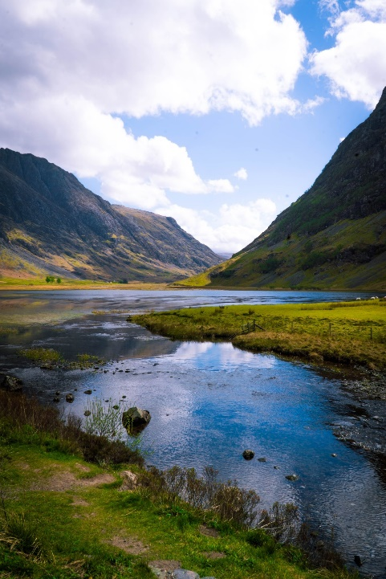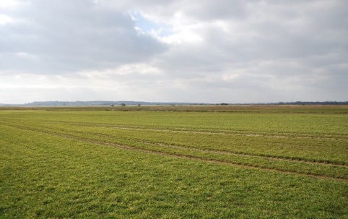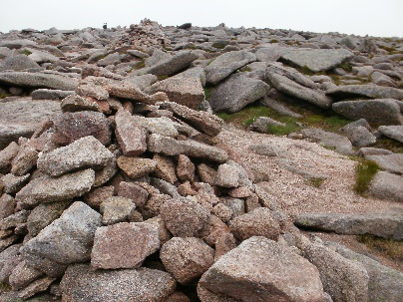

**g**

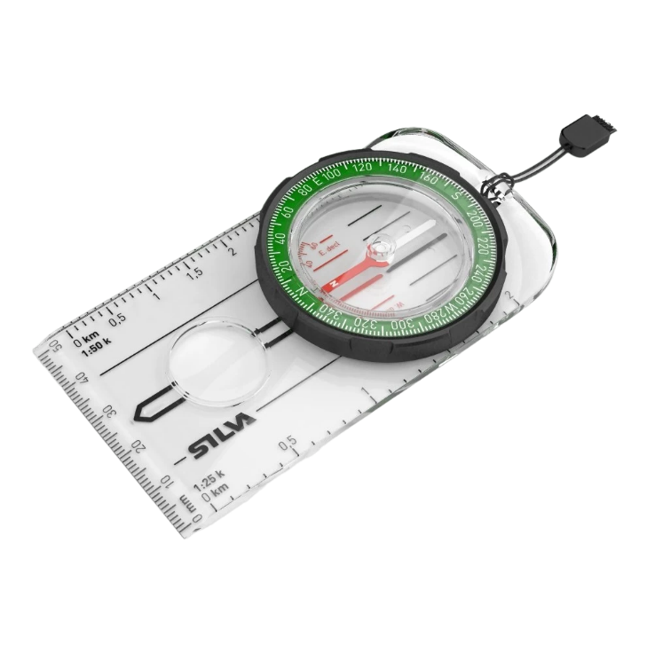

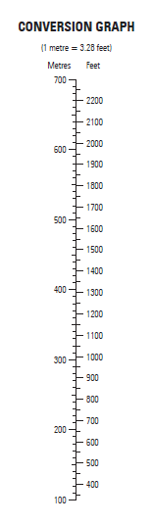

**h**

Some maps show distances in **feet** – and miles and others in metres – and kilometres.

**j**

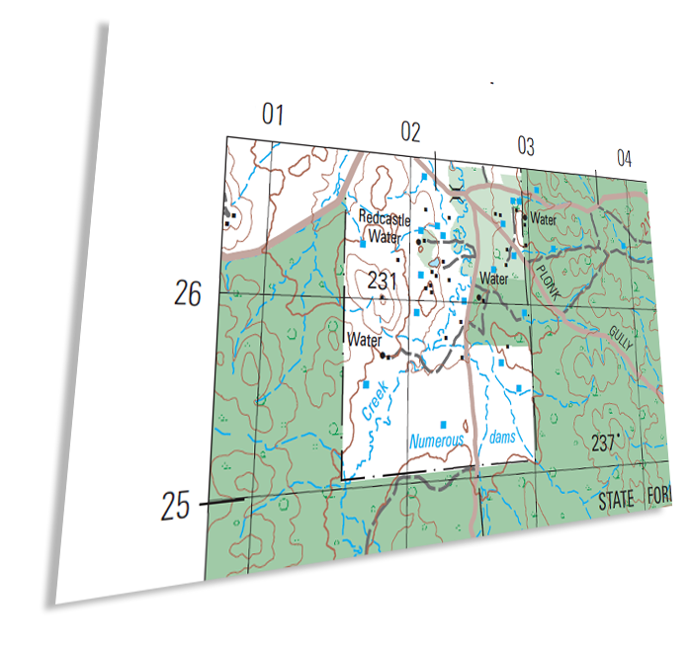

**k**

**i**

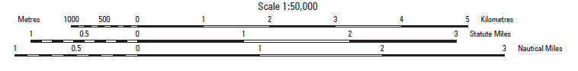

compass // terrain // metre // scale // grid reference

1. Now let’s practise saying the words. Listen and repeat.
2. Choose three of the vocabulary items below that you want to practise to make sure you are saying them clearly.

* Underline the stressed syllable in each of them (if it has more than one syllable).
* Write a short sentence for each word.
* Then, in groups of 2-3, take turns. Practise saying the word and the sentence to your partner(s).
* Ask your partner to write down your words and sentences.

route contour lines grid distance

elevation grid line compass terrain

metre scale grid reference

terrain location distance

1. Match the words on the left to the definitions on the right. Write a letter next to the definition.   
   Then check your answers with a partner. Look at the example.
2. grid reference
3. grid
4. grid line
5. distance
6. elevation
7. contour lines
8. terrain
9. **route**
10. compass
11. scale
12. metre
13. feet

the length of the space between 2 points

the unit of length used in some countries (e.g. the USA)

lines on a map that show the height of the land

it shows the distance of the map compared to the distance on the ground e.g. 1 centimetre = 500 metres

the natural features of the land e.g. hills, valleys

**a way to travel from A to B**

straight lines that cross each other to form squares on the map

a line on a map forming part of the grid

the unit of length used in Australia and most countries in Southeast Asia as part of the metric system

an instrument with a pointer which shows the direction of magnetic north

height above sea level

the numbers in a grid system which show location

h

1. Use the words from the box below to fill in the gaps in the story. Look at the pictures in exercise one and two for help. The first one is done for you.

route // grid reference // scale // ~~terrain~~ //

elevation // distance // grid // compass // metres

// //

terrain

In military operations, maps are very important tools for navigation. A map shows the 1_______________ of the land, including hills and valleys. A map also shows the 2_____________________, which is the changes in height. To measure the distance between two points, you need to understand the map’s 3_______________, which tells you how much smaller the map is compared to the real world. When marking a 4______________ on the map, it’s important to use the 5_______________________________ to identify the exact location of a point. These are the numbers around the four sides of the map and the straight lines all over the map. To calculate the 6____________________ between two points, use the scale and the 7__________________ lines and measure it in 8__________________ or feet. Finally, always use a 9________________________ to make sure you’re going in the right direction.

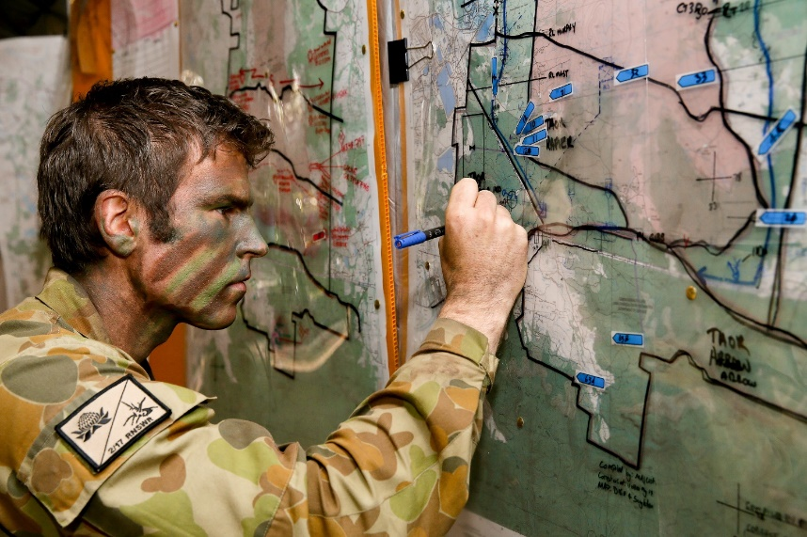

*Captain James Clennan, Adjutant 2nd/17th Battalion Royal New South Wales Regiment, using his map reading skills during Exercise Polygon Wood.*

* 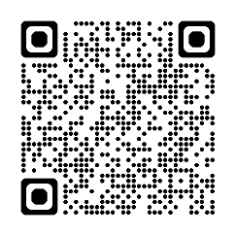Watch this YouTube video. Type on YouTube [Map Reading – Squared Away – Army Jobs](https://www.youtube.com/watch?v=Z1qRrnzNsAA) or scan the QR Code.
* Write down the words you hear (or see) that you learned in this lesson.
* Now, read this transcript below of a part of the video. Watch the video again from 1:33min. Look at how the pauses are marked with this symbol **\** .

|  |  |  |
| --- | --- | --- |
| 1:33min | a. | I know I’ve got **\** a river **\** to my left |

* Now, watch these parts of the video again, starting from 1:36min. Listen for the pauses and mark them with a **\ .**

|  |  |  |
| --- | --- | --- |
| 1:36min | b. | I’ll also be moving through a few built-up areas |
| 1:41min | c. | also on my left past a river there is a track |
| 1:44min | d. | also we’ll have high ground to my left and right |
| 1:47min | e. | and that’s telling me that I’m moving down through a valley |

* Working in pairs, practise reading aloud the phrases above. Take turns to read them: one student reads b. and d.; the other student reads c. and e. Stop after each one, and check with your partner if you’ve used the pauses correctly.

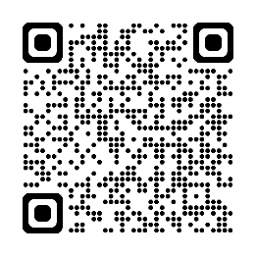

* For more practice with the words you’ve learned here, scan the QR code.
* This Vocabulary Builder links with 🡪 Lesson: Map Reading and Navigation

Vocabulary Builder: Terrain Features

© Commonwealth of Australia 2024  
This work is copyright. Apart from any use as permitted under the Copyright Act 1968 (Cth),   
no part may be reproduced by any process without prior written permission from the Department of Defence.