**Military English**

Lesson: Life of a UN Peacekeeping Medic – PART C: Deployment to INTERFET, Timor Leste

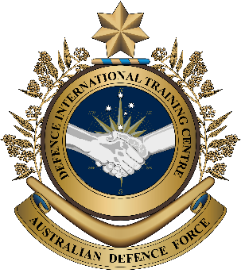

**Overview:** This is the third of four lessons that will teach vocabulary related to being a ‘Medic’ and Army nurse during United Nations (UN) Peacekeeping missions.

**In this lesson, you will:**

* use listening skills.
* learn the meaning of new vocabulary and expressions.
* use new vocabulary and expressions in context.

## Prepare for Listening

1. These are some of the tasks Peacekeeping medics do. Discuss what they are with a partner. What else do UN Peacekeeping medics do?

c.

a.

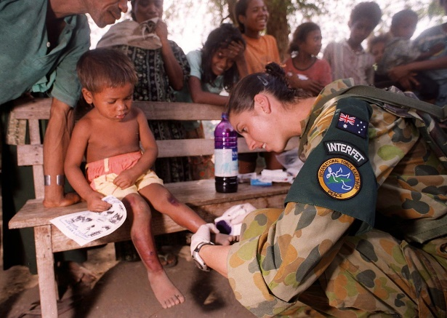

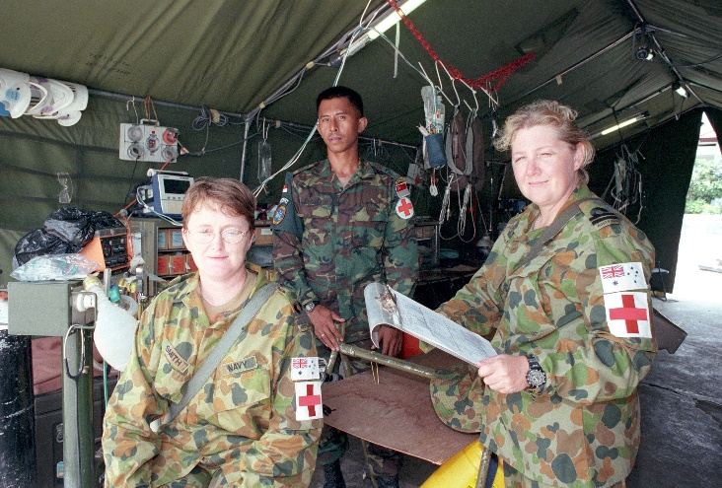

b.

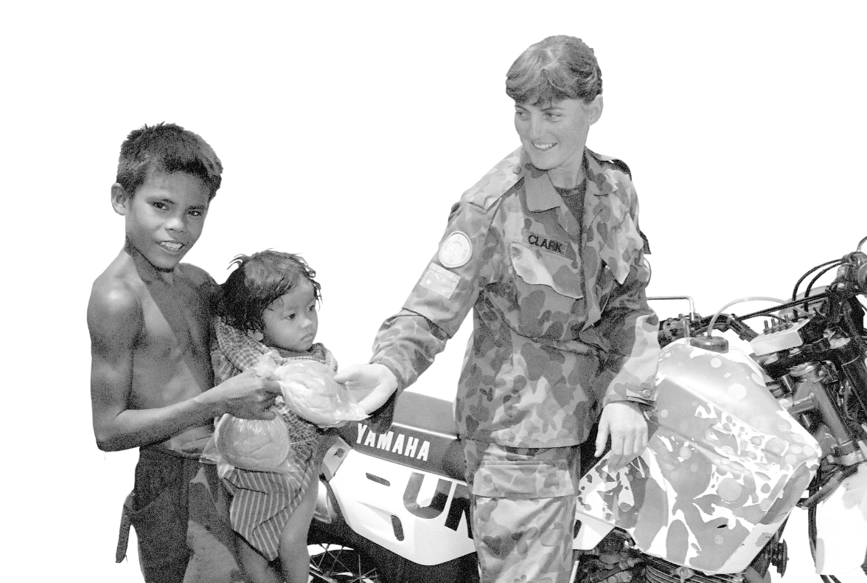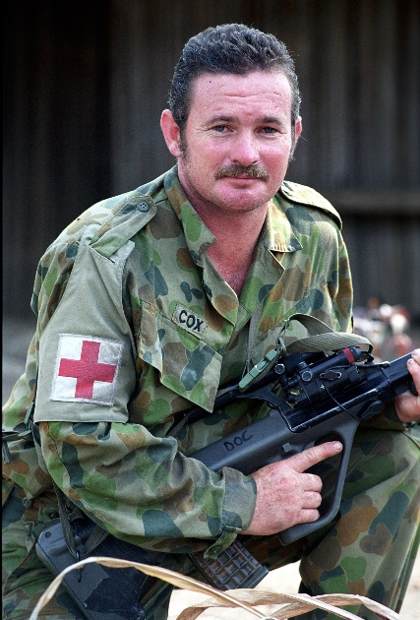

d.

## Listening – Part 1

1. Listen to the interview with Army nurse WO1 Beth Andrews. Which two points does she talk about?

Her deployment in Cambodia A memorable event during her deployment

Her daily responsibilities Her training

## Learning Military Vocabulary

1. The words listed in bold below are important vocabulary and expressions that you should learn to use. Match the vocabulary on the left with their definitions on the right. Look at the example.

|  |  |  |  |  |  |  |
| --- | --- | --- | --- | --- | --- | --- |
| Table one |  | |  |  | | |
| my next deployment was a **D+14** (= Deployment + 14 Days)(n) | |  | | |  | 1. a person responsible for managing the daily operations of a hospital ward (ward = section) | |
| set up a **field hospital** (n) | | **d** | | |  | 1. information (in numbers) that show the number of people who have been injured or killed e.g. in a war or natural disaster | |
| to provide **humanitarian care** (n) | |  | | |  | 1. medics deploy to an area of operations to set up a field hospital 14 days after the first group of troops has deployed | |
| a **Ward Master** manages patients (n) | |  | | |  | **\\d85userdata.dpe.protected.mil.au\ma\marcos.pougy\Downloads\20161022army0000_3873.jpg d. a temporary medical facility set up near a battlefield, disaster site, or other emergency area to provide medical care for the injured** | |
| to provide **casualty statistics** (n) | |  | | |  | 1. a process of returning a person to their home country | |
| I assisted with **repatriation** (n) | |  | | |  | 1. medical care (or procedures) given to a person to help an illness, injury, or other medical condition, e.g. medications or surgery | |
| she was at the field hospital for **treatment** (n) | |  | | |  | 1. assistance and services provided to people in need, especially during emergencies like a natural disaster or conflicts | |

**INTERFET (International Force Timor)** - A multinational non-United Nations peacekeeping task force.   
It was organised and led by Australia to resolve a security crisis in Timor Leste between 1999-2000 until UN peacekeepers arrived.

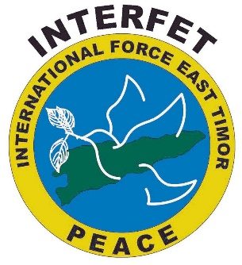

|  |  |  |  |
| --- | --- | --- | --- |
| Table two |  |  |  |
| we needed to do some **major surgery** (n) |  |  | 1. File:Helicopter Landing Area, Rothiemurchus Lodge - geograph.org.uk -  1468706.jpg - Wikimedia Commonsthe spot where aircraft touch down (on the ground) |
| unfortunately she got a **severe infection** (n) |  |  | 1. a big and complicated operation in a hospital |
| she **passed away** (v) |  |  | 1. when bacteria or viruses attack the body and make the person sick |
| the chopper approached the **landing area** (n) |  |  | 1. = died |
| the Special Operation guys were on a **recce (n)** (recce can also be a v) |  |  | 1. a short mission to get information about the enemy or an area |

1. Now let’s practice saying the words. Listen and repeat.

## Listening – Part 2

1. Listen to the interview again and answer the questions below.
2. A person in camouflage uniform standing next to a patient

   Description automatically generatedAfter Cambodia and Bougainville, where was WO1 Beth Andrews next deployment to?

\_\_\_\_\_\_\_\_\_\_\_\_\_\_\_\_\_\_\_\_\_\_\_\_\_\_\_\_\_\_\_\_\_\_\_\_\_\_\_\_\_\_\_\_\_\_\_\_\_\_\_\_

1. Which two jobs did she have at the field hospital?

\_\_\_\_\_\_\_\_\_\_\_\_\_\_\_\_\_\_\_\_\_\_\_\_\_\_\_\_\_\_\_\_\_\_\_\_\_\_\_\_\_\_\_\_\_\_\_\_\_\_\_\_

1. What was the cause of the elderly lady’s death?

\_\_\_\_\_\_\_\_\_\_\_\_\_\_\_\_\_\_\_\_\_\_\_\_\_\_\_\_\_\_\_\_\_\_\_\_\_\_\_\_\_\_\_\_\_\_\_\_\_\_\_\_

1. How did they take the elderly lady’s body back to her village?

\_\_\_\_\_\_\_\_\_\_\_\_\_\_\_\_\_\_\_\_\_\_\_\_\_\_\_\_\_\_\_\_\_\_\_\_\_\_\_\_\_\_\_\_\_\_\_\_\_\_\_\_

1. How did the Special Operations soldiers find the elderly lady?

\_\_\_\_\_\_\_\_\_\_\_\_\_\_\_\_\_\_\_\_\_\_\_\_\_\_\_\_\_\_\_\_\_\_\_\_\_\_\_\_\_\_\_\_\_\_\_\_\_\_\_\_

1. Here is the transcript of the interview. Listen to it and fill in the gaps with the missing words you hear.

**A:** Good afternoon listeners. Welcome back to Radio Station 4U2 and our ongoing interviews with military veterans. I’m Ben Renolds and in today’s interview we will continue talking with Warrant Officer Beth Andrews, who is currently serving with the Australian Army as a nurse. We are going to talk with her about her experience in UN peacekeeping operations, her various deployments, and life as a nurse in the modern military.

**A:** Hello Warrant Officer Beth Andrews, thank you for returning to our station again to tell our listeners about your experience as an Australian Army nurse.

**B:** Thank you Ben. It is always my pleasure to share some of my experiences with your listeners.

**A:** Last week you told us about your deployments to Cambodia and Bougainville. After this, did you deploy overseas again?

**B:**  Well, my next major deployment was to Timor Leste in 1999 in what we call 1.\_\_\_\_\_\_\_\_\_\_\_ or Deployment plus 14 days. So, D+14 means 14 days after the first group of troops has deployed to the area of operations, the medics deploy to set up a 2.\_\_\_\_\_\_\_\_\_\_\_\_\_\_\_\_\_\_\_\_\_\_\_. The field hospital is set up to provide humanitarian care and obviously care for our own personnel who had deployed. This was one of Australia’s biggest deployments as a host nation for a very long time.

**A:** What was your role during the Timor Leste mission?

**B:** I was the Operation Sergeant for the opscell at the field hospital even though I’m a medic, and I was also what we call a 3.\_\_\_\_\_\_\_\_\_\_\_\_\_\_\_\_\_\_\_\_\_\_\_\_\_. Being a Ward Master means I managed all the patients in and out of ward, as well as maintain records and statistics. Every day I went to INTERFET Headquarters to provide 4.\_\_\_\_\_\_\_\_\_\_\_\_\_\_\_\_\_\_ statistics. I also assisted with repatriation of injured military personnel back to Australia and transport of local people back to where they needed to go in Timor Leste.

**A:** Can you share any memories from your time in Timor Leste that really stand out in your mind?

**B:** One thing stands out in my mind… well, on one occasion, we received an old lady who had been badly injured. Some Australian Army Special Operations soldiers brought her to our field hospital for 5.\_\_\_\_\_\_\_\_\_\_\_\_\_\_\_\_\_\_\_\_\_\_\_ and we needed to do some major surgery on this old lady. She was in her late 60s, early 70s and it was just unfortunate that she got a severe infection. She was only with us for about six days and she 6.\_\_\_\_\_\_\_\_\_\_\_\_\_\_\_\_\_\_\_\_\_\_\_\_\_. Only the soldiers who brought her in knew the village in the mountains where she came from. But, we were determined to return her to her village for a burial ceremony, especially because she was very senior in her village. So we had to seek approval for a chopper to take her back to her village and find the original team who had picked her up. There were no roads to the village because it was high up in the mountains. There was only access by foot. It was interesting to be a part of that trip to escort the old lady’s body back to her village. When the helicopter approached the village 7.\_\_\_\_\_\_\_\_\_\_\_\_\_\_\_\_\_\_\_\_\_\_, it was completely deserted, but when the chopper landed, people came out from behind the bushes in all directions. One of the soldiers on board was an interpreter, who helped us talk with the village elders about how we had tried to save the old lady. The villagers were all so grateful, and very emotional. They couldn’t stop touching us and thanking us. Even the Special Operations soldiers with us were tearing up. This was just one instance where we were able to help local villagers. Of course, there would have been many others out there who needed help. This was only brought to our attention due to the Special Operations guys being on a 8.\_\_\_\_\_\_\_\_\_\_\_\_\_\_\_ that day and they were flagged down. Many other villagers in these isolated areas would have passed away simply by not having access to basic medical services.

**A:** Thank you! That was a very emotional story. It’s been great having you here today. That was Warrant Officer Beth Andrews speaking for Radio Station 4U2. Until next time.

Note: this transcript is an edited version for educational purposes and based on a live interview from a podcast “Life on The Line” with Australian Army Medic, Warrant Officer Elizabeth Matthews – see: <https://www.youtube.com/watch?v=iR2ObTJKEh0>

## Practice

1. Work in pairs or small groups. Create a short role play based on the interview.

* Decide who is the interviewer and interviewee.
* Use as many of the words from exercise three as possible.
* Use the questions below to help you plan what you’re going to say.

Why are medics important in a Peacekeeping operation?

Is knowing how to use a weapon a useful skill as a Peacekeeping medic?

What are the challenges faced by military medics in a UN peacekeeping mission?

**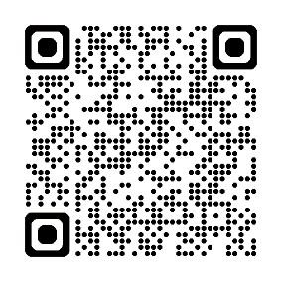**

## Watch the video about healthcare and ‘Telemedicine’ services during a UN operation in Central Africa known as MINUSCA (United Nations Multidimensional Integrated Stabilization Mission in The Central African Republic). Type on YouTube “[Behind the scenes of UN Operations – Enhancing remote healthcare with Telemedicine](https://www.youtube.com/watch?v=j1dP40fIQ-4)”, or scan the QR code.

## Answer these questions as you watch:

1. What is telemedicine?
2. How does telemedicine support UN medics and Casualty Evacuations (CASEVAC) in the field (see video at 2:20 and 3:30 – also read English sub-titles for parts spoken in French language)?
3. What are some of the challenges for using telemedicine in remote areas of central Africa (see video from 3:47)?

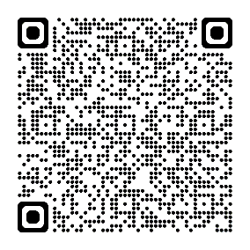

## For more practice with the words you’ve learned here, scan the QR code.

© Commonwealth of Australia 2024  
This work is copyright. Apart from any use as permitted under the Copyright Act 1968 (Cth),   
no part may be reproduced by any process without prior written permission from the Department of Defence.