

**Military English**

Lesson: Conducting a Checkpoint (CP) - Reading

**Overview:**  
This lesson focuses on the topic of working at a checkpoint and the vocabulary connected to this.

**In this lesson, you will:**

* read and understand the gist of paragraphs in a text
* read and find detail in a text
* learn the meaning of new words
* use new words in a speaking activity

## Prepare for Reading

1. Work in small groups. Discuss your answers to the questions.

## What is in the picture?

## When or why do you need these?

## Have you worked at one of these? When? Why? What jobs did you do? What jobs might you need to do at one of these?

**checkpoint** (CP) (n) – a place where soldiers or the police stop and check people or vehicles (e.g. cars, buses, motorcycles, etc).

## Reading

1. Read the text below quickly. Then match paragraphs 1-6 to the question it answers. Look at the example.

**☛ *TIP!*** *Read the questions first, so you have an idea of what you need to find in the text. In this exercise, the idea is NOT to understand everything but to get an overall idea.*

\_\_\_\_\_ When and where is it?

\_\_\_\_\_ What do you need?

\_\_\_\_\_ What is it?

\_\_\_\_\_ How should it work?

1

\_\_\_\_\_ What are some different parts?

\_\_\_\_\_ What do personnel need to have?

\_\_\_\_\_ What is some advice for working   
 at a CP?

**At a Checkpoint**

1. 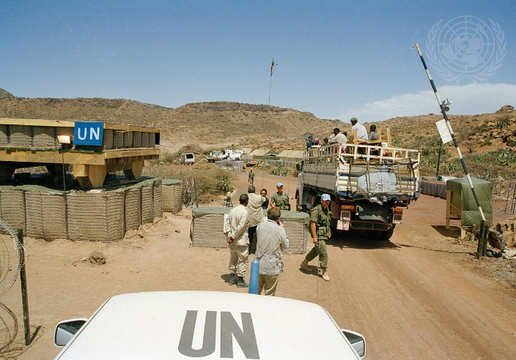A checkpoint (CP) is **deployed** on a road or track to control movement (of people, or illegal products) into and out of an area (e.g. a **buffer zone**, or a country’s **border**). The checkpoint will also observe, check, inspect, search personnel or vehicles, prevent human **trafficking**, and deny enemy forces to move freely.
2. Permanent CPs set up on main roads. These cannot be moved or closed without authority. Personnel may set up temporary checkpoints on smaller roads, for a specific period.

*credit: UN Photo / Jorge Aramburu*

1. Usually, an **infantry battalion** (Inf Bn) will set up the CP. At a vehicle checkpoint (VCP), the Inf Bn will monitor and control movement. They will also conduct security checks. Part of the Inf Bn will conduct area security for the CP. They will usually be a short distance away from the CP. CPs may also have personnel such as the UN Police, local police and other officials to help with criminals and traffickers.
2. 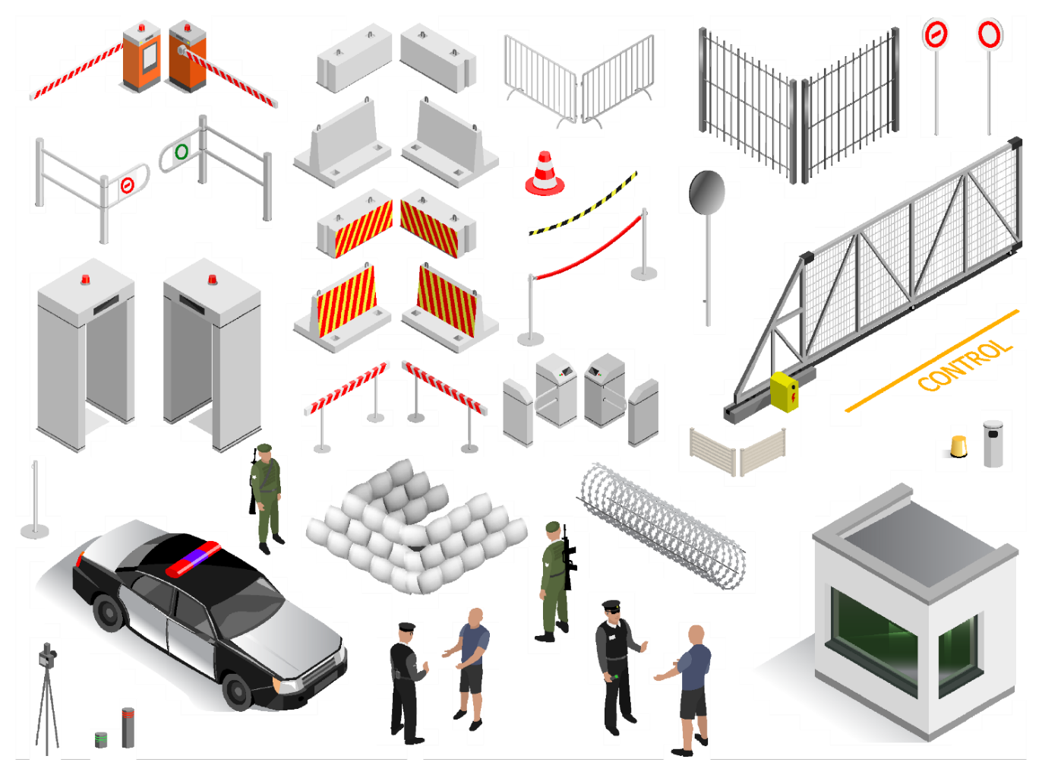CP personnel need to show respect for local customs and culture, speak a second or ‘local’ language and be friendly and professional.
3. A CP needs a lot of equipment. This might include:

* sandbags
* 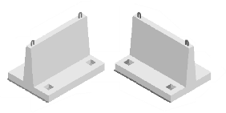heavy concrete blocks (used to slow down

vehicles when placed in a certain way)

* razor wire (in and around the CP)
* anti-vehicle **barriers** (e.g. dragon’s teeth)
* **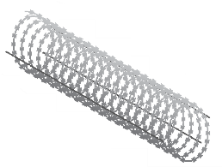**communications equipment
* a **first aid kit** and a **medic**
* **binoculars**, **flashlights**, **spotlights** and **night vision goggles**
* **inspection mirrors** (to look under vehicles)
* road signs (e.g. for speed limit in/out of the CP)

1. A permanent CP will include: a search area, a **holding area** and a meeting area.
2. CP personnel should conduct CPs safely and securely, and show respect for **human rights**.

*Adapted from: English for UN Military Peacekeepers. A practical training resource for UN Military Peacekeepers p.32-33*

1. Read the text again and answer the questions. Write no more than eight key words in your answers. Look at the example in item a.

on a road or track (small road)

1. In paragraph 1, where will you find a checkpoint (CP)? \_\_\_\_\_\_\_\_\_\_\_\_\_\_\_\_\_\_\_\_\_\_\_\_\_\_\_\_\_\_\_\_\_\_\_
2. What jobs will a CP usually do? \_\_\_\_\_\_\_\_\_\_\_\_\_\_\_\_\_\_\_\_\_\_\_\_\_\_\_\_\_\_\_\_\_\_\_\_\_\_\_\_\_\_\_\_\_\_\_\_\_\_\_\_\_\_\_\_
3. What is the main difference between a permanent and a temporary CP? \_\_\_\_\_\_\_\_\_\_\_\_\_\_\_\_\_\_\_\_\_\_
4. What part of the UN will work at the CP? \_\_\_\_\_\_\_\_\_\_\_\_\_\_\_\_\_\_\_\_\_\_\_\_\_\_\_\_\_\_\_\_\_\_\_\_\_\_\_\_\_\_\_\_\_\_\_\_
5. According to paragraph 4, what skills do you need at a U.N. CP? \_\_\_\_\_\_\_\_\_\_\_\_\_\_\_\_\_\_\_\_\_\_\_\_\_\_\_\_\_
6. What advice is in the last paragraph about how to do a good job at a CP? \_\_\_\_\_\_\_\_\_\_\_\_\_\_\_\_\_\_\_\_\_\_

## Learning Military Vocabulary

1. The words in bold in the text are important military vocabulary that you should learn to use. Match the military words on the left to their definitions on the right on tables one and two (on the next page).  
   Look at the example.

|  |  |  |  |
| --- | --- | --- | --- |
| Table one |  |  |  |
| a CP is **deployed** | **e** |  | 1. the part of the army that fights on land, when it is in a group of more than 300 soldiers |
| a **buffer zone** (n) |  |  | 1. \\d85userdata.dpe.protected.mil.au\ma\marcos.pougy\Downloads\pexels-roger-brown-3435524-5673523.jpga small box that has equipment in it to help with small medical problems |
| a country’s **border** (n) |  |  | 1. an area of land that marks the end of one country and the beginning of another |
| human **trafficking** (n) / *traffickers (n)* |  |  | 1. an area of land between two enemy forces |
| an **infantry battalion** (n) |  |  | **e. when soldiers or equipment are moved to a place when it is**  **needed** |
| anti-vehicle **barriers** (n) |  |  | 1. \\d85userdata.dpe.protected.mil.au\ma\marcos.pougy\Downloads\JPAU26JUN03SB026.jpga person in the military who works to help personnel who get hurt or injured |
| a **first aid kit** (n) |  |  | 1. illegally buying, selling or moving things (or people) between different countries |
| a **medic** (n) |  |  | 1. equipment or anything that will stop people (or vehicles) entering another place |
| Table two |  |  |  |
| **binoculars** (n) |  |  | 1. a place in the CP, people cannot move out of this when you put them in here |
| **flashlights** (n)  *or torch* |  |  | 1. \\d85userdata.dpe.protected.mil.au\ma\marcos.pougy\Downloads\20140405ran8504132_107.jpgspecial equipment to help you see very far away |
| **spotlights** (n) |  |  | 1. \\d85userdata.dpe.protected.mil.au\ma\marcos.pougy\Downloads\20091018adf8115142_047.jpg\\d85userdata.dpe.protected.mil.au\ma\marcos.pougy\Downloads\20131017ran8098578_199.jpgspecial glasses to help you see at night |
| **night vision goggles** (n) |  |  | 1. a strong light that shines on a small area LED Mobile Light Tower rent, Feature : Easy installation, Weather  resistance, Durability at Rs 20000 in BARMER |
| **inspection mirrors** (n)  *or search mirror* |  |  | 1. the ideas that many people around the world agree are basic to living a (good) life e.g. having food, freedom of speech, freedom from inhuman treatment, and more |
| areas such as a **holding area** (n) |  |  | 1. ML25LT LED 3-Cell C Flashlight – Maglite\\d85userdata.dpe.protected.mil.au\ma\marcos.pougy\Downloads\20141104adf8540618_042.jpga light that you can hold in one hand; the power comes  from batteries |
| to respect **human rights** (n) |  |  | 1. a special mirror with a long handle, used by security or military officers; it is used to look for dangerous or hidden objects under vehicles and in hard-to-see places \\d85userdata.dpe.protected.mil.au\ma\marcos.pougy\Downloads\20171008adf8526162_083.jpg |

1. Now let’s practise saying the words. Listen and repeat.
2. In the sentences below, select the correct word from the group of three choices. Look at the example.
   1. The soldiers asked the civilians from the car to wait in the **human rights // holding area // spotlight**.
   2. Police often use **spotlights // inspection mirrors // human rights** to search under a car.
   3. At midnight, the troops used their **night vision goggles // binoculars // flashlights** to see across the valley.
   4. A: “We need someone who can help the sick civilians coming through here.”

B: “I’ll ask the UN if they can send us a **flashlight // first-aid kit // medic**.”

* 1. We cannot enter the field next to the checkpoint because it is **an inspection mirror // deployed // a buffer zone**.
  2. The UN wants to help make sure all people around the world enjoy **holding areas // human rights // trafficking**.
  3. Making sure the CP is safe from terrorists is an important task for a(n) **spotlight // first aid kit // infantry battalion.**
  4. The border guard asked the driver of the vehicle to stop in the **medic // flashlights // search area.**

## Practice

1. Describe and draw. Describe your picture of a vehicle checkpoint so that your partner can draw it.

* If you’re student A, turn to page 6.
* If you’re student B, turn to page 7.

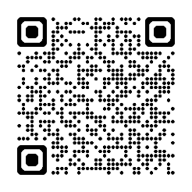

* Watch this video. Type on YouTube: [Nepalese Army Soldiers Conducting Vehicle Checkpoint in Exercise Khaan Quest 2013](https://www.youtube.com/watch?v=qak2UWAbYUE) or scan the QR code. Write down the things you see in the video from this lesson.

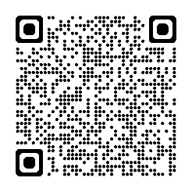

* For more practice with the words you’ve learned here, scan the QR code for a Quizlet practice activity.
* This lesson links with 🡪 Vocabulary Builder – Parts of a vehicle checkpoint;

Lesson – Listening: Conducting a Checkpoint – coming soon

© Commonwealth of Australia 2024   
This work is copyright. Apart from any use as permitted under the Copyright Act 1968 (Cth), no part may be reproduced by any process without prior written permission from the Department of Defence.

STUDENT A

* Think about how to describe what you can see. Use the language box below to help you.
* Try not to look at your partner’s picture until you are both finished describing.
* You start. Then Student B will describe his/her picture.
* Who can describe their picture the best?

|  |  |
| --- | --- |
| LANGUAGE BOX | Describing your picture:   * The checkpoint is on a straight road. * There is/are \_\_\_\_\_\_\_\_\_. * In the middle / to the right / to the left is/are \_\_\_\_\_\_\_\_. * Near / between the \_\_\_\_\_\_\_\_\_\_\_\_\_ is a \_\_\_\_\_\_\_\_\_\_\_\_\_.   When you’re drawing your picture:   * I didn’t get that, could you repeat please? * What do you mean? * Roger that. |

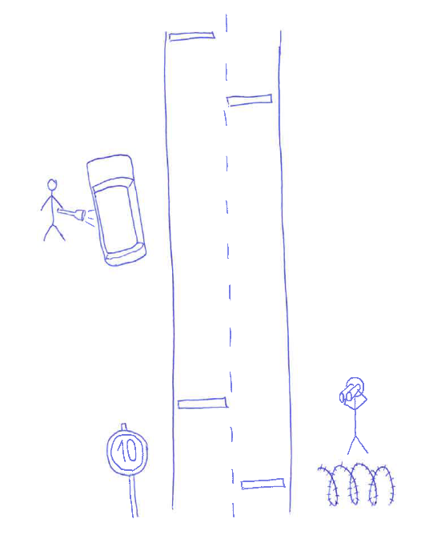

Describe this picture to student B →

Then draw below the picture of a checkpoint Student B describes to you:

STUDENT B

* Think about how to describe what you can see. Use the language box below to help you.
* Try not to look at your partner’s picture until you are both finished describing.
* Student A starts. Then you’ll describe your picture.
* Who can describe their picture the best?

|  |  |
| --- | --- |
| LANGUAGE BOX | Describing your picture:   * The checkpoint is on a straight road. * There is/are \_\_\_\_\_\_\_\_\_. * In the middle / to the right / to the left is/are \_\_\_\_\_\_\_\_. * Near / between the \_\_\_\_\_\_\_\_\_\_\_\_\_ is a \_\_\_\_\_\_\_\_\_\_\_\_\_.   When you’re drawing your picture:   * I didn’t get that, could you repeat please? * What do you mean? * Roger that. |

Draw below the picture of a checkpoint Student A describes to you:

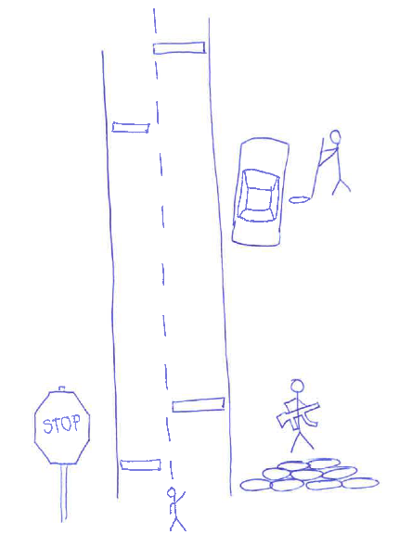

Then describe this picture   
to student A →