

**Military English**

Lesson: A Job in the Navy – Boatswain’s Mate – Listening

**Overview:** This lesson presents vocabulary related to the job of a Boatswain’s Mate and Patrol Boats.

**In this lesson, you will:**

* use listening skills to practise listening for specific information.
* learn the meaning of new vocabulary and expressions.
* use new vocabulary and expressions in context.

## Prepare for Listening

1. Work in pairs. Take turns interviewing your partner.

* Talk about an interesting experience during your time in the navy.
* To prepare, take some notes about what you’re going to say – you’re going to need them later. Think about the questions in the Language Box below.
* Use the Language Box to ask your partner some questions about their story.

**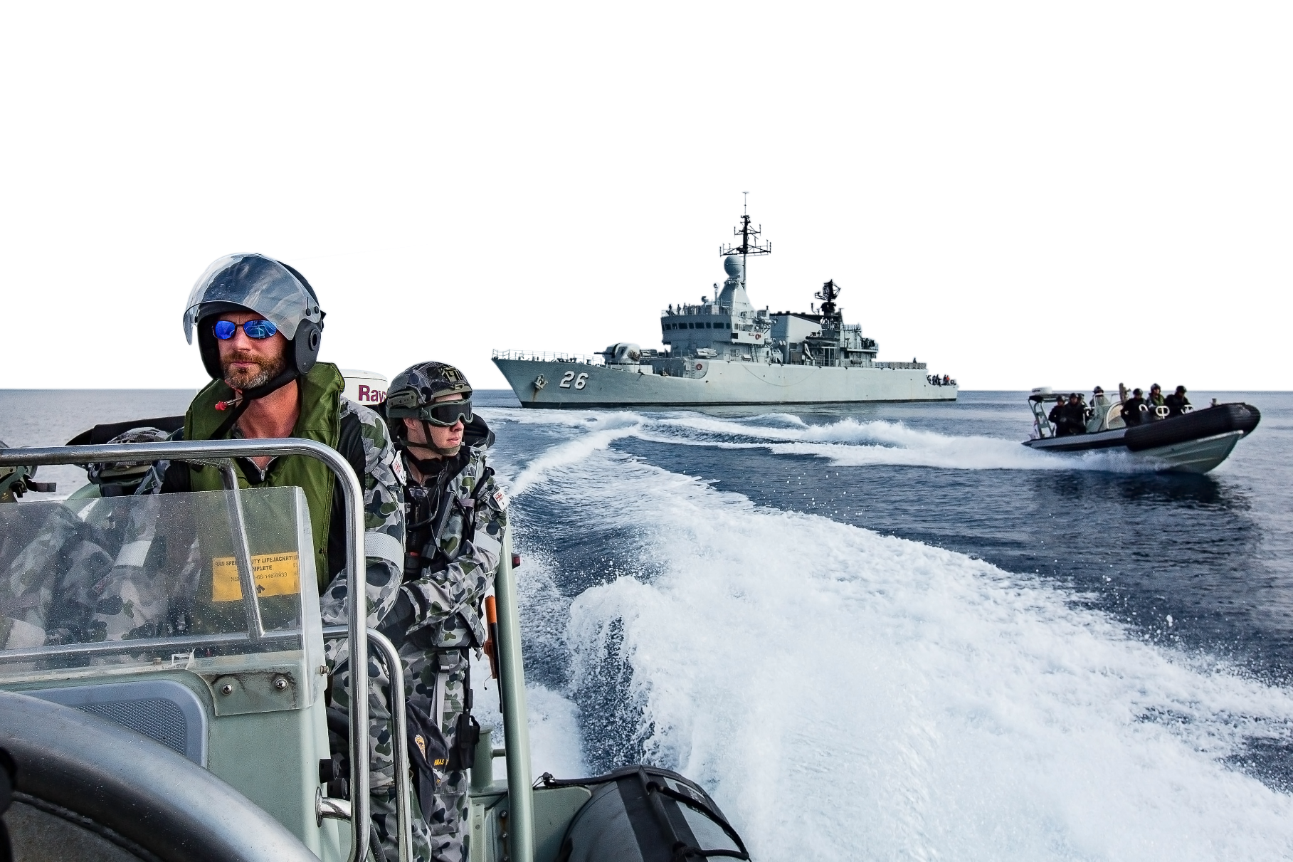Interview topic: Think about an interesting experience during your time in the Navy.**

**RHIB** (/rɪb/) – stands for Rigid Hull Inflatable Boat. It’s a fast, small boat. The Royal Australian Navy operates many RHIBs. Does your Navy have RHIBs?

|  |  |
| --- | --- |
| **LANGUAGE  BOX** | * Can you talk about something interesting that happened at work?   + What happened?   + When did it happen?   + Who was there?   + What happened later? |

*HMAS Toowoomba and Royal Malaysian Navy ship KD Lekir (26) conduct boarding party exercises in 2018.*

*HMAS Toowoomba and Royal Malaysian Navy ship KD Lekir (26) dispatch their boarding parties in Toowoomba's rigid hull inflatable boats during Exercise Bersama Shield 2018.*

1. Now, use your notes to write your story.
   * Use the Language Box below to help you.
   * When you’re ready, work with your partner. Read his/her story.
   * Check for mistakes such as spelling, grammar and use of vocabulary.
   * Keep your story, you’ll need it for exercise nine.

|  |  |
| --- | --- |
| **LANGUAGE  BOX** | * One day \_\_\_\_\_\_\_\_\_\_\_... * It happened in/during/after/when \_\_\_\_\_\_\_\_\_\_\_... * \_\_\_\_\_\_\_\_\_\_\_ were there/with me… * After that/later, \_\_\_\_\_\_\_\_\_\_\_\_\_... |

## Listening

1. Before you listen to a Navy sailor talking about an interesting story that happened to him, look at the picture.

* **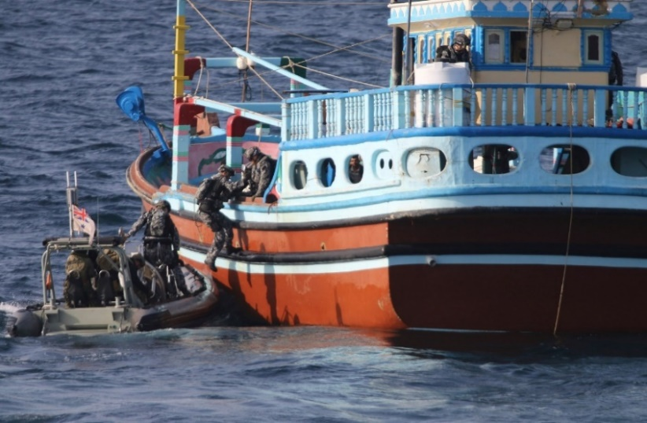**What is the boarding party doing?
* Why do you think they are doing this?
* Now listen to the interview and check your answers.

**boarding party** (n) - a group of Navy personnel who work together to get on board another ship.

1. Read the questions below. Next, listen to the radio interview again and answer the questions. Then work with a partner to compare your answers.
2. 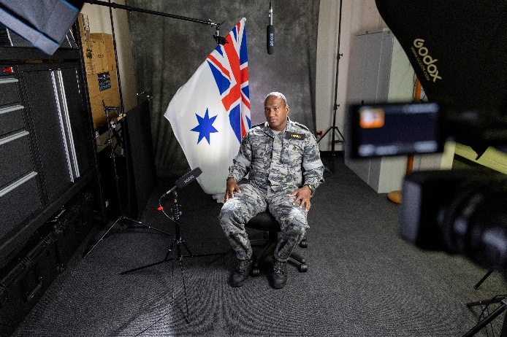What type of ship was Able Seaman (AB) Peter Jackson working on?

\_\_\_\_\_\_\_\_\_\_\_\_\_\_\_\_\_\_\_\_\_\_\_\_\_\_\_\_\_\_\_\_\_\_\_\_\_\_\_\_

1. What was AB Peter Jackson’s job in this operation?

\_\_\_\_\_\_\_\_\_\_\_\_\_\_\_\_\_\_\_\_\_\_\_\_\_\_\_\_\_\_\_\_\_\_\_\_\_\_\_\_

1. What did the boarding party find in the boat?

\_\_\_\_\_\_\_\_\_\_\_\_\_\_\_\_\_\_\_\_\_\_\_\_\_\_\_\_\_\_\_\_\_\_\_\_\_\_\_\_

1. How did AB Jackson feel after the operation?

\_\_\_\_\_\_\_\_\_\_\_\_\_\_\_\_\_\_\_\_\_\_\_\_\_\_\_\_\_\_\_\_\_\_\_\_\_\_\_\_

## Learning Military Vocabulary

1. The words listed in bold below are important vocabulary and expressions that you should learn to use. Match the vocabulary on the left column with their definitions on the right. Look at the example. Then compare your answers with a partner.

|  |  |  |  |
| --- | --- | --- | --- |
| Table one |  |  |  |
| **Able Seaman** (n)  *abbreviation: AB* | **f** |  | 1. a job on board a ship; these personnel do things like drive the boat and look after small arms (e.g. pistols and rifles) on the boat |
| **posted** to a patrol boat (v) |  |  | 1. a danger; something that might cause danger |
| an **illegal fishing** boat (adj) |  |  | 1. Rifle Scope Australia - Buy Riflescopes Online Today | OZScopesa group of seamen who work together to get on board another ship |
| a serious **threat** (n) |  |  | 1. a device used to aim or to view things |
| to form a **boarding party** (n) |  |  | 1. fishing in an area where it is against the law |
| as a **Boatswain’s Mate** (BM) (n)  *also spelled Bosun’s Mate* |  |  | 1. **a rank in the Navy (between Leading Seaman and Seaman)** |
| through their **scope** (n) |  |  | 1. given a position |

|  |  |  |  |
| --- | --- | --- | --- |
| Table two |  |  |  |
| **boarded** the boat (v) |  |  | 1. to make something/a person feel safe; not in danger |
| the main **compartment** (of a ship) (n) |  |  | 1. move onto a boat or ship |
| the **crew** was trying (n) |  |  | 1. actions to keep the seas and oceans safe from threats like pirates, illegal fishing, or other dangerous activities |
| our **close-combat behaviours** training(adj) |  |  | 1. \\d85userdata.dpe.protected.mil.au\ma\marcos.pougy\Downloads\20221220ran8562953_0042.jpgthe part of a city or town that has water and where a boat can stay |
| to **safeguard** (v) the evidence |  |  | 1. \\d85userdata.dpe.protected.mil.au\ma\marcos.pougy\Downloads\20210719ran8620187_0133 (1).jpgthe actions military personnel need when fighting the enemy in a small space |
| back to **port** (n) |  |  | 1. a team working on board a boat or plane |
| our **maritime security** mission (adj) |  |  | 1. a closed space on a ship |

1. Now let’s practice saying the words. Listen and repeat.

The pronunciation of Boatswain’s Mate is /ˈbəʊsnz meit/, with the stress on the first syllable.

1. Write the correct answer in the space.
2. Safety at sea is very important. The crew needs to follow the rules carefully to \_\_\_\_\_\_\_\_\_\_\_\_\_\_\_\_\_\_ a ship.

board // safeguard // post

1. The ship will dock at the \_\_\_\_\_\_\_\_\_\_\_\_\_\_\_\_\_\_ to load supplies and allow the crew to rest before continuing the mission.

port // scope // crew

1. When a \_\_\_\_\_\_\_\_\_\_\_\_\_\_\_\_\_\_\_\_\_\_\_\_ needs to inspect a ship, they work together to make sure everything is safe and secure.

crew // boarding party // scope

1. When there is a \_\_\_\_\_\_\_\_\_\_\_\_\_\_\_\_\_\_ to the ship, the crew must always be prepared to respond quickly to keep everyone safe.

scope // port // threat

1. During the storm, some of the \_\_\_\_\_\_\_\_\_\_\_\_\_\_\_\_\_\_\_\_\_\_\_\_ filled with seawater.

crew // compartments // ports

## Practice

1. In the radio interview, AB Jackson talked about his work as a Boatswain’s Mate (BM).

Read the blue box and then discuss questions a-b with a partner.

**Job - Boatswain’s Mate**

Main tasks:

* looking after and maintaining small arms (e.g. rifles, pistols, machine guns) on a ship
* driving the ship and small boats, such as RHIBs
* looking after and maintaining the ship
* boarding parties
* anchor work

*A Royal Australian Navy Able Seaman during boarding party training.*

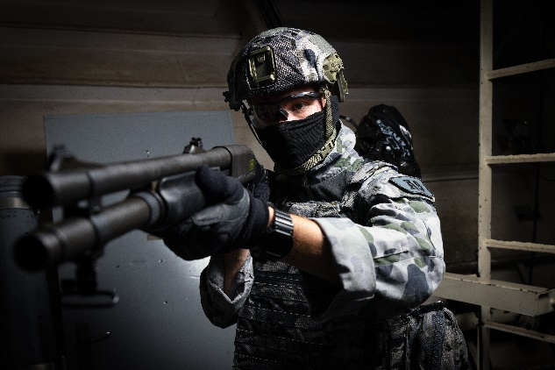

1. Have you been a Boatswain’s Mate (BM)?

If YES, did you like it? Why?

If NO, would you like to be a BM? Why?

1. Which of the five tasks above do you think would be the most interesting? Why?
2. Rewrite your story from exercise two. Use the paper on page six.

* Try to:
  + correct any mistakes e.g. spelling, verb tense, use of vocabulary
  + include the new vocabulary you learned in this lesson
* Then swap your story with your partner from exercise two. Can you help improve his/her story? Look at:
  + spelling mistakes
  + verb tense
  + use of vocabulary

1. Now take your partner’s story and work with a new partner.

* Read the story your new partner has.
* Decide which of the two stories is the most interesting.

1. Discuss these questions with a partner. Use complete sentences and the words you learned in exercise five.
2. Stopping illegal fishing is a common job of patrol boats. What other activities might a patrol boat conduct?
3. Talk about a time when you were part of a boarding party. If you haven’t been part of one, what do you think it would be like?
4. What type of training do you need to be part of a boarding party?

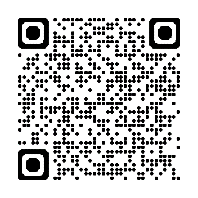

## Watch this video about someone who works as an Able Seaman. Type on YouTube [Boarding Party gets the Job Done on HMAS Darwin](https://www.youtube.com/watch?v=x-QGvoD6wXI) or scan the QR code. 🡪



## For more practice with the words you’ve learned here, scan the QR code for a set of flashcards. You can do some more study on the vocab in this lesson on your own with these. 🡪

## This lesson links with: Lesson – A Job in the Navy (Reading)

Vocabulary Builder – Parts of a Ship

Vocabulary Builder – Types of Navy Vessels

© Commonwealth of Australia 2024   
This work is copyright. Apart from any use as permitted under the Copyright Act 1968 (Cth), no part may be reproduced by any process without prior written permission from the Department of Defence.

Exercise nine. Rewrite your story from exercise two on the lines below. Try to:

* correct any mistakes
* include the new vocabulary you learned in this lesson
* exchange your story with your partner from exercise two. Can you help improve his/her sentences? Look at:
  + spelling mistakes
  + verb tense
  + use of vocabulary

\_\_\_\_\_\_\_\_\_\_\_\_\_\_\_\_\_\_\_\_\_\_\_\_\_\_\_\_\_\_\_\_\_\_\_\_\_\_\_\_\_\_\_\_\_\_\_\_\_\_\_\_\_\_\_\_\_\_\_\_\_\_\_\_\_\_\_\_\_\_\_\_\_\_\_\_\_\_\_\_\_\_\_\_\_\_\_\_\_\_\_\_\_\_\_\_\_\_\_\_\_\_\_\_\_\_\_\_\_\_\_\_\_\_\_\_\_\_\_\_\_\_\_\_\_\_\_\_\_\_\_\_\_\_\_\_\_\_\_\_\_\_\_\_\_\_\_\_\_\_\_\_\_\_\_\_\_\_\_\_\_\_\_\_\_\_\_\_\_\_\_\_\_\_\_\_\_\_\_\_\_\_\_\_\_\_\_\_\_\_\_\_\_\_\_\_\_\_\_\_\_\_\_\_\_\_\_\_\_\_\_\_\_\_\_\_\_\_\_\_\_\_\_\_\_\_\_\_\_\_\_\_\_\_\_\_\_\_\_\_\_\_\_\_\_\_\_\_\_\_\_\_\_\_\_\_\_\_\_\_\_\_\_\_\_\_\_\_\_\_\_\_\_\_\_\_\_\_\_\_\_\_\_\_\_\_\_\_\_\_\_\_\_\_\_\_\_\_\_\_\_\_\_\_\_\_\_\_\_\_\_\_\_\_\_\_\_\_\_\_\_\_\_\_\_\_\_\_\_\_\_\_\_\_\_\_\_\_\_\_\_\_\_\_\_\_\_\_\_\_\_\_\_\_\_\_\_\_\_\_\_\_\_\_\_\_\_\_\_\_\_\_\_\_\_\_\_\_\_\_\_\_\_\_\_\_\_\_\_\_\_\_\_\_\_\_\_\_\_\_\_\_\_\_\_\_\_\_\_\_\_\_\_\_\_\_\_\_\_\_\_\_\_\_\_\_\_\_\_\_\_\_\_\_\_\_\_\_\_\_\_\_\_\_\_\_\_\_\_\_\_\_\_\_\_\_\_\_\_\_\_\_\_\_\_\_\_\_\_\_\_\_\_\_\_\_\_\_\_\_\_\_\_\_\_\_\_\_\_\_\_\_\_\_\_\_\_\_\_\_\_\_\_\_\_\_\_\_\_\_\_\_\_\_\_\_\_\_\_\_\_\_\_\_\_\_\_\_\_\_\_\_\_\_\_\_\_\_\_\_\_\_\_\_\_\_\_\_\_\_\_\_\_\_\_\_\_\_\_\_\_\_\_\_\_\_\_\_\_\_\_\_\_\_\_\_\_\_\_\_\_\_\_\_\_\_\_\_\_\_\_\_\_\_\_\_\_\_\_\_\_\_\_\_\_\_\_\_\_\_\_\_\_\_\_\_\_\_\_\_\_\_\_\_\_\_\_\_\_\_\_\_\_\_\_\_\_\_\_\_\_\_\_\_\_\_\_\_\_\_\_\_\_\_\_\_\_\_\_\_\_\_\_\_\_\_\_\_\_\_\_\_\_\_\_\_\_\_\_\_\_\_\_\_\_\_\_\_\_\_\_\_\_\_\_\_\_\_\_\_\_\_\_\_\_\_\_\_\_\_\_\_\_\_\_\_\_\_\_\_\_\_\_\_\_\_\_\_\_\_\_\_\_\_\_\_\_\_\_\_\_\_\_\_\_\_\_\_\_\_\_\_\_\_\_\_\_\_\_\_\_\_\_\_\_\_\_\_\_\_\_\_\_\_\_\_\_\_\_\_\_\_\_\_\_\_\_\_\_\_\_\_\_\_\_\_\_\_\_\_\_\_\_\_\_\_\_\_\_\_\_\_\_\_\_\_\_\_\_\_\_\_\_\_\_\_\_\_\_\_\_\_\_\_\_\_\_\_\_\_\_\_\_\_\_\_\_\_\_\_\_\_\_\_\_\_\_\_\_\_\_\_\_\_\_\_\_\_\_\_\_\_\_\_\_\_\_\_\_\_\_\_\_\_\_\_\_\_\_\_\_\_\_\_\_\_\_\_\_\_\_\_\_\_\_\_\_\_\_\_\_\_\_\_\_\_\_\_\_\_\_\_\_\_\_\_\_\_\_\_\_\_\_\_\_\_\_\_\_\_\_\_\_\_\_\_\_\_\_\_\_\_\_\_\_\_\_\_\_\_\_\_\_\_\_\_\_\_\_\_\_\_\_\_\_\_\_\_\_\_\_\_\_\_\_\_\_\_\_\_\_\_\_\_\_\_\_\_\_\_\_\_\_\_\_\_\_\_\_\_\_\_\_\_\_\_\_\_\_\_\_\_\_\_\_\_\_\_\_\_\_\_\_\_\_\_\_\_\_\_\_\_\_\_\_\_\_\_\_\_\_\_\_\_\_\_\_\_\_\_\_\_\_\_\_\_\_\_\_\_\_\_\_\_\_\_\_\_\_\_\_\_\_\_\_\_\_\_\_\_\_\_\_\_\_\_\_\_\_\_\_\_\_\_\_\_\_\_\_\_\_\_\_\_\_\_\_\_\_\_\_\_\_\_\_\_\_\_\_\_\_\_\_\_\_\_\_\_\_\_\_\_\_\_\_\_\_\_\_\_\_\_\_\_\_\_\_\_\_\_\_\_\_\_\_\_\_\_\_\_\_\_\_\_\_\_\_\_\_\_\_\_\_\_\_\_\_\_\_\_\_\_\_\_\_\_\_\_\_\_\_\_\_\_\_\_\_\_\_\_\_\_\_\_\_\_\_\_\_\_\_\_\_\_\_\_\_\_\_\_\_\_\_\_\_\_\_\_\_\_\_\_\_\_\_\_\_\_\_\_\_\_\_\_\_\_\_\_\_\_\_\_\_\_\_\_\_\_\_\_\_\_\_\_\_\_\_\_\_\_\_\_\_\_\_\_\_\_\_\_\_\_\_\_\_\_\_\_\_\_\_\_\_\_\_\_\_\_\_\_\_\_\_\_\_\_\_\_\_\_\_\_\_\_\_\_\_\_\_\_\_\_\_\_\_\_\_\_\_\_\_\_\_\_\_\_\_\_\_\_\_\_\_\_\_\_\_\_\_\_\_\_\_\_\_\_\_\_\_\_\_\_\_\_\_\_\_\_\_\_\_\_\_\_\_\_\_\_\_\_\_\_\_\_\_\_\_\_\_\_\_\_\_\_\_\_\_\_\_\_\_\_\_\_\_\_\_\_\_\_\_\_\_\_\_\_\_\_\_\_\_\_\_\_\_\_\_\_\_\_\_\_\_\_\_\_\_\_\_\_\_\_\_\_\_\_\_\_\_\_\_\_\_\_\_\_\_\_\_\_\_\_\_\_\_\_\_\_\_\_\_\_\_\_\_\_\_\_\_\_\_\_\_\_\_\_\_\_\_\_\_\_\_\_\_\_\_\_\_\_\_\_\_