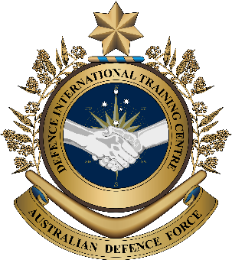
Overview:
This lesson presents vocabulary related to Infantry Officers.
In this lesson, you will:
- read and find the main idea and detail in a text
- learn the meaning of new words
- use new words in a conversation

Military English
Lesson: A job in the Army – Infantry Officer – Reading

Prepare for Reading
- Look at the pictures below and answer the questions with your partner.
- What are the jobs of an Infantry Officer?
- On missions, what does an Infantry Officer need to be successful?
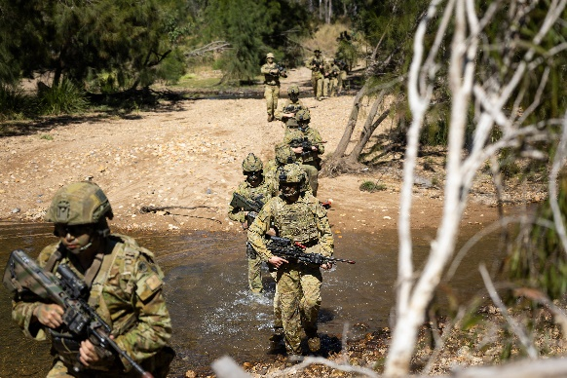
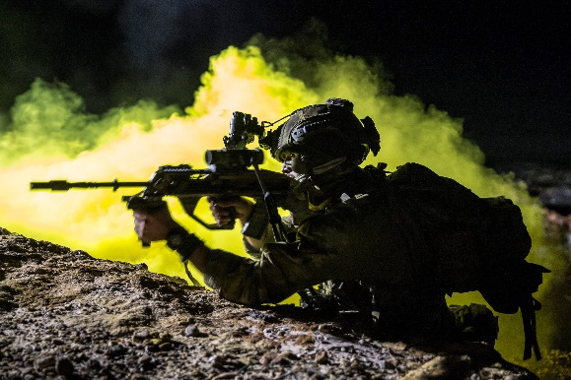

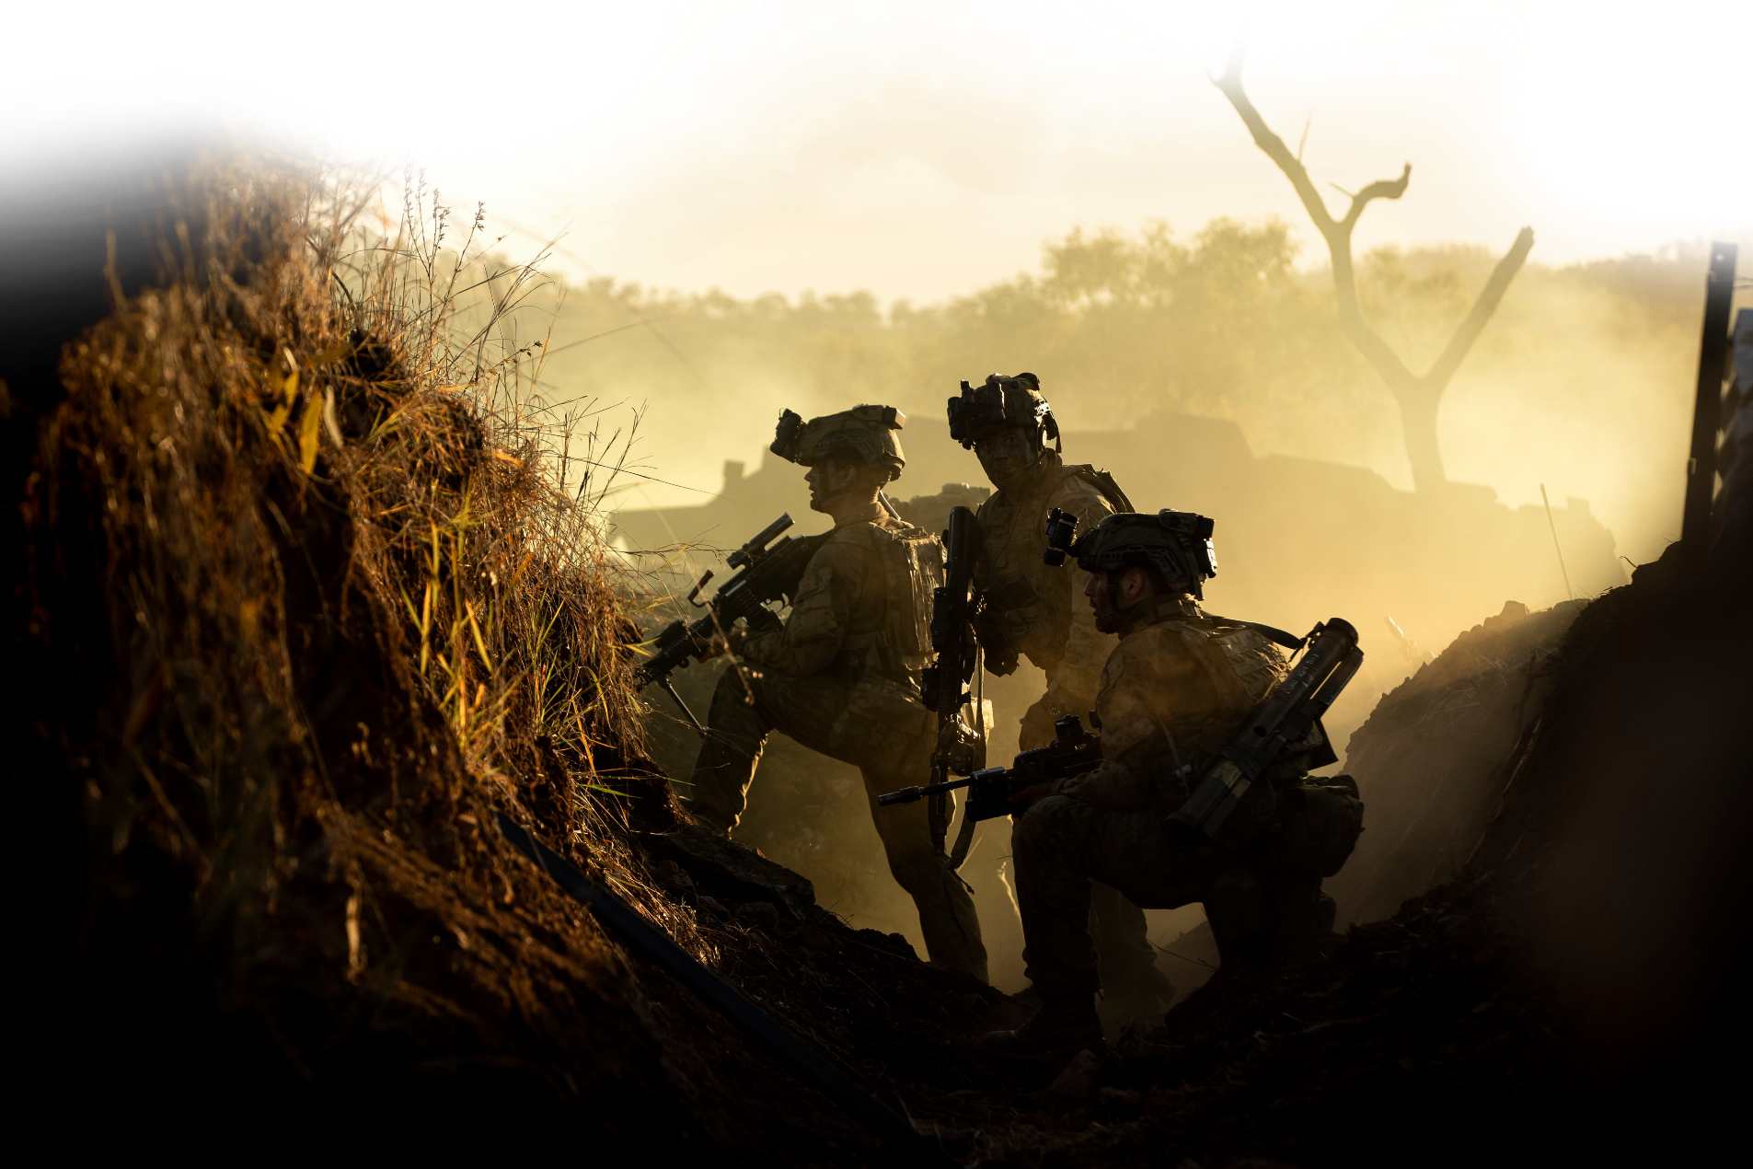
? i __ f __ __ t__ __ = The part of the army that directly fights the enemy, often on the front lines. The soldiers usually move on foot.

? i ___ f ___ ___ t___ ___ = The part of the army that engages in direct combat with the enemy. The soldiers usually move on foot.

Reading
- Quickly read the job description of an Infantry Officer. What is each paragraph 1-4 about? Write the number next to each sentence below.

_____ a. When and how Infantry Officers know what roles they will do.
_____ b. What Infantry Officers might do in their first posting.
_____ c. The jobs and requirements of infantry soldiers.
_____ d. The job(s) Infantry Officers may do in the third year.

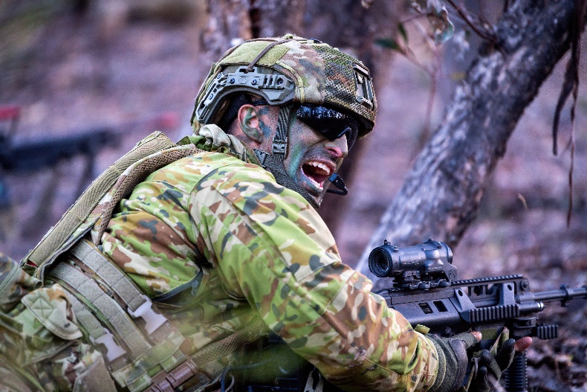
ARMY
INFANTRY OFFICER
About the role:
1
Army General Service Officers are given specific roles shortly before graduation from the Royal Military College (RMC). These roles are based on their success during training.
2
The job of the Infantry is to find and engage the enemy, to kill or capture them, to take and hold ground, and to repel attacks. They do this by day or night, in any weather or terrain. Infantry is the main combat part of the Army. This job needs soldiers and officers to be very strong both mentally and physically. Officers, in particular, are expected to lead by example.
3
Some of the cadets who complete their training from RMC are assigned to the Royal Australian Infantry (RAInf) Corps. These officers can expect to spend three or four years as a Lieutenant (LT). Their first job will usually be in an infantry battalion. During this time, they will usually be a rifle platoon Commander and possibly a specialist platoon Commander.
4
Some officers may spend their third year in one of the following positions:
- Command of a Battalion's specialist platoon, such as heavy weapons, reconnaissance, sniper, or mortars.
- Platoon Commander at the School of Infantry (Singleton, New South Wales) or the 1st Recruit Training Battalion (Kapooka,
New South Wales).
- Liaison officer at a brigade headquarters.
- Read the text again and decide if the statements are True (T) or False (F).

______ a. After graduating from RMC, Army General Service Officers can have different jobs.
______ b. Officers in the Royal Australian Infantry (or Infantry Officers) are good leaders when they show their soldiers how to behave.
______ c. Infantry Officers should have good fitness (body and mind).
______ d. After graduating from RMC, Infantry Officers assigned to the Royal Australian Infantry Corps will usually be in charge of a battalion.
______ e. Three years after being assigned to the Royal Australian Infantry Corps, Officers become Platoon Commanders.

Learning Military Vocabulary
- The words in bold are important military words that you should learn. Match the military words on the left to their definitions on the right. Look at the example first.

table one
about the role (n) |  |  | - a large group of soldiers (300-1,000) who fight on the ground; the officer in command is usually a Lieutenant Colonel
find and engage the enemy (v) |  |  | 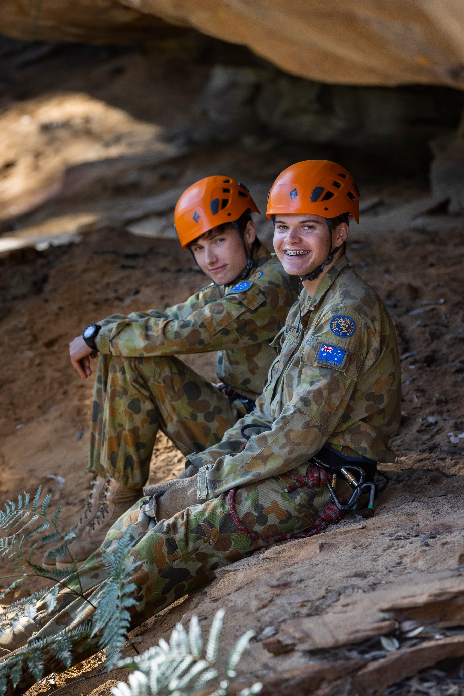  - a student training to become a military officer
to kill or capture them (v) | d |  | - a small group (20-50) of soldiers who work together as a team; the leader is usually a Lieutenant
to repel attacks (v) |  |  | - to take control of the enemy or their territory and stop them from fighting
some of the cadets who complete (n) |  |  | - to start fighting or attacking the enemy
an infantry battalion (n) |  |  | - specific duties or positions assigned to personnel based on their performance and skills
to be a rifle platoon commander (n) |  |  | - to push back, or stop the enemy from coming closer

table two
a battalion's specialist platoon (n) |  |  | 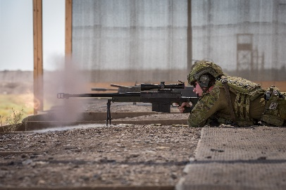  - a marksman who is trained to shoot at targets from far away; they often hide from the enemy
reconnaissance (n)  also recce /ˈreki/, or recon /ˈriːkɒn/ |  |  | 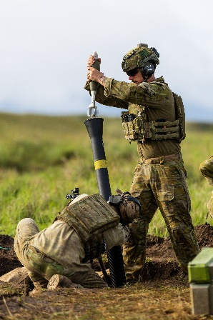  - a type of weapon that fires explosive shells at high angles to hit targets that are far away or hidden
sniper (n) |  |  | - to gather information about enemy forces or terrain
mortars (n) |  |  | - an officer who helps different groups communicate and work together; they make sure everyone has the information they need
liaison officer (n) |  |  | - a group of soldiers with special skills for certain tasks; they do things like work with heavy weapons, handle communications and provide medical help
brigade headquarters (n) |  |  | - a large group of soldiers in the army – usually 3,000-5,000 soldiers

- Now let’s practise saying the words. Listen and repeat.
- Look at the words in the tables. See where the stress is marked with underlining. Listen and repeat.
- This time do not look at the words. Listen and repeat.

- Complete the sentences below with words from exercise four.
- Before the attack, the platoon conducted a ___________________ to locate the enemy positions.
- The mission was a success as the platoon managed to _________________ the strategic hill from the
enemy.
- The Lieutenant Colonel took command of the 5th ________________ for their deployment overseas.
- During a joint military exercise, the ___________________________________ from participating countries makes sure their forces coordinate their plans and work well together.
- The _____________________ hides in a safe place and waits for the right moment to fire at a target.
- The mission was to ___________________________ the attack and stop the enemy from advancing.
joint military exercise (n) – when the military of two or more countries train together

Practice
- Work with a partner. Let’s practise the words from this lesson in a role play.
- Student A: you’re a Recruitment Officer. Your job is to help people interested in joining the Army.
- Student B: you want to become an Infantry Officer. You want more information about this role.
- Look at the questions below. Before you begin, think about how you will answer them.
- Try to use the new words you’ve learned in this lesson. You can use ideas from exercises 2-4 for help.

Student A Student B
Good morning.
Good morning. Can I ask about the infantry?

Of course. They’re very important in the Army. Why are you interested in the Infantry?

I’d like to be an Infantry Officer because…

Ok, and do you know why the Infantry is so important in the Army?

Yes, the Infantry is important because…
…
What are the main jobs I will do in the Infantry?

Infantry Officers can expect to…

Ok, thanks. One more question. What happens after the cadet training finishes?

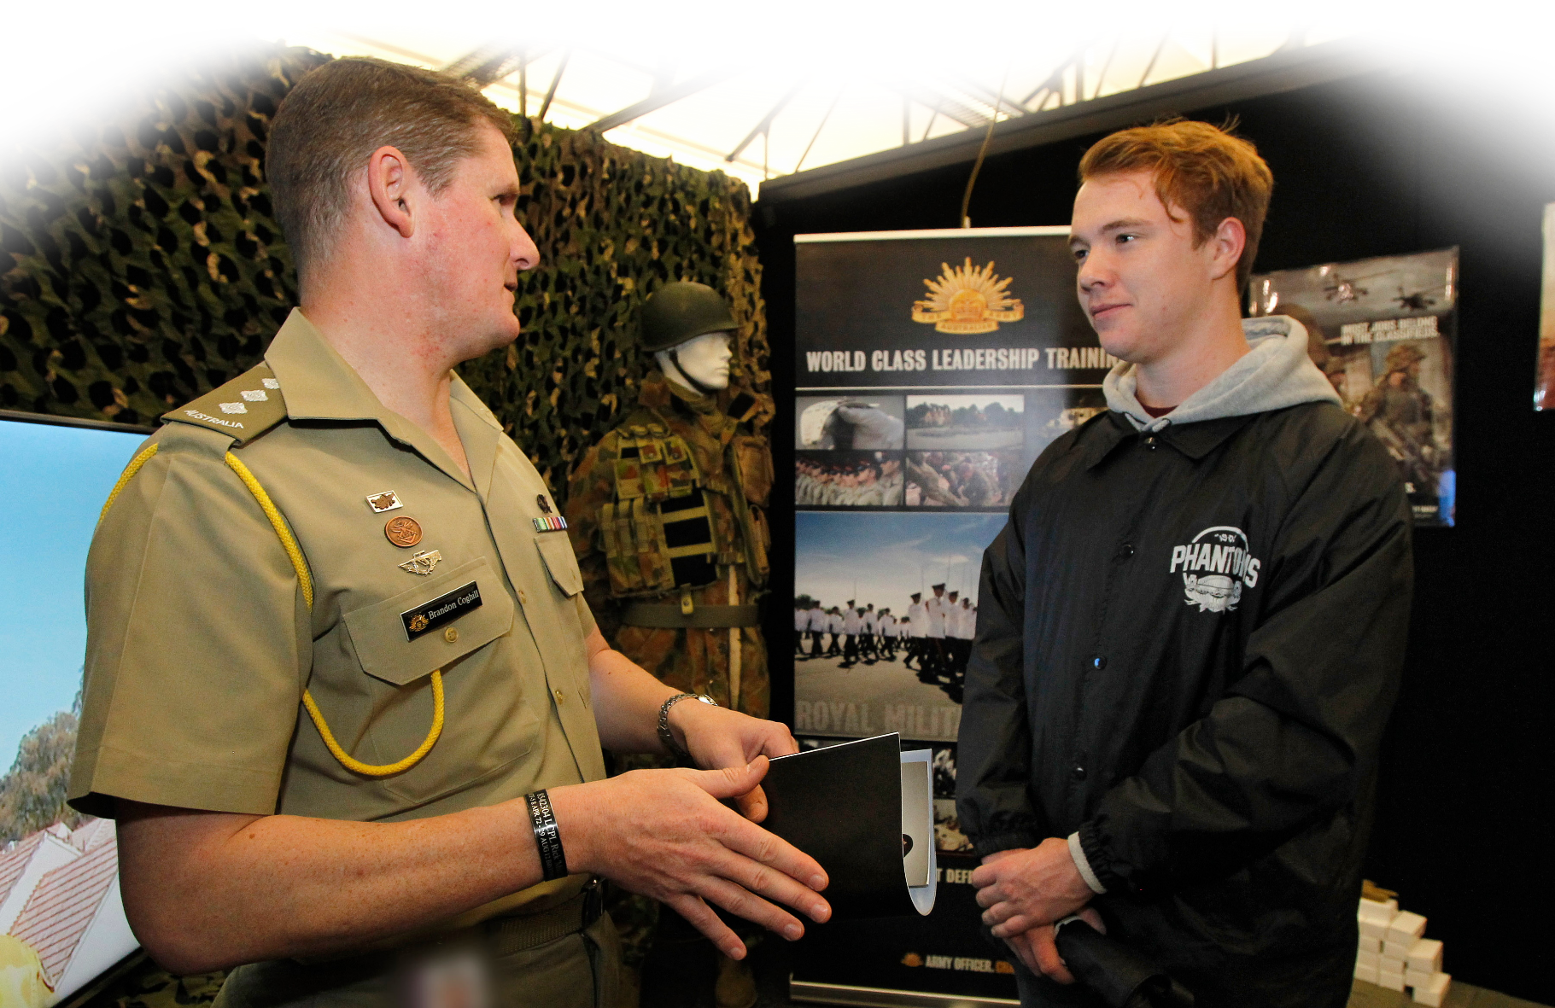
The officers spend three or four years as…


- Watch this video about infantry soldier training. Type on YouTube The Royal Australian Corps of Infantry regimental officer basic course (ROBC) or scan the QR code.
Watch the video and circle one correct answer for the questions below.
- What type of infantry training are they doing?
sniper training // jungle training // physical training
- What is the most difficult part of the course?
less time to act // flying on a helicopter // being a leader
- Soldiers who want a successful career in infantry need to be:
big, strong and fit // willing to be outdoors for many hours // good at air assaults



For more practice with the words you’ve learned here, scan the QR code for a set of flashcards. You can do some more study on the vocab in this lesson on your own with these.

This lesson links with: Lesson – Out Field (Reading)
Lesson – Recruit Training in the Australian Army (Listening)
Vocabulary Builder – Terrain Features
Vocabulary Builder – Ranks in the Australian Army

© Commonwealth of Australia 2024
This work is copyright. Apart from any use as permitted under the Copyright Act 1968 (Cth),
no part may be reproduced by any process without prior written permission from the Department of Defence.

