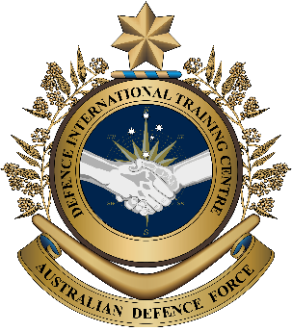

**Military English**

Lesson: Joint Military Exercises – Listening

**Overview:** This lesson presents vocabulary related to military exercises that include the armed forces of two or more countries.

**In this lesson, you will:**

* practise listening for gist and specific information
* learn the meaning of new vocabulary and expressions
* practise using new words.

## Prepare for Listening

1. Work in pairs and talk about joint military exercises.

* Before you start, think about what you’re going

**joint exercise** (n) – when soldiers from different countries train together.

to say and take notes.

* Keep your notes, you’ll use them again   
  for exercise nine.
* Use one of the Language Boxes below to help you prepare.

I have been on a joint exercise.

|  |  |
| --- | --- |
| **LANGUAGE  BOX A** | * I trained with personnel from …(country)… * It was fun / useful / hard / … because … * This was ...(where?)… * The training was …(when?)… * There were ...(number)… people in the training, I think. |

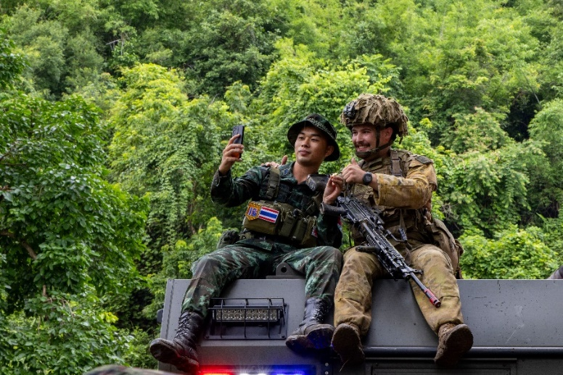

Exercise Chapel Gold

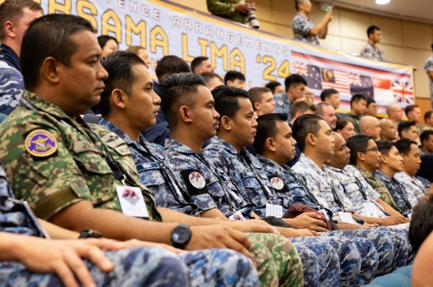

Exercise Bersama Lima

I have not been on a joint exercise.

|  |  |
| --- | --- |
| **LANGUAGE  BOX B** | * I think training with …(nationality e.g. the Americans)… might be good. * Training with people from other countries can help because ... * It might be difficult to … * But I think it could be a good experience because … |

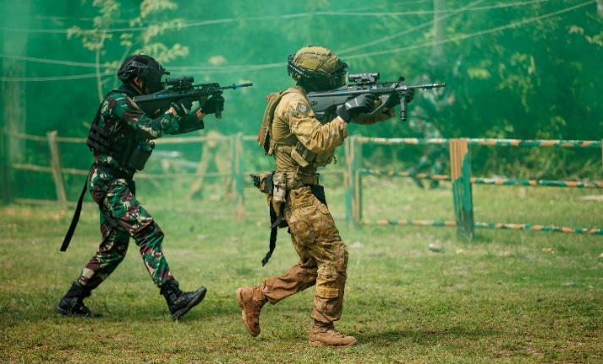

Exercise Wirra Jaya

## Listening

1. Listen to an Australian Defence Force officer talking about a joint exercise. Circle the correct **answer**:

This talk is happening **at the beginning // during // at the end** of the exercise.

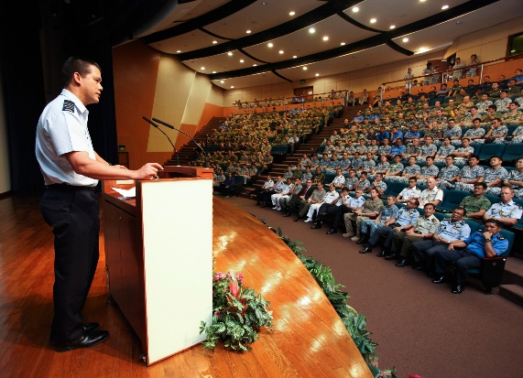

1. Listen to the recording again and circle the correct answers.
2. Which four countries were in the exercise?

Vietnam // Tonga // Australia // Thailand // Indonesia

1. How many people were in the exercise?

over 10,000 // over 20,000 // over 30,000

1. How many boats were in the exercise?

52 // 14,000 // 27

1. When will the next Exercise Talisman Sabre be?

two years from now // this year // in 52 days

## Learning Military Vocabulary

1. The words listed in bold below are important vocabulary and expressions that you should learn to use. Match the vocabulary on the left column with their definitions on the right. Look at the example. Then compare your answers with a partner.

|  |  |  |  |
| --- | --- | --- | --- |
| Table one |  |  |  |
| our recent **joint** **exercise** (n) | **c** |  | 1. work with other people or countries in a positive and friendly way |
| excellent opportunities for **international engagement** (n) |  |  | 1. \\d85userdata.dpe.protected.mil.au\ma\marcos.pougy\Downloads\20231104adf8615597_0154.jpgwhen the government, or people, help others after a natural disaster like a tsunami, flood, etc. |
| many **partner countries** (n) |  |  | **c. when a lot of military personnel train together to prepare for a real situation e.g. a war** |
| **build relationships** with other nations (v) |  |  | 1. when one group fights another group with weapons |
| very important in **armed conflict** (n) |  |  | 1. working with people from different countries |
| deliver **disaster relief** (n) |  |  | 1. friendly countries that often work together |
| Table two |  |  |  |
| activities, including **aerial** **drills** (n) |  |  | 1. \\d85userdata.dpe.protected.mil.au\ma\marcos.pougy\Downloads\20240919raaf8683332_0022.jpgmeetings to share information, give instructions or discuss a situation |
| **live-fire** exercises (adj) |  |  | 1. military personnel who help people to understand each other when they speak different languages |
| we had several **briefings** (n) |  |  | 1. to help people during difficult times, for example, after a natural disaster (a flood, tsunami, etc.) or in a war. This help can be e.g. bringing food, water, and medicine. |
| with help from **military interpreters** (n) |  |  | 1. training exercises with real weapons and real bullets |
| there were a lot of **downtime** **activities** (n) |  |  | 1. training exercises using aeroplanes |
| **humanitarian aid** **missions** (n) |  |  | 1. \\d85userdata.dpe.protected.mil.au\ma\marcos.pougy\Downloads\20150224ran8581277_128.jpgfree time activities that are fun |

1. Now let’s practice saying the words. Listen and repeat.
2. Look at vocabulary items a-d below and where the stress is marked with underlining. Three of these phrases have the same word stress pattern.

Now listen, notice how the syllables are stressed, and repeat. Circle the phrase with a different stress pattern.

* 1. partner countries
  2. aerial drills
  3. armed conflict
  4. disaster relief

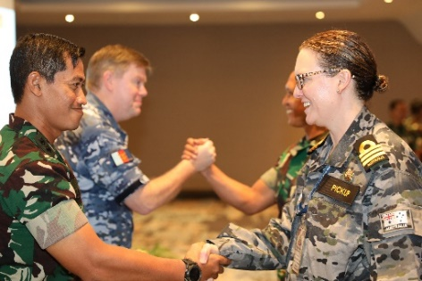

*Opening ceremony of the joint combined Exercise Nusa Bhakti AUSINDO 2022 between Australian and Indonesian forces.*

1. Listen to the recording again and use the words you have learnt to complete the gaps in the text below.

Good afternoon everyone, and thank you for joining me. I am here to talk about our recent **\_\_\_\_\_\_\_\_\_\_\_\_\_\_\_\_\_\_ exercise, Exercise Talisman Sabre**.

First of all, the exercise was a great success. We had excellent opportunities for **international engagement and m**any **\_\_\_\_\_\_\_\_\_\_\_\_\_\_\_\_\_\_\_\_\_\_ countries** joined us, including Thailand, Indonesia, and Tonga. These exercises help us **build relationships** with other nations, which is very important in armed **\_\_\_\_\_\_\_\_\_\_\_\_\_\_\_\_\_\_\_\_.** Another reason why joint exercises are important is after a natural disaster like an earthquake or tsunami. In these situations, countries need to work together to deliver disaster **\_\_\_\_\_\_\_\_\_\_\_\_\_\_\_\_\_** to help the people affected.

Our teams conducted many activities, including aerial **\_\_\_\_\_\_\_\_\_\_\_\_\_\_\_\_\_**, and **live fire** exercises, where our forces used real ammunition to practise their skills. It was important that everyone understood the mission, so we had several **briefings**, with help from military **\_\_\_\_\_\_\_\_\_\_\_\_\_\_\_\_\_\_\_\_\_\_\_\_\_\_**.

This year’s exercise was very large. There were 52 aircraft, 27 navy ships and more than 30,000 personnel training together. And although we all worked very hard, there were a lot of **\_\_\_\_\_\_\_\_\_\_\_\_\_\_\_\_\_\_\_\_\_\_\_ activities**, giving our personnel a chance to relax and build friendships with our international partners.

Overall, exercises like this prepare us for any situation where we might need to act quickly, for example **humanitarian aid \_\_\_\_\_\_\_\_\_\_\_\_\_\_\_\_\_.**

Thank you, and I look forward to the next Exercise Talisman Saber in two years’ time.

1. Circle the correct **item** from the vocabulary in exercise four to complete the sentence.
2. The commander spoke clearly when he gave the **military exercise // briefing** to all the troops.
3. The **military interpreters // partner countries** did a good job helping with clear communication.
4. There was a lot of damage from the hurricane, so friendly countries helped with   
   **international engagement // disaster relief**.
5. It’s important to be safe during **humanitarian aid missions // live fire-exercises** because soldiers use real bullets.
6. **Aerial drills // downtime activities** help air force personnel to improve their flying skills.

## Practice

1. You’re going to tell the same story from exercise one, but this time to a different partner.

* Before you start, think about what you’re going to say. Use the notes you made in exercise one.
* Remember, you can use one of the Language Boxes from exercise one to help you.
* Check for any new words you can add from this lesson. Use as many as you can.
* Your partner will listen to your story. He/she will put a check mark next to the vocabulary from this lesson that you use:

joint exercise // international engagement // partner countries // build relationships //   
armed conflict // disaster relief // aerial drills // live-fire exercises // briefings //   
military interpreters // downtime activities // humanitarian aid missions

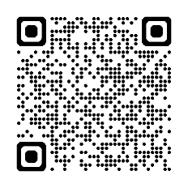

## Watch this video about an air mobility exercise between the Royal Australian Air Force (RAAF) and the Indonesian Air Force.

## Type on YouTube [ADF Exercise Rajawali AUSINDO](file:///C:\Users\kristin.walters\AppData\Local\Microsoft\Windows\INetCache\Content.Outlook\M5J2NPK0\ADF%20Exercise%20Rajawali%20AUSINDO) or scan the QR code 🡪

While you watch the video, answer these questions:

1. How often does the exercise happen?
2. According to FLGOFF Ben Broderick, why is it important to conduct exercises with Indonesia?

****

## For more practice with the words you’ve learned here, scan the QR code for a set of flashcards. You can do some more study on the vocab in this lesson on your own with these.🡪

## This lesson links with: Lesson – Reading – Military Exercises

© Commonwealth of Australia 2024   
This work is copyright. Apart from any use as permitted under the Copyright Act 1968 (Cth), no part may be reproduced by any process without prior written permission from the Department of Defence.