

**Military English**

Vocabulary Builder – Army Symbology

**Overview:**  
This worksheet lists vocabulary for identifying basic army symbols used in maps.

**In This Vocabulary Builder you will:**

* learn vocabulary to describe basic army symbols.

1. 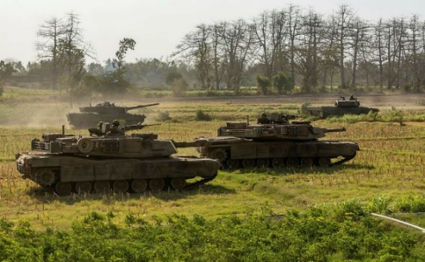Work with a partner. Look at the symbols inside each picture. Most armies use these on maps to give information about many things. Match the words in the box below to the correct symbol for **Unit Types** **(Combat Arms)**.

a. ________________________________

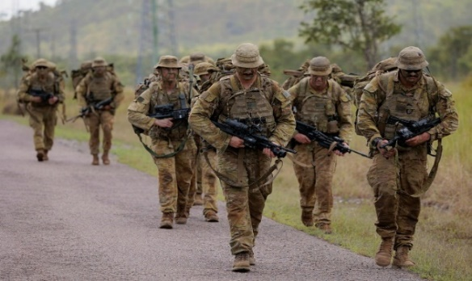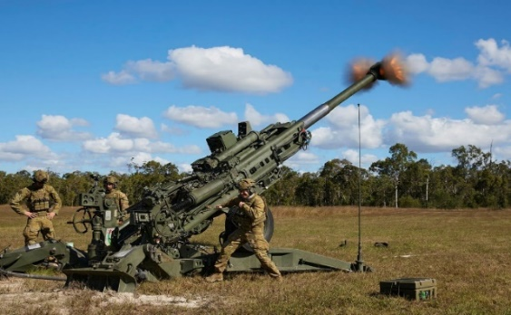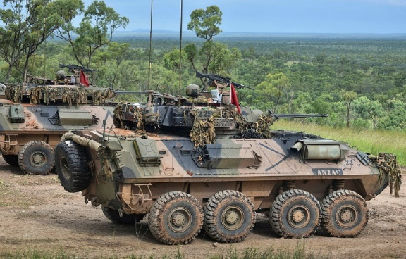

c. ________________________________

e. ________________________________

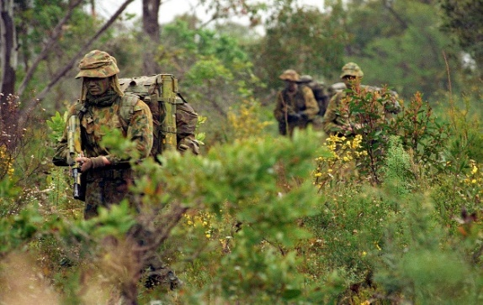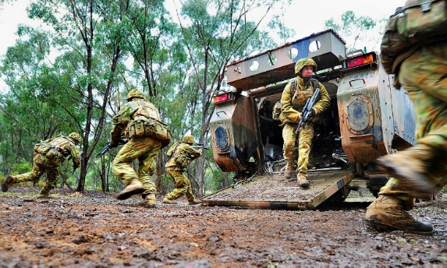

recon // armoured // mechanised infantry // infantry // artillery // armoured recon wheeled

f. ________________________________

d. ________________________________

b. ________________________________

1. Label the symbols for **Unit Colour and Shape**. Use the words in the box below.

d. ________________

c. ________________

b. ________________

a. ________________

enemy // neutral // friendly // unknown

1. Label the symbols for **Unit Sizes**. Use the words in the box below.

a. ________________

b. ________________

c. ________________

d. ________________

platoon // fire team // company // section *

**\* UNIT SIZES:**

platoon 🡪 20-60 soldiers fire team 🡪 4 soldiers

company 🡪 100-300 soldiers section 🡪 8-12 soldiers

1. Let’s practise saying the words. Pay attention to the stressed syllables/words e.g. infantry. Listen and repeat.
2. Use what you learned in exercises 1-3 to describe the complete unit symbols below. The first has been done for you.

*unit size ↓*

*unit type ↓*

*unit colour and shape ↓*

1. A friendly mechanised infantry platoon.
2. An ______________ __________________________ __________________.
3. An ______________ __________________________ __________________.
4. A ______________ __________________________ __________________.
5. An ______________ __________________________ __________________.
6. A ______________ __________________________ __________________.
7. Work with a partner and complete the map. Student A, **stay on this page**. Student B **go to page 5**.

**STUDENT A**

* You have information that student B needs. Student B has information that you need.
* Take turns asking and answering questions. Use the Language Box to help you.
* Start by asking student B about place number 1. Then draw the symbol in box 1.
* Now answer Student’s B question about box number 2.

|  |
| --- |
| **LANGUAGE  BOX** |
| Student A asks: What unit can you see in place number 1?  Student B answers: I can see a _______ _______ _______ in place number 1.  Student B asks: What unit can you see in place number 2?  Student A answers: I can see a _______ _______ _______ in place number 2.  And so on… |

* Keep asking and answering until you both have a complete map.

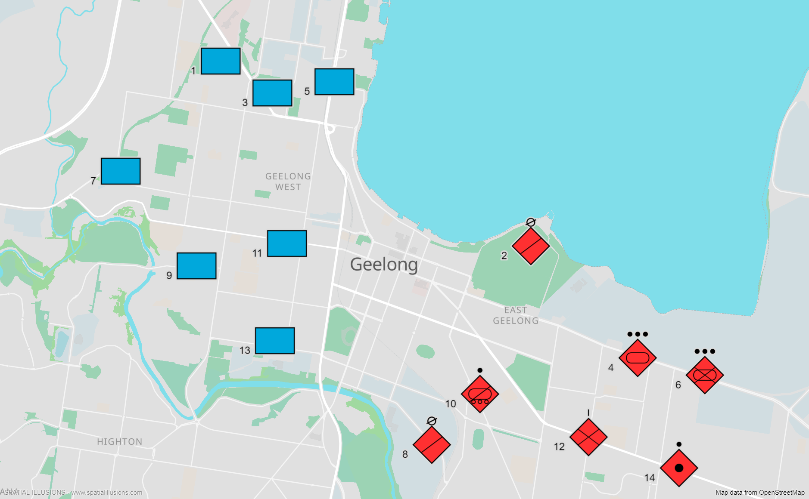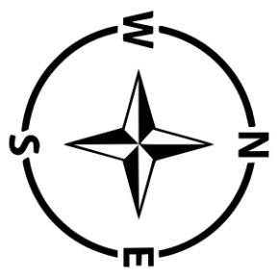

[*www.spatialillusions.com*](http://www.spatialillusions.com)*. Map data from OpenStreetMap.*

**STUDENT B**

* You have information that student A needs. Student A has information that you need.
* Take turns asking and answering questions. Use the Language Box to help you.
* Start by answering student A about place number 1.
* Now ask Student’s B question about box number 2. Then draw the symbol in box 2.

|  |
| --- |
| **LANGUAGE  BOX** |
| Student A asks: What unit can you see in place number 1?  Student B answers: I can see a _______ _______ _______ in place number 1.  Student B asks: What unit can you see in place number 2?  Student A answers: I can see a _______ _______ _______ in place number 2.  And so on… |

* Keep asking and answering until you both have a complete map.

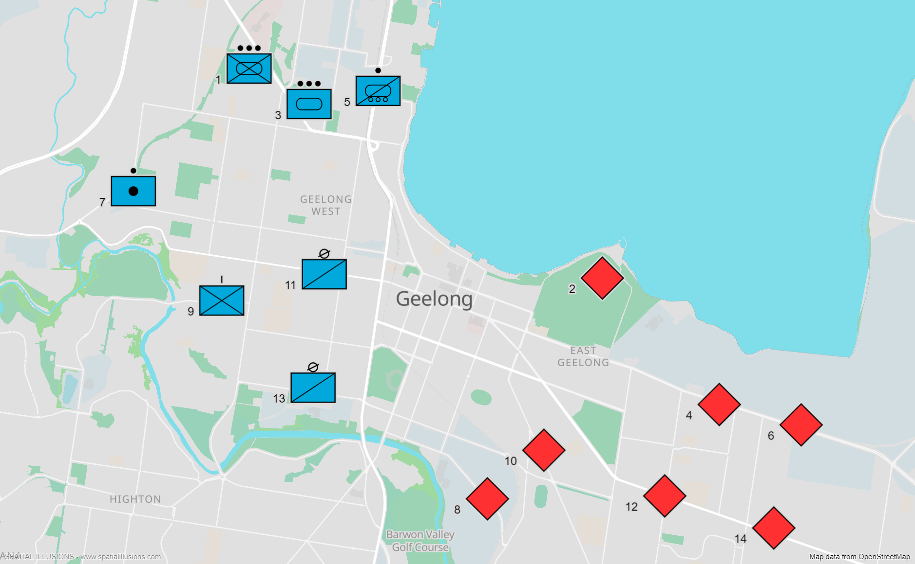

[*www.spatialillusions.com*](http://www.spatialillusions.com)*. Map data from OpenStreetMap.*

* Watch this YouTube video and draw and write the names of the symbols that were not included in this lesson. Type on YouTube [Wargaming Basics - Military Symbology](https://www.youtube.com/watch?v=SWP3eBlOX3w) or scan the QR Code to the right 🡪



## For more practice with the words you’ve learned here, scan the QR code for a set of flashcards. You can do some more study on the vocab in this lesson on your own with these. 🡪

* This Vocabulary Builder links with 🡪 Lesson: Jungle Warfare Training (Listening)

Lesson: Out Field (Listening)

© Commonwealth of Australia 2024  
This work is copyright. Apart from any use as permitted under the Copyright Act 1968 (Cth),   
no part may be reproduced by any process without prior written permission from the Department of Defence.