**Military English**

Vocabulary Builder: Countries and Flags – Oceania – Part A

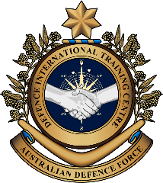

**Overview:**  
This sheet lists vocabulary of countries, their flags, nationalities, and languages in Oceania.

**In this vocabulary builder, you will:**

* learn and use vocabulary related to Oceanian countries.

1. Work in pairs and answer these questions.
2. Which number on the map below is Oceania?
3. What do you know about the countries in Oceania e.g. their size and the language(s) people speak in these countries?

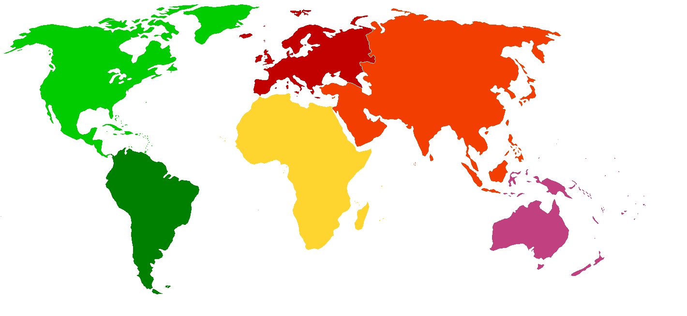

**6**

**4**

**2**

**1**

**3**

**5**

1. Work in pairs. Finish the spelling of each country. Look at the example.

|  |  |
| --- | --- |
| 1. Mi c ron e s ia (also Federated States  of Micronesia, or FSM) | 1. __ar__hal__ I__la__ds |
| 1. __on__a | 1. T__va__ __ |
| 1. __an__a__u | 1. S__m__a |
| 1. S__lo__on I__la__ds |  |

1. Practise the pronunciation of these countries. Listen and repeat.
2. Guess the country. Look at these nationalities and languages and write the correct country in the space. Look at the example.

|  |  |  |
| --- | --- | --- |
| **Nationality** | **Language** | **Country** |
| 1. Solomon Islander | English; Pijin | _______________________________  Solomon Islands |
| 1. Micronesian | English | _______________________________ |
| 1. Ni-Vanuatu | Bislama; English; French | _______________________________ |
| 1. Tongan | Tongan; English | _______________________________ |
| 1. Tuvaluan | Tuvaluan; English | _______________________________ |
| 1. Samoan | Samoan; English | _______________________________ |
| 1. Marshallese | Marshallese; English | _______________________________ |

1. Practise the pronunciation of these nationalities and languages. Listen and repeat.
2. Let’s practise the vocabulary from this lesson. Do a speaking activity with your classmates.

* Talk to your classmates to complete the information on the countries below.
* Your teacher will give you a country card – ‘your’ country. Answer your classmates’ questions about your country. Ask your classmates questions about their countries to complete the table.
* First, fill in the information about ‘your’ country in the table below.
* Now, think about what questions you’re going to ask. Write them in the spaces below. Look at the example.
* Remember, you need to ask and answer questions!

QUESTIONS:

Where are you from?

country: ___________________________________________________________________

nationality: ________________________________________________________________

language(s): _______________________________________________________________

flag colours: _______________________________________________________________

|  |  |  |  |  |
| --- | --- | --- | --- | --- |
| **Country** | | **Nationality** | **Language(s)** | **Flag – colours** |
| *Example:* | Australia | Australian | English | blue, white, red |
| Solomon Islands | |  |  |  |
| Micronesia | |  |  |  |
| Vanuatu | |  |  |  |
| Samoa | |  |  |  |
| Tonga | |  |  |  |
| Marshall Islands | |  |  |  |
| Tuvalu | |  |  |  |

* 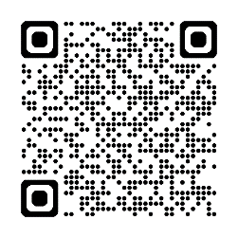Watch this video. Follow the instructions on the screen. Type on YouTube [Oceania Flag Quiz | Guess the National Flag](https://www.youtube.com/watch?v=R8X9e6MKUDg) or scan the QR code.
* For more practice with the words you’ve learned here, scan the QR code for a set of flashcards. You can do some more study on the vocab in this lesson on your own with these. 🡪
* This Vocabulary Builder links with 🡪 Vocabulary Builder – Countries and Flags – Oceania – Part-B

© Commonwealth of Australia 2025  
This work is copyright. Apart from any use as permitted under the Copyright Act 1968 (Cth),   
no part may be reproduced by any process without prior written permission from the Department of Defence.