**Military English**

Lesson: Explosives Training and Cooperation in the Philippines

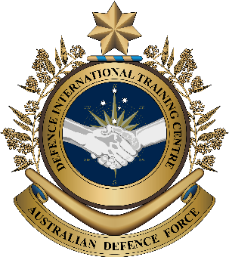

**Overview:** This lesson presents vocabulary related to explosives training and cooperation between the Australian Defence Force and the Philippines Army.

**In this lesson, you will:**

* Use reading skills to identify key vocabulary.
* Learn the meaning of new vocabulary and expressions.
* Use new vocabulary and expressions in context.

## 

## Prepare for Reading

1. Look at the pictures and discuss the following questions in pairs or small groups.
2. What are the soldiers doing?
3. What is the Australian soldier doing?
4. 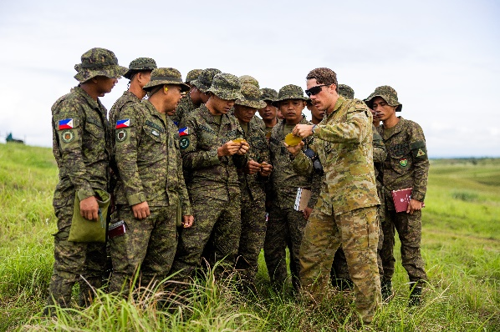Why do militaries from different countries   
   often train together?

**mortar (n) -**a short, light cannon that fires explosive shells at a high angle.

## Reading

1. Read the text below quickly. What is the main idea in the text? Choose, a, b or c
2. The Australian Army practised firing rockets with the Philippine Army.
3. Australian and Philippine armies trained together using mortars.
4. The Australian soldiers learned about mortars from the Philippine Army.

~~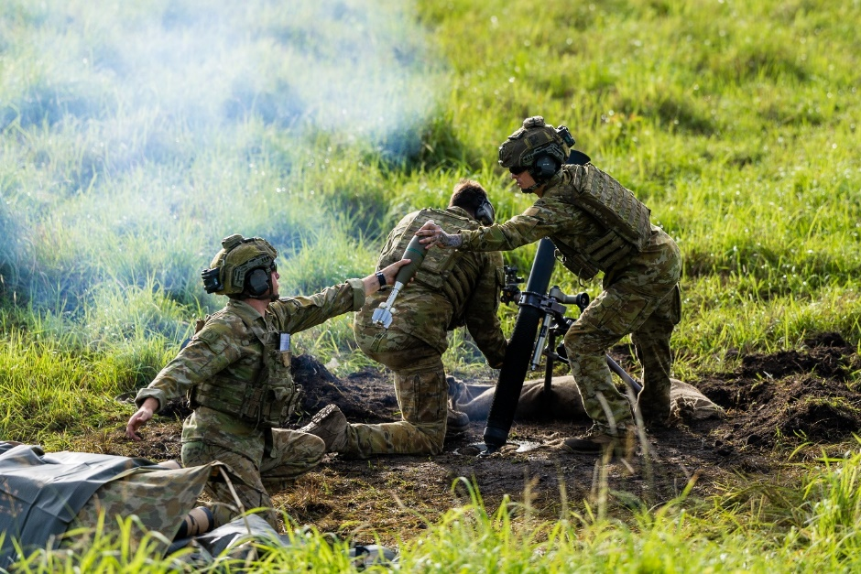~~From sunrise to sunset, the hills of Luzon in the northern Philippines were busy with fire activity from Australian Army mortars during a basic mobile fire controller course.

Soldiers from 1st Royal Australian Regiment (1RAR) taught mortar **standard operating procedures (SOPs)** and how Australians call for fires, then **conducted** a   
**live-fire** exercise for Filipino personnel.

*Australian Army soldiers fire an 81mm mortar in Luzon, Philippines.*

LT Peter Kuschert(Australian Army) **commanded** the activity and was happy with how his team and the Philippine Army **cooperated**. “We **adjusted** the mortar live-fire training to help the Philippine Army improve their skills in using mortars for **territorial defence** and to develop the **partnership** with the Australian Army,” said LT Kuschert.

The Filipinos wanted to learn from the Australians. “We are enjoying the training. All the Australians are friendly – there is great **camaraderie**,” said 2LT Rickey Arellano, from the Philippine Army.

The training team also included a **Liaison Officer** to help the two armies communicate. Overall, conducting activities like this increases **interoperability** and builds stronger relationships between Australia and the Philippines.

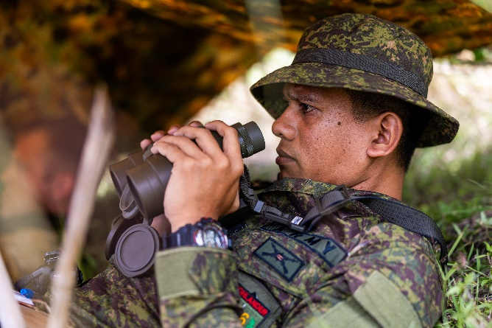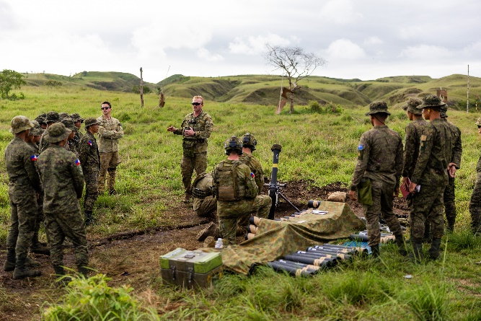

*Australian and Philippine Army soldiers during the training activity.*

*Text adapted from* [*Defence News*](https://www.defence.gov.au/news-events/news/2024-07-01/explosive-cooperation-philippines)*.*

## Learning Military Vocabulary

1. The words listed in bold below are important vocabulary and expressions that you should learn to use. Match the vocabulary on the left with their definitions on the right. Look at the example “**d.**”

|  |  |  |  |  |  |  |  |  |  |  |
| --- | --- | --- | --- | --- | --- | --- | --- | --- | --- | --- |
| Table one |  | | |  |  | | | | | |
| taught **standard operating procedures (SOPs)** (n) | |  | | | |  | | 1. Official steps for doing regular tasks, especially in the military or other organisations. For example, the rules to follow when using mortars. | | |
| **conducted** a live-fire exercise (v) | | **c** | | | |  | | 1. to use real weapons and ammunition (e.g. bullets) in training or exercise | | |
| a **live-fire** exercise (n) | |  | | | |  | | **c. to organise or do something, like training or an event, e.g. “The soldiers __________ an exercise” – meaning they organised and did the exercise** | | |
| **commanded** the activity (v) | |  | | | |  | | 1. to work together with others | | |
| the two teams **cooperated** well (v) | |  | | | |  | | 1. to lead a group or activity | | |
| Table two | | |  | | | |  | |  | |
| we **adjusted** the training (v) | |  | | | |  | | 1. a feeling of friendship and trust between people who spend time together, especially in difficult situations | |
| using mortars for **territorial defence** (n) | |  | | | |  | | 1. the ability of different groups, systems, or organisations to work well together | |
| to develop the **partnership** (n) | |  | | | |  | | 1. keeping a country or area safe from attacks or threats | |
| there is great **camaraderie** (n) | |  | | | |  | | 1. to change something a little to make it better or correct. | |
| the team also included a **Liaison Officer** (n) | |  | | | |  | | 1. a military person who helps different groups share information and work together | |
| activities like this increase **interoperability** (n) | |  | | | |  | | 1. when different groups (e.g. countries) share the same goal and work together to achieve it | |

1. Now let’s practice saying the words. Listen and repeat.
2. Read the text again and decide if the statements below are true or false. Circle the correct answer.
3. The training took place in the southern Philippines. **True / False**
4. Lieutenant Peter Kuschert was pleased with how the Australian and Philippine Army teams   
   worked together. **True / False**
5. The Australian Army soldiers taught the Philippine Army how to use mortars   
   for territorial defence. **True / False**
6. The Filipinos did not enjoy the training with the Australians. **True / False**
7. The Joint Australian Training Team – Philippines helps improve interoperability between Australia and the Philippines. **True / False**
8. Complete the sentences below using words from exercise three.
9. The training aimed to help the Philippine Army's ability to use mortars for _____________________.
10. The Australian Army soldiers __________________ a live-fire exercise to train and assess the skills of the Philippine Army personnel.
11. Second Lieutenant Ricky said the soldiers felt a strong sense of _____________________ as they trained together during the activity.
12. Soldiers from Australia’s 1RAR helped the Philippine Army learn ______________________________ ________________________ _________________________ (SOPs) for how to call in mortar firing.
13. The training helped improve the __________________________ between the Australian and Philippine armies, allowing them to work better together.

## Practice

1. Work with a partner. Imagine you have to plan a joint training exercise between your country and Australia. In this exercise, the soldiers from both countries will learn and practise military skills and teamwork.

* Plan the Exerciseand think about:
  + the type of training activity.
  + the goals of the exercise and how the two armies will work together.
  + how you’re going to quickly present the plan to other classmates.
* Use new Vocabulary**:** try to use some of the vocab that you learned in this lesson.
* Then, share your plan:

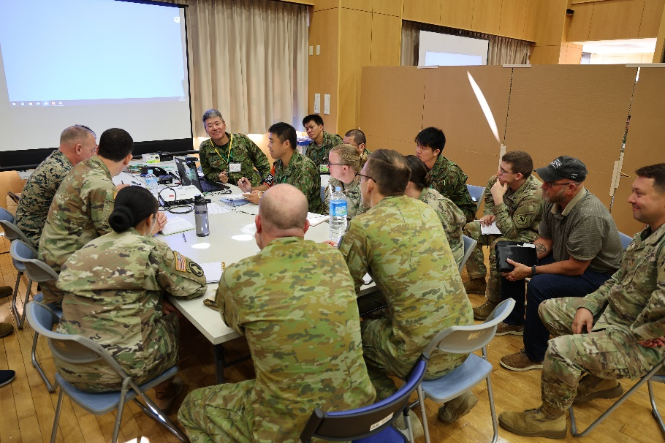

*Planners from the Australian Army, United States Army and Japanese Ground Self-Defense Force have   
a meeting before a joint exercise.*

When your group *talks* about the plan:

* + Explain why your activities help improve interoperability, camaraderie and cooperation   
    between the two countries.

When you *listen* to the other group, tell them if

* + the plan helps improve interoperability, camaraderie   
    and cooperation between the two countries.
  + you would use this plan in your unit.
* Watch the video about the training. Type on YouTube [ADF | Joint Australian Training Team – Philippines](https://www.youtube.com/watch?v=-_YZs3FVCLk) or scan the QR code to the right.

While you watch, write down the words you hear in the video that you learned in this lesson.



* For more practice with the words you’ve learned here, scan the QR code for a set of flashcards. You can do some more study on the vocab in this lesson on your own with these. 🡪
* This Lesson links with 🡪 Vocabulary Builder – Types of Army Weapons

Lesson – Military Exercises (reading)

© Commonwealth of Australia 2025  
This work is copyright. Apart from any use as permitted under the Copyright Act 1968 (Cth),   
no part may be reproduced by any process without prior written permission from the Department of Defence.