
Military English
Lesson: An Officer’s Biography - Listening

Overview:
This lesson practises listening in the context of a military member’s biography and related vocabulary of military service.
In this lesson, you will:
- listen for specific information
- listen for gist
- learn the meaning of new words
- use new words in context

Prepare for Listening
- Look at the pictures and discuss the questions with a partner.
- What is happening in in pictures A, B and C?
* military personnel – (milpers) anyone in uniform who works for the military.
pronunciation: /ˌpɜːsəˈnel/
- What is the person’s job in picture A?
- How do military personnel* get these?
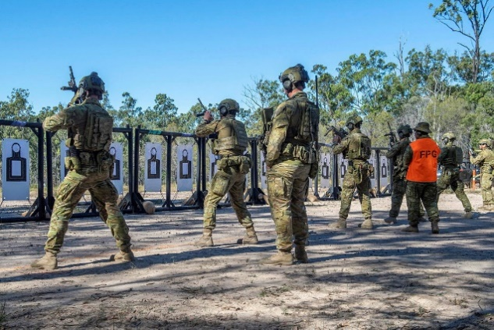
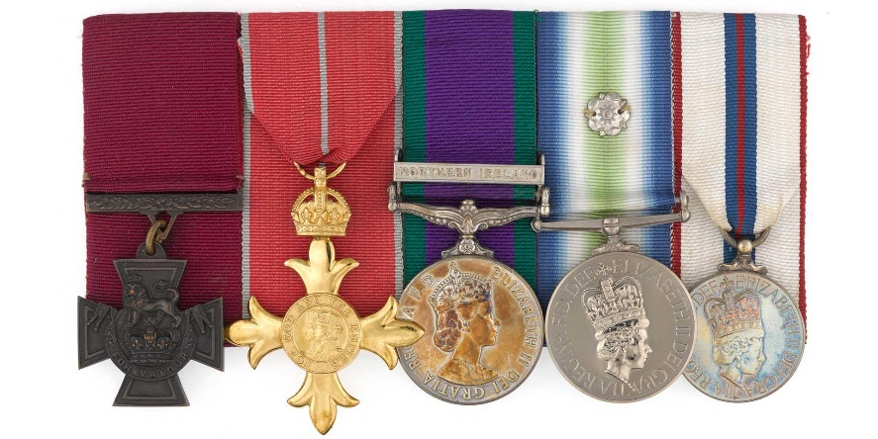
C

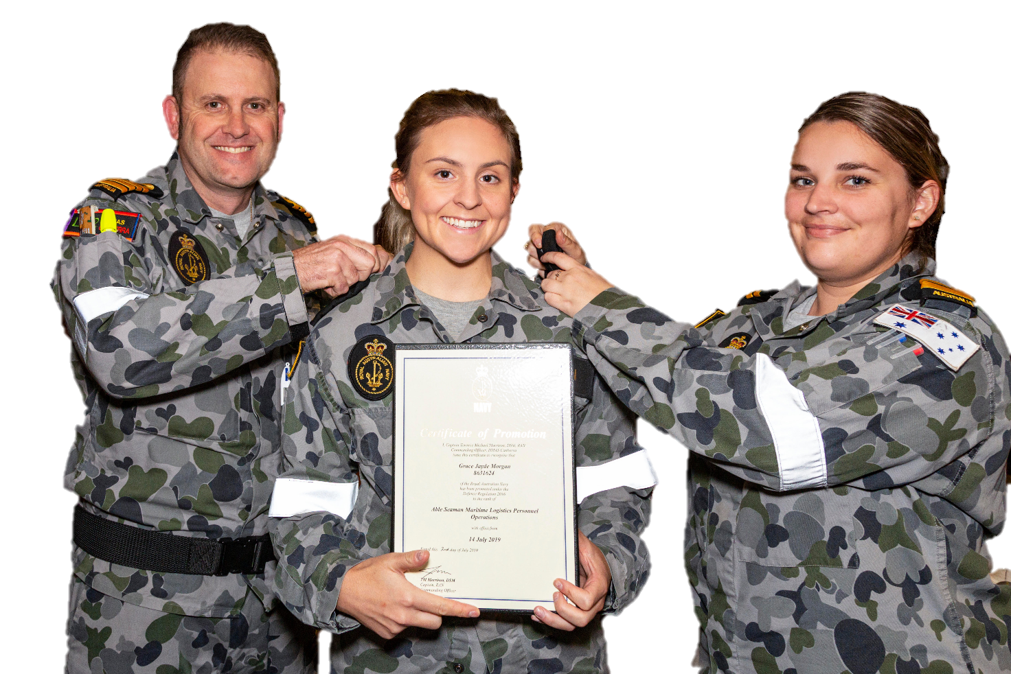
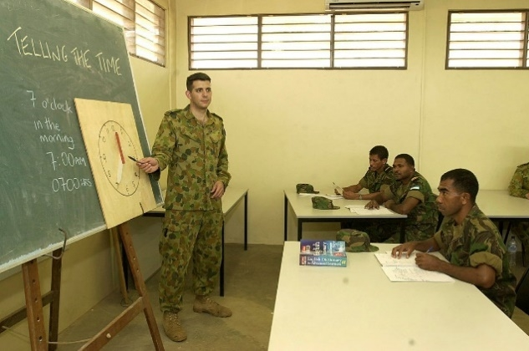
B
A

Listening
ceremony – a special event to celebrate or mark something important.
pronunciation: /ˈserəməni/
- You will listen to a recording about a ceremony.
- read the questions below
- listen and choose the correct answer (1, 2, or 3) to each question.
- then, compare your answers in small groups

              - Where did CAPT Smith train to become an Army Officer?
1. Royal Military College
2. Task Group Taji 3
3. Land Warfare Centre – Canungra
              - What is CAPT Smith's job today?
1. Training team leader
2. Education Officer
3. Artillery Officer

              - When did CAPT Smith start working as an Education Officer?
1. in 2014
2. in 2017
3. in 2023

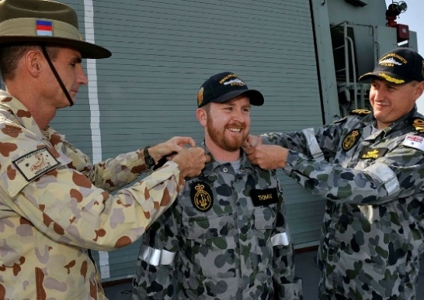
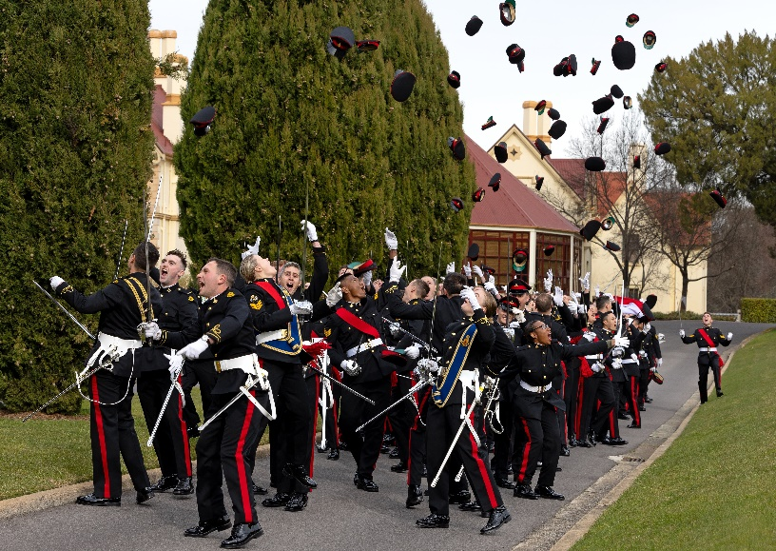
              - What type of ceremony is happening in the listening (1,2 or 3)?
3.
1.

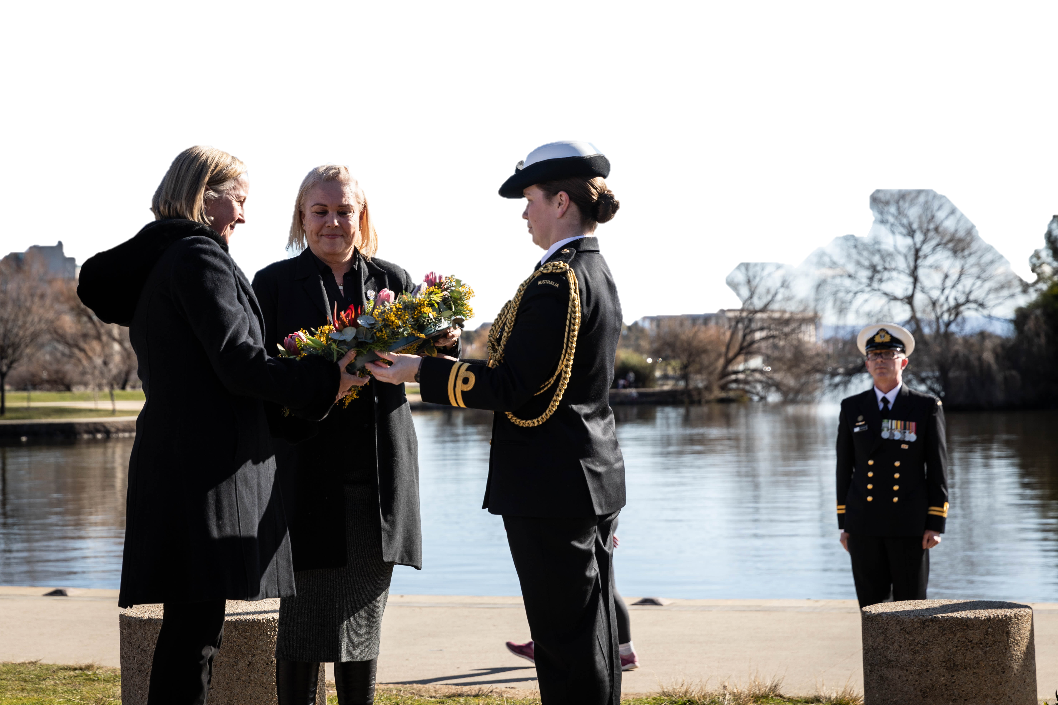
2.

- Listen to the audio again. Fill in the blanks to complete the sentences correctly with the words you hear. Check your answers with a partner after you have finished.

“Ladies and gentlemen,
Today, we are here for a special occasion to celebrate the promotion of LT Jane Smith. This is an important moment that highlights LT Smith’s hard work. LT Smith made a significant commitment when she joined the ________________. Being a commissioned officer means she has an important duty to her country. Let me tell you more about LT Jane Smith.
LT Smith, a dedicated Australian Army officer, was born in Port Melbourne, Victoria. LT Smith joined the Australian Regular Army in January _________, and graduated from the Royal Military College in June ________. Upon graduation, she posted to the 8th/12th Regiment, Royal Australian Artillery.
In 2020, LT Smith deployed to Iraq on Operation OKRA with Task Group Taji _____ as a training team leader. In this deployment, LT Smith conducted Advanced Marksmanship courses, and trained ______________ from the Iraqi infantry.
In 2023, LT Smith transferred to the Royal Australian Army Education Corps and posted to the Land Warfare Centre – Canungra. There, she started ________________ as an Education Officer. LT Smith’s current posting is at the Army Education Centre – South East Queensland.
Her awards include the Australian Operational Service Medal – Greater Middle East Operation.
Today, LT Smith is promoted to the rank of ______________.
Congratulations, Captain Jane Smith!
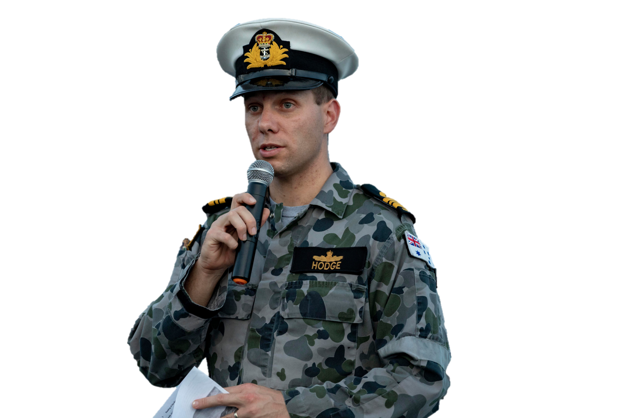
Let’s hear from Captain Jane Smith…”

Learning Military Vocabulary
- The words in bold in the text are important military vocabulary that you should learn to use. Match the military words on the left to their definitions on the right on tables one and two.
Look at the example.

Table one
celebrate the promotion of Jane Smith (n) | f |  | - an officer who has higher rank and leadership responsibilities than a non-commissioned officer (NCO)
She joined the military (v) |  |  | - = job, responsibility
a commissioned officer (n) |  |  | - to start a new job
an important duty (n) |  |  | - to pass a course
she graduated from the Royal Military College (v) |  |  | - to start doing something new in the military e.g. work in a different unit, at a different place
She (was) posted to the 8th/12th Regiment (v) |  |  | f. a move to a higher military rank e.g. when an officer  moves from the rank of Lieutenant to Captain

Table two
LT Smith (was) deployed to Iraq (v) |  |  | - to move to another area in the same organisation
infantry (n) |  |  | - to send military personnel to a place for a mission
LT Smith transferred to another unit (v) |  |  | 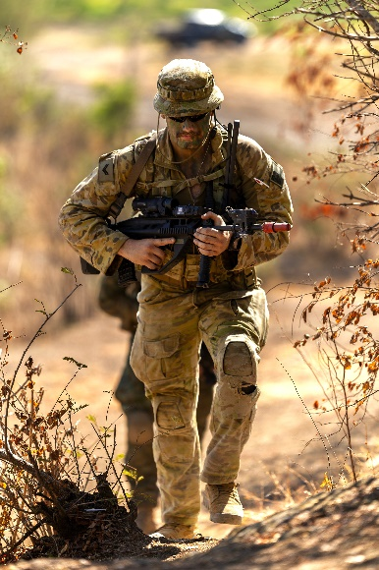  - soldiers who fight on foot
the Royal Australian Army Education Corps (n)  (corps is pronounced /kɔː/) |  |  | 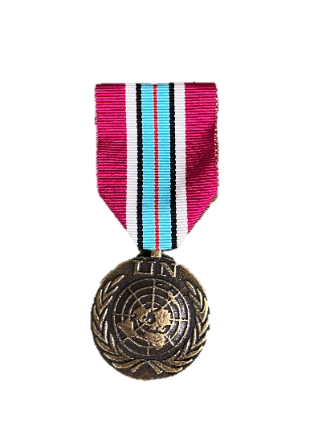
the rank of captain (n) |  |  | - the position or level that military personnel have e.g. Captain, Major, Lieutenant Colonel, etc
awards (n) |  |  | - a prize to a soldier or officer because they did something special, brave or courageous
medal (n) |  |  | - military units that are part of a bigger group; they work together and have the same goal

- Now let’s practise saying the words. Listen and repeat.

- Look at the verbs and their nouns in the table below. Then, select the correct word form in bold (verb or noun) for each sentence a-d.
Verb (present tense) | Verb (past simple and participle) | Noun
graduate | graduated | graduation
promote | promoted | promotion
post | posted | posting
deploy | deployed | deployment

- My colleague’s promotion // promote ceremony is at 0900 tomorrow.
- MAJ Anderson’s posting // posted in Bangkok ends at the end of the year.
- The cadets graduation // graduated last week. It was a beautiful ceremony.
- The Australian Defence Force deployment // deploys peacekeeping forces to different parts of the world.

- Complete the sentences below with words from Exercise 4.

- General is the highest ______________________ in the Army.
- A Sergeant is a non-commissioned officer; a Lieutenant is a _______________________.
- An ________________ soldier fights on foot and uses weapons such as rifles and grenades.
- After the successful mission Corporal Singh received a _____________________ for his acts of bravery.
- Major Fraser used to be a Lieutenant Commander in the Navy. He ___________________ to the Army about two years ago.
- A soldier’s most important _____________ is to defend their country and follow orders with discipline.

Practice
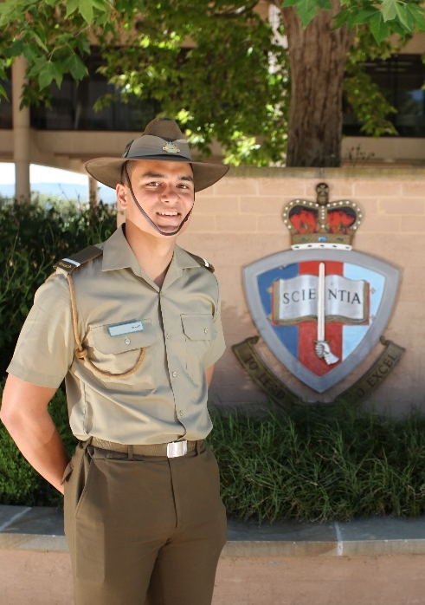
- Your Commanding Officer (CO) has asked you to write a text for him to read at a promotion ceremony. Read the notes he prepared below and write a speech on a separate piece of paper. Use the text on page 3 to help you. After that, with a partner, take it in turns reading your texts aloud.

Notes for LT Jones’ promotion to the rank of Captain (CAPT) this Thursday:

Name: Stuart Jones

Rank: Lieutenant (LT)

Place of birth: Ballarat, Victoria

Joined: 2017 (Army)

Graduated from Royal Military College (RMC): 2019

Postings:

Royal Australian Regiment: 2019

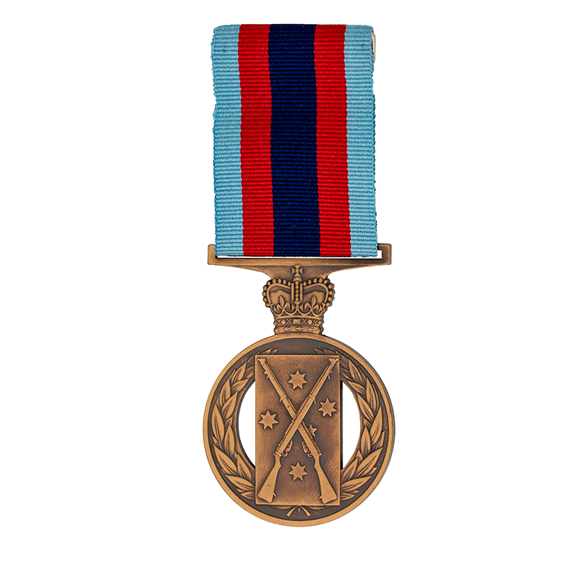
Transferred to 8th Signal Regiment: 2022

Deployment:

Peacekeeping Operation UNMISS (South Sudan): 2021
- Awards:
  - Champion Shots Medal: 2020


- For more practice with the words you’ve learned here, scan the QR code.
- This lesson links with VB – Ranks in the Australian Army

Write your text below:
Ladies and gentleman,
Today, we’re here for a special occasion to celebrate ___________________________________________
_________________________________________________________________________________________
_________________________________________________________________________________________
_________________________________________________________________________________________
_________________________________________________________________________________________
_________________________________________________________________________________________
_________________________________________________________________________________________
_________________________________________________________________________________________
_________________________________________________________________________________________
_________________________________________________________________________________________
_________________________________________________________________________________________
_________________________________________________________________________________________
_________________________________________________________________________________________
_________________________________________________________________________________________
_________________________________________________________________________________________
_________________________________________________________________________________________
_________________________________________________________________________________________
_________________________________________________________________________________________
_________________________________________________________________________________________
_________________________________________________________________________________________
_________________________________________________________________________________________
© Commonwealth of Australia 2024
This work is copyright. Apart from any use as permitted under the Copyright Act 1968 (Cth),
no part may be reproduced by any process without prior written permission from the Department of Defence.

