**Military English**

Lesson: Jungle Warfare Training – Reading



**Overview:**  
This lesson presents vocabulary related to joint training.

**In this lesson, you will:**

* read a text for main ideas
* find specific information in a text
* learn the meaning of new words and practise talking about Jungle Warfare Training.

## Prepare for Reading

1. Look at the photos of soldiers training in Tully. Use your guessing skills and talk to your friends:

**Tully Training Area**   
is where the Australian Army conducts jungle warfare training.

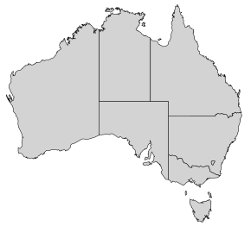

What did they do during the training?

What did they learn?

What was hard?

What was fun?

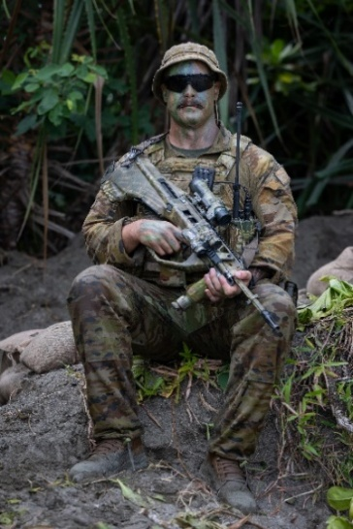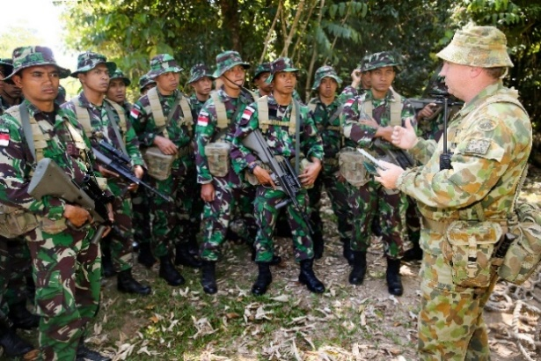

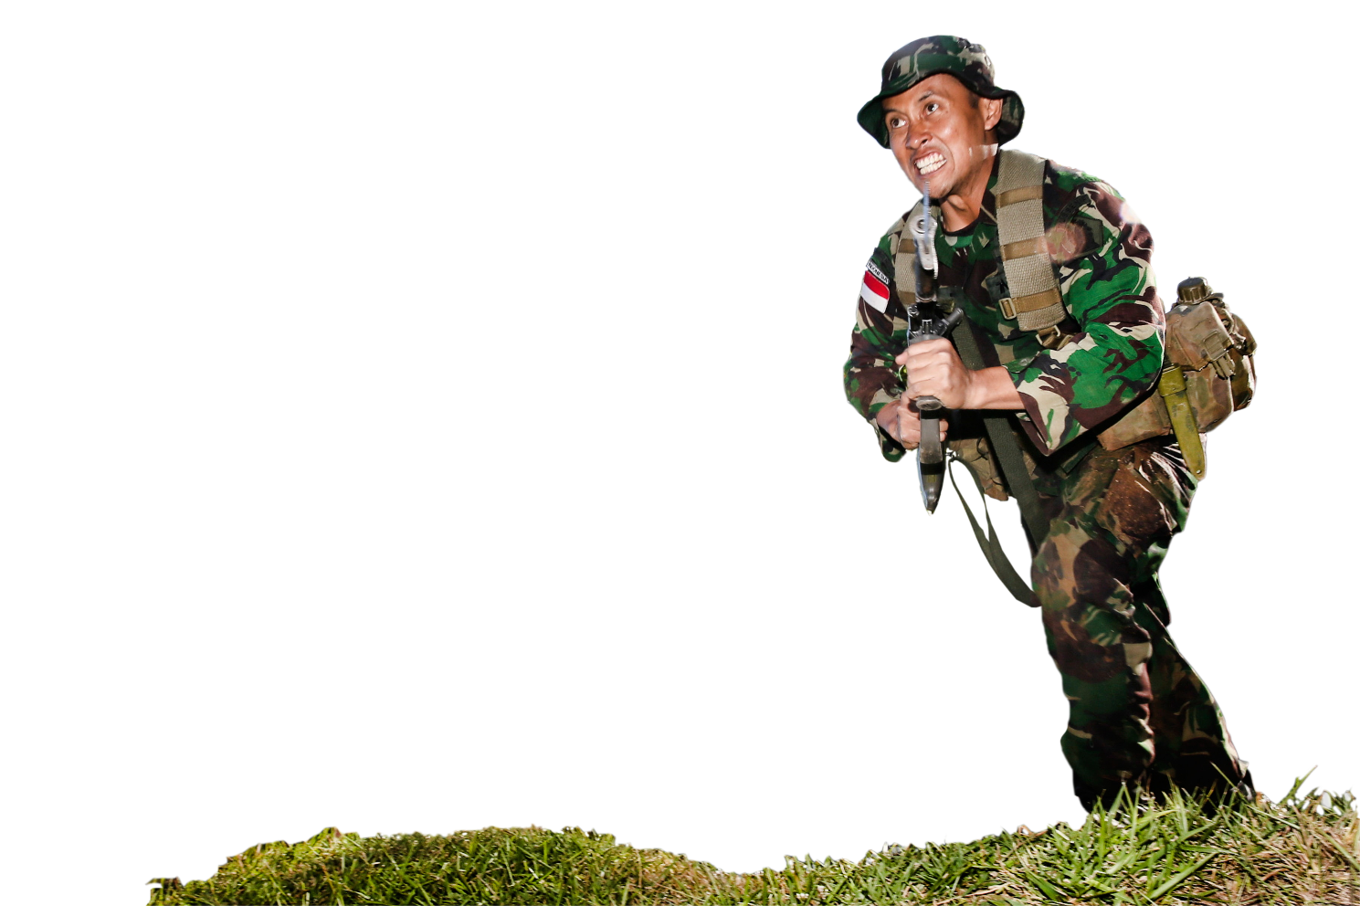

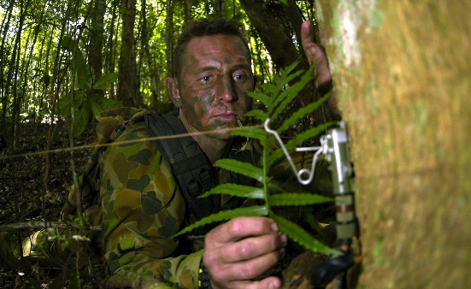

*An Indonesian Army Officer at the Tully training area during the Junior Officer Combat Instructor Training (JOCIT) course conducted by the Australian Army.*

1. There are some words we need for today’s reading in the box. Match them with the pictures.

compass // maps // GPS // foliage // region

**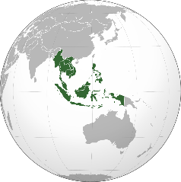**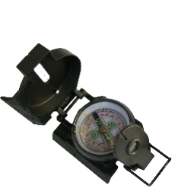

**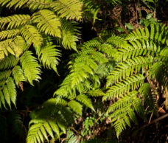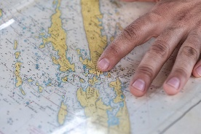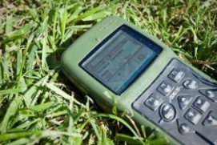**

a. \_\_\_\_\_\_\_\_\_\_\_ b. \_\_\_\_\_\_\_\_\_\_\_\_ c. \_\_\_\_\_\_\_\_\_\_\_\_\_\_\_\_ d. \_\_\_\_\_\_\_\_\_\_\_\_\_\_\_\_ e. \_\_\_\_\_\_\_\_\_\_\_\_\_\_\_\_

1. Listen and check your answers.

## Reading

1. Quickly read an interview with a soldier from the Indonesian Army. Match the questions to the answers.

|  |
| --- |
| What did you learn there? What did you enjoy most about the training?  What were the biggest challenges? Why were you in Tully? |

**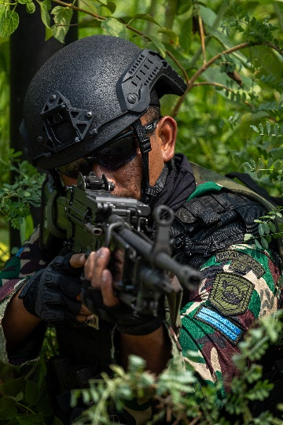**a. \_\_\_\_\_\_\_\_\_\_\_\_\_\_\_\_\_\_\_\_\_\_\_\_\_\_\_\_\_\_\_\_\_\_\_\_\_\_\_\_\_\_\_\_\_\_\_\_\_\_\_\_\_

I was in Tully as part of a **joint training exercise** with the Australian and Indonesian armies. Tully is in Queensland at the top of Australia. The training was to improve our jungle warfare skills. We learned about **going on patrol** in the jungle and many skills for jungle warfare.

b. \_\_\_\_\_\_\_\_\_\_\_\_\_\_\_\_\_\_\_\_\_\_\_\_\_\_\_\_\_\_\_\_\_\_\_\_\_\_\_\_\_\_\_\_\_\_\_\_\_\_\_\_\_

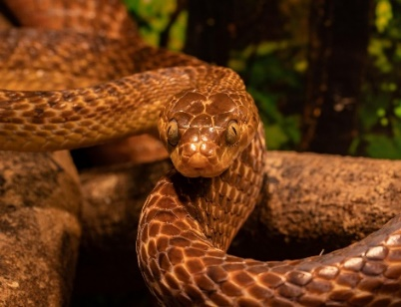A lot! Before we started, we listened to a **briefing** about some of the **natural hazards** at Tully. The Commanding Officer told us about things in the jungle in Tully we should be careful of. I was scared about the snakes! But the Australian officer said that they are more afraid of us. My favourite thing I learned was making **booby traps**. These are hard to see but can kill and hurt the enemy. We also learned that jungle warfareis different to other types of warfare. You are not just fighting the enemy but also dealing with the challenges of the **terrain**. It can be difficult to fight in the jungle. I learned a lot during the training.

c. \_\_\_\_\_\_\_\_\_\_\_\_\_\_\_\_\_\_\_\_\_\_\_\_\_\_\_\_\_\_\_\_\_\_\_\_\_\_\_\_\_\_\_\_

**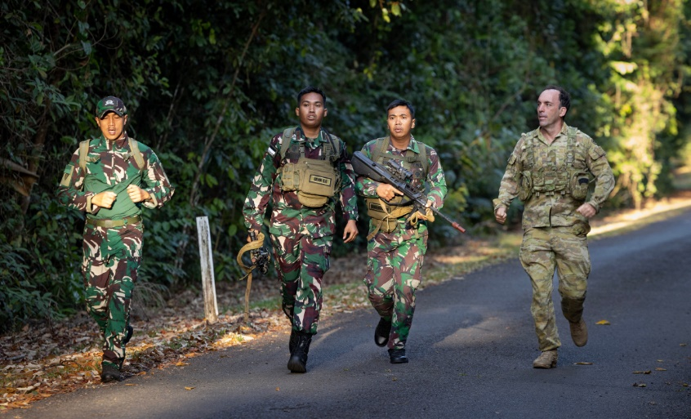**Some of the training was very hard! Even going on basic **manoeuvres** in the jungle can be challenging. All the trees mean that GPS often doesn’t work well, so you have to use a compass and maps a lot more. The thick jungle means that the enemy can easily surprise and **ambush** us, so **concealment** **A person with an object in the grass
**is important. We used foliage like leaves and trees to **camouflage** and hide ourselves. In one exercise, we had to **infiltrate** the enemy camp. This means we tried to get into their camp. It was hard and fun to practice **guerrilla warfare** and the special **tactics** we can use in the jungle. Sadly, one of the soldiers in my **platoon** hurt his leg on a rock under the leaves. The jungle can be very dangerous and challenging.

d. \_\_\_\_\_\_\_\_\_\_\_\_\_\_\_\_\_\_\_\_\_\_\_\_\_\_\_\_\_\_\_\_\_\_\_\_\_\_\_\_\_\_\_\_

The best part was working with the Australian soldiers. We are neighbours, so it is good to practice working together. The jungle is still an important part of our region. This means training to fight in the jungle is also very important. It was a very fun training exercise.

****

1. Listen and check your answers from exercise 4.
2. Read the article again. Find the answers to these questions in the text. Look at the example.

Tully, Queensland, Australia

1. Where was the training? \_\_\_\_\_\_\_\_\_\_\_\_\_\_\_\_\_\_\_\_\_\_\_\_\_\_\_\_\_\_\_\_\_\_\_\_\_\_\_\_\_\_\_\_\_\_\_\_\_\_\_\_\_\_\_\_\_\_\_\_\_\_
2. What animal was the soldier scared of at first? \_\_\_\_\_\_\_\_\_\_\_\_\_\_\_\_\_\_\_\_\_\_\_\_\_\_\_\_\_\_\_\_\_\_\_\_\_\_\_\_\_\_\_\_
3. What is different and difficult about jungle warfare? \_\_\_\_\_\_\_\_\_\_\_\_\_\_\_\_\_\_\_\_\_\_\_\_\_\_\_\_\_\_\_\_\_\_\_\_\_\_\_\_
4. What can stop GPS from working in the jungle? \_\_\_\_\_\_\_\_\_\_\_\_\_\_\_\_\_\_\_\_\_\_\_\_\_\_\_\_\_\_\_\_\_\_\_\_\_\_\_\_\_\_\_\_
5. How did they make themselves hard to see in the jungle? \_\_\_\_\_\_\_\_\_\_\_\_\_\_\_\_\_\_\_\_\_\_\_\_\_\_\_\_\_\_\_\_\_\_\_\_
6. Why is it important for Australians and Indonesians to work together? \_\_\_\_\_\_\_\_\_\_\_\_\_\_\_\_\_\_\_\_\_\_\_\_\_
7. Look at the words in **bold** in the reading. We will match them to their definitions next. First, look at them in the sentences and talk to your friends. Have you seen them before? What part of speech are the words? What do you think they mean?

**Learning Military Vocabulary**

1. The words in **bold** are important military vocabulary that you should learn. Match them to their definitions on the right. Look at the example and write the answers in the middle column.

|  |  |  |  |  |  |
| --- | --- | --- | --- | --- | --- |
| Table 1 |  |  | |  | |
| a **joint training exercise** with the Australian and Indonesian army | **f** |  | | 1. \\d85userdata.dpe.protected.mil.au\ma\marcos.pougy\Downloads\20241111army8616835_0187.jpg(n) a group of soldiers leaving a safe area to check for anything dangerous or to watch what is happening | |
| **going on patrol** in the jungle |  |  | | 1. (n) dangerous things in nature that can cause harm | |
| listened to a **briefing** |  |  | | 1. (n) physical features of an area of land such as hills, rivers, forests, and roads | |
| some of the **natural hazards** |  |  | | 1. (n) planned movements of soldiers or military vehicles | |
| making **booby traps** |  |  | | 1. (n) hidden objects or devices designed to hurt or kill someone unexpectedly | |
| challenges of the **terrain** |  |  | | 1. **(n) when personnel from different militaries learn together** | |
| going on basic **manoeuvres** |  |  | | 1. Preview image for asset(n) a short meeting where someone in charge tells a group of people important information about a job or task they need to do | |
| Table 2 |  | |  | |  |
| the enemy can easily surprise and **ambush** |  | |  | | 1. (n) a small group of approximately 30 soldiers (Australian Army). |
| **concealment** is important |  | |  | | 1. **A person with an object in the grass     AI-generated content may be incorrect.**(n) a way of making people or equipment look like their surroundings so they are harder to see |
| leaves and trees to **camouflage** |  | |  | | 1. (n) a type of fighting done by small groups who are not part of a regular army.They often use surprise attacks and hide in places like jungles or mountains to fight against a larger and stronger enemy. |
| to **infiltrate** the enemy camp |  | |  | | 1. (n) a surprise attack where soldiers hide and then suddenly attack an enemy that is passing by. The enemy does not see the attack coming. |
| to practice **guerrilla warfare** |  | |  | | 1. (n) small plans and ways that soldiers fight in a battle. It's how they try to win. |
| **tactics** we can use in the jungle |  | |  | | 1. (v) to secretly move into an enemy area or position without being seen |
| one of the soldiers in my **platoon** |  | |  | | 1. (n) when soldiers or equipment are hidden so that the enemy cannot see them |

****

1. Listen and check.

****

1. Now let’s practise saying the words. Listen and repeat.

## Practice

1. Complete the questions with new words from the box.

// ambush // platoon // natural hazards // briefing // tactics // conceal //

1. What \_\_\_\_\_\_\_\_\_\_\_\_\_\_\_\_\_\_\_\_\_\_\_\_\_\_\_\_\_\_\_\_\_\_do you have to be most careful of in jungle warfare?
2. What was the last \_\_\_\_\_\_\_\_\_\_\_\_\_\_\_\_\_\_\_\_ you went to? What important information did you hear?
3. What \_\_\_\_\_\_\_\_\_\_\_\_\_\_\_\_\_\_\_\_\_\_can soldiers use in the jungle?
4. How can a \_\_\_\_\_\_\_\_\_\_\_\_\_\_\_\_\_\_\_\_\_\_\_\_\_\_\_ work well together in the jungle?
5. How would you \_\_\_\_\_\_\_\_\_\_\_\_\_\_\_\_\_\_\_\_\_\_\_\_ your platoon’s position in the jungle?
6. What should soldiers do if their patrol is caught in an \_\_\_\_\_\_\_\_\_\_\_\_\_\_\_\_\_\_\_\_\_?
7. Discuss the questions above with your partner to practise the new words.
8. Stand up and walk around the room. Can you find a different person for each of the ten items?

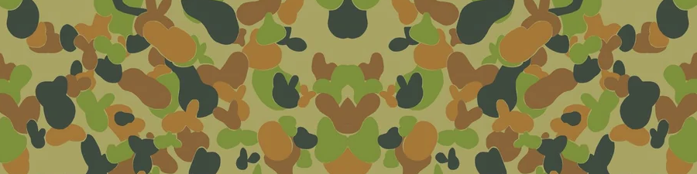

Find someone who…

…wants to go to Tully.

…is scared of snakes.

…has made a booby trap.

…wants to go on a joint training exercise.

…has been to a briefing this month.

…likes one of the same things about jungle warfare training as you.

…thinks jungle warfare training is challenging.

…like going on patrol in the jungle.

…thinks jungle warfare training is not too hard.

…has the same favourite terrain as you.



* Watch this video about joint training exercise with Japan and Australia. Type “[Cavalry comes to grips with jungle conditions](https://www.youtube.com/watch?v=1S0elibS7GI)” on YouTube or scan the QR code 🡪
* Imagine **you** are on this training. Make a list of things you enjoy and things you find challenging. Compare your list with your partner.

* For more [practice](https://quizlet.com/au/1030760578/jungle-warfare-training-reading-flash-cards/?i=578pkl&x=1qqt) with the words you’ve learned here, scan the QR code. 🡪
* This lesson links with 🡪 Vocabulary Builder – What’s in your webbing?

Vocabulary Builder – Parts of a Tactical Field Kit

Lesson – Jungle Warfare Training - Listening

© Commonwealth of Australia 2025  
This work is copyright. Apart from any use as permitted under the Copyright Act 1968 (Cth),   
no part may be reproduced by any process without prior written permission from the Department of Defence.