**Military English**

Lesson: Leadership – Inspiring Aussies – Uncle Reg – Listening



**Overview:** This lesson presents vocabulary related to being a good leader.

**In this lesson, you will:**

* practise listening for gist and specific information.
* learn and practise new vocabulary and expressions about leadership.

## Prepare for Listening

1. First, work by yourself. Think about some leaders you know. Look at the words in the box. Are they **qualities** of a good leader or a bad leader (or both!)?

speaks clearly // brave // selfish // fair // listens to ideas // angry // rude //   
strict // quick // kind // honest // dishonest // tries hard // funny

1. In pairs, discuss:
   1. What **qualities** does a good leader have? Why? Can you think of one more?
   2. What **qualities** does a bad leader have? Why? Can you think of one more?
   3. What **qualities** do bad and good leaders both have? Can you think of one more?
   4. “Everyone needs to be a leader.” Do you agree?

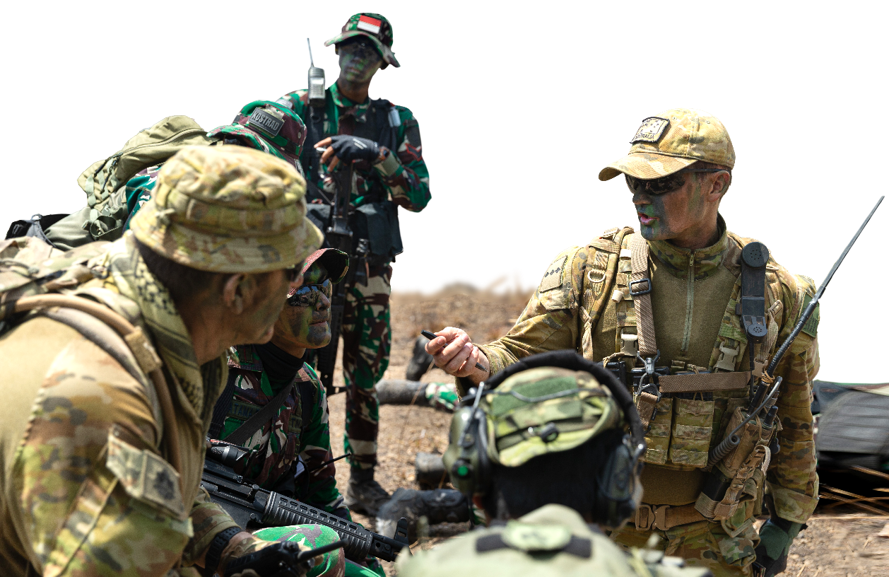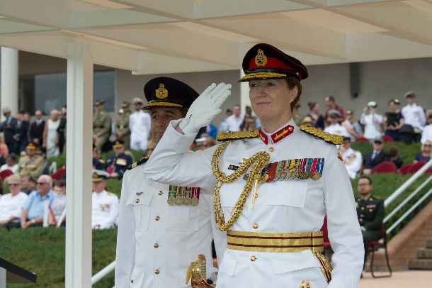

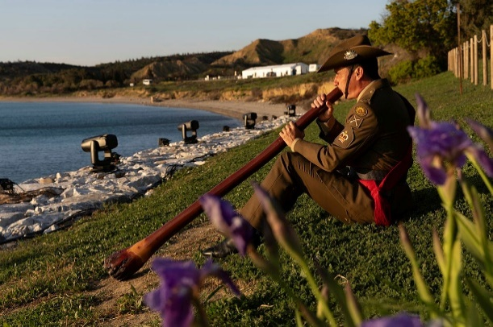

1. Here are some pictures from today’s Aussie leader, Uncle Reg. Can you find these words in the photos?

an aboriginal man // a bayonet charge // a platoon // the bush

1. What else can you see in the pictures? Why is Uncle Reg important? What do you think the listening is about?

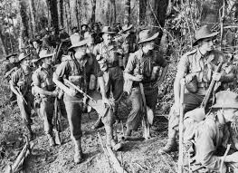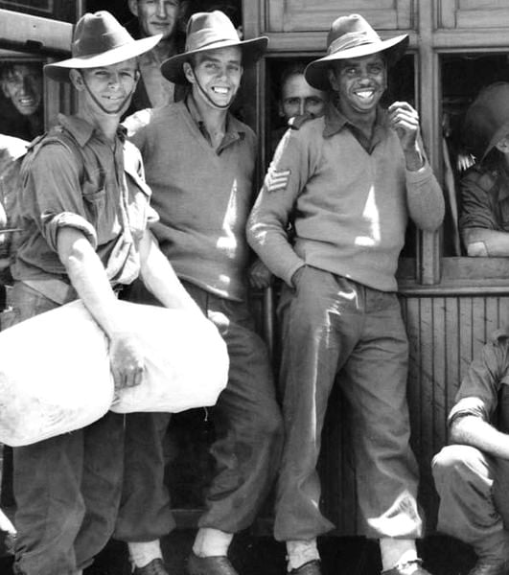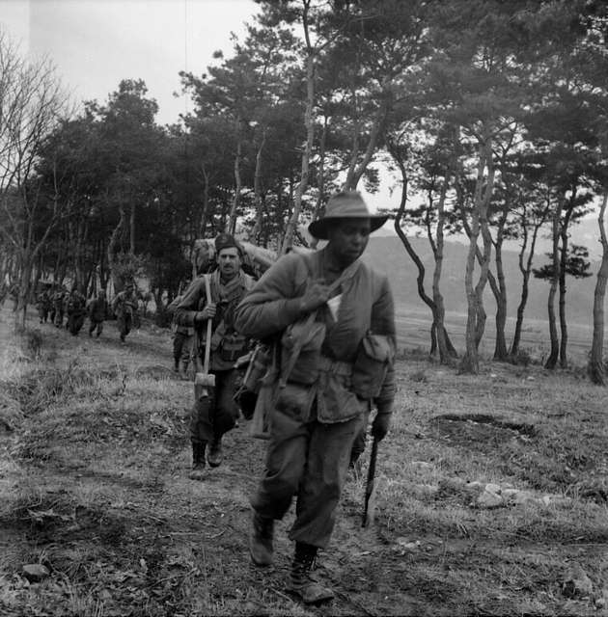

## A black background with a black square AI-generated content may be incorrect.Listening

1. Listen to the talk. How much can you understand? Were your guesses right?

1. Listen for detail. Complete with the word or number you hear.

1940

* 1. Uncle Reg joined the army in ____________________.

**Did you know?**

In Aboriginal culture, we call a man ‘uncle’ to show them respect.   
Do you do the same in your culture?

* 1. Uncle Reg’s ___________________ saw him trying hard. It made them try hard as well.
  2. Uncle Reg was part of a bayonet charge in Libya in _____________.
  3. He was left behind in Greece for _________ months.
  4. He fought in New Guinea in __________.
  5. Uncle Reg’s ___________________ loved him and loved serving under him.
  6. Uncle Reg showed Australia that __________________ is not important to be a good leader.

## Learning Military Vocabulary

1. The words listed in bold below are important vocabulary and expressions that you should learn to use. Match the vocabulary on the left with their definitions on the right. Look at the example.

|  |  |  |  |
| --- | --- | --- | --- |
| Table 1 |  |  |  |
| is very **inspiring** | **e** |  | 1. Preview image for asset (adj) not being scared in difficult situations | |
| the first aboriginal to become a **commissioned officer** |  |  | 1. (n) people who work together as a group | |
| Uncle Reg had many **qualities** |  |  | 1. (n) things about your personality e.g. kind, funny or brave | |
| His **team** saw him trying |  |  | 1. (n) a trained military leader who is given the rank and power to lead, command and make decisions by the government. | |
| Uncle Reg had so many **victories** |  |  | **e. (adj) to make someone feel they want to do something   and believe they can do it** | |
| Uncle Reg was **brave** |  |  | 1. (n) an important task or job you must do | |
| on a **mission** to Greece |  |  | 1. (v) to stop fighting and give yourself to the enemy | |
| he didn’t **surrender** |  |  | 1. Preview image for asset(n)when you win something | |
| Table 2 |  |  |  |
| He used the **resources** he did have |  |  | Preview image for asseti. (n) a place where armies fight | |
| knew how to **manage** his people |  |  | j. (n) being a good leader | |
| his team found this **battlefield** very hard |  |  | k. (v) to plan, use and organise things well such as time and money | |
| there weren’t enough **supplies** like food |  |  | l. (n) something that a country or person has that they can use | |
| He treated his **subordinates** well |  |  | m. (n) food or other things you need to live or do a job | |
| colour doesn’t matter in **leadership** |  |  | n. (n) the people a leader is  in charge of | |

1. Listen and check.

1. Now, let’s practise saying the words. Listen and repeat. Look at where the stress is underlined in words that have more than one syllable.
2. Complete the questions below with a word for the box. Then, ask and answer the questions with your partner about you.

team // bravest // battlefield // resources // commissioned // subordinates

* 1. What qualities does a leader need in their _________________? Do you have these qualities?
  2. Does a military leader need to be a _____________________ officer? Why or why not?
  3. What is the best __________________ you have ever been in? Why did you work so well together?
  4. In the ____________________ in New Guinea, many things were very difficult. What is more difficult for you: being hot, OR not having enough supplies? Why?
  5. What _____________________do you have to help you learn English? What is your favourite?
  6. Who is the ____________________ person you know? Why?

## Practice – Mini presentation

1. Think about a good leader you know. Make notes about them in the table. Try to use at least 3 new words from today!

|  |  |  |
| --- | --- | --- |
|  | A quality they have | How it helps them be a good leader |
| 1 |  |  |
| 2 |  |  |
| 3 |  |  |

1. Work with a partner. Tell your partner about your leader. They will listen and try to ask extra questions. Here is some useful language to help you.

2. The first quality they have is…

3. An example of this quality is …

1. A good leader I know is…

5. This makes their subordinates feel…

4. Another quality they have is…

6. The third quality they have is…

7. I think this quality helps them to…

8. Thanks for listening to my ideas about being a good leader. Do you have any questions?

## 

## You will watch a video about Uncle Reg. Type in YouTube [BushTV Untold Stories - REG SAUNDERS](https://www.youtube.com/watch?v=rVPqqP41Ikw) or scan the QR code. 🡪

Look at the order of events in Uncle Reg’s life. Order them 1-6. Look at the example. Then watch again and check.

|  |  |
| --- | --- |
|  | His ship sank. |
|  | He served as a captain in Korea. |
| 1 | He fought in North Africa and Greece. |
|  | He was left behind. |
|  | His brother died in New Guinea. |
|  | He graduated as an officer. |



## For more [practice](https://quizlet.com/au/1037679006/lesson-leadership-inspiring-aussies-uncle-reg-listening-flash-cards/) with the words you’ve learned here, scan the QR code for a set of Quizlet flashcards. You can do some more study on the vocab in this lesson on your own with these. 🡪

## This lesson links with 🡪 MilEng - Lesson – Leadership – Reading

© Commonwealth of Australia 2025   
This work is copyright. Apart from any use as permitted under the Copyright Act 1968 (Cth), no part may be reproduced by any process without prior written permission from the Department of Defence.