
Military English
Lesson: Studying at DITC – Listening

Overview: This lesson presents vocabulary related to studying abroad, specifically at the Defence International Training Centre (DITC).
In this lesson, you will:
- learn about being a student at DITC.
- practise listening for gist and specific information.
- learn and practise new vocabulary and expressions.

Prepare for Listening
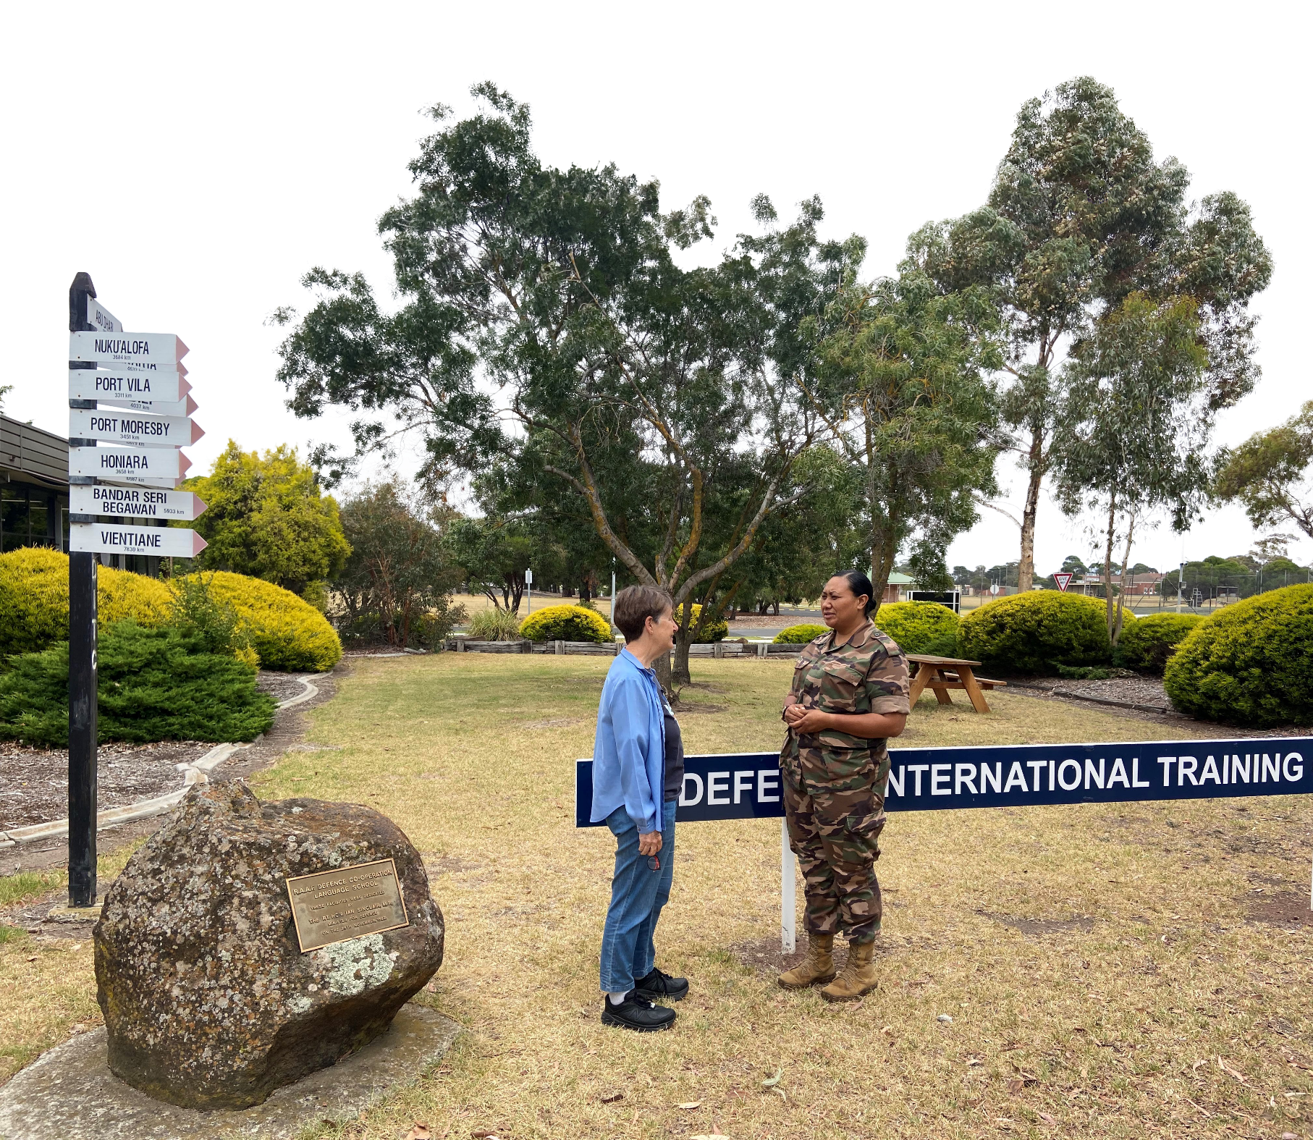
- Think about when you joined the military. In pairs, discuss:
a. Where did you first do your military training?
b. Describe your experience of basic military training.
- Was it hard or easy?
- How long was the basic training?
- When was it?
c. Do you know anyone from your country who has studied in another country?
d. What do you know about DITC? s


- Look at the pictures of things around DITC and use your guessing skills to match the pictures to the words. Then, listen and check.
gym // library // graduation ceremony // the mess // uniform // computer room

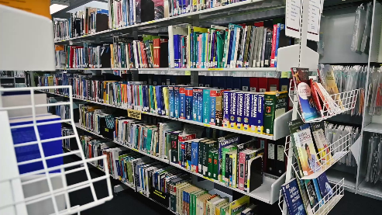
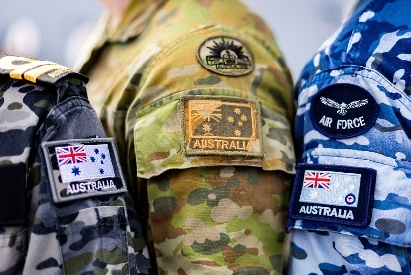

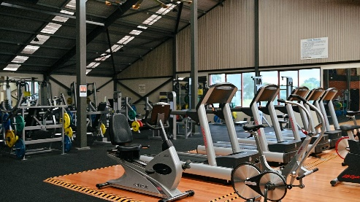

a. ______________________ b. _______________________ c. ________________________
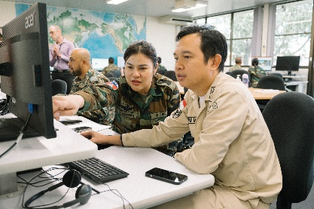
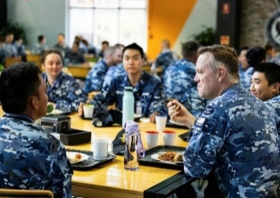
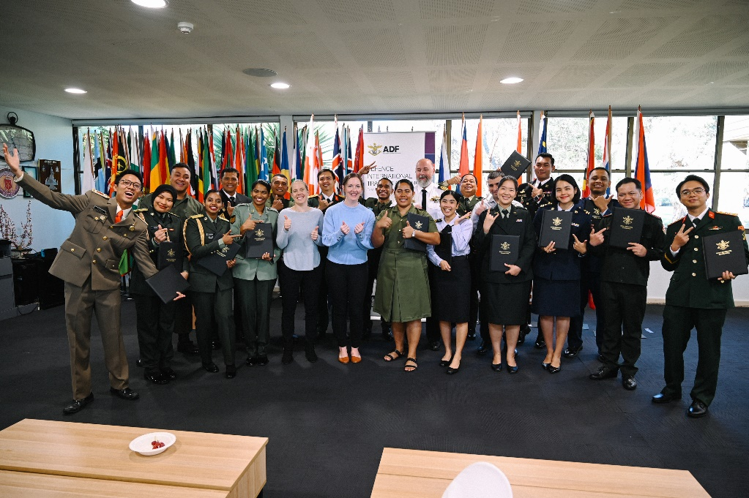

d. ______________________ e. _______________________ f. __________________________

- Look at the people in the picture on the first page and guess with your friend. Who are they? Where are they? What are they talking about?

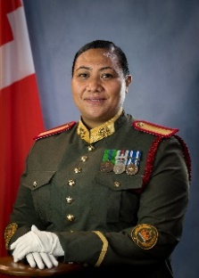

Listening
WO2 Lilamani Holi, from Tonga, has been a DITC student in AAELC, MELT, TPC and ARTC courses.
- Watch an interview with a DITC student. What is the main idea?
- Comparing studying in Australia with her country.
- Her experience as a student at DITC.
- Her experience as a teacher at DITC.
- The pros and cons of DITC.
- Watch again and decide if the following sentences are true or false. Write T or F in the space.
- WO2 Holi is from Tonga. _____
- Students work out how the base and Australian culture works independently. _____
- Classes go from 0800 to 1600. _____
- Students should make sure they only do independent study in the library. _____
- When they’re not studying, students are free to make their own plans. _____
- When it is time to graduate, the students work together to write speeches. _____
- WO2 Holi says her favourite thing about Australia is the food. _____

Learning Military Vocabulary
- The words listed in bold below are important vocabulary and expressions that you should learn to use. Match the vocabulary on the left with their definitions on the right. Look at the example.
Table 1
we go on a base tour | e |  | - (n) when 3 or more students work together
a lot of pair work |  |  | - (n) a social event; people cook food outside and eat together
celebrate with a barbecue |  |  | - (n) when two students work together
we also have independent study |  |  | - (n) study that you do on your own like homework
a lot of group work |  |  | e. (n) when a guide takes you around the base to show you the buildings
Table 2
with different cultures |  |  | - (n) military staff and DITC students live and sleep here
the Commons  or common room |  |  | - (n) exercise to keep strong and fit
we can do this in the accommodation block |  |  | - (n) you can sit, talk and relax here
use our allowance |  |  | - (n) special ways of thinking and acting for a group of people; for instance, Australians shake hands when they meet someone new
we do physical training |  |  | - (n) an amount of money for each DITC student to spend
- Listen and check.
- Now, let’s practise saying the words. Listen and repeat. Look at where the stress is underlined in words that have more than one syllable.

- Complete the questions below with a word for the box. Then, ask and answer the questions with your partner about you.
independent study // barbecue // physical training // uniform // allowance // gym

- What type of ____________________ do you prefer? Swimming or running?

- What’s your favourite kind of meat to eat at a _________________ ?

- Did you have to wear a ____________________ when you were at school? Did you like it?

- How many days a week do you go to the ___________________? Do you want to go more?

- Did you have an _____________________ when you were a kid? What did you spend it on?

- Do you ever do ________________________ when the teacher doesn’t ask? What things do you do?

Practice – Guessing game!
- Work in groups of three. One person will describe a picture. The other 2 people will try to be the first to guess. Use the useful language to help you play the game.
You can do physical training there.
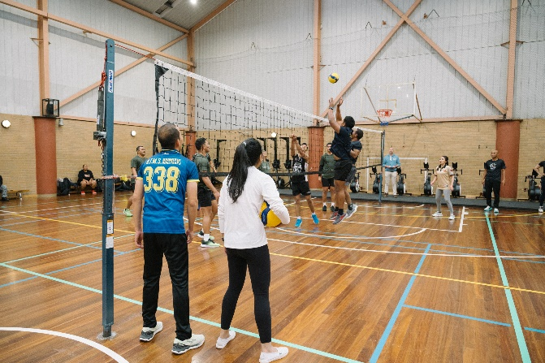
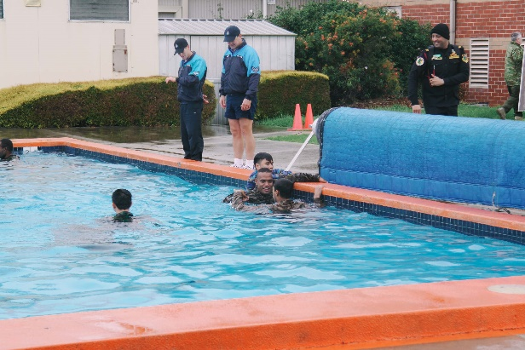

Is it the gym?

No. It’s dangerous if you can’t swim.
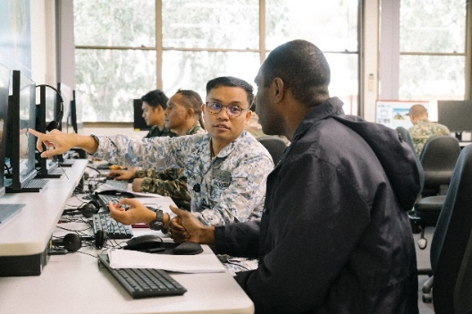

Is it the pool?
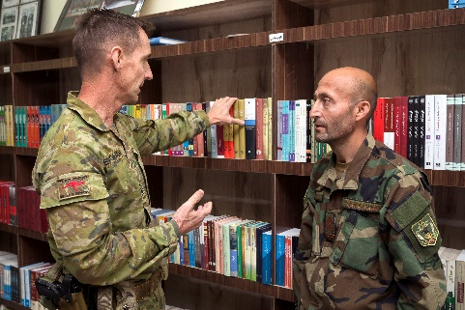

Correct! One point!

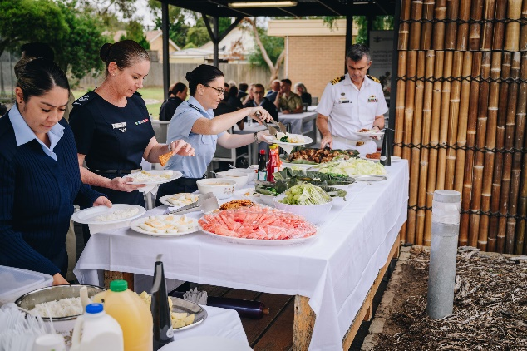

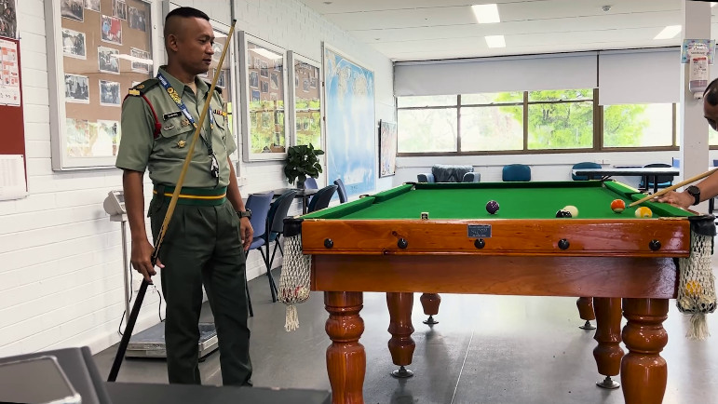

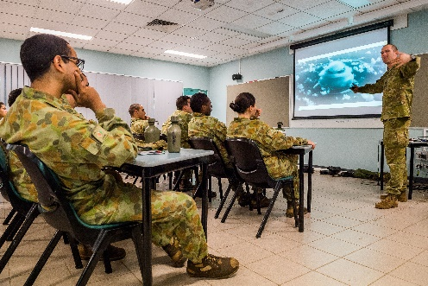

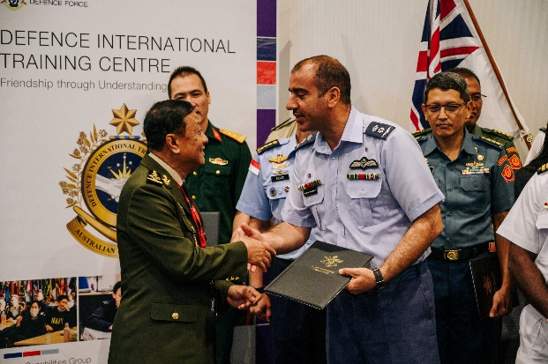
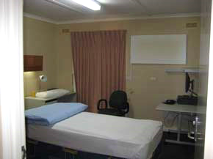

- In a group / in pairs, discuss the questions below.
- What do you think might be the best part of studying at DITC?
- What do you think might be the most difficult/challenging part of living and studying at DITC?
- What would you do in your free time if you studied at DITC?
- Your own ideas! (Try to use the vocabulary from today’s lesson about DITC).
Here is some useful language to help you.
I think the best part of studying at DITC might be …
But it might be difficult to ………

For me it might be ……..
What about you?



Watch a video about soldier training at Kapooka. Type on YouTube Soldier Training at Kapooka or scan the QR code.

Circle the words from today’s lesson that you see in the video.
uniform // barbeque // gym // allowance // group work // accommodation block


For more practice with the words you’ve learned here, scan the QR code for a set of Quizlet flashcards. You can do some more study on the vocab in this lesson on your own with these.

This lesson links with: Lesson – Studying Abroad – Reading
Lesson – Living on a Military Base – Listening
Vocabulary Builder – Facilities on an Army Base
Vocabulary Builder – Facilities on an Air Force Base
Vocabulary Builder – Facilities on a Navy Base

© Commonwealth of Australia 2025
This work is copyright. Apart from any use as permitted under the Copyright Act 1968 (Cth), no part may be reproduced by any process without prior written permission from the Department of Defence

