# 

**Military English**

Lesson: Disaster Relief – Changing Climate; Changing Defence Force – Reading

**Overview:**  
This lesson is about disaster relief and how the defence forces can help.

**In this lesson, you will:**

* read to identify opinions
* learn the meaning of new words.
* use new words

## Prepare for Reading

1. Look at the photos below and discuss with a partner:
2. What can you see in the pictures?
3. How many **natural disasters** can you see in the pictures?
4. There are more **natural disasters** now than in the past. Why do you think that is?

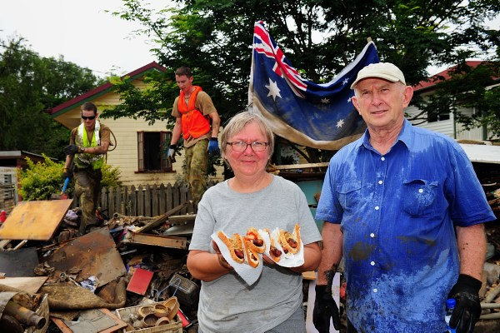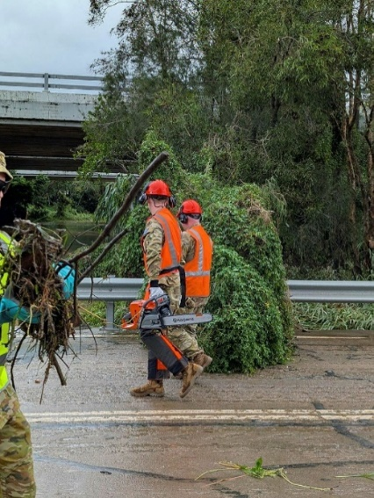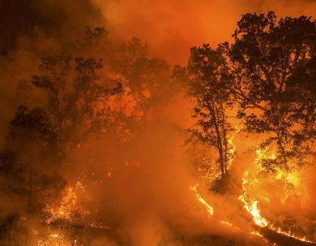

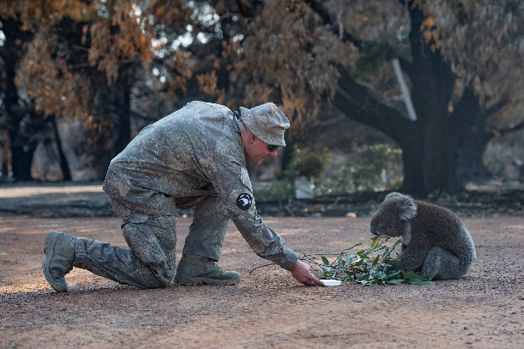

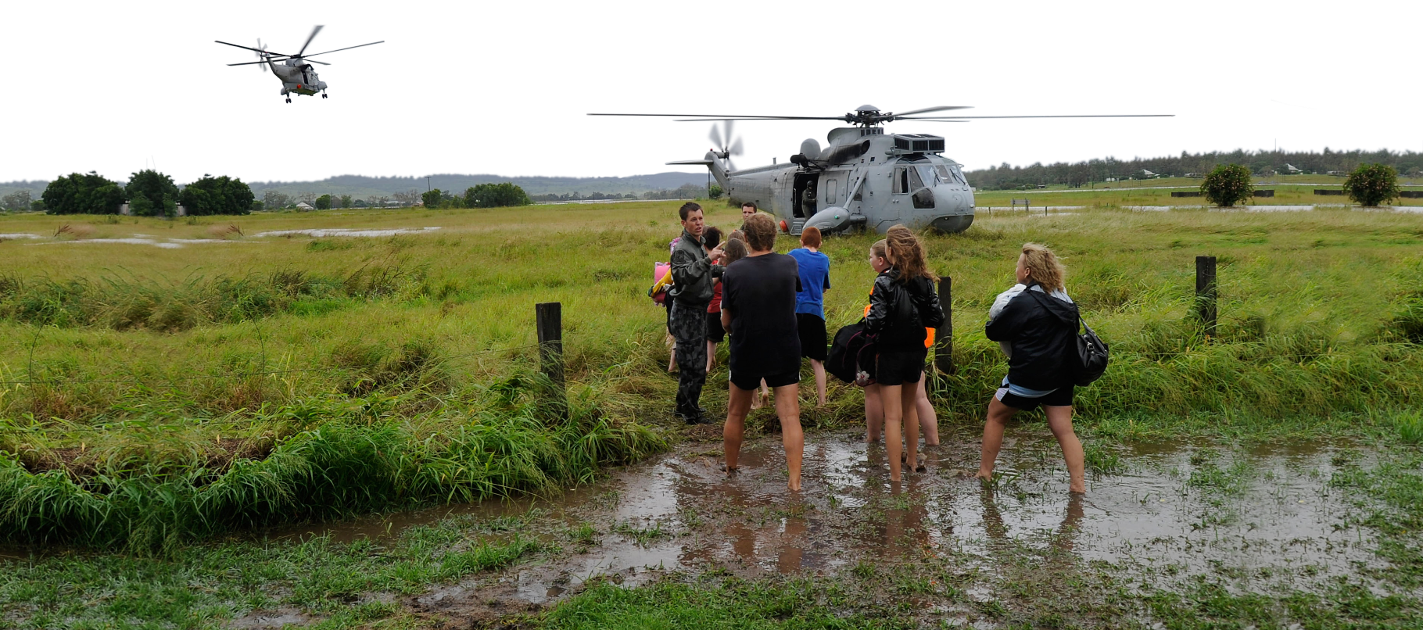

1. There are some words we need for today’s reading in the box. Match them with the pictures.

* Which pictures show people assisting other people? Write the letters here: \_\_\_\_\_\_\_\_\_\_\_\_\_\_

evacuate // climate change // airdrop // victim // sandbags // elderly

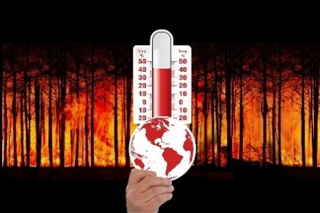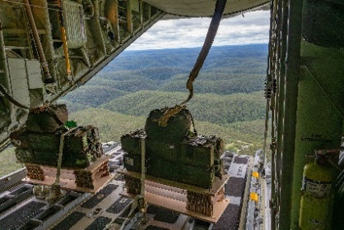

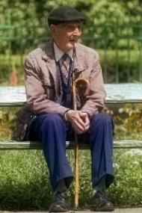

e. \_\_\_\_\_\_\_\_\_\_\_\_\_\_\_\_\_\_\_\_\_\_

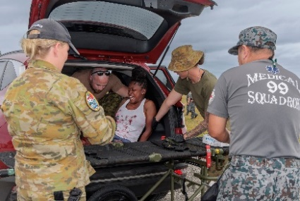

b. \_\_\_\_\_\_\_\_\_\_\_\_\_\_\_\_\_\_\_\_\_\_

a. \_\_\_\_\_\_\_\_\_\_\_\_\_\_\_\_\_\_\_\_\_\_

c. \_\_\_\_\_\_\_\_\_\_\_\_\_\_\_\_\_\_\_\_\_\_

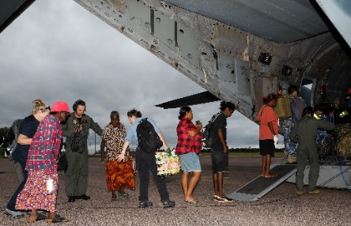

f. \_\_\_\_\_\_\_\_\_\_\_\_\_\_\_\_\_\_\_\_\_\_

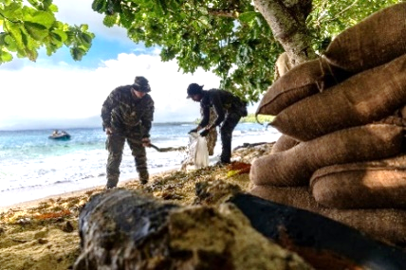

d. \_\_\_\_\_\_\_\_\_\_\_\_\_\_\_\_\_\_\_\_\_\_

****

1. Listen and check.

**Tip: When you see a new word in English, you can:**

* use the sentence to help you guess the meaning
* check with a friend or teacher if you need help

**Reading**

1. Read and listen to the article. What does the writer think?
2. The ADF shouldn’t help with natural disasters.
3. The ADF should only be used for wars.
4. The ADF should help more with natural disasters.

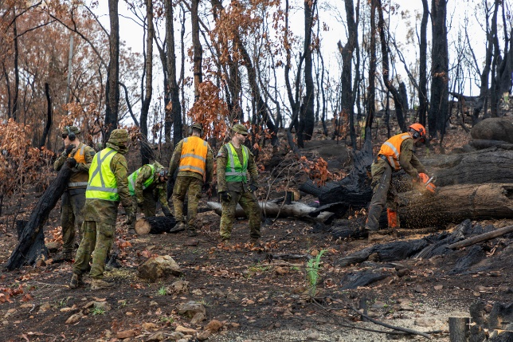Climate changeis very bad in Australia, and it is only going to get worse. This is because climate change will cause more **natural disasters**. For example, there will be more bushfires, floods and **droughts**. I think the Australian Defence Force (ADF) can assist more with these disasters in four main ways.

First, the ADF can get more people and buy more equipment to help. For example, they might need more planes. These can help put out burning **bushfires** or to **airdrop** supplies for victims. The ADF should make sure they have enough people to help as well. They might need more personnel as climate change gets worse.

Second, they can help before a natural disaster gets very bad. For example, when rivers start to rise, they can assist by making sandbags. Sandbags can help stop the water flooding towns as much. In addition, bushfires are a big problem in Australia and many people lose their homes and lives when the fires burn. The ADF can make **fire breaks** to stop bushfires from getting bigger.

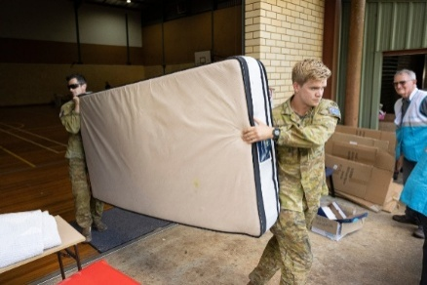Third, when disasters happen, the ADF can be **on standby** to **deploy** to the area to assist the **survivors** - the people who have lived through the disaster. For instance, in summer there are a lot of natural disasters, so the ADF should have personnel in Australia at this time of year. Sometimes, they might use planes to **airlift** important **disaster relief supplies**, like food and water, to people who need them. If a place is very dangerous, the ADF can also help to **evacuate** people to a safer place. For example, in operation Flood Assist in 2022, they helped more than 100 elderly Australians **stranded** by the **flood** waters. They couldn’t get away because the roads were under water. The ADF helped them get to safety.

Finally, the ADF can assist after a disaster. For example, they can help throw away rubbish and clean the streets after a flood. People need a lot of help after a natural disaster.

Some people think if the ADF spends too much time helping with **disaster relief**, there will not be enough personnel left to defend Australia if there is a war. But the ADF’s main job has always been keeping Australians safe. It is just that now the biggest threat to Australians is the changing climate.

As climate change gets worse, Australia will need the ADF to help more and more. In my opinion, the ADF are the best people to help Australia in natural disasters.

1. Read the article again. Decide if the writer agrees with these sentences. Write yes or no.
   1. Global warming is getting better in Australia. \_\_\_\_\_\_
   2. The ADF has enough people to help with natural disasters in the future. \_\_\_\_\_\_
   3. Personnel making sandbags can help reduce flooding. \_\_\_\_\_\_
   4. The ADF should be ready to act in summer. \_\_\_\_\_\_
   5. One way the ADF can help is giving people supplies they need to live. \_\_\_\_\_\_
   6. The older Australians couldn’t leave because they didn’t have a car. \_\_\_\_\_\_
   7. The biggest danger to Australia is war. \_\_\_\_\_\_
2. Discuss with your partner. Do you agree with the writer’s ideas? Why/not?

1. Look at the words in **bold** in the reading. We will match them to their definitions next. First, look at them in the sentences and talk to your friends. What part of speech are the words? What do you guess they mean?

**Learning military vocabulary**

1. The words in **bold** are important military vocabulary that you should learn. Match them to their definitions on the right. Look at the example and write the answers in the middle column.

|  |  |  |  |
| --- | --- | --- | --- |
| Table 1 |  |  |  |
| climate change will cause more **natural disasters** | **f** |  | 1. Free Dryness Drought photo and picture(n) when there is no rain for a long time - a big problem for farmers |
| bushfires, floods and **droughts** |  |  | 1. \\d85userdata.dpe.protected.mil.au\ma\marcos.pougy\Downloads\20230501raaf8660203_0022.jpg(n) to drop things like food, water, or medicine from an aircraft (like a helicopter or plane) down to the ground |
| put out burning **bushfires** |  |  | 1. (adj) waiting and prepared to act quickly |
| planes to **airdrop** supplies |  |  | 1. (v) to send people, like personnel or helpers, and equipment to a place where they are needed |
| **fire breaks** to stop bushfires | e |  | 1. \\d85userdata.dpe.protected.mil.au\ma\marcos.pougy\Downloads\20200114adf8616835_137.jpg(n) empty spaces in the land where there are no trees or grass; these spaces help to stop big fires from burning in new areas |
| the ADF can be **on standby** | c |  | 1. **(n) very bad events caused by nature that can hurt people and damage places e.g. big storms, floods, earthquakes, and bushfires** |
| **deploy** to the area | d |  | 1. \\d85userdata.dpe.protected.mil.au\ma\marcos.pougy\Downloads\20200212adf_214.jpg(n) big fires that happen in the countryside, in forests and grasslands; they can spread very quickly and be dangerous; in Australia, they often happen in the hot, dry summer |

|  |  |  |  |
| --- | --- | --- | --- |
| Table 2 |  |  |  |
| the **survivors** - the people who have lived through the disaster | k |  | 1. (n) helping people after a natural disaster |
| planes to **airlift** | n |  | 1. (n) things needed to help people after a natural disaster e.g. food and water |
| **disaster relief supplies**, like food and water | i |  | 1. (v) to be stuck in a place and unable to leave or get help |
| **evacuate** people to a safer place | m |  | 1. (n) people who have lived through a dangerous event, like a natural disaster |
| elderly Australians **stranded** | j |  | 1. Preview image for asset(n/v) when a lot of water covers land that is normally dry |
| **flood** waters | l |  | 1. \\d85userdata.dpe.protected.mil.au\ma\marcos.pougy\Downloads\20230302raaf8557649_0003.jpg(v) to move people away from a dangerous area |
| helping with **disaster relief** | h |  | 1. (v) to move people or things by aircraft, especially when it's urgent or when other ways of travel are not possible |

****

1. Listen and check.A black background with a black square

   AI-generated content may be incorrect.
2. Let’s practise saying the words. Listen and repeat.

**Practice**

1. Complete the questions with new words from the box.

disaster relief supplies // natural disaster // deploy // drought // evacuate // flood

1. What \_\_\_\_\_\_\_\_\_\_\_\_\_\_\_\_\_\_\_\_\_\_\_\_\_\_\_\_\_\_is the biggest problem in your country?
2. Do you think your armed forces should \_\_\_\_\_\_\_\_\_\_\_\_\_ personnel when there is a disaster?
3. Farmers have problems in a \_\_\_\_\_\_\_\_\_\_\_\_\_\_\_\_\_\_ because there is not enough food for the animals. What other problems can this cause?
4. In addition to food and water, what other \_\_\_\_\_\_\_\_\_\_\_\_\_\_\_\_\_\_\_\_\_\_\_\_\_\_\_\_\_ can be airlifted?
5. Some people don’t \_\_\_\_\_\_\_\_\_\_\_\_\_\_\_\_\_\_ when there is a natural disaster. Why is this?
6. What can you do if you are in your house and \_\_\_\_\_\_\_\_\_\_\_ waters are rising?
7. Discuss these questions with your partner to practise the new words.
8. You are part of a working group to think about ways your armed forces can help in times of natural disaster.

* Work in groups of 3-4.
* Choose one natural disaster that happens in your country.
* Discuss the following.

1. 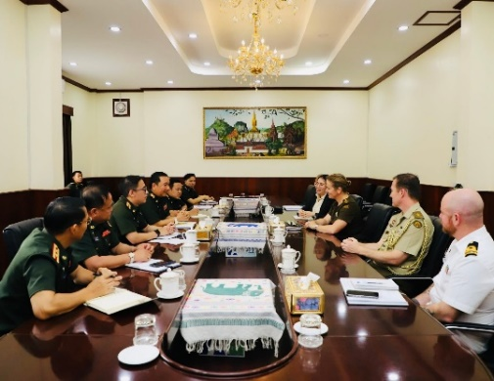Do your armed forces need more equipment or people for this?
2. How can the armed forces help before a problem gets very bad?
3. How can your armed forces help when the disaster is happening?
4. How can your armed forces help after the disaster?

When the disaster is happing,   
we can…

The armed forces can help before a disaster by…

The worst natural disaster   
in our country is…

We need more…

1. Share your ideas with the class.

* Watch this video about how the ADF helped in COVID. Circle the things the ADF did. Type on [ADF marks one-year milestone of Operation COVID-19 Assist](https://www.youtube.com/watch?v=DOwlKP2zkIw) or scan the QR code:

|  |  |
| --- | --- |
| Helped the elderly  Helped in schools  Border control  COVID testing | Kept people in their houses  Deployed 1,000 people  Made PPE |

Did your country’s armed forces help in COVID? What did they do?



* For more [practice](https://quizlet.com/au/1054950733/lesson-disaster-relief-changing-climate-changing-defence-force-reading-flash-cards/?new) with the words you’ve learned here, scan the QR code. 🡪
* This lesson links with 🡪 Vocabulary Builder – Natural Disasters;

Lesson – Disaster Relief – Listening.

© Commonwealth of Australia 2025  
This work is copyright. Apart from any use as permitted under the Copyright Act 1968 (Cth),   
no part may be reproduced by any process without prior written permission from the Department of Defence.