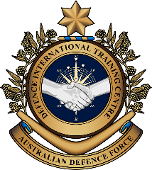
Military English
Vocabulary Builder – Parts of a Tactical Field Kit

Overview:
This worksheet lists vocabulary related to items in a tactical field kit.
In this lesson, you will:
- learn vocabulary for items in a tactical field kit
- practise using the vocabulary
- use the vocabulary in speaking activities

- Complete the description of a tactical field kit with words from the box.
strong // gear // out field // safe // water canteen // first aid kit

What is a tactical field kit?
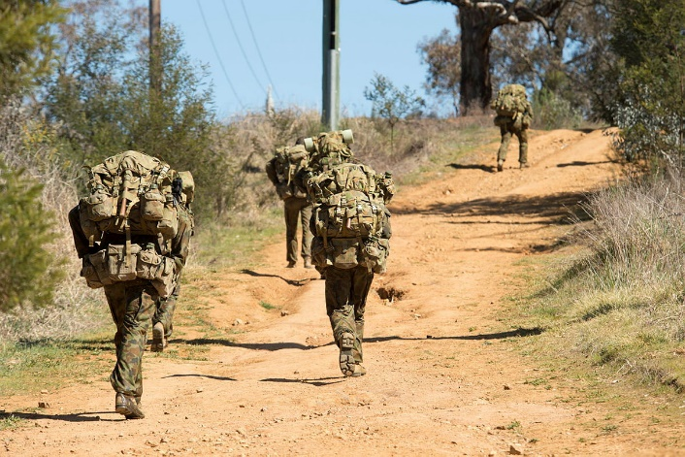
A tactical field kit has important things soldiers carry when they’re ^{a.}______________________. It has ^{b.}_______________ for different jobs. There might be a ^{c.}___________________________ for drinking, or a ^{d.}__________________________ for injuries. A tactical field kit needs to be ^{e.}_____________ and light. Soldiers use these kits to stay ^{f.}___________________ and complete their missions.

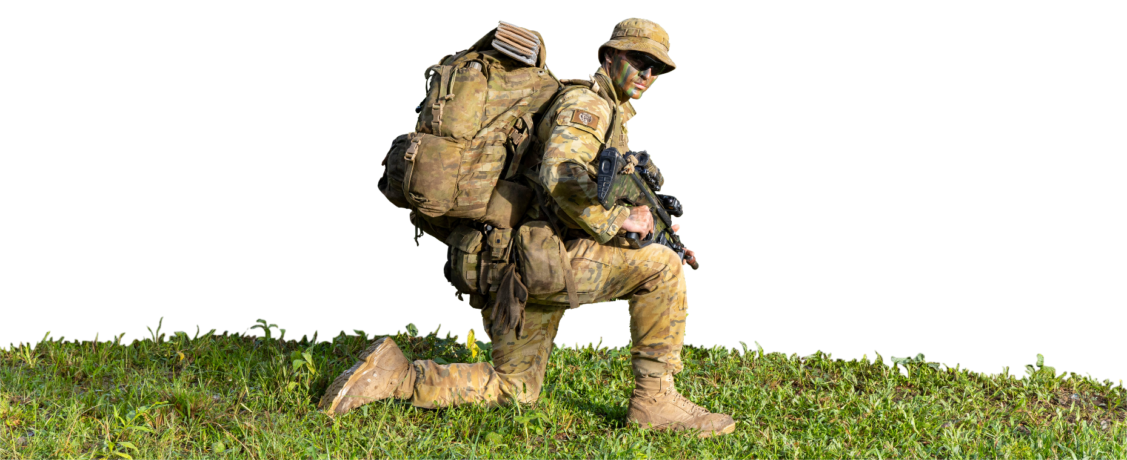

An Australian Army soldier carries his tactical field kit while on a patrol during Exercise Chapel Gold – Chiang Rai, Thailand.


- Listen and check.
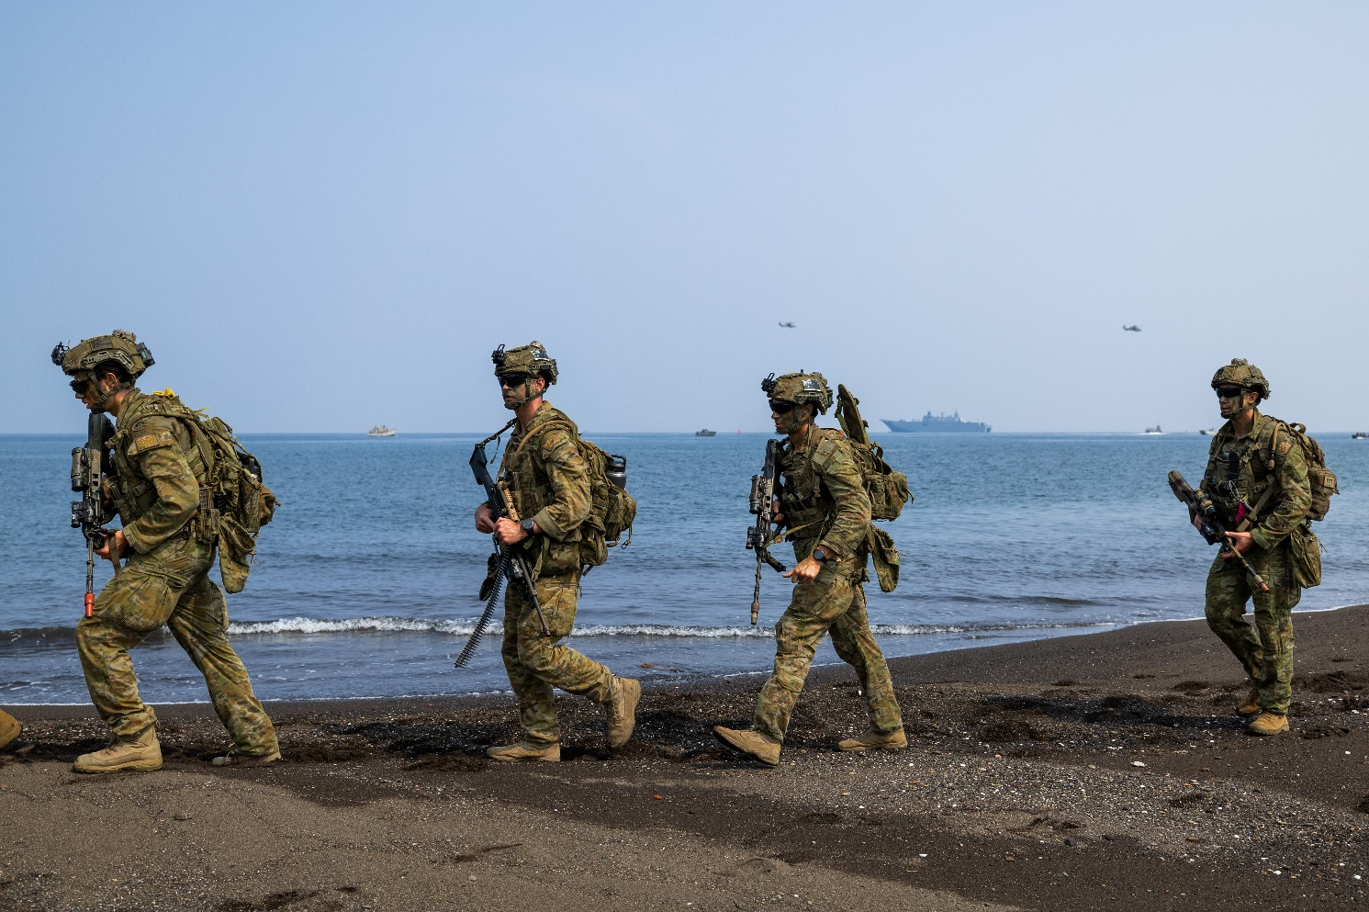
- Talk to your friends. Do you have a tactical field kit? What does it have in it?

- Look at the some of the items Australian soldiers often carry in their tactical field kits. Do you know their names in English? Try to match as many items as you can to the words in the box. Continues next page.
hearing protection // backpack // Camelbak // sleeping mat // GPS // ratpack // entrenching tool // Hootchie // combat gloves

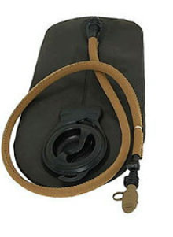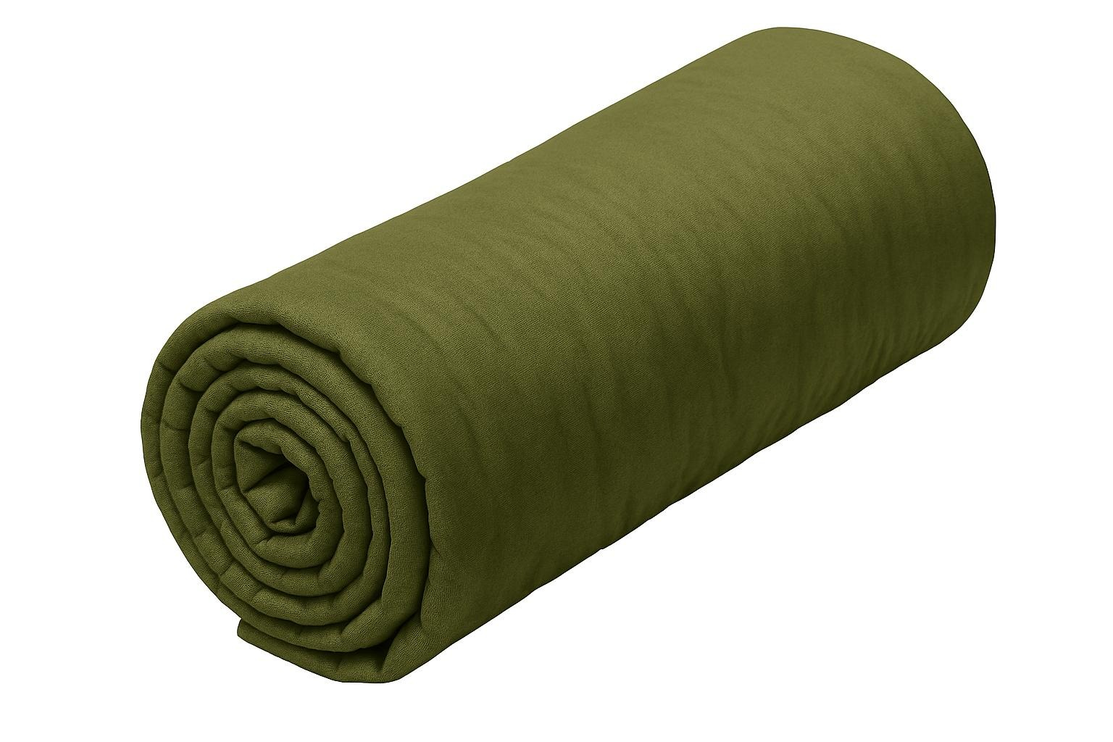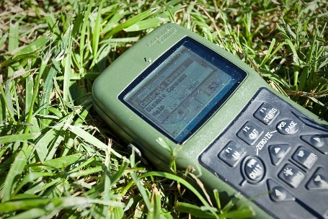
a. _________________ b. _________________ c. _________________
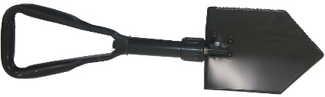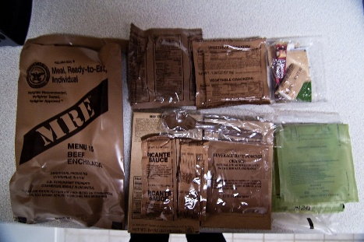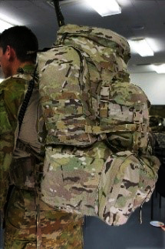
d. _____________________________ e. _______________________ f. ________________
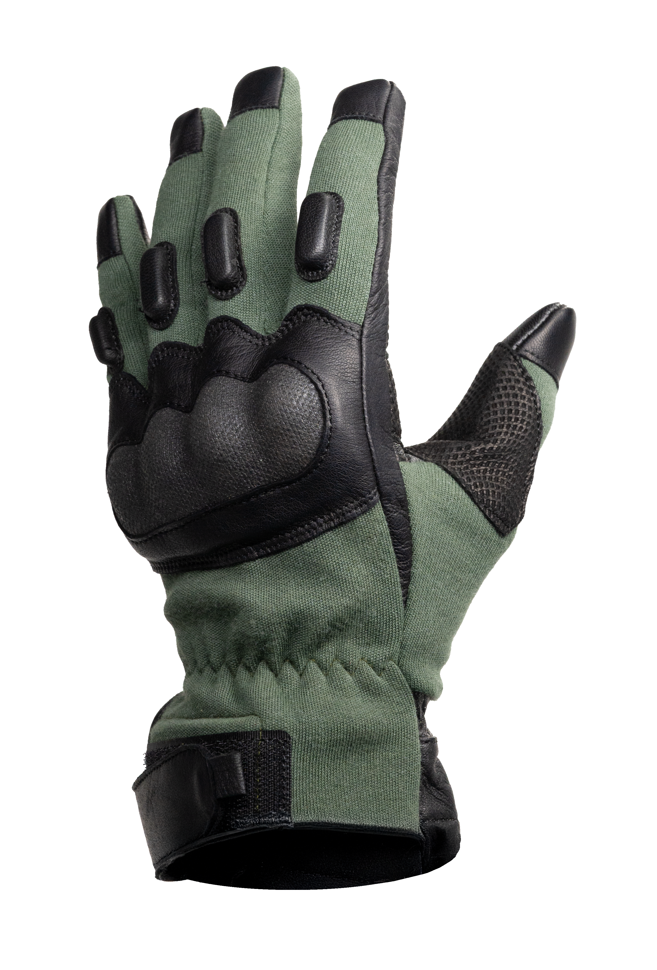
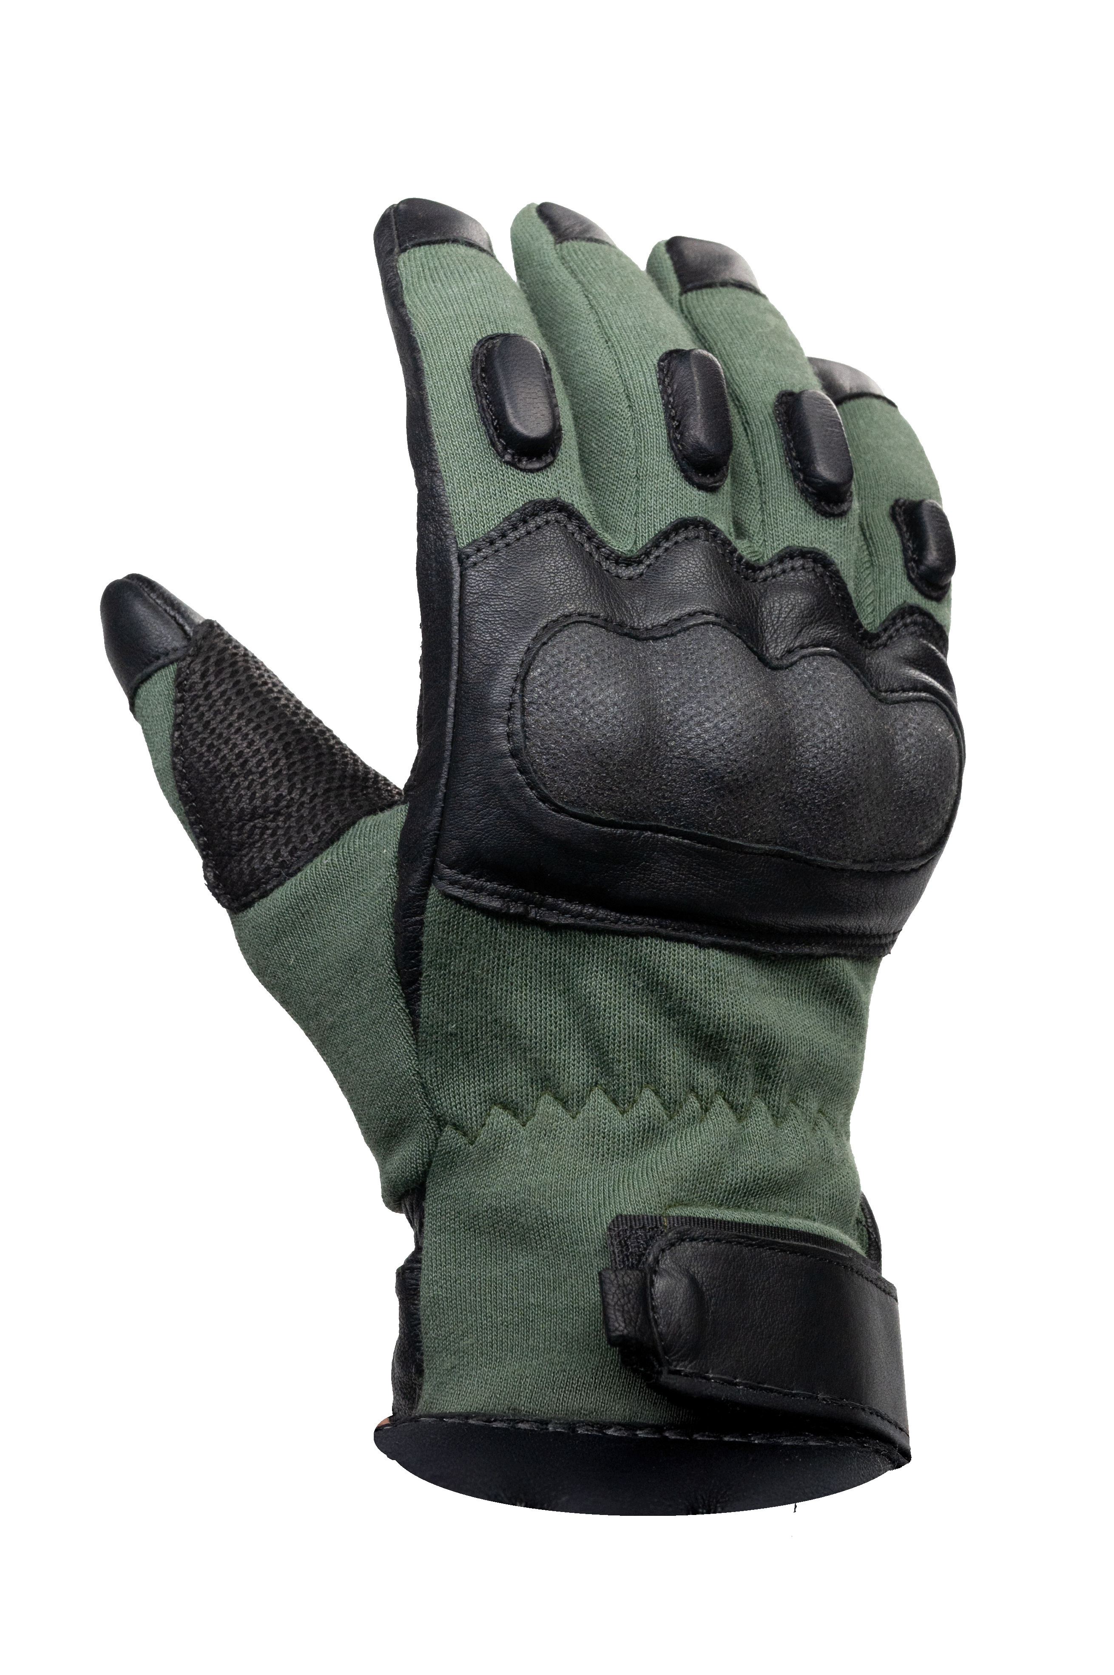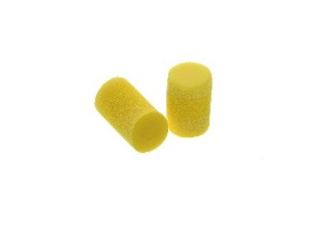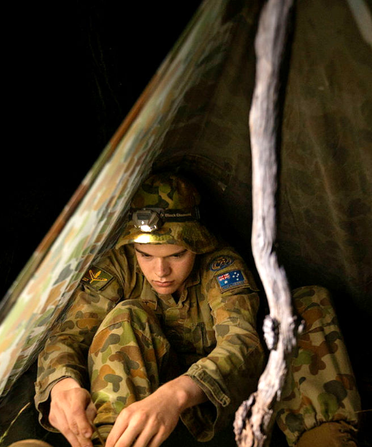
g. ________________________ h. _______________________ i. ______________________

multitool // ammunition // webbing // eye protection // raincoat
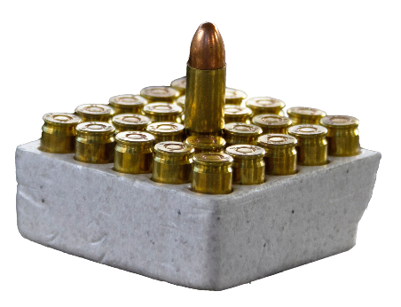
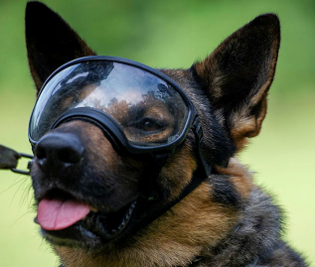

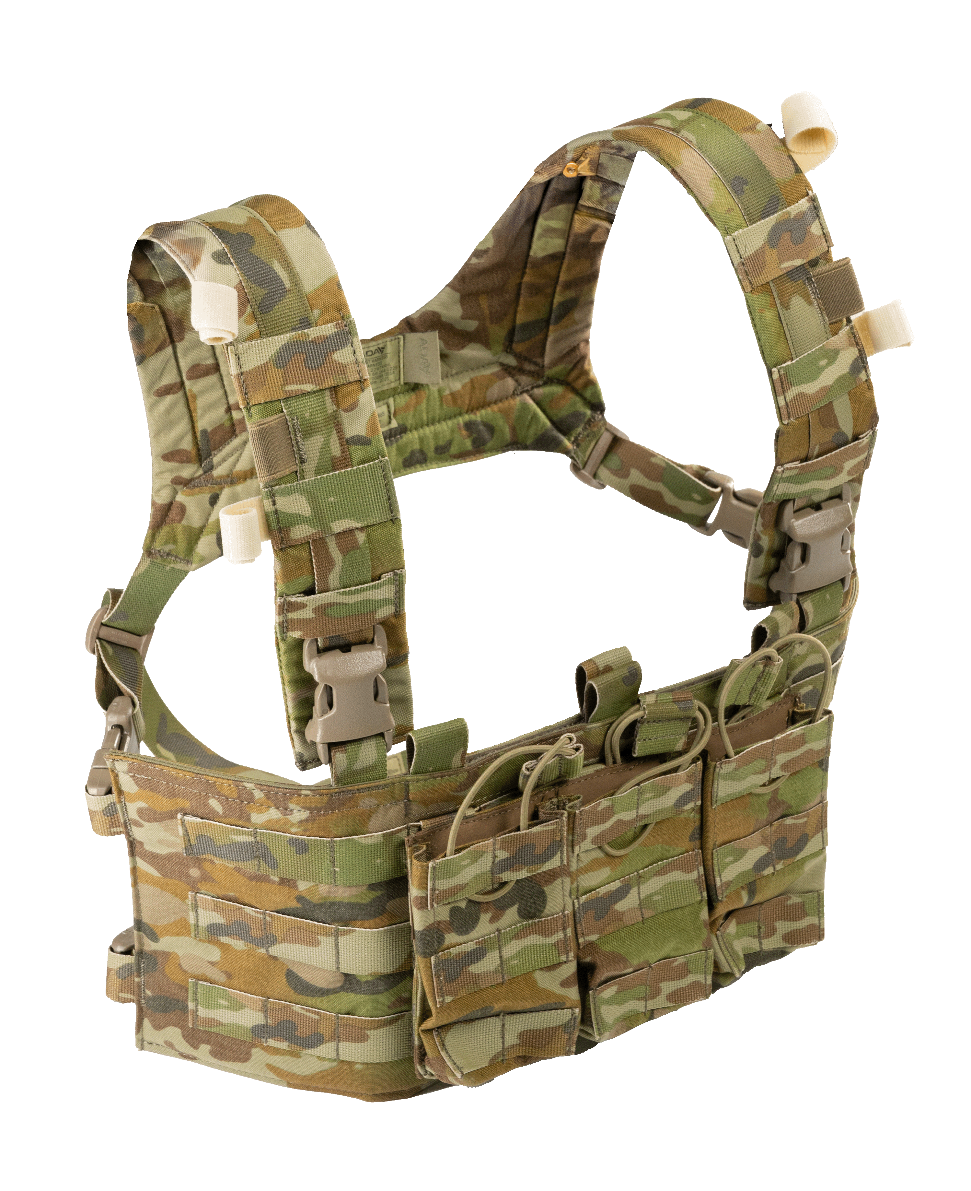
j. ________________________ k. _______________________

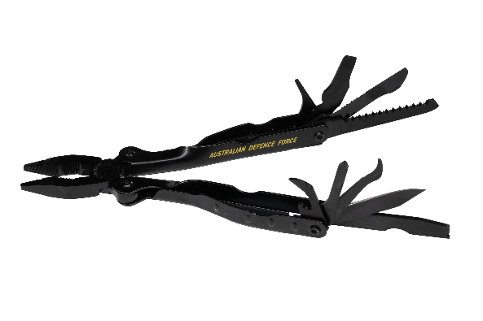
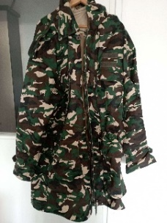
l. ______________________
m. ______________________

n. _____________________
- Listen, check and repeat.

- Look at the categories for tactical field kit items. Match the items to categories.
- How many more words can you add to each category?
Medical Supplies | Navigation and Communication | Tools and equipment | Personal Protective equipment (PPE) | Survival gear

- Speaking – Would you be okay?
Look at the example:
It’s time to make camp, but you have lost your hootchie!
I would use my rain jacket and some sticks to make a shelter.

Your turn! You are missing some of your kit! What could you do to survive in the situations in the boxes?
It’s time to sleep, but you have lost your sleeping mat.
You need to find north, but the GPS is broken.
You are hungry but you have lost your ration pack.

You need to make a fire, but you don’t have any matches.
It’s time to move but there is a big hole in the bottom of your backpack.
Someone has broken their arm, but the first aid kit is missing.

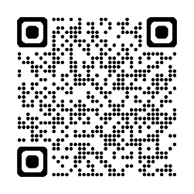
- Writing race! Scan the QR code and watch the video “My most expensive loadout”. How many things do you know the English word for? Write as many as you can with your partner. Which pair can get the most in the class?

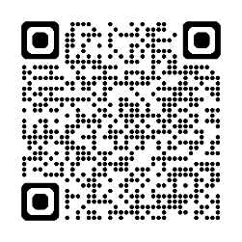
- For more practice with the words you’ve learned here, scan the QR code for a set of flashcards. You can do some more study on the vocab in this lesson on your own with these.

- This Vocabulary Builder links with: Lesson – What’s in Your Webbing (Listening)
Lesson – Jungle Warfare Training (Listening)
Lesson – Out Field (Listening)
Lesson – A Job in the Army – Infantry Soldier (Reading)
© Commonwealth of Australia 2025
This work is copyright. Apart from any use as permitted under the Copyright Act 1968 (Cth),
no part may be reproduced by any process without prior written permission from the Department of Defence.

