**Military English**

Lesson: Drones – The Future of Warfare? – Reading



**Overview:**  
This lesson covers a new and interesting type of drone and the future of warfare.

**In this lesson, you will:**

* read a text for main ideas
* find specific information in a text
* learn the meaning of new words.
* practice talking about drones and the future of warfare
* use new words in a conversation.

## Prepare for Reading

1. Look at the photos of the **Corvo PPDS (Precision Payload Delivery System)** **drone.**

How is it similar and different to other drones you know?

What do you think this drone can do?

Why do you think they are special?

Do you know this drone?

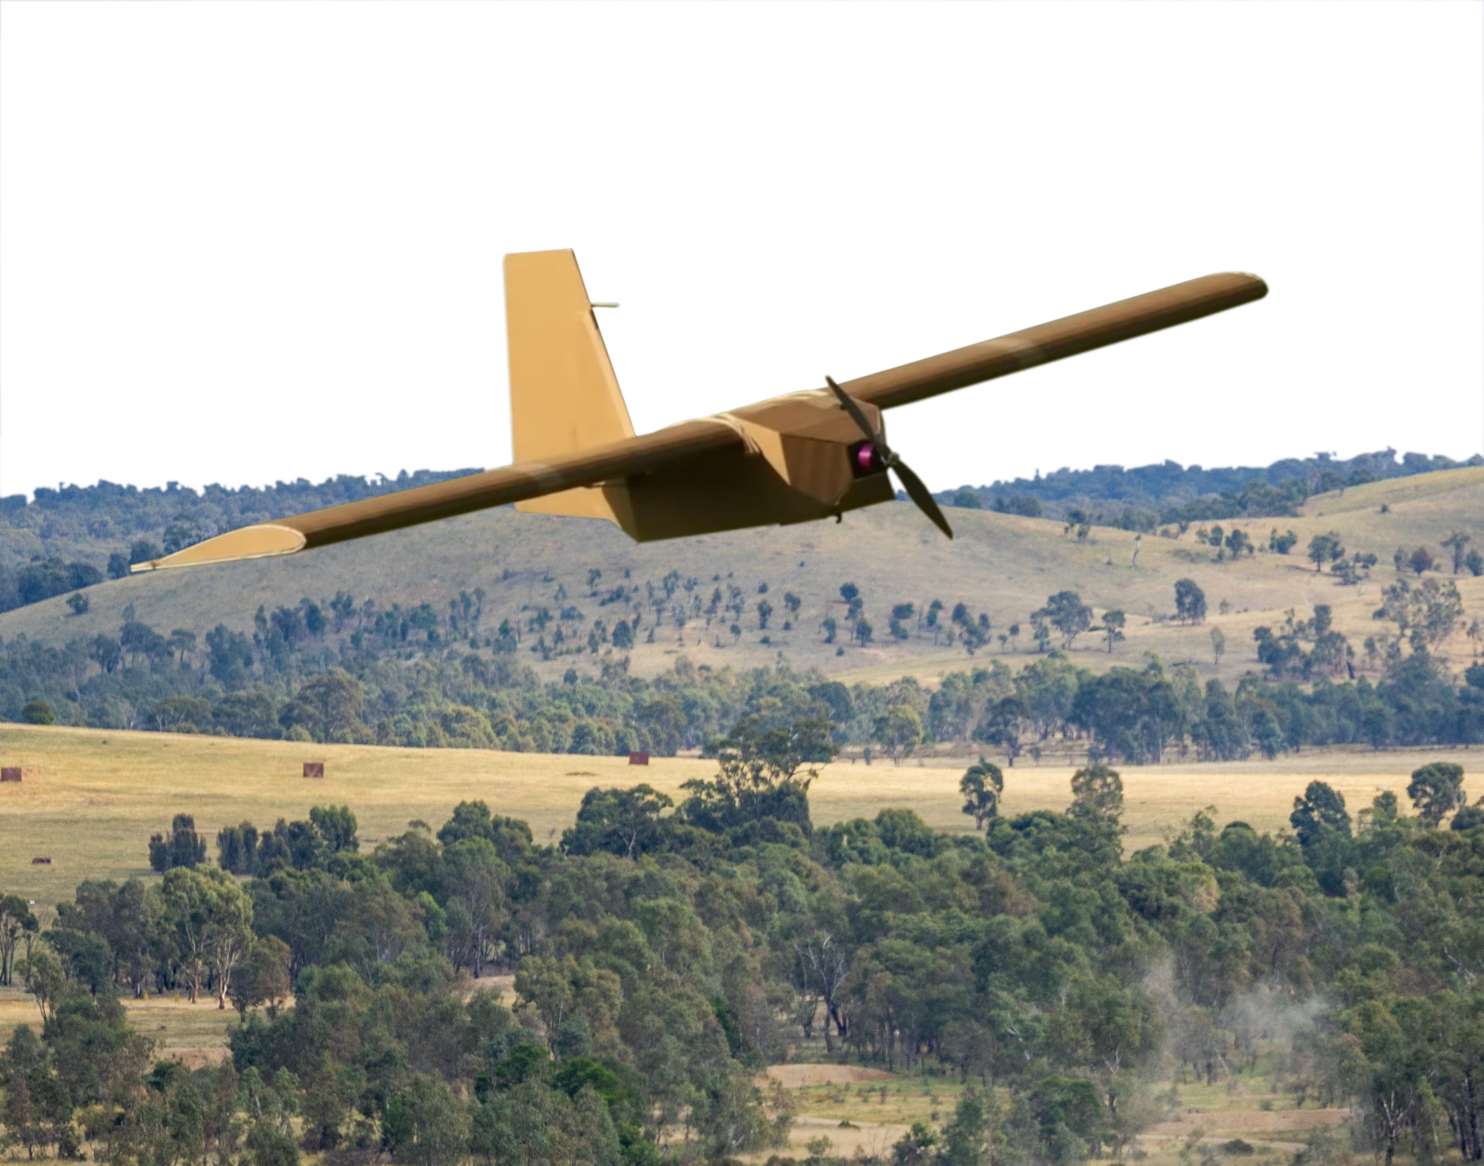

1. Here are some words we need for today’s reading. Match them with the pictures.

transport // rubber bands // injury // cardboard // wax // radar //   
sticky tape // metal // medicine

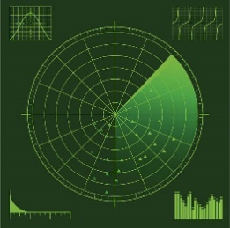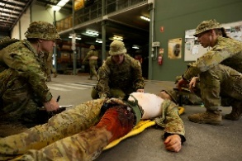



a. ___________________

c. _______________________

b. _________________





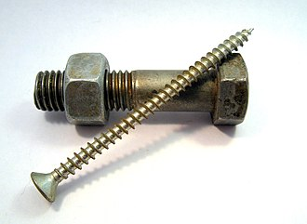

d. __________________

e. _____________

f. __________________________

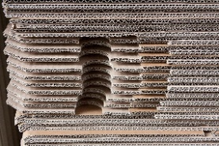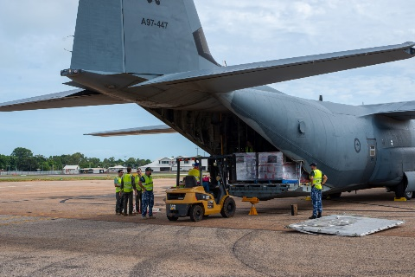

g. _____________________

h. _____________________

i. _____________________

1. Listen, check and repeat.

## A black background with a black square AI-generated content may be incorrect.Reading

1. Read an article about a new military drone on the next page. Match the headings to the paragraph.   
   Look at the example. Then, listen and check.

**Reading tip:**

When we match headings, we are not looking for key words, but **main ideas**. The best way to do this question type is to read the paragraph, think about the main idea, and then match that to one of the choices.

~~Introducing the Corvo PPDS!~~

The future of war?

Easy to move & cheap to make

The future of war

Look! No hands!

How the drone is used in Ukraine

Introducing the Corvo PPDS!

__________________________________________________________

It might look like a toy **aircraft**, but many people think this **drone** is the future of war. The Corvo PPDS is made by an Australian company. The Australian Army has been sending 100 of these drones to Ukraine a month since March 2023.

__________________________________________________________

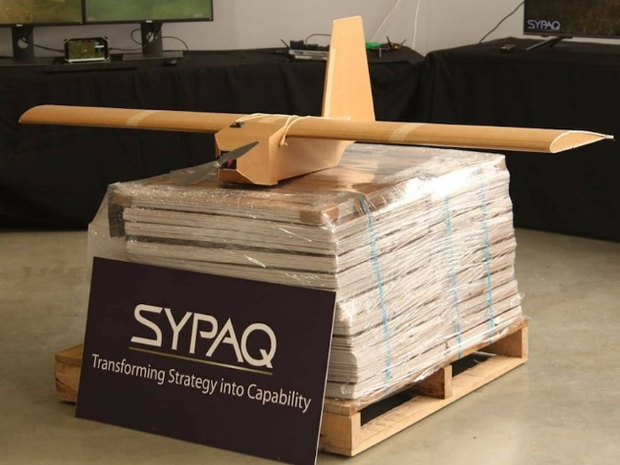The most interesting thing is that it is made out of cardboard, sticky tape, and rubber bands! There are many benefits to this. First, it is easy to transport. Australia sends it to Ukraine in flat pack packages, and Ukrainian soldiers put them together with glue. Second, this makes the drones very cheap. They can cost as little as $3500. Another big benefit is that they are hard for the enemy to see. Because they are made of cardboard, **radars** find it hard to see Corvo PPDS drones. The radars can only “see” the metal parts of the drone, but these are very small.

__________________________________________________________

The drone can fly **autonomously**, which means that it doesn’t need a **drone operator**. Soldiers use a **GPS** to tell the drone where to go. Then, it flies by itself. This is important. It stops soldiers getting tired and gives them time to do other things.

__________________________________________________________

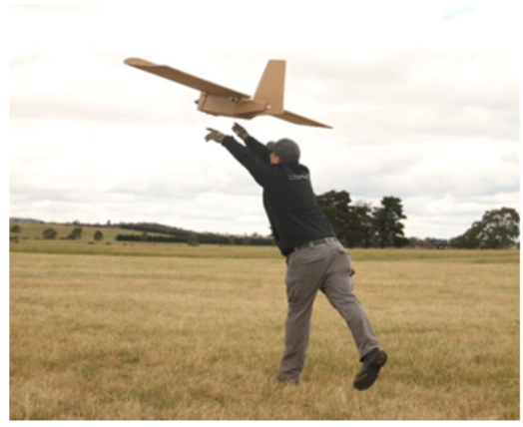SYPAQ, the company that makes the drones, say they first made the drones to get bags of blood to help injured soldiers. However, the drone is being used in Ukraine in many ways. First, it can carry lots of types of **payloads** – not just blood. For instance, it can take important things like medicine, food, and ammunition to soldiers in dangerous places. This is safer than sending trucks or **ground troops**. Second, the Corvo can be used for **reconnaissance** and **surveillance**. Ukrainian soldiers can put a **high**-**resolution camera** like a GoPro on it. The drone can then fly over an area and take pictures and videos. This helps soldiers see the **battlespace** without getting hurt. Because they cannot be seen by radars, they are good at **drone strikes**. Recently, a **swarm** of Corvo PPDSdrones destroyed $100 million USD of aircraft! Not bad for drones that only cost $3500!

__________________________________________________________

Many people are watching the war in Ukraine very closely. They think this will help them to understand the future of war. At the moment, it seems that drones will be an important part of that future.

1. Read the article again. Complete the sentences with one word or a number from the text.
2. The Ukraine army gets ____________ of these drones from the Australian Armed Forces per month.
3. The ____________________ parts of the drone are invisible to radar.
4. Soldiers have time for other tasks because the _________________ can fly by themselves.
5. Using the drones to deliver goods makes life _________________ for trucks and ground troops.
6. Sticking a camera on the Corvo PPSS helps soldiers see the _______________________ safely.
7. Wars will probably have more drones in the ____________________.

**Tip: When you see a new word in English, you can:**

* ask a classmate.
* use an English-English dictionary.
* use the sentence to help you guess the meaning.

1. Look at the words in **bold** in the reading. We will match them to their definitions next. First, look at them in the sentences and talk to your friends. Do you know any of them? Have you ever heard or read these words before?

What part of speech are the words? What do you guess they mean?

**Learning military vocabulary**

1. The words in **bold** are important military vocabulary that you should learn. Match them to their definitions on the right. Look at the example and write the answers in the middle column.

|  |  |  |  |  |  |
| --- | --- | --- | --- | --- | --- |
| Table 1 |  |  | |  | |
| like a toy **aircraft** | **f** |  | | 1. (n) the things an aircraft, like a drone, carries e.g. supplies, cameras, or weapons | |
| this **drone** is the future |  |  | | 1. **Preview image for asset**(n) systems that use radio waves to find things like planes or ships; they send out radio waves, and if these waves hit something, they bounce back - this is how the radar “sees” | |
| **radars** find it hard to see |  |  | | 1. (n) “Global Positioning System”; a system that uses satellites to find the exact location of things on Earth; soldiers and drones use this to know where they are and to find their way | |
| The drone can fly **autonomously** |  |  | | 1. H:\My Documents\Mil Eng\Lessons\L - Military Drones - Reading\cover.png(n) an aircraft that flies without a pilot inside; it comes in many sizes; it is usually controlled from the ground using a remote control | |
| it doesn’t need a **drone operator** |  |  | | 1. (n) a person who controls a drone from the ground; they use a special device to tell the drone where to go and what to do | |
| Soldiers use a **GPS** |  |  | | 1. **(n) a machine that can fly in the air e.g. planes, helicopters, and drones** | |
| it can carry lots of types of **payloads** |  |  | | 1. (adv) when something does something by itself without a person controlling it | |
| Table 2 |  | |  | |  | |
| safer than sending trucks or **ground troops** |  | |  | | 1. Free Drones in Formation Image | Download at StockCake(n) a large group of drones flying together at the same time; they often work together to do a task, like watching a large area or attacking a target from many directions | |
| can be used for **reconnaissance** |  | |  | | 1. (n) watching an area or people carefully over time | |
| reconnaissanceand **surveillance** |  | |  | | 1. (n) the area where a battle or fighting is happening or could happen; it includes the land, air, and even space where military activities take place | |
| a **high**-**resolution camera** like a GoPro |  | |  | | 1. Preview image for asset(n) personnel who fight on the ground; they move by walking or using vehicles on land, not in the air or on water | |
| see the **battlespace** |  | |  | | 1. (n) attacks by drones carrying missiles or bombs | |
| they are good at **drone strikes** |  | |  | | 1. (n) this can take photos with a lot of detail | |
| a **swarm** of Corvo PPDS |  | |  | | 1. (n) finding out information about an enemy or an area | |

1. Listen and check.

1. Now let’s practise saying the words. Listen and repeat.

## Practice

1. Using new words. Complete the questions with new words from the box.

GPS // high-resolution camera// autonomously // payloads // ground troops // drone

1. Has your unit ever used a _____________________________like a GoPro? What for?
2. These drones can fly ___________________. Is this positive or negative?
3. The drone in today’s lesson can carry ____________________ up to 5 kg. What things could be useful to send to soldiers in the battlespace?
4. Have you ever flown a ___________________? Would you like to be a drone operator in the future?
5. How can _____________________ use drones to help them plan what to do?
6. Will _________________ replace maps in the future? What do you prefer if you are out field? Why?
7. Discuss these questions with your partner to practice the new words.
8. Preparing to speak. Write down 5 ideas you have about what war might be like 30 years in the future. Use words from today’s lesson.

1. __________________________________________________________________________________

2. __________________________________________________________________________________

3. __________________________________________________________________________________

4. __________________________________________________________________________________

5. __________________________________________________________________________________

**Speaking**

1. Stand up and walk around the room. Can you find at least one person who agrees with your predictions?

I haven’t thought of that before. I’m not so sure.

I completely agree with you!

I’m not sure I agree with that at all.



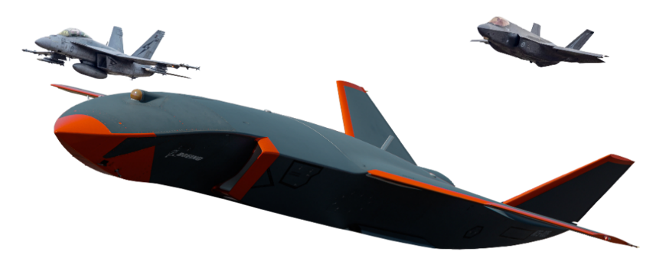



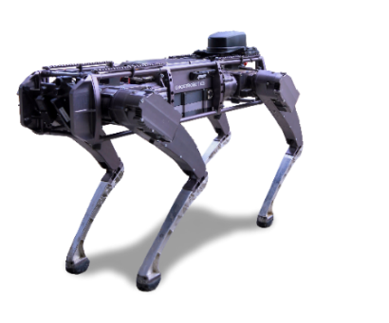

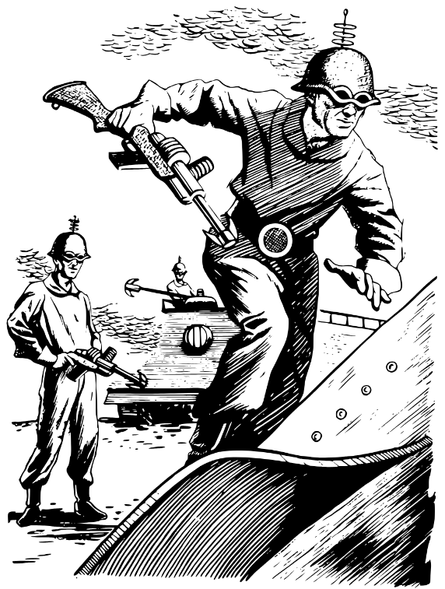

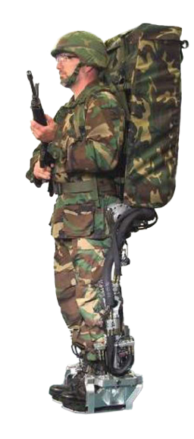

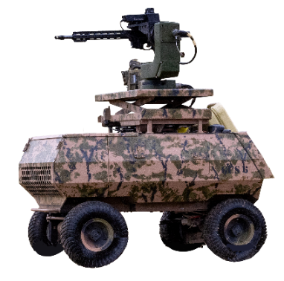



* Watch this video about the drone in today’s reading. Type “[Aussie company SYPAQ develops cardboard drones for defence if Ukraine](https://www.youtube.com/watch?v=-k-2W23s3Ys)” on YouTube or scan the QR code 🡪

1. Listen, and circle words from the lesson that you hear.

swarm // reconnaissance // surveillance // cardboard // radars //   
rubber bands // battlespace // drone // payloads

1. Is there any other military vocab in the video that you want to learn? Write it below.
2. The people talk about the possibility of the Australian Army using the drones. What might your army use the drones for?

* For more [practice](https://quizlet.com/au/1048979694/lesson-drones-the-future-of-warfare-reading-flash-cards/) with the words you’ve learned here, scan the QR code. 🡪
* This lesson links with 🡪 Lesson: Military Drones – Listening

Vocabulary Builder: Parts of an Aircraft

Vocabulary Builder: Parts of a Helicopter

© Commonwealth of Australia 2025  
This work is copyright. Apart from any use as permitted under the Copyright Act 1968 (Cth),   
no part may be reproduced by any process without prior written permission from the Department of Defence.