**Military English**

Vocabulary Builder: Countries and Flags – Oceania – Part B

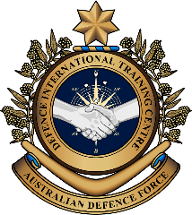

**Overview:**  
This worksheet lists vocabulary of seven Oceanian countries, their flags, nationalities and languages.

**In this vocabulary builder, you will:**

* learn and use vocabulary related to countries in Oceania.

1. What countries are in Oceania? Discuss in pairs and give as many answers as you can.
2. Work in pairs. Finish the spelling of each country. Look at the example.

|  |  |
| --- | --- |
| 1. Australia | 1. F\_\_ j \_\_ |
| 1. N\_\_w \_\_eal\_\_ \_\_ d | 1. P\_\_la\_\_ |
| C:\Users\marcos.pougy\Desktop\Flag_of_Kiribati.svg.png   1. Ki\_\_i\_\_ati | 1. \_\_au\_\_u |
| 1. \_\_ap\_\_a N\_\_w G\_\_ \_\_nea |

1. A black background with a black square

   AI-generated content may be incorrect. Practise the pronunciation of these countries. Listen and repeat.
2. Use the table on the right to write the nationality of each country next to their flags. Look at the example.

|  |  |
| --- | --- |
| **Country** |  |
|  |  |
|  | \_\_\_\_\_\_\_\_\_\_\_\_\_\_\_\_\_\_\_  Australian |
|  | \_\_\_\_\_\_\_\_\_\_\_\_\_\_\_\_\_\_\_ |
| 1. C:\Users\marcos.pougy\Desktop\Flag_of_Kiribati.svg.png | \_\_\_\_\_\_\_\_\_\_\_\_\_\_\_\_\_\_\_ |
|  | \_\_\_\_\_\_\_\_\_\_\_\_\_\_\_\_\_\_\_ |
|  | \_\_\_\_\_\_\_\_\_\_\_\_\_\_\_\_\_\_\_ |
|  | \_\_\_\_\_\_\_\_\_\_\_\_\_\_\_\_\_\_\_ |
|  | \_\_\_\_\_\_\_\_\_\_\_\_\_\_\_\_\_\_\_ |

|  |  |
| --- | --- |
| **Nationality** | **Official Language\*** |
| Fijian | English; Fijian |
| Nauruan | English |
| Australian | English |
| Palauan | Palauan; English |
| New Zealander | English; Maori |
| Papua New Guinean | English; Tok Pisin |
| I-Kiribati | English; Gilbertese |
|  | |
| \* **official language** (n) – the language(s) that a country uses in important documents and communication | |

1. Practise the pronunciation of these nationalities and languages. Listen and repeat.
2. Do you still remember the words and flags you learned in this lesson? Work with a partner. Play a game.

**Student A, stay on this page. Student B, turn to the next page.**

STUDENT A

* This is a competition. The student with the most correct answers is the winner.
* Ask your partner the questions below. If they give the correct answer, it’s one point for him/her.
* Take turns. You ask one question, then your partner asks you one question, and so on.
* For example: A: *Which country has four red stars on its flag?*

B: *It’s \_\_\_\_\_\_\_\_\_\_\_.*

|  |  |  |
| --- | --- | --- |
| **Read these questions to student B.** | **If student B gives these answers, give them one point (✓).** | **Put a tick (✓) in each space below if student B answers correctly.** |
| How many stars are on Australia’s flag? | six |  |
| What languages do Fijian people speak? | English and Fijian |  |
| Which country has the sun and the sea on its flag? | Kiribati |  |
| What do we call people from Nauru? | Nauruan |  |
| What colours are on the Palauan flag? | blue and yellow |  |
| What two languages do Papua New Guinean people speak? | English and Tok Pisin |  |
| What are the two languages in New Zealand? | English and Maori |  |
| Total: | |  |

STUDENT B

* This is a competition. The student with the most correct answers is the winner.
* Ask your partner the questions below. If they give the correct answer, it’s one point for him/her.
* Take turns. You ask one question, then your partner asks you one question, and so on.
* For example: A: *Which country has five white stars and a bird on its flag?*

B: *It’s \_\_\_\_\_\_\_\_\_\_\_.*

|  |  |  |
| --- | --- | --- |
| **Read these questions to student A.** | **If student A gives these answers, give them one point (✓).** | **Put a tick (✓) in each space below if student A answers correctly.** |
| What two languages do I-Kiribati people speak? | English and Gilbertese |  |
| What colours are on Nauru’s flag? | dark blue, yellow and white |  |
| What language do Nauruan people speak? | English |  |
| What do we call people from Palau? | Palauan |  |
| What do we call people from Fiji? | Fijian |  |
| What language do Australian people speak? | English |  |
| Total: | |  |



* 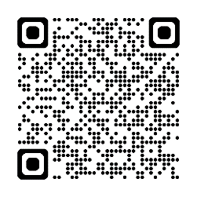Watch this video. Follow the instructions on the screen. Type on YouTube [Oceania Flag Quiz | Guess the National Flag](https://www.youtube.com/watch?v=R8X9e6MKUDg) or scan the QR code. 🡪
* 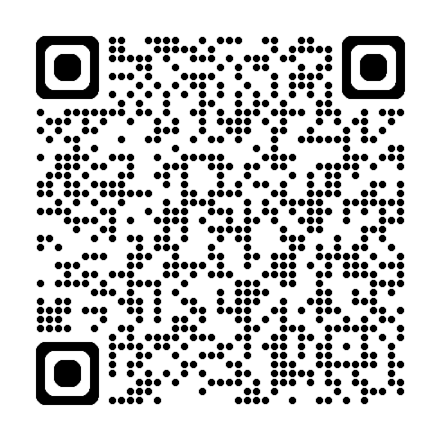For more practice with the words you’ve learned here, scan the QR code for a set of flashcards. You can do some more study on the vocab in this lesson on your own with these. 🡪
* This Vocabulary Builder links with 🡪 Vocabulary Builder – Countries and Flags – Oceania Part A

© Commonwealth of Australia 2025  
This work is copyright. Apart from any use as permitted under the Copyright Act 1968 (Cth),   
no part may be reproduced by any process without prior written permission from the Department of Defence.