
Military English
Lesson: What’s in Your Webbing? - Listening

Overview:
This lesson will keep practicing words from the vocabulary builder “What’s in your webbing?”. It will help you practice listening to and understanding the words and to use them in speaking.
In this lesson, you will:
- listen for some general and specific information in a text
- learn the meaning of new words
- use new words in sentences
- talk about useful items you can put in your webbing

Prepare for Listening
- Look at the pictures of soldiers surviving in the jungle. Talk to your friends.
- What are they doing in the pictures?
- What gear is useful for the activities?
- What do you take with you when you go into the jungle?

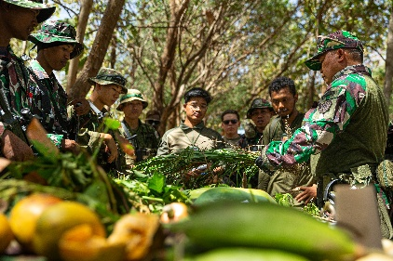
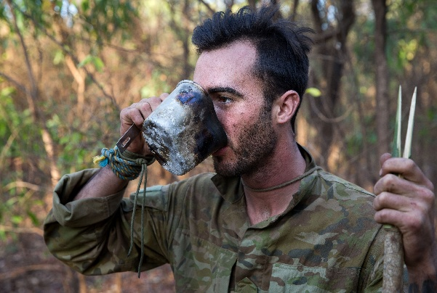

survive (v) – to live through a dangerous situation.

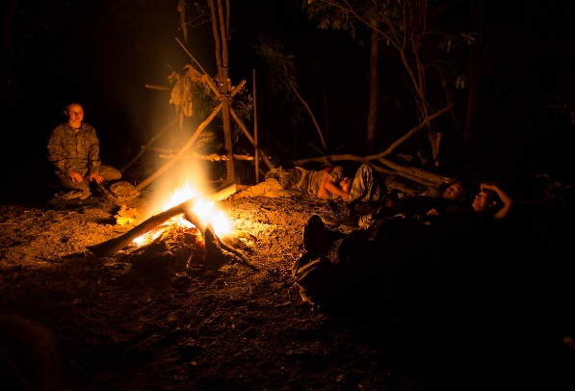

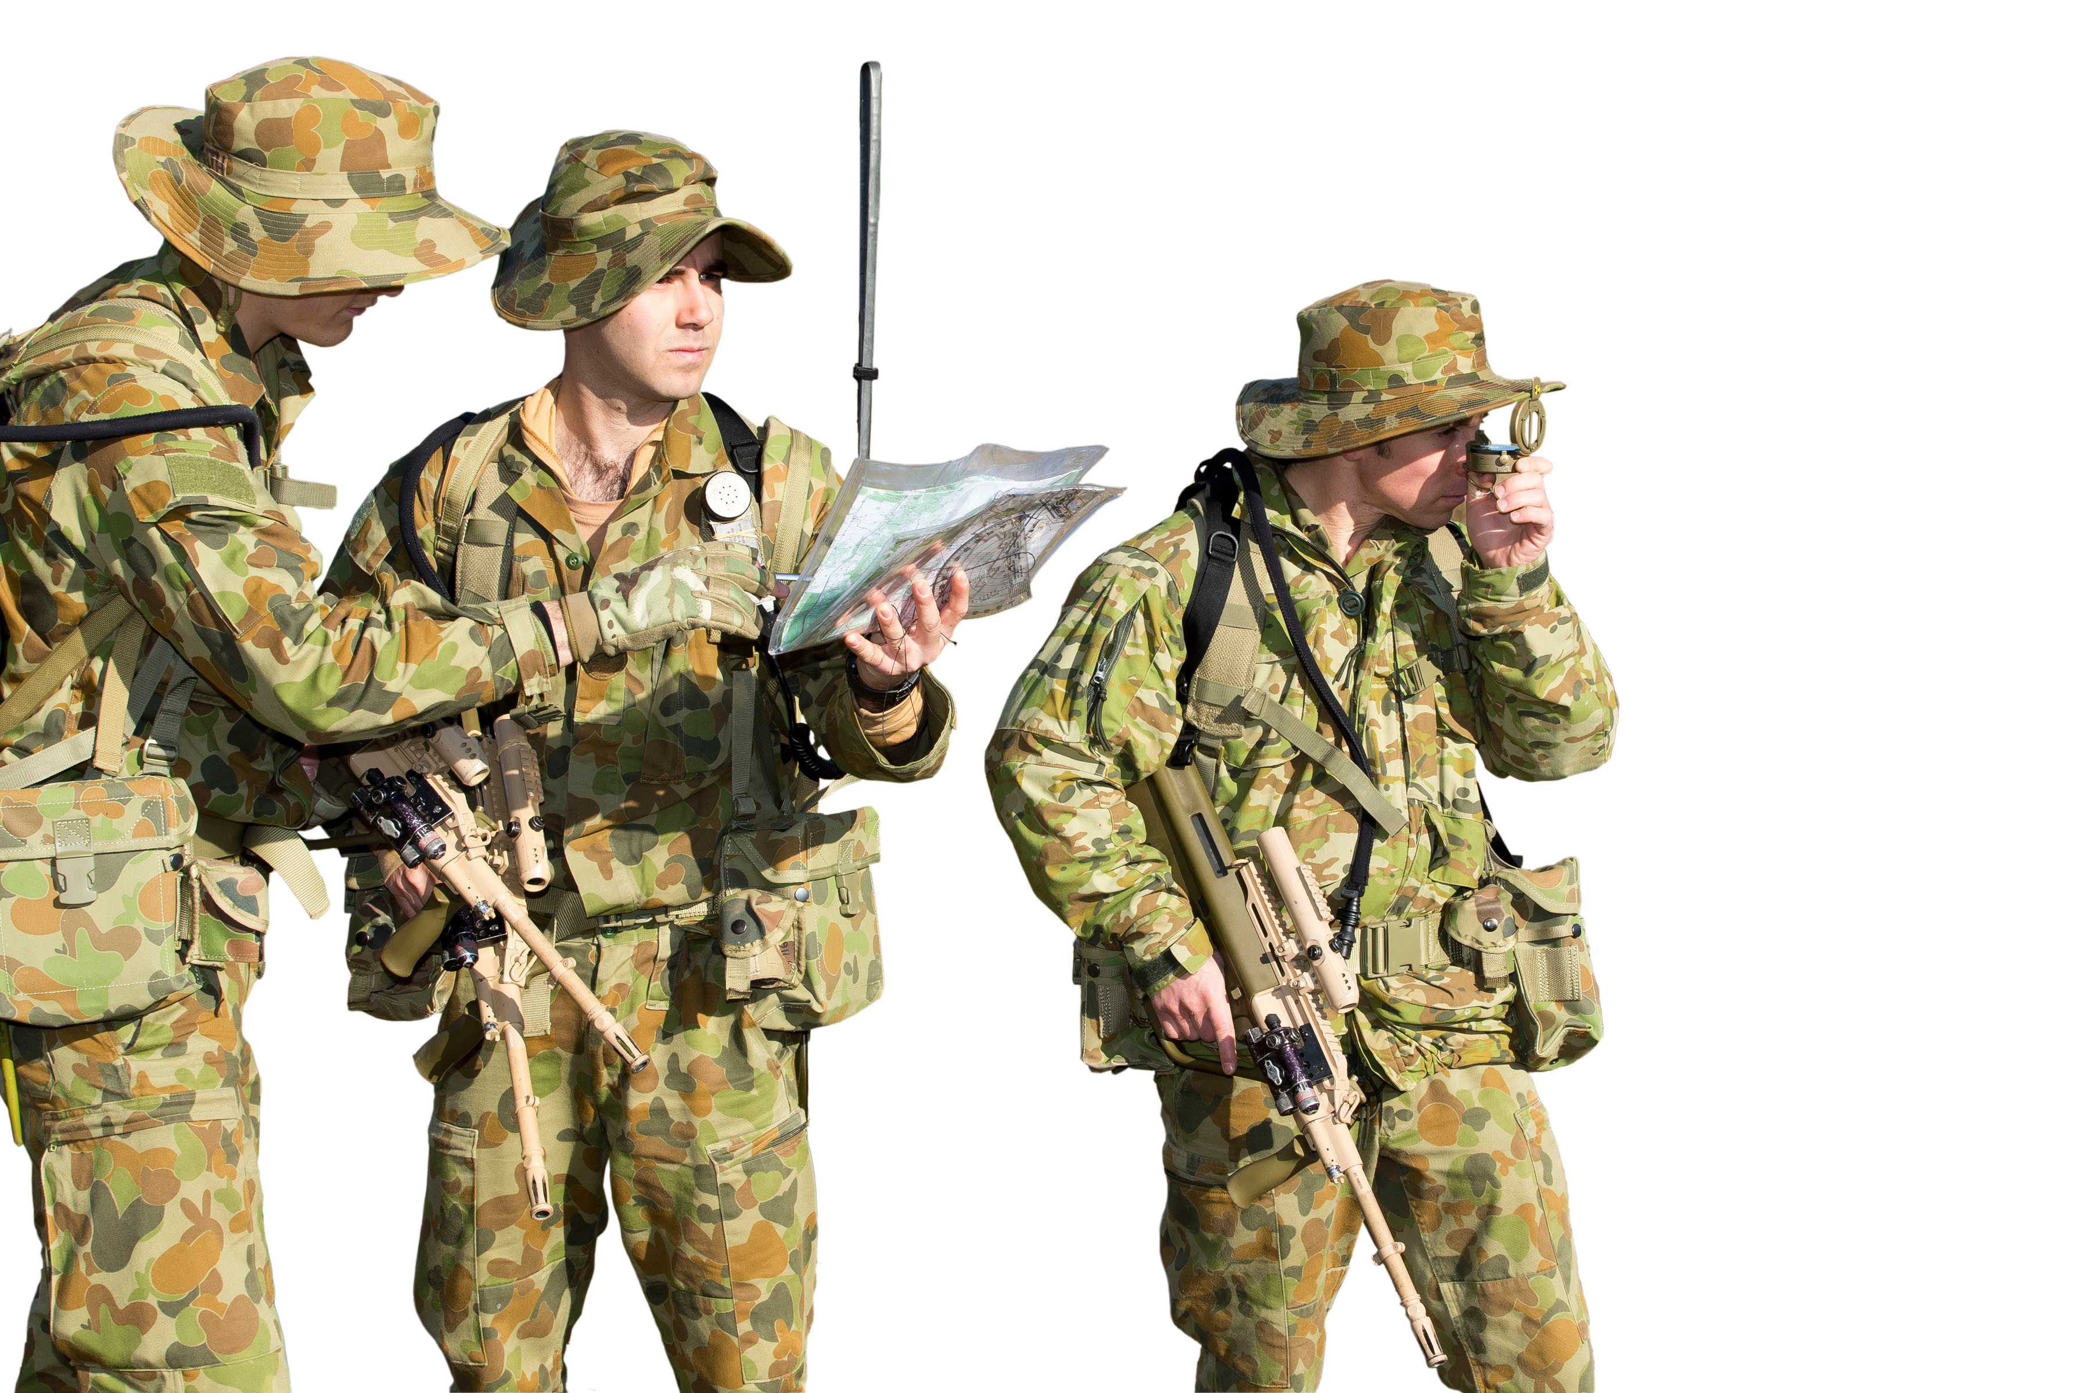

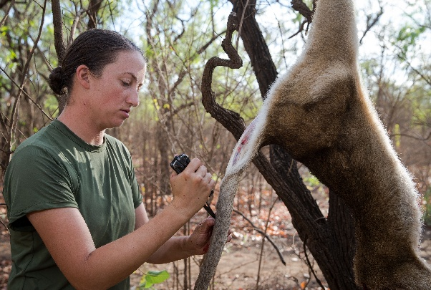

- These are words we will need for the listening. Look at the pictures and match as many as you can with words from the box.
a vest // a belt // silver // batteries // jungle // the dark // signal // navigate // secret

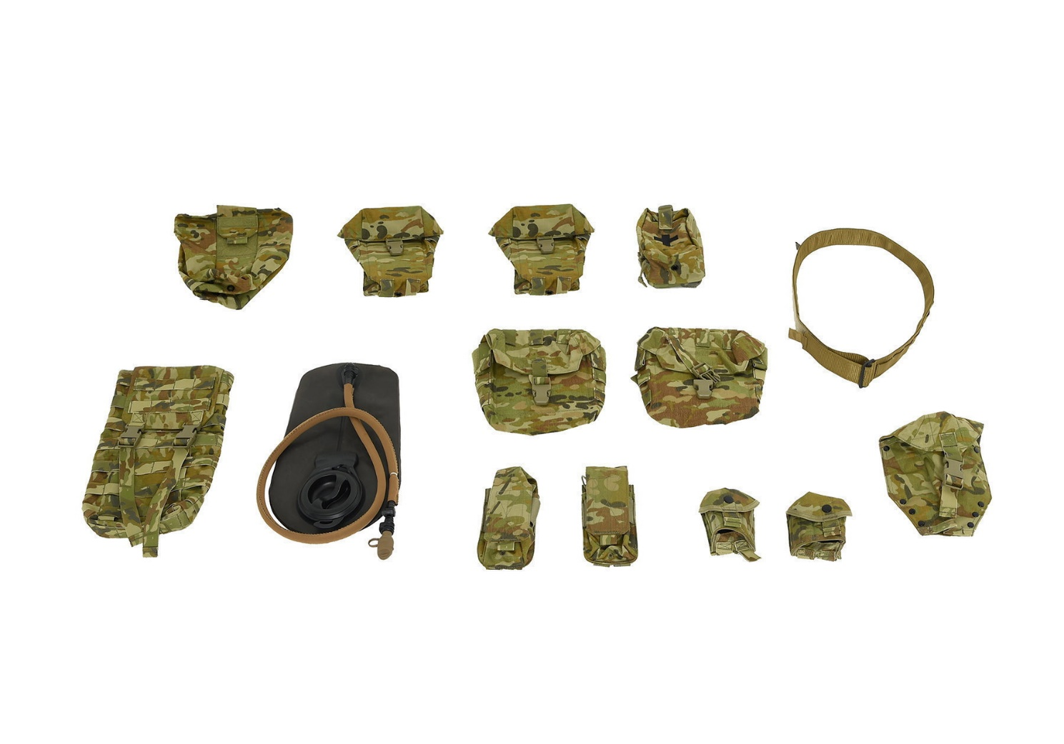
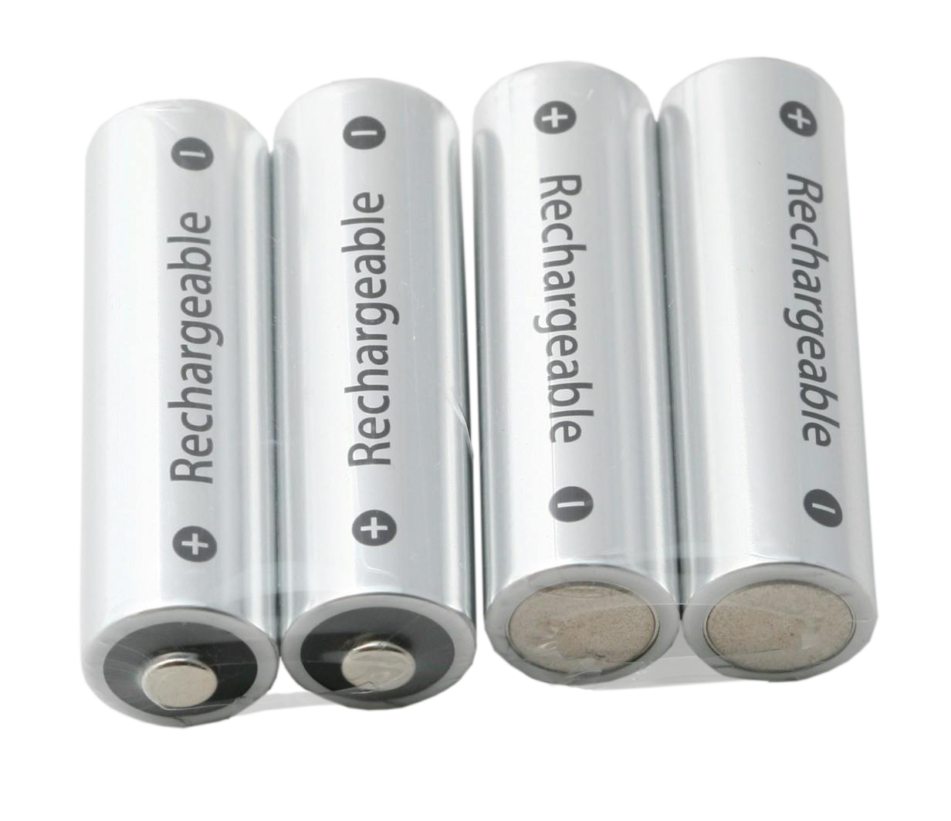
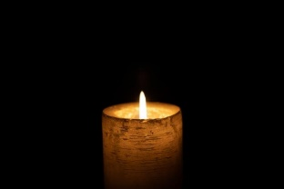


d. _________________
b. _________________
c. _________________
a. _________________
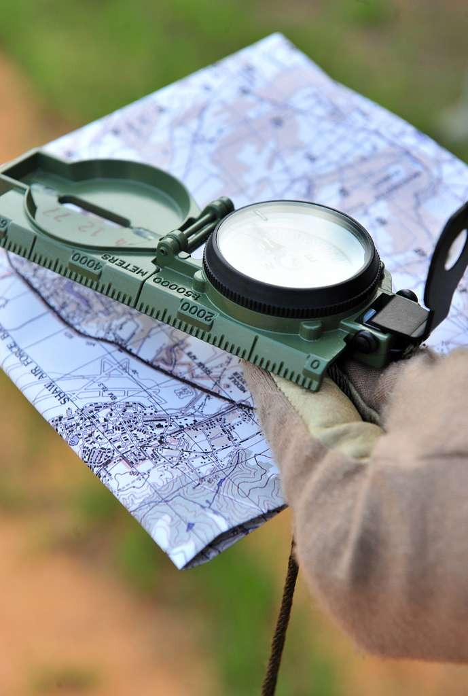
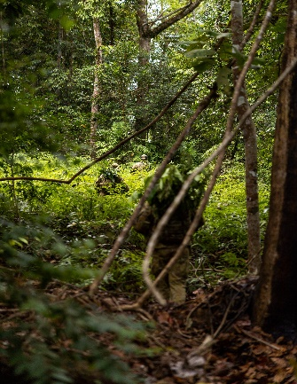
e. __________________

f. __________________

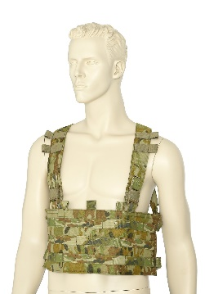

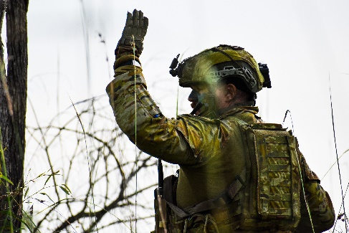
i. ___________________
g. ___________________
h. ___________________


- Listen, check, and repeat.

- Discuss these questions with your partner to practise the new words.
- Can you navigate using a compass?
- Do you use hand signals in your job? If yes, show your partner some of the hand signals you use and say what they mean.
- Do you ever do training in the dark? Do you like it?
- Silver is a metal and a colour in English. Can you see anything that is silver in the room?
- Can you think of 5 things that need batteries? When was the last time you got angry about something having a flat battery?
- Do you ever wear a belt or a vest for work? Why?
Listening
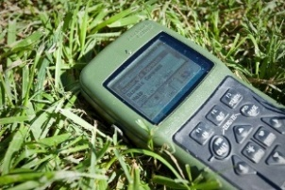
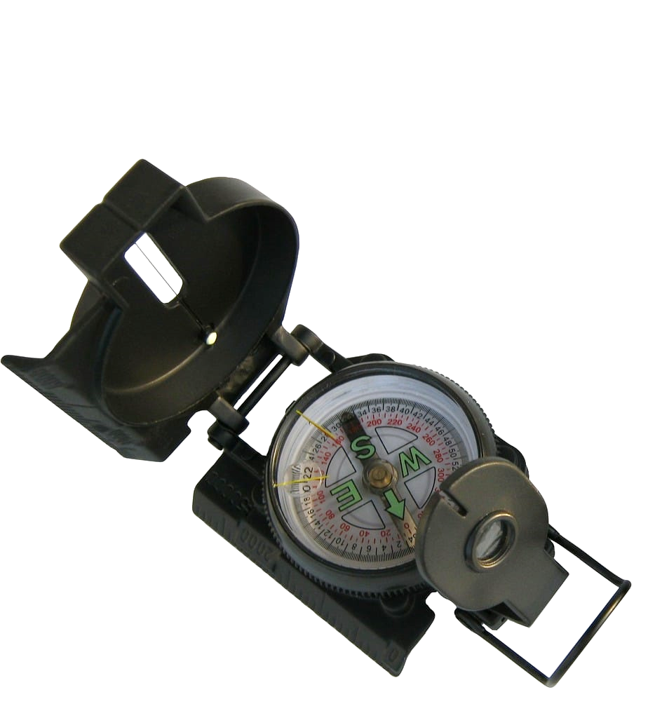
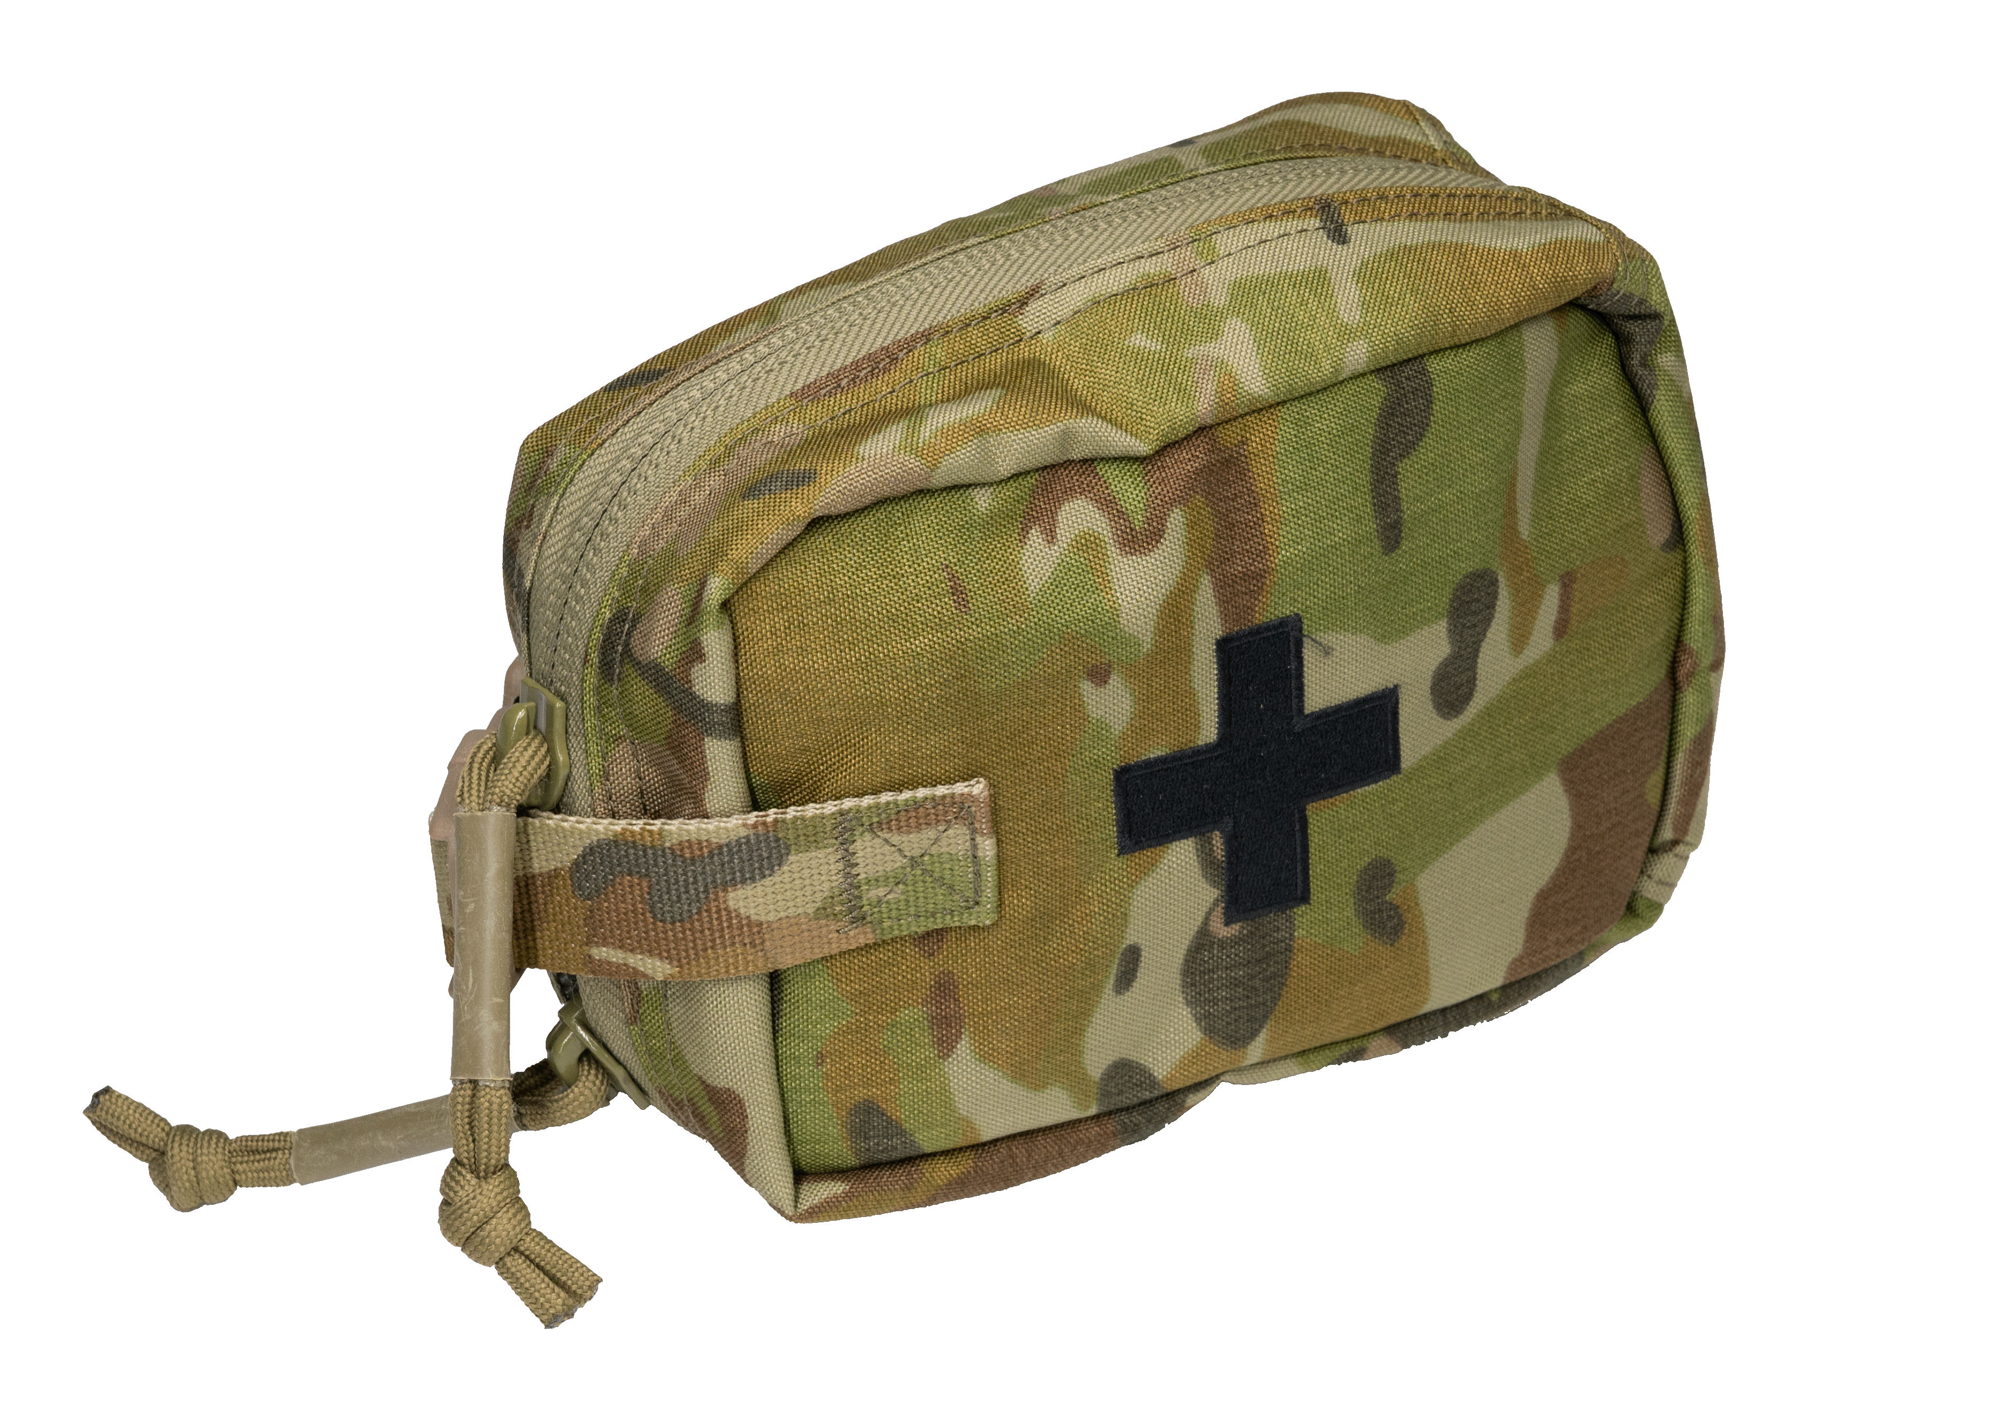
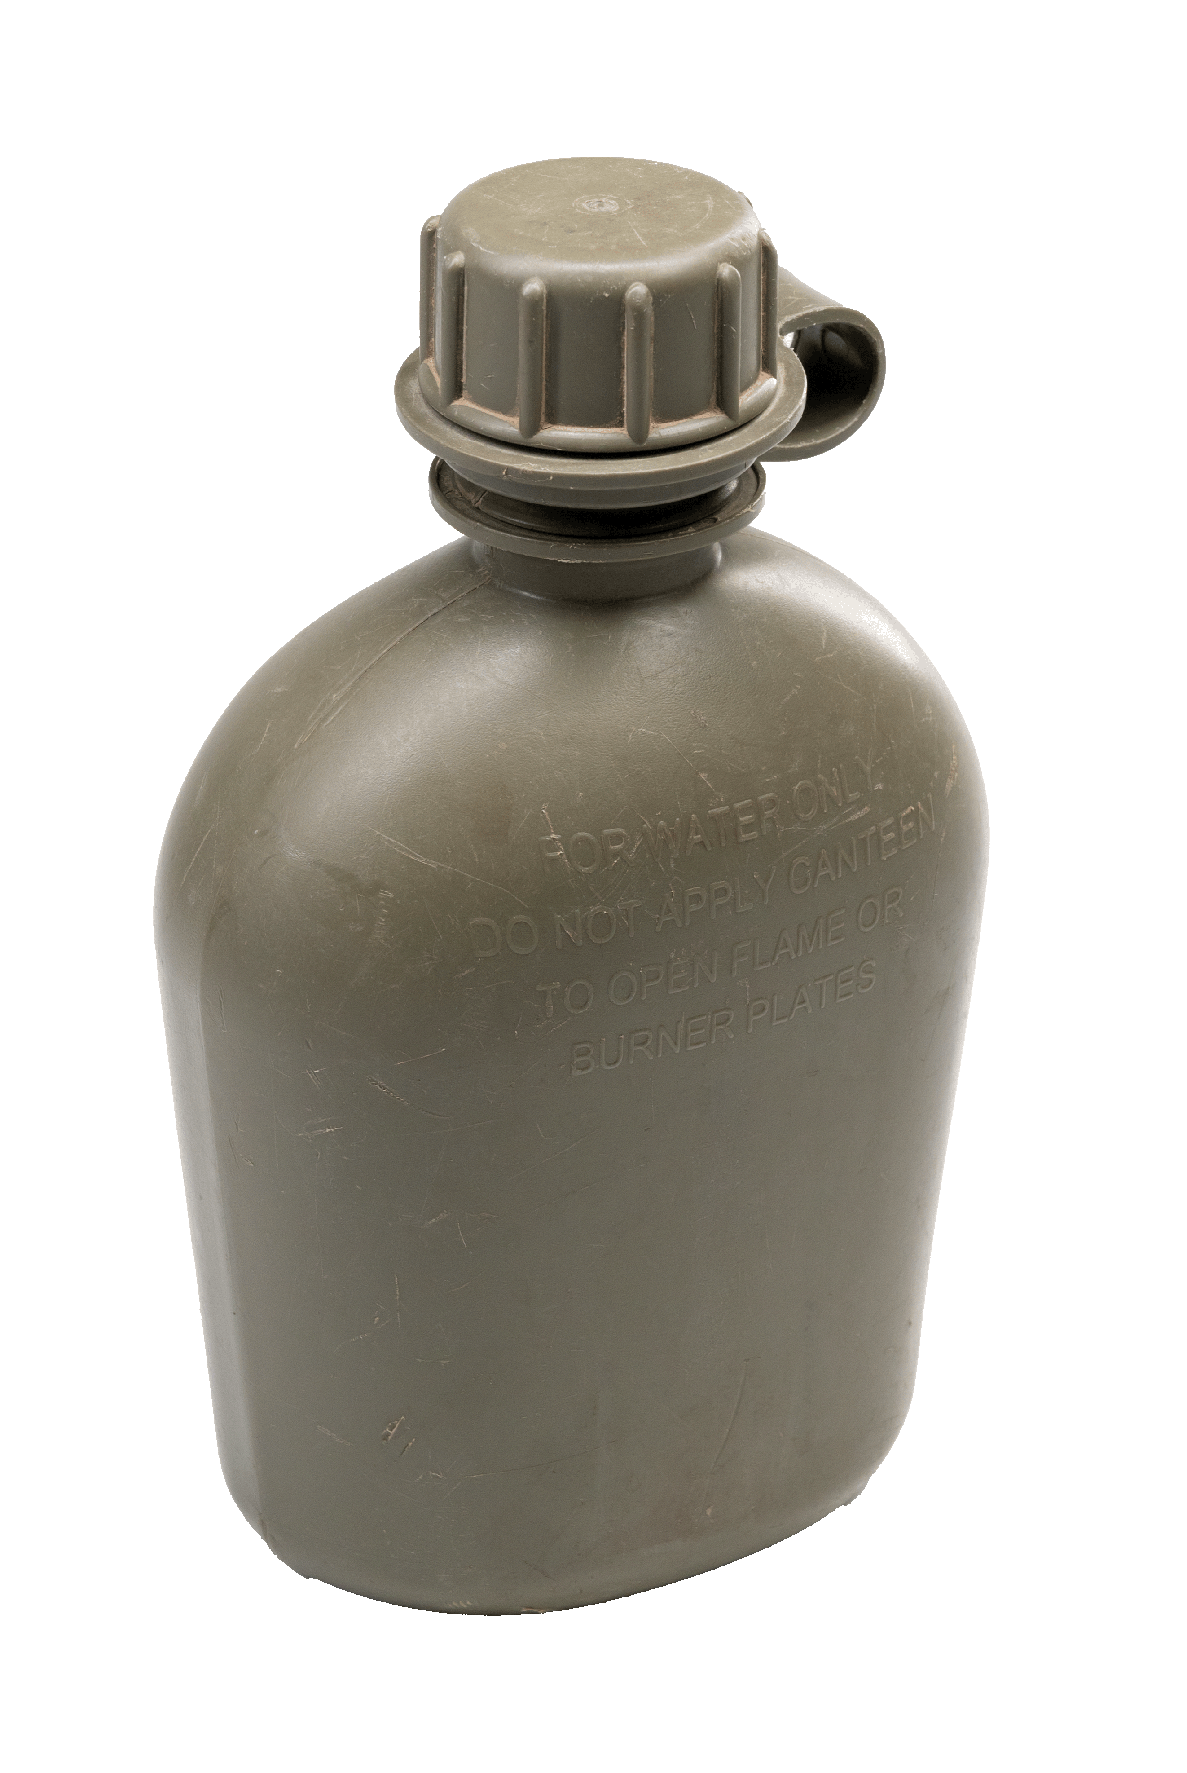
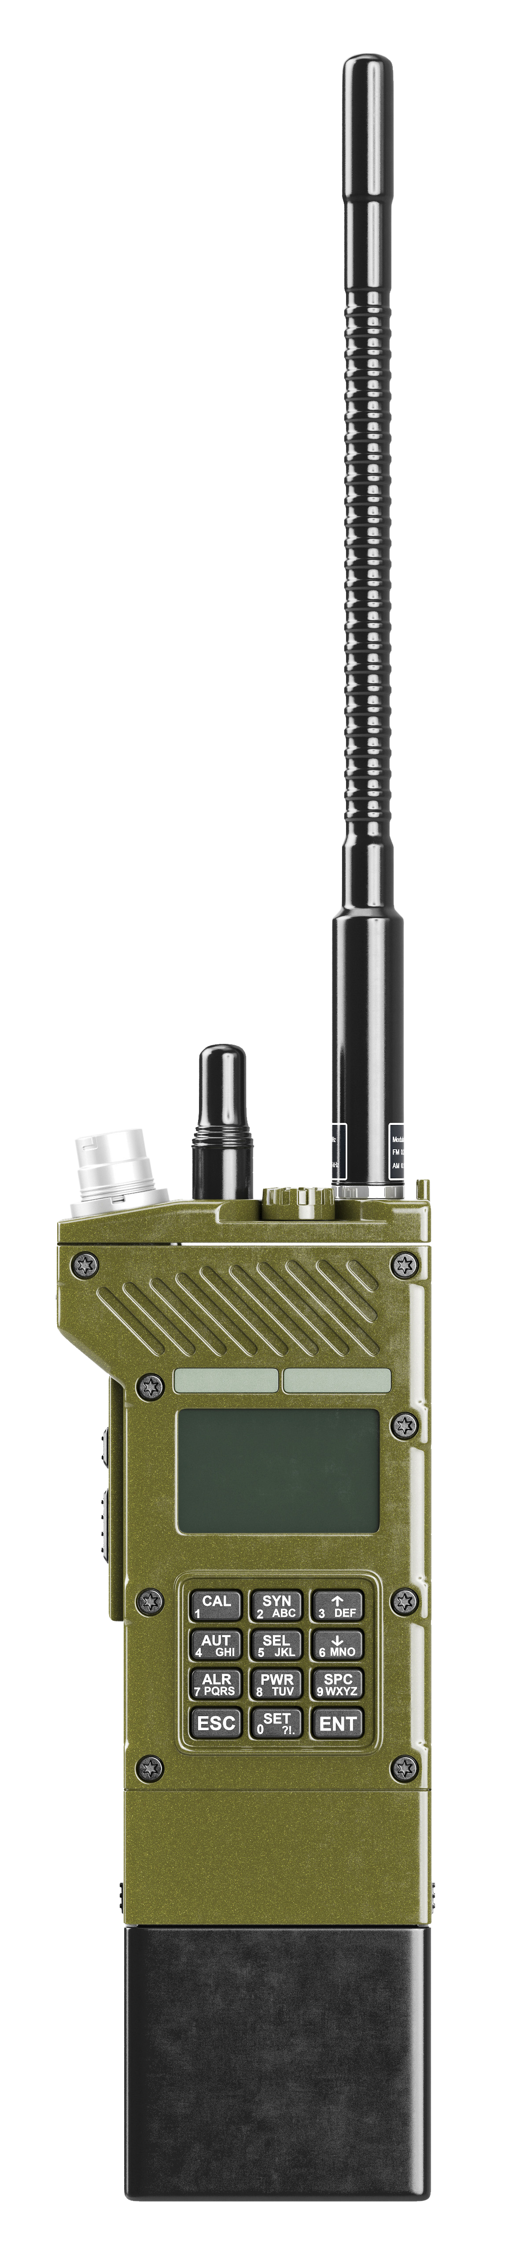
- Private Annie is going to talk about five things she has in her webbing to help her survive in the jungle. Before you listen, guess which 5 things she has in her webbing. Check with a partner.
Do you have the same ideas?

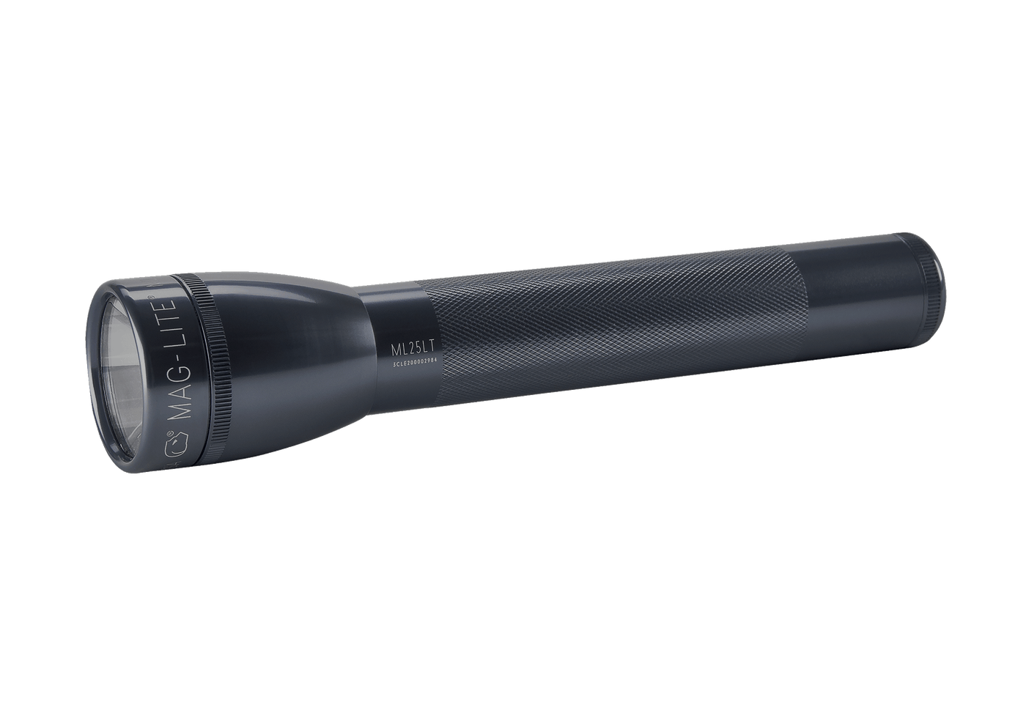

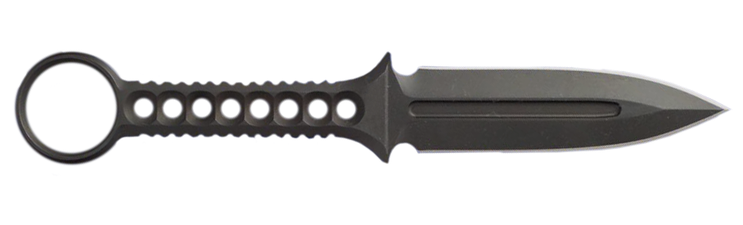
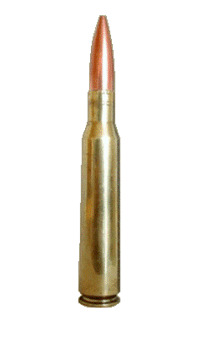

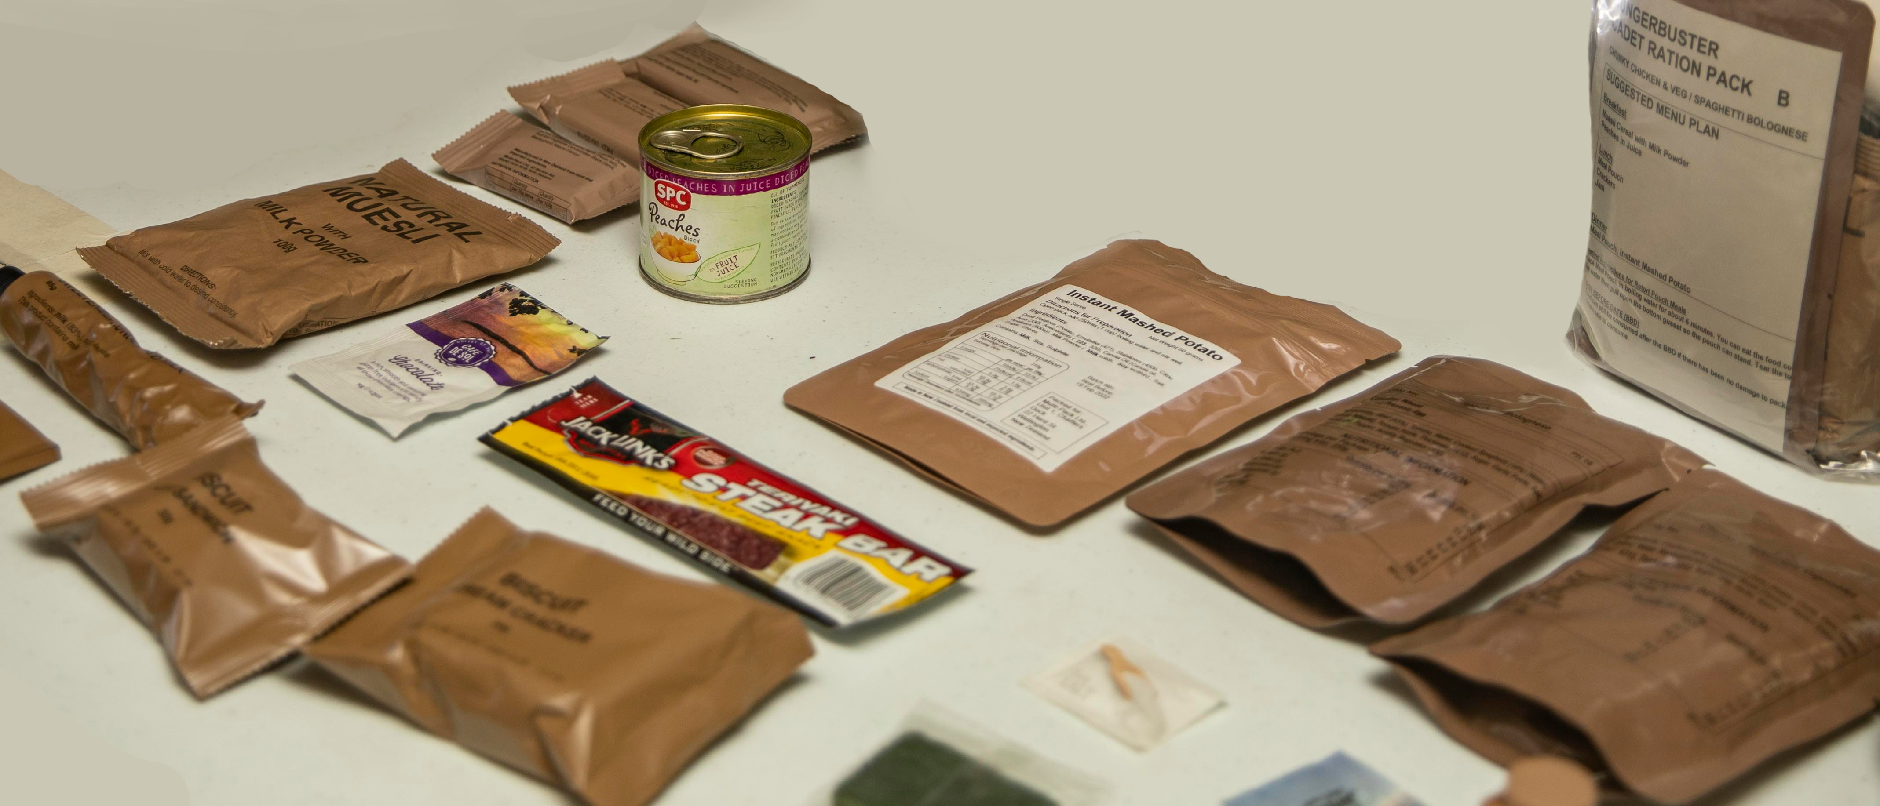

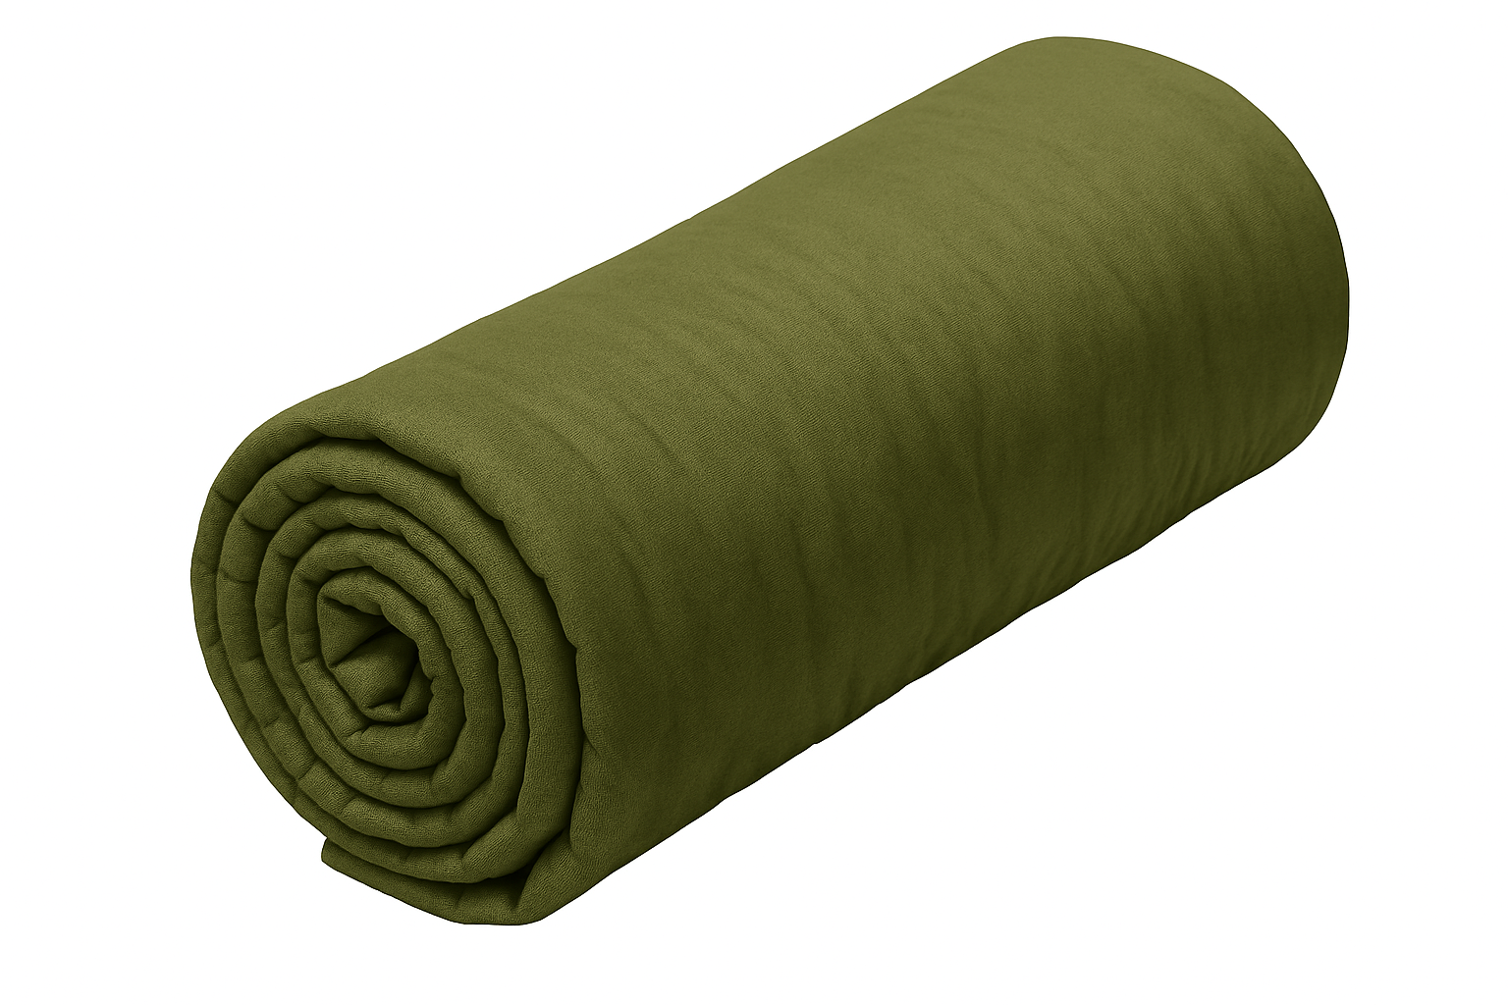

- Listen and check. Tick the items PTE Annie takes to the jungle.
- Listen again and complete the sentences with one word from the listening. The first one has been done for you as an example.
private
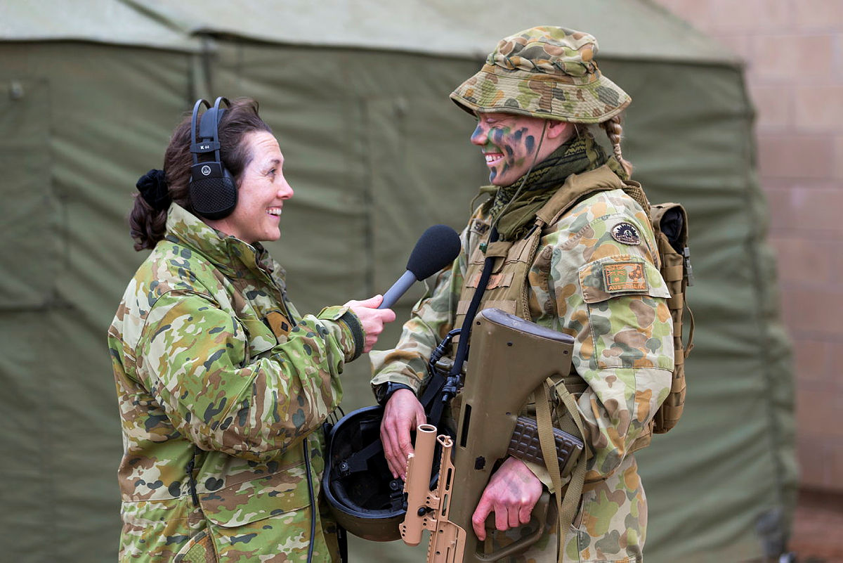
        - Annie has the rank of ________________ in the Australian army.
        - Webbing is a _______________ and vest that you can add pouches to.
        - Webbing helps soldiers get things they need ________________.
        - It is very important to fill the canteen in ________________weather to stay hydrated.
        - The canteen sits inside of the canteen ________________.
        - It is important for the radio to have a full ________________before you take it anywhere.
        - You can ________________using a compass without a battery.
        - Ratpacks are a type of ________________supply that usually don’t need to be cooked.
        - You can use a torch to ________________for help.
        - Private Annie has some secret ________________in her last pouch.
Learning military vocabulary
- The words in bold are important military vocabulary that you should learn. Match them to their definitions on the right. Look at the example and write the answers in the middle column.
Table 1
webbing is a special belt, a vest, and set of pouches | f |  | - (n) equipment soldiers use - compass, canteen, multitool, cam paint, magazines etc
gear to survive |  |  | 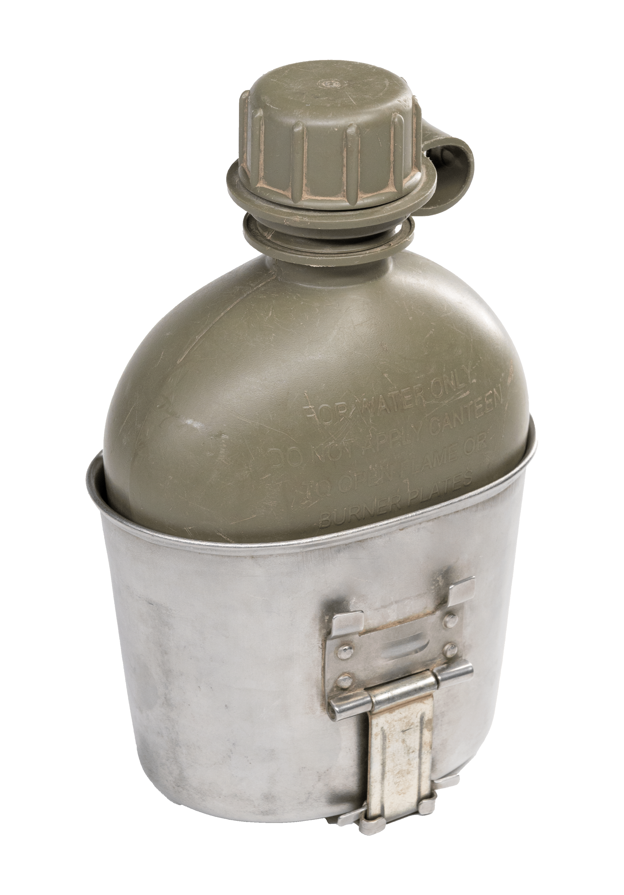  - (n) a water bottle with a special shape to make it easy to carry
set of pouches |  |  | - (v) to talk or to send messages
Number 1 is my canteen |  |  | - (n) they are used to  send and receive messages
a canteen cup |  |  | 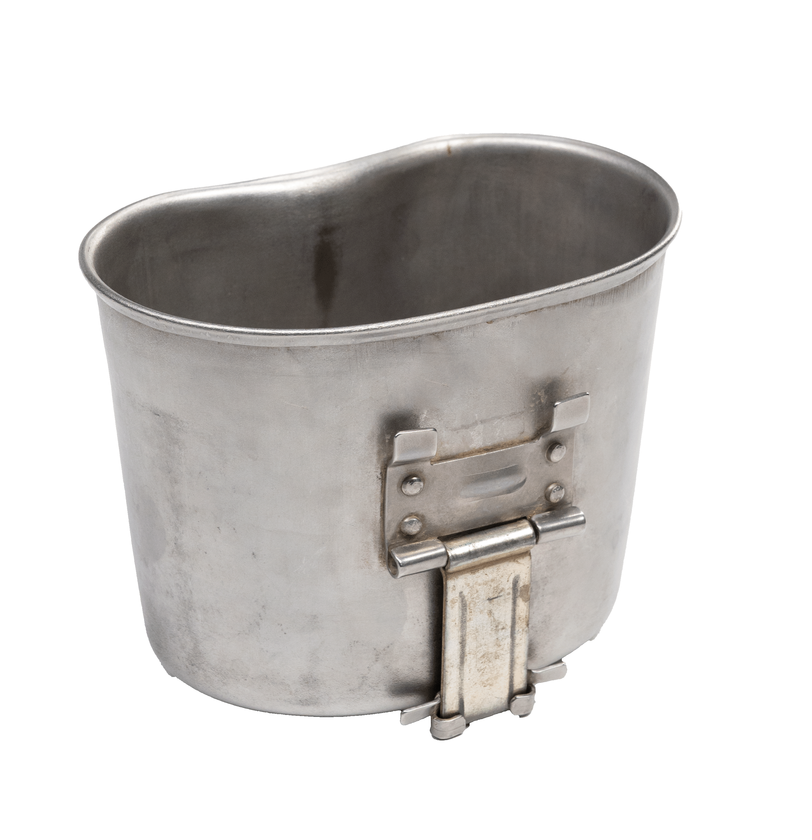  - (n) a cup that fits on the bottom of a canteen
Radios help us to communicate |  |  | 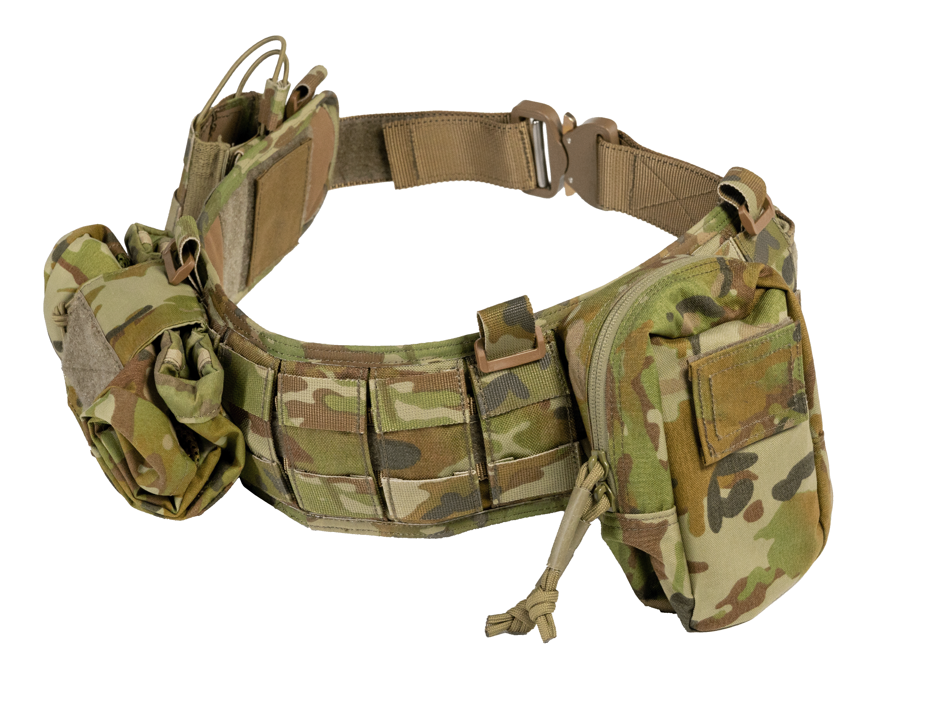  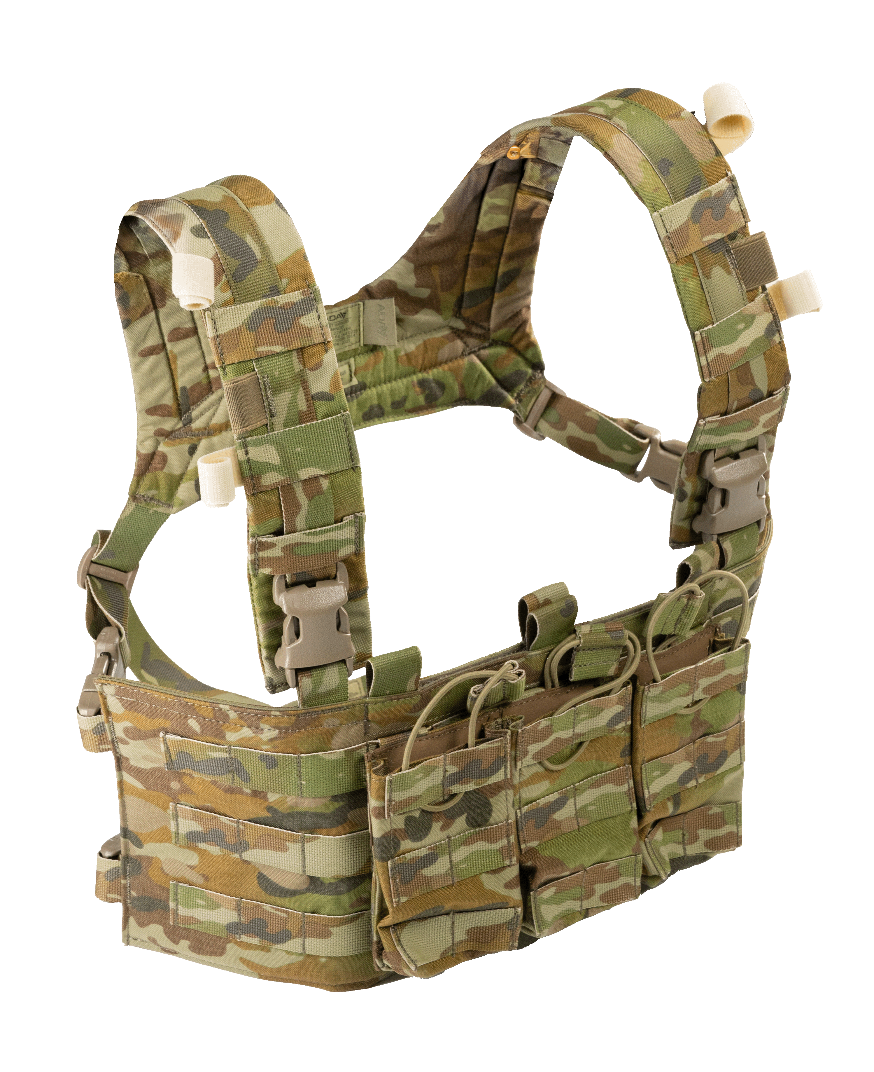  f. (n) worn by soldiers to help  them carry gear and to  get to important  things quickly
Radios help us to communicate |  |  | 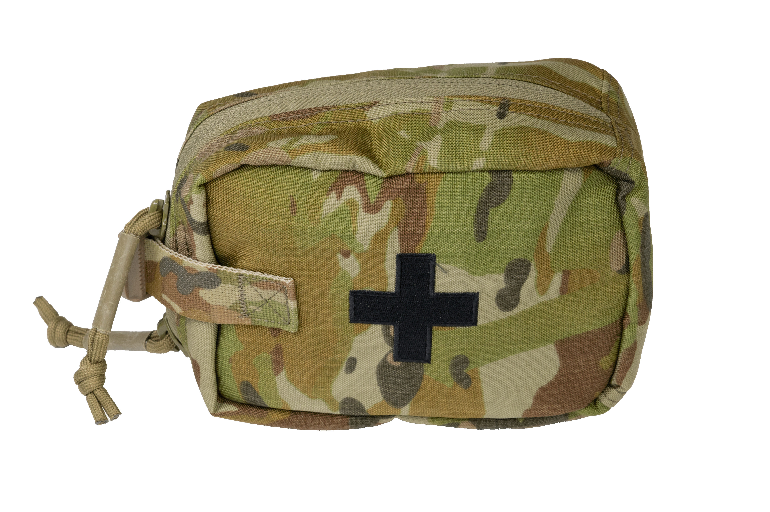  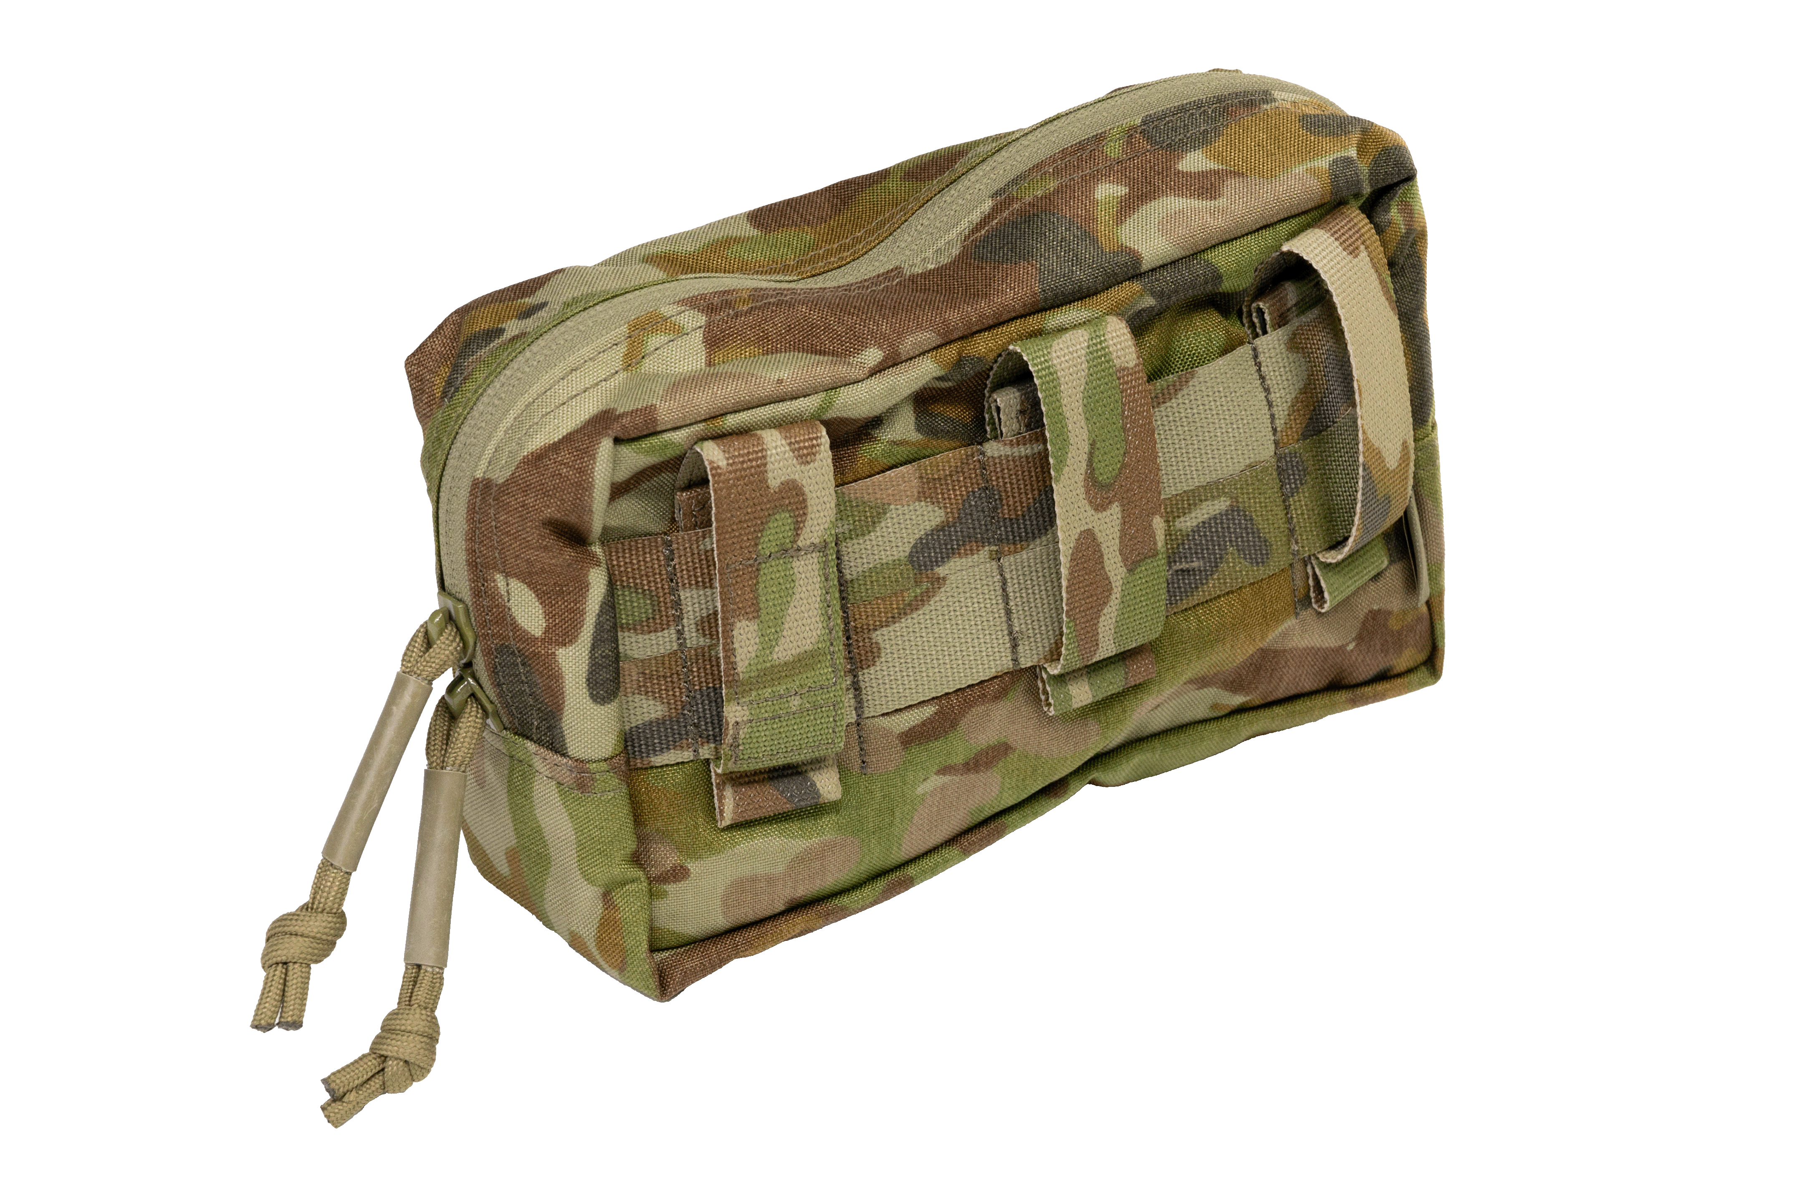  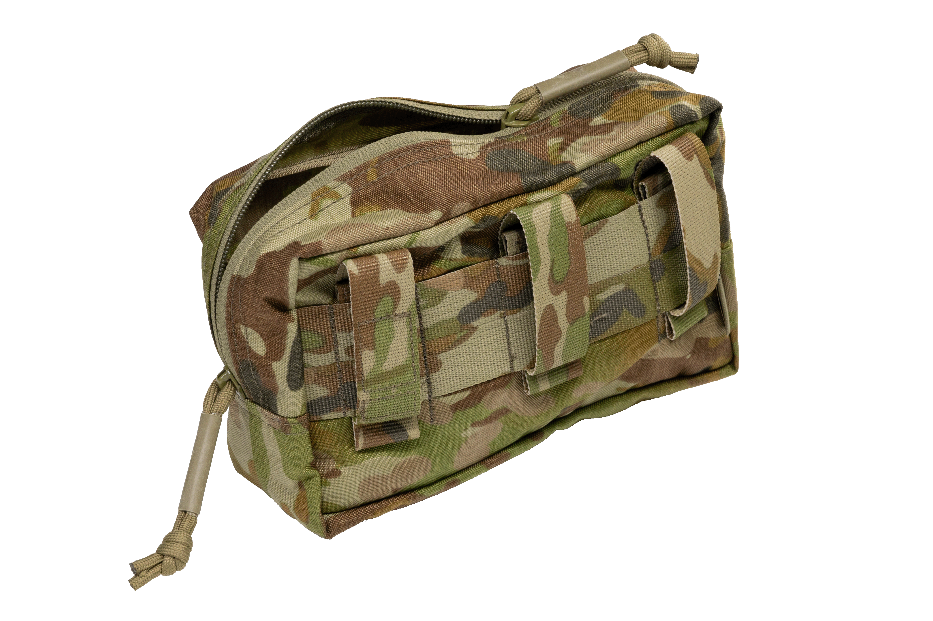  - (n) little bags that can be attached to webbing to carry things.

Table 2
always navigate with a compass |  |  | 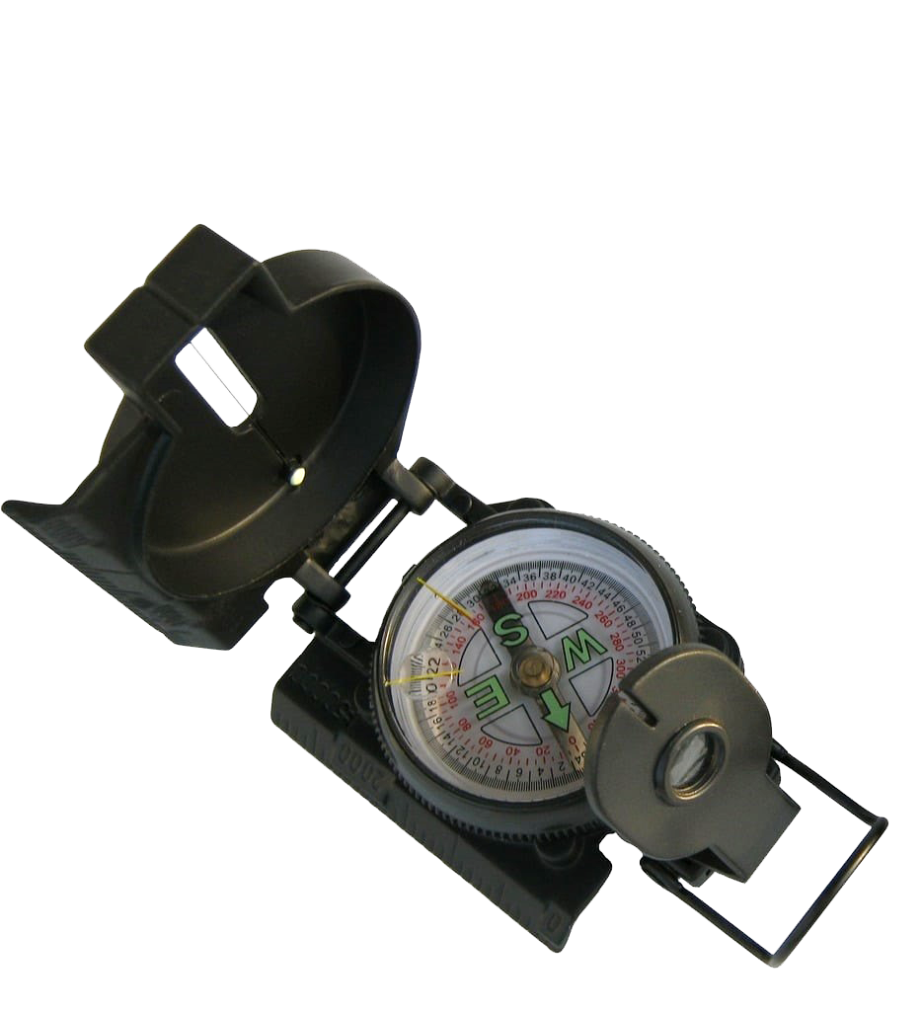  - (v) to find the right way to go. You can use a compass for this
Ratpacks are food supplies |  |  | - (n) an emergency signal = . . . _ _ _ . . .
A torch for seeing in the dark |  |  | - (n) a device for finding  direction; the needle  always points north
Gear to survive |  |  | 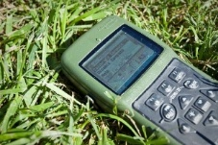  - (n) a Global Positioning System helps soldiers to navigate
sending an SOS signal |  |  | - (n) food soldiers carry when they’re out field
A GPS doesn’t always work well in the thick jungle |  |  | - (v) to live through a difficult situation
navigate with a compass |  |  | 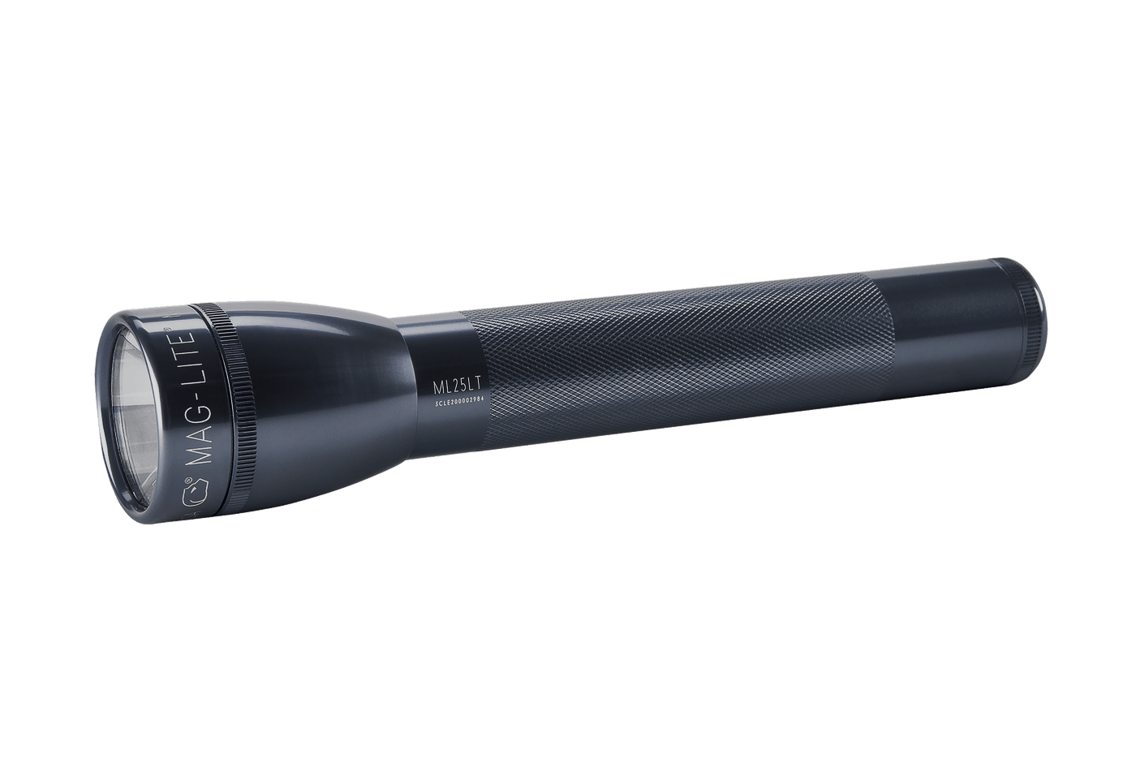  - (n) a small light
- Listen and check your answers.
- Now, let’s practise saying the words. Listen and repeat. Look at where the stress is underlined in words that have more than one syllable.

Practice
- Talk to your friend. Did PTE Annie choose good gear? Why/not?

- Write down what 5 pieces of gear you would take in your webbing to survive in the jungle. You can use words from today’s lesson and your own imagination. Think about why they would be useful. Ask your friends or teacher for any words you need.
Piece of gear | Why it is useful

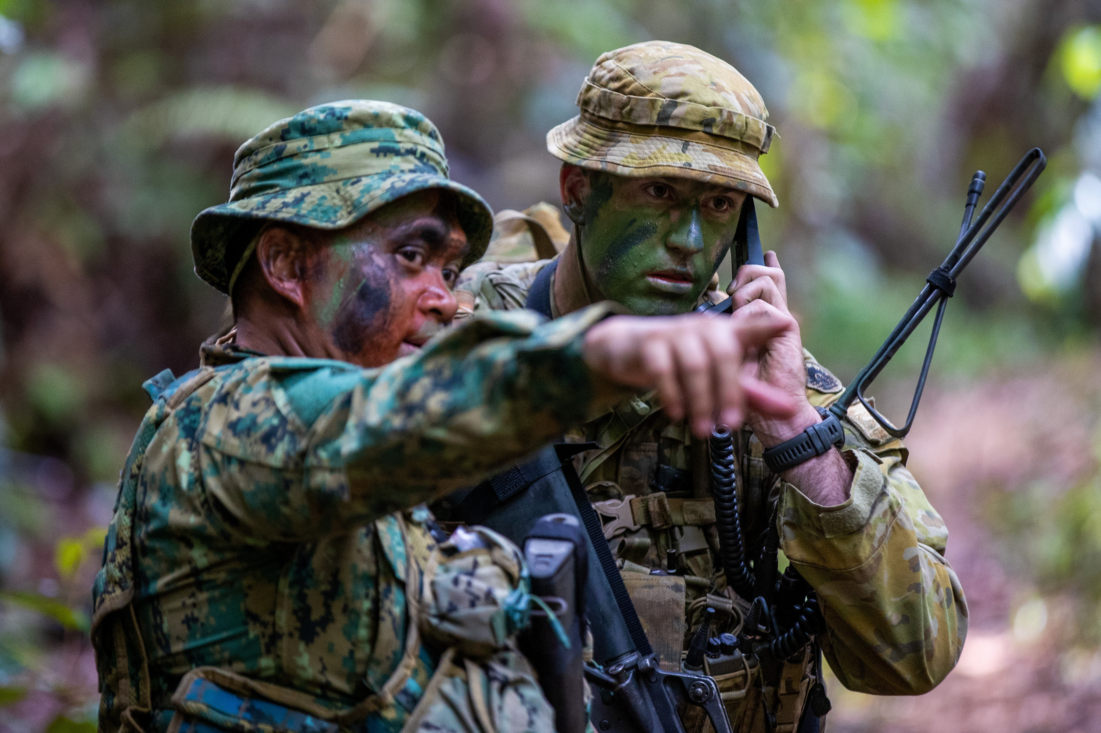
Officers from the Royal Brunei Army and Australian Army during Exercise Mallee Bull's jungle survival training, in Brunei. Nov 2022.
- Stand up and interview 3 other students. Ask them about their webbing. Do you agree with their ideas?
Oh really? Why?
That’s interesting. Why is _____ useful?

I chose ______ also, but why did you choose that?



You will watch a video about a good way to use a can in the jungle. Type on YouTube Lifehacks for Camping or scan the QR code.

Can you think of any other ways a can could be useful in the jungle? Look in your bag. Is there anything in it you could use to survive in the jungle? Be creative!



For more practice with the words you’ve learned here, scan the QR code for a set of Quizlet flashcards. You can do some more study on the vocab in this lesson on your own with these.

This lesson links with: Vocabulary Builder- What’s in Your Webbing?
Vocabulary Builder – Parts of a Tactical Field Kit

© Commonwealth of Australia 2025
This work is copyright. Apart from any use as permitted under the Copyright Act 1968 (Cth),
no part may be reproduced by any process without prior written permission from the Department of Defence.

