**Military English**

Lesson: Women in Blue Berets – Peacekeeping in South   
Sudan – Listening

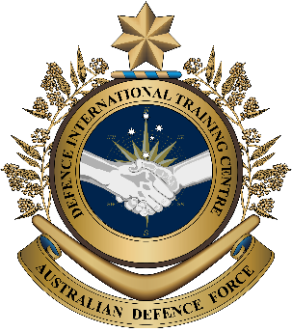

**Overview:** This lesson is about women working in the UN peacekeeping forces in South Sudan.

**In this lesson, you will:**

* learn about the role women play in peacekeeping.
* practise listening for gist and specific information.
* learn and practise new vocabulary and expressions.

## Prepare for Listening

1. Look at the pictures around the page and talk to your partners.

a. What can you **see** in the picture?

b. Why do you **think** this is happening?

c. What do the pictures make you **want to know**?

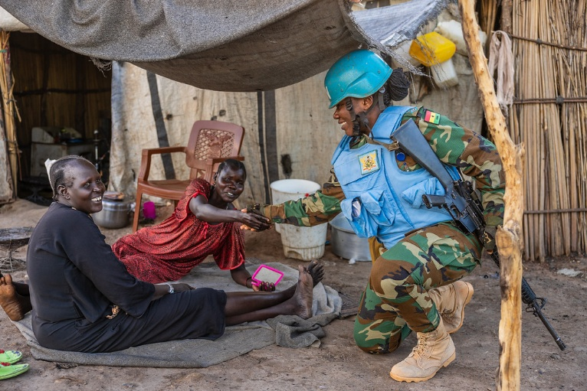

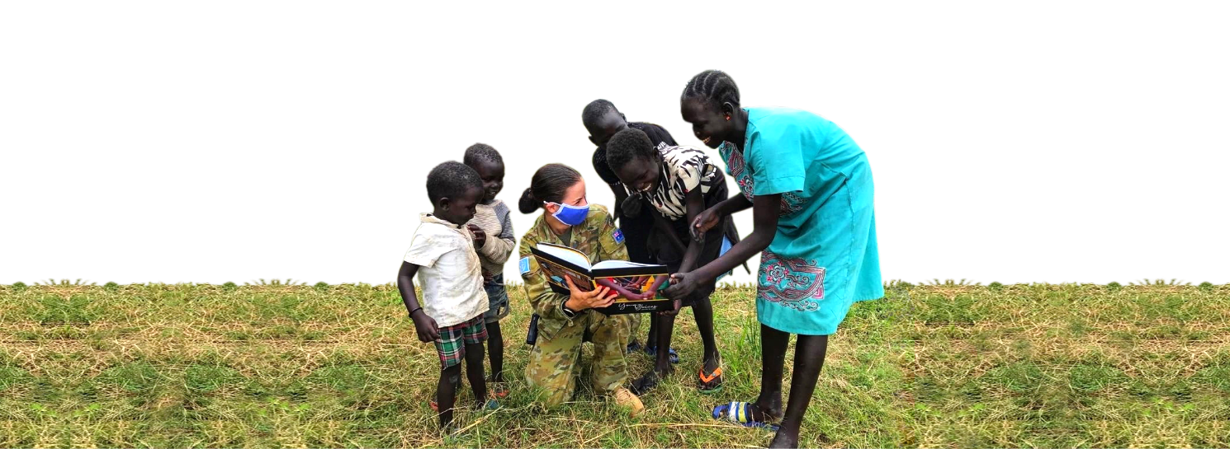

1. **A black background with a black square

   AI-generated content may be incorrect.** Match the words in the box to the pictures. Then, listen and check.

|  |
| --- |
| beret // respect // trust // role // The United Nations // peace |

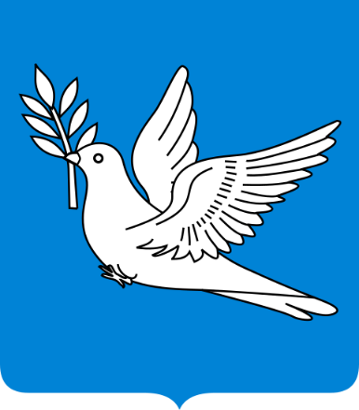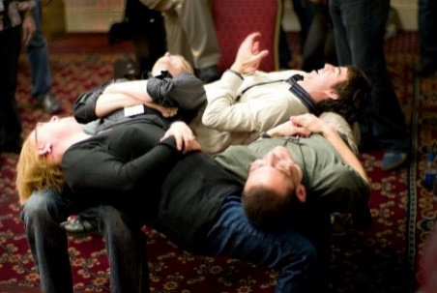

a. \_\_\_\_\_\_\_\_\_\_\_\_\_\_\_\_\_\_\_\_\_\_\_\_ b. \_\_\_\_\_\_\_\_\_\_\_\_\_\_\_\_\_\_\_\_\_\_\_\_\_ c. \_\_\_\_\_\_\_\_\_\_\_\_\_\_\_\_\_\_\_\_\_\_\_\_\_

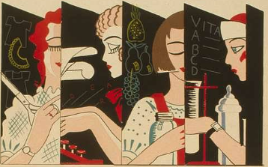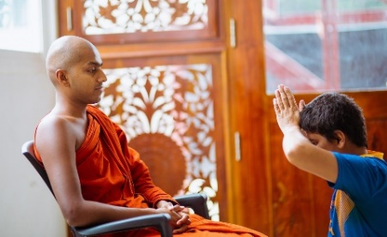

*(Similar to a job)*

d. \_\_\_\_\_\_\_\_\_\_\_\_\_\_\_\_\_\_\_\_\_\_\_\_ e. \_\_\_\_\_\_\_\_\_\_\_\_\_\_\_\_\_\_\_\_\_\_\_\_\_ f. \_\_\_\_\_\_\_\_\_\_\_\_\_\_\_\_\_\_\_\_\_\_\_\_\_

1. Discuss the questions with a partner to practise the new words.
2. Is your country a part of the **United Nations**? Where are the offices? What do they do in your country?
3. How do you show **respect** for your boss?
4. Why is **trust** important in the military?
5. What is your **role** now? What other **roles** have you hadin the past?
6. Is your country at war or at **peace**?
7. What do you know about the ‘blue **beret**’?

## A black background with a black square AI-generated content may be incorrect.Listening

1. Listen to the podcast. What is the main idea? Tick the correct answer.
2. Katie is talking about the important role of women soldiers in the United Nations.
3. Katie is talking about the problems women soldiers cause.
4. Katie is talking about things women soldiers cannot do in South Sudan.
5. A black background with a black square

   AI-generated content may be incorrect. Listen again and complete the sentences with one word from the listening. Look at the example.

female

1. Katie is on the podcast to talk about the role \_\_\_\_\_\_\_\_\_\_\_\_\_\_\_\_\_\_ Blue Berets play.
2. Blue Berets work hard to keep civilians \_\_\_\_\_\_\_\_\_\_\_\_\_\_\_\_\_\_.
3. \_\_\_\_\_\_\_\_\_\_\_\_\_\_\_\_\_\_ are not allowed in all places in South Sudan culture.
4. Male Blue Berets are not allowed in people’s \_\_\_\_\_\_\_\_\_\_\_\_\_\_\_\_\_\_\_\_.
5. Respecting the culture can help people \_\_\_\_\_\_\_\_\_\_\_\_\_\_\_\_\_\_ the Blue Berets
6. An important UN policy is called ‘\_\_\_\_\_\_\_\_\_\_\_\_\_\_\_\_\_\_\_\_\_, Peace and Security’.
7. In conflict, women have different \_\_\_\_\_\_\_\_\_\_\_\_\_\_\_\_\_\_\_\_ and experiences to men.
8. Listening to women can help make a \_\_\_\_\_\_\_\_\_\_\_\_\_\_\_\_\_\_\_\_ that lasts.

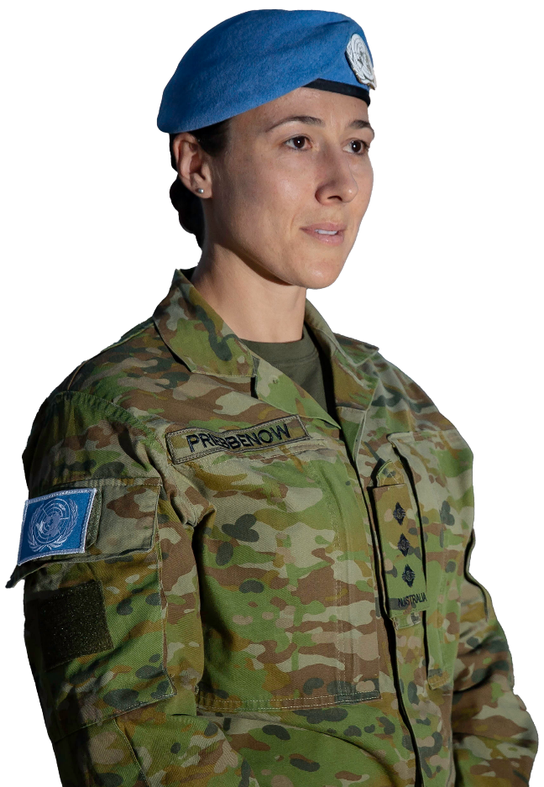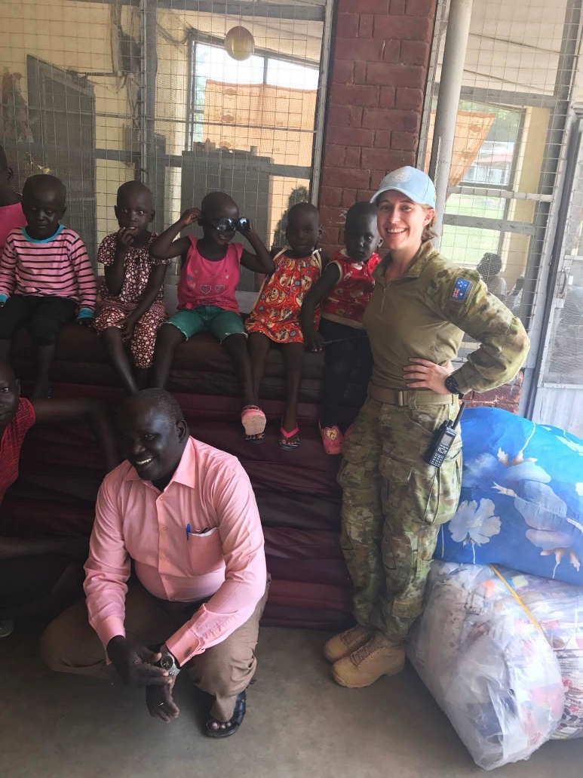

## Learning Military Vocabulary

1. The words listed in bold below are important vocabulary and expressions that you should learn to use. Match the vocabulary on the left with their definitions on the right. Look at the example.

|  |  |  |  |
| --- | --- | --- | --- |
| Table 1 |  |  |  |
| **Blue Berets** are soldiers for the UN | **e** |  | 1. (n) people on peacekeeping operations | |
| a **peacekeeping operation** in South Sudan |  |  | 1. (n) people who are not soldiers, UN workers, or part of the war | |
| to be a **peacekeeping** **force** |  |  | 1. Contingent of Nepalese Peacekeepers Arrives in Juba from H… | Flickr(n) a group whose job is to stop the fighting, keep people safe, and help the country; they are not on anyone’s side in a war | |
| to keep **civilians** safe |  |  | 1. (n) a special operation, usually conducted by the UN; usually, soldiers go to a place that has fighting to try stop it or to keep the peace | |
| in South Sudan **culture** |  |  | \\d85userdata.dpe.protected.mil.au\ma\marcos.pougy\Downloads\20170914adf8630742_013.jpg**e. (n) personnel from armies from many different countries who come together to help the UN make and keep the peace** | |
| **female peacekeepers** have important roles |  |  | 1. (n) the places where the fighting is happening | |
| the **conflict zones** can change quickly |  |  | 1. Free Vectors, PNGs, Mockups & Backgrounds | rawpixel(n)special ways of thinking and acting for a group of people | |
| Table 2 |  |  |  |
| we **screen** female civilians |  |  | 1. (n) a UN document that says that women should play an important role in building peace | |
| make sure they are not a **threat** |  |  | 1. (n) strong peace that will last for a long time | |
| conducting **house searches** |  |  | 1. (n) something that is dangerous and could hurt people | |
| **Women, Peace and Security Policy** |  |  | 1. (v) to check to make sure someone is not dangerous | |
| **women should have leadership roles** |  |  | 1. (n) to check a house doesn’t have dangerous things or people in it | |
| **lead to a lasting peace** |  |  | 1. Royal Australian Air Force Group Capt. Barbara Courtney, - NARA & DVIDS  Public Domain Archive Public Domain Search(n) to have a higher decision-making job | |

1. **A black background with a black square

   AI-generated content may be incorrect.** Listen and check.

****

1. Now, let’s practise saying the words. Listen and repeat. Look at where the stress is underlined in words that have more than one syllable.
2. Complete the questions below with a word for the box. Then, ask and answer the questions with your partner.

|  |
| --- |
| leadership role // culture // civilian // peacekeeping operation //  conflict zones // house searches |

1. Do you think the \_\_\_\_\_\_\_\_\_\_\_\_\_\_\_\_\_\_\_\_\_ of the Army, Navy and Air Force are different?
2. Have you ever had a \_\_\_\_\_\_\_\_\_\_\_\_\_\_\_\_\_\_ job, or have you always been in the armed forces?
3. Do you think you would be good in a \_\_\_\_\_\_\_\_\_\_\_\_\_\_\_\_\_\_\_\_\_\_\_\_\_\_\_\_\_\_? What would be easy and hard about making decisions for your team?
4. Would you like to go on a \_\_\_\_\_\_\_\_\_\_\_\_\_\_\_\_\_\_\_\_\_\_\_\_\_\_\_\_\_\_\_\_\_\_\_ to South Sudan?
5. How can peacekeepers keep civilians safe in \_\_\_\_\_\_\_\_\_\_\_\_\_\_\_\_\_\_\_\_\_\_\_\_\_\_\_\_\_\_?
6. Why is it important to conduct \_\_\_\_\_\_\_\_\_\_\_\_\_\_\_\_\_? What things do you think they are looking for?

## Practice – Role play

## Preparing to speak 🡪 Look at the chart. Brainstorm ideas onto it.

|  |  |
| --- | --- |
| Benefits to your workplace of having women | Benefits to women of being in your workplace |
|  |  |

## Role play 🡪 Take on the roles below and have a conversation. Try to use the new words you’ve learned in this lesson. Then, swap roles.

**Student A: (Recruitment Officer):** Your job is to get more people to join your country's armed forces. You strongly believe that having more women is a good idea. Tell your boss about your ideas to get more women to join.

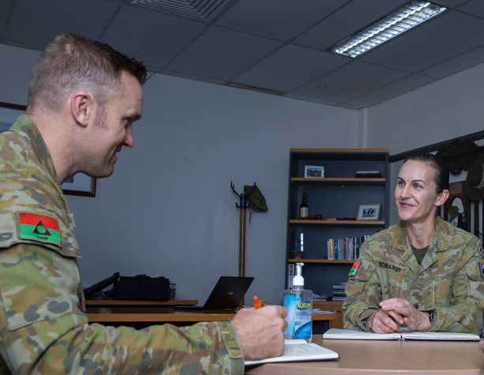**Student B: (Senior Officer):** You are Student A's boss. You are not sure about this idea. You don’t think women want to join and think women are not as useful as men. Listen and ask extra questions to make sure you understand student A’s ideas well.

I am worried about…

One benefit would be…

We can get more women to join by (+ verb + ing)

I’m not sure I agree.



## \\d85userdata.dpe.protected.mil.au\ma\marcos.pougy\Downloads\camera icon.png You will watch a video about how peacekeepers helped a school in South Sudan. Search You Tube for “[Vietnamese peacekeepers transfer humanitarian projects to South Sudan](https://www.youtube.com/watch?v=GELIu_1RZZw)” or scan the QR code. 🡪

## Tick the ways the peacekeepers helped:

* They taught classes
* They built a road
* They built a school
* They gave them a computer and a library
* They made sure they had water
* They drove the students to school



## For more practice with the words you’ve learned here, scan the QR code for a set of Quizlet flashcards. You can do some more study on the vocab in this lesson on your own with these. 🡪

## This lesson links with: Lesson: Demining – Women in the Defence Forces – Reading

Lesson: Life of a UN Peacekeeping Officer – Medic – parts A, B, C and D – Listening

Lesson: A day in the Life of a UN Peacekeeping Officer – Reading

Lesson: Demining – Women in the Defence Forces – Reading

© Commonwealth of Australia 2025   
This work is copyright. Apart from any use as permitted under the Copyright Act 1968 (Cth), no part may be reproduced by any process without prior written permission from the Department of Defence.