

**Military English**

Lesson: An Officer’s Biography – Reading

**Overview:**  
This lesson presents vocabulary related to an army officer’s life and career, in the context of a biography sent to the CO of a new unit.

**In this lesson, you will:**

* read and find the main idea in a text
* read for detail
* learn the meaning of new words
* use new words in writing
* practise writing your own biography

## Prepare for Reading

1. Discuss these questions with a partner.

Yes? What do you write?

a. Before you start working in a new place, do you have to talk or write to your new CO?

No? How do you usually introduce yourself?

b. How will you meet all the other people when you are in a new unit?

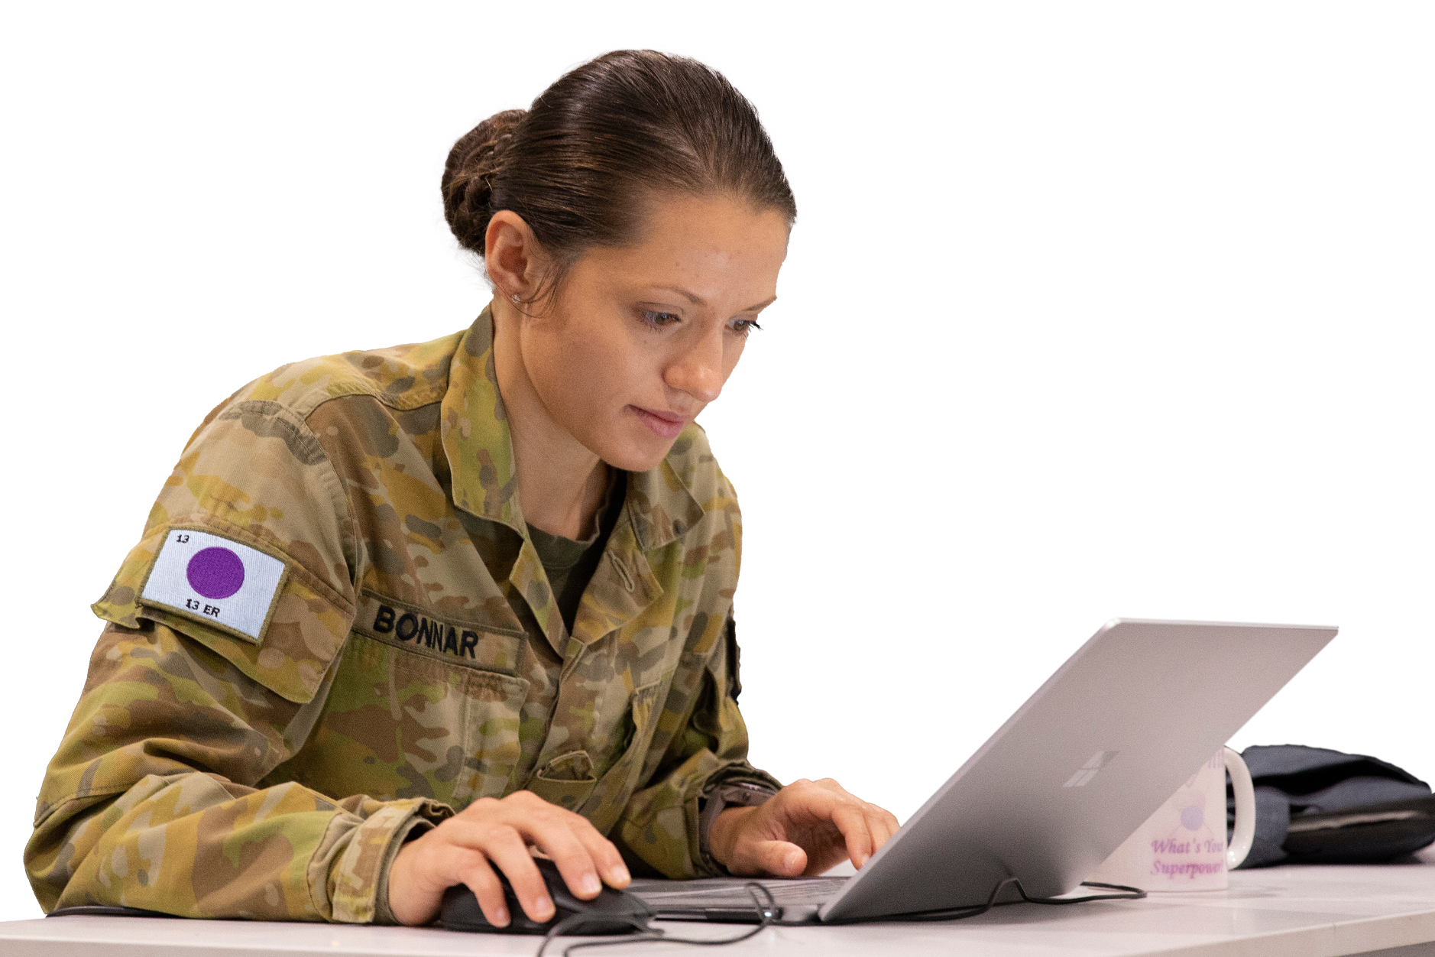

**biography** (n) – a short story of who you are and what jobs you have done.

Short form – **bio**.

1. In the ADF, before starting work in a new place, an officer must send a letter to his/her new CO.
2. Look at the list of topics below. Write the topics below in the correct box.

* rank
* when you joined the army, navy or air force
* any awards or medals you have
* things you’re not good at
* what you like doing in your job
* past jobs
* future jobs
* education
* family
* spare time activities
* favourite food
* names of pets

what is NOT in a bio

what MIGHT be in a bio

what MUST be in a bio

## Reading

1. Read this letter from an Australian Army Officer quickly. Answer the questions, as you read.
   1. Is this formal or informal? How do you know?
   2. Who is sending the letter? Who is receiving it?
   3. Do you think Penny will be good at her new job? Why/not?

|  |  |
| --- | --- |
|  | **AUSTRALIAN DEFENCE FORCE**  **TRAINING CENTRE** |
| Defence International Training Centre |

1. **Lieutenant Colonel Maria Famm**

Commanding Officer

Defence Force School of Languages  
Royal Australian Air Force Base Williams

LAVERTON VIC 3027

Dear Ma’am

1. I am excited to begin my Vietnamese language course at the Defence Force School of Languages   
   so I can go to Vietnam in the future. I would like to take this opportunity to introduce myself.
2. In 2018, I was **commissioned** into the Royal Australian Army Educational **Corps,** because I wanted a challenging and exciting **career.**
3. My first **posting** as a Lieutenant was to **Headquarters** – Education Wing at Simpson **Barracks**, Melbourne. Here I gave educational support to the Defence Force School of Signals. In 2019, I completed the **Specialist** Service Officers’ First Appointment Course at Royal Military **College** – Duntroon, Canberra. In 2020, I was posted to Army Education Centre – Central West at the Royal Australian Air Force (RAAF) Base Edinburgh, South Australia. Here, I provided instructor professional development for the Warrant Officer and Non-Commissioned Officer Academy. At the end of 2021, I was **promoted** to the **rank** of Captain and then posted to the Army Logistics Training Centre at Latchford Barracks, Bonegilla in 2022. Here, I provided learning systems advice to the Workforce and Training Group trade **cells**. I am currently posted to the Defence International Training Centre as an instructor.
4. I am married without children. My husband is an RAAF **Warrant Officer**, who is **based** at RAAF **Base** Point Cook, in Melbourne. I like sports, especially volleyball. I also enjoy playing the guitar.
5. I look forward to improving my language skills at the Defence Force School of Languages to help me with my future posting to Vietnam.

Yours faithfully

1. **Penny Tarnar**

Captain

Instructor

0412 123 456

penny.tarnar@defence.gov.au

1. Order the parts of the letter. Look at the example.

The reason for writing.

When the writer joined the military and details of their training.

Personal life such as family and spare time.

Future plans.

**1**

The COs name and contact details.

List of postings highlighting why you will be good at the new job.

The writer’s name and contact details.

## Learning Military Vocabulary

1. The words in **bold** are important military words that you should learn. Match the military words on the left to their definitions on the right. Look at the example first.

|  |  |  |  |  |  |  |
| --- | --- | --- | --- | --- | --- | --- |
| Table one |  | |  | |  | |
| I was **commissioned** into the… | |  | |  | | 1. (n) Military personnel live and sleep in these buildings. | |
| Royal Australian Army Educational **Corps** | | **f** | |  | | 1. (v) When military personnel move to a different place to work for some time e.g. 2 years. | |
| a challenging and exciting **career** | |  | |  | | 1. (v) To be given the right to lead in the military. | |
| My first **posting** was to… | |  | |  | | **d. (n) A group who has the same kind of job or trade.** | |
| posting was to **Headquarters** – Education Wing | |  | |  | | 1. (n) An expert in their field. | |
| To Simpson **Barracks** | |  | |  | | 1. (n) The jobs or work someone does over their lifetime. | |
| **Specialist** Service Officers | |  | |  | | 1. (n) The place where military leaders plan and control operations. | |
| Table two | |  | |  | |  | |
| Royal Military **College** | |  | |  | | 1. (n) A building or group of buildings where soldiers work and live. | |
| I was **promoted** | |  | |  | | 1. (n) Small groups of people who work together on a special task or area. They are like small teams within a bigger group. | |
| the **rank** of captain | |  | |  | | 1. (n) A high-ranking soldier. | |
| Workforce and Training Group trade **cells** | |  | |  | | 1. (n) What level an officer or a soldier is. For example, lieutenant, captain, private, etc. | |
| My husband is a **Warrant Officer** | |  | |  | | 1. (v) To stay at a main workplace or home location for a job in a particular place. For an officer, it is where they live and work most of the time. | |
| who is **based** at | |  | |  | | 1. (v) when someone moves to a higher level or position in the military e.g. move from captain to major | |
| Air Force **Base** | |  | |  | | 1. (n) a school that teaches or trains people for a job | |

1. A black background with a black square

   AI-generated content may be incorrect. Now let’s practise saying the words. Listen and repeat.
2. Complete the sentences below with words from exercise four.
3. When I went across to the _________________________ the CO was in her office.
4. The highest _________________ in the army is General.
5. I went to military __________________________ to do officer training for 3 months.
6. The General works at a large army _________________ in the capital of my country.
7. I am a Lieutenant. In two years, I hope to be ___________________ to Captain.
8. Look at CAPT Tarnar’s letter on page 3 again. Highlight the verbs in the text.

* What tense are they in?
* Are they active or passive? Why?

1. Read sentences from another bio below. Can you put the verbs in the right tense and correct voice (passive or active)? Look at the example.

am based

1. Currently, I (base) at the Defence Force School of Languages.
2. I (join) the RAN in 1990 as an Apprentice at HMAS Nirimba.
3. I (base) in this position within the United States Fifth Fleet as the Director of Operations for the Combined Maritime Forces in 2018.
4. I (serve) as the Chief of Staff to the Chief of the Defence Force from 2022-2021.
5. I (commission) as an officer in 2024.
6. I (promote) to the rank of Commodore in 2009.
7. I (look) forward to being deployed as a peacekeeper in the future.
8. In the future, I want (post) overseas.

## Speaking practice

1. Congratulations! You have your new dream posting and are getting ready to write a letter introducing yourself to your new CO! Make notes about the following.

* What the job is and where it is
* When you joined the military and your training
* List of postings highlighting why go will be good at this job
* Personal life such as family and spare time
* Future plans

1. Tell your partner about yourself using the notes above. Do they think you will be good at the new job? Do they have any other ideas for your letter?

**Writing practice**

1. Now try writing your own letter of introduction.

* Use pages 2-5 to help you structure your writing.
* Try to use as many of the words from this lesson as possible

__________________________________________________________________________________________________________________________________________________________________________________________________________________________________________________________________________________________________________________________________________________________________________________________________________________________________________________________________________________________________________________________________________________________________________________________________________________________________________________________________________________________________________________________________________________________________________________________________________________________________________________________________________________________________________________________________________________________________________________________________________________________________________________________________________________________________________________________________________________________________________________________________________________________________________________________________________________________________________________________________________________________________________________________________________________________________________________________________________________________________________________________________________________________________________________________________________________________________________________________________________________________________________________________________________________________________________________________________________________________________________________________________________________________________________________________________________________________________________________________________________________________________________________________________________________________________________________________________________________________________________________________________________________________________________________________________________________________________________________________________________________________________________________________________________________________________________________________________________________________________________________________________________________________________________________________________________________________________________________________________________________________________________________________________________________________________________

1. Before you give your writing to a partner who will read your bio, check if you have used

* past and present tense
* passive and active voice correctly
* vocabulary from the lesson

## For more practice with the words you’ve learned here, scan the QR code for a set of flashcards. You can do some more study on the vocab in this lesson on your own with these. 🡪

## This lesson links with: Lesson – An Officer’s Biography (Listening)

© Commonwealth of Australia 2025  
This work is copyright. Apart from any use as permitted under the Copyright Act 1968 (Cth),   
no part may be reproduced by any process without prior written permission from the Department of Defence.