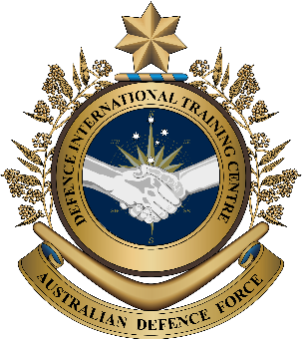

**Military English**

Lesson: United Nations Blue Helmets – Reading

**Overview:**  
This lesson presents vocabulary related to the Blue Helmets in the United Nations (UN).

**In this lesson, you will:**

* read and find the main ideas in a text
* read for detail
* learn the meaning of new words
* use new words in a conversation

## Prepare for Reading

1. Look at the pictures below and discuss these questions with your partner.
2. What jobs do the Blue Helmets do?

**Blue Helmet** (n) –   
a soldier of a UN Peacekeeping force.

Why blue? The helmets are the same colour as the UN flag and are easy to see.

1. Have any personnel from your country worked as a UN Blue Helmet?   
   Did they enjoy it? If you don’t know any, would you like to be one? Why?

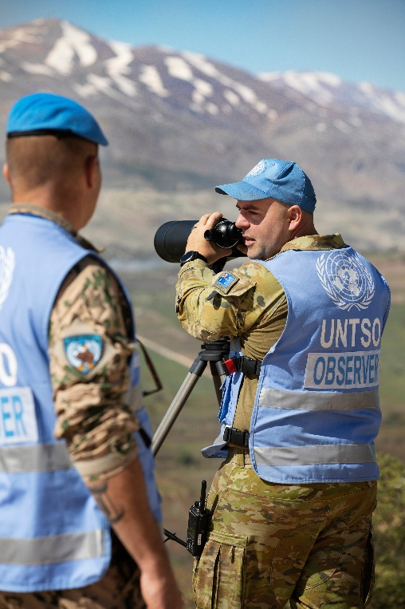

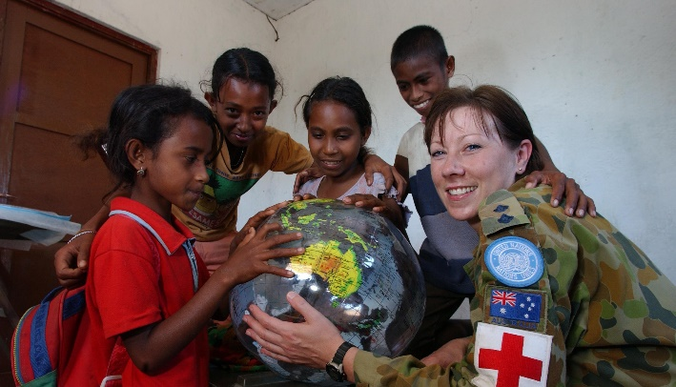

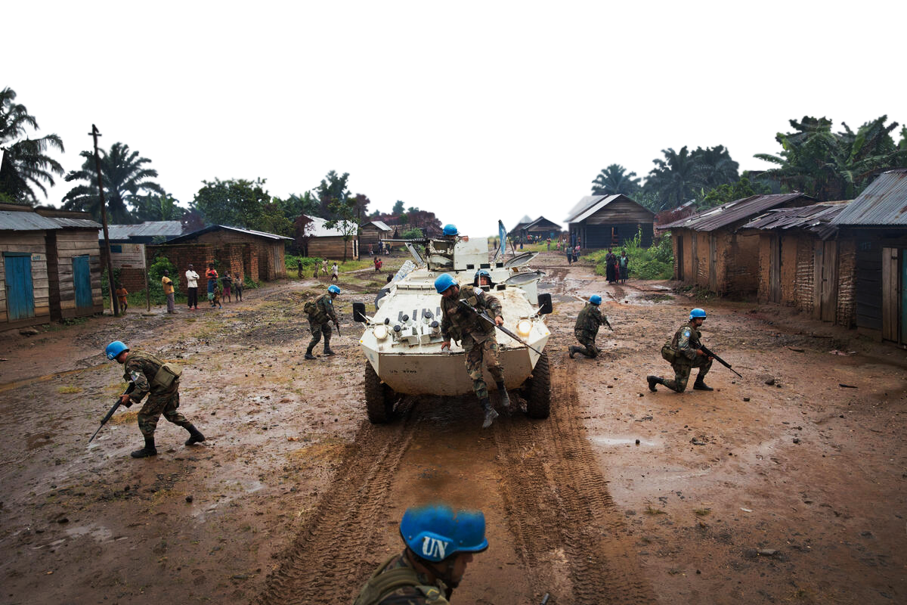

*image: UN*

## Reading

1. Read the text quickly. Which paragraph of the text answers each of the questions below? Write the questions at the top of each paragraph.

* What other jobs do UN Peacekeepers do?
* Where do the Blue Helmets come from?
* What do Blue Helmets do to keep the peace?

A. \_\_\_\_\_\_\_\_\_\_\_\_\_\_\_\_\_\_\_\_\_\_\_\_\_\_\_\_\_

All military personnel who work under the **Blue Helmet** are members of their own national armies. They are **seconded** to work under the command and control of the United Nations.

The UN has more than 97,000 UN military personnel from more than 120 countries. They bring different cultures and experience to the job, but they all have the same goal – peace. At present, most troops come from African and Asian countries. For example:

|  |  |  |  |  |
| --- | --- | --- | --- | --- |
| Country | Experts | Police | **Staff Officer** | Troops |
| Nepal | 40 | 226 | 112 | 5,753 |
| Ghana | 0 | 26 | 84 | 2,197 |
| Cambodia | 7 | 0 | 19 | 584 |
| Thailand | 13 | 1 | 5 | 273 |
| Timor-Leste | 2 | 0 | 0 | 0 |
| Indonesia | 14 | 140 | 37 | 2,478 |
| Malaysia | 14 | 24 | 14 | 824 |

*True as at 30/09/2024*

## B. \_\_\_\_\_\_\_\_\_\_\_\_\_\_\_\_\_\_\_\_\_\_\_\_\_\_\_\_\_

## Some of the tasks of the Blue Helmets:

* **Protect** civilians and UN personnel.
* **Monitor** a **disputed** **border**.
* Monitor peace activities in **post-conflict** areas.
* Provide **security** across a **conflict zone** and during elections.
* Assist **in-country** military personnel with training and support.
* Assist **ex-combatants** with **peace agreements**.

## C. \_\_\_\_\_\_\_\_\_\_\_\_\_\_\_\_\_\_\_\_\_\_\_\_\_\_\_\_\_

The most common sort of UN peacekeeper is the **infantry soldier**. However, the UN also needs personnel with special skills, for example engineers to help build new roads in South Sudan, helicopter **crews** and medical personnel.

1. Read the text again, and complete the spaces with numbers or letters.
2. Number of Blue Helmet police from Indonesia: \_\_\_\_\_\_\_\_\_\_\_\_
3. Number of Blue Helmet troops from Ghana: \_\_\_\_\_\_\_\_\_\_\_\_
4. The biggest number of Blue Helmets have this job: \_\_\_\_
5. Number of Staff Officers from Malaysia: \_\_\_\_\_\_\_\_\_\_\_\_

## \\d85userdata.dpe.protected.mil.au\ma\marcos.pougy\Downloads\pngkey.com-united-nations-logo-png-1391666.png

**FACT SHEET**

## Learning Military Vocabulary

1. The words in **bold** are important military words that you should learn. Match the military words on the left to their definitions on the right. Look at the example.

|  |  |  |  |
| --- | --- | --- | --- |
| Table one |  |  |  |
| personnel who work under the **Blue Helmet** |  |  | 1. (adj) when two or more countries disagree on the ‘line’ dividing their countries |
| they are **seconded** |  |  | 1. (adj) the time after a war |
| **Staff Officer** | **e** |  | 1. (v) to watch an activity to make sure people are following the rules or to see what is happening |
| **protect** civilians  *protection (n)* |  |  | 1. \\d85userdata.dpe.protected.mil.au\ma\marcos.pougy\Downloads\UN7720725.jpg(n) part of a UN peacekeeper's uniform; we often use this to talk about a peacekeeper   *image: UN* |
| **monitor** borders |  |  | 1. **(n) this officer** [**helps**](https://dictionary.cambridge.org/dictionary/english/help) **their boss** [**plan**](https://dictionary.cambridge.org/dictionary/english/plan)[**military**](https://dictionary.cambridge.org/dictionary/english/military)[**operations**](https://dictionary.cambridge.org/dictionary/english/activity) **and make decisions.** |
| a **disputed** **border** |  |  | 1. (v) to defend or keep safe |
| in **post-conflict** areas |  |  | 1. (v) when the military of a country sends personnel to work in a different unit or country for a short time |

|  |  |  |  |
| --- | --- | --- | --- |
| Table 2 |  |  |  |
| provide **security** |  |  | 1. (n) people who were fighting in a war, but not anymore |
| across a **conflict zone** |  |  | 1. (n) when groups or countries agree to stop fighting; this is usually an official paper (document). |
| **in-country** military personnel |  |  | 1. \\d85userdata.dpe.protected.mil.au\ma\marcos.pougy\Downloads\20241115army8663170_0013 (1).jpg(n) groups of soldiers who work together in vehicles such as aircraft, ships, tanks |
| assist **ex-combatants** |  |  | 1. (n) protection of people, organizations, or nations from danger |
| assist with **peace agreements** |  |  | 1. (n) a soldier who fights on foot and uses guns and other weapons e.g. assault rifles, grenades |
| **infantry soldier** |  |  | 1. (n) an area where fighting is happening |
| helicopter **crews** |  |  | 1. (n) inside a country |

****

1. Now let’s practise saying the words. Listen and repeat.
2. Complete the sentences below with words from exercise four.
3. Personnel from a country can be \_\_\_\_\_\_\_\_\_\_\_\_\_\_\_\_\_\_\_\_ to different UN Peacekeeping Operations.
4. In many missions, the most important thing is to \_\_\_\_\_\_\_\_\_\_\_\_\_\_\_\_\_\_ civilians.
5. Over 70,000 UN \_\_\_\_\_\_\_\_\_\_\_\_\_\_\_\_ \_\_\_\_\_\_\_\_\_\_\_\_\_\_\_\_\_\_ are deployed in many parts of the world.
6. A \_\_\_\_\_\_\_\_\_\_\_\_\_ \_\_\_\_\_\_\_\_\_\_\_\_\_\_\_\_\_ is important to end the fighting and bring peace to a region.
7. \_\_\_\_\_\_\_\_\_\_\_\_\_\_\_\_\_\_\_\_\_ at a military base is very important to keep all the personnel inside it safe.
8. The peace talks included many people who were still fighting but also \_\_\_\_\_\_\_\_\_\_\_\_\_\_\_\_ who once fought in the war.
9. Ship’s \_\_\_\_\_\_\_\_\_\_\_\_\_\_\_\_\_ work on different areas of the ship, such as in the galley, the engine room or cleaning equipment.

## Practice

1. Are you ready to put on the Blue Helmet?

* Think of the things that a blue helmet does. Can you do these things? What can you do to get better at these things?
* Write them down below, in a few words.

**I feel ready to serve in UN peacekeeping operations.**

|  |  |
| --- | --- |
| Things I can already do | Things I want to get better at |
|  |  |

1. Show your list to your partner and discuss. Do they have skills you do not? How did they get them?   
   Do they have any ideas about how you can get better?

|  |  |  |
| --- | --- | --- |
| **LANGUAGE BOX** | Asking questions:   * How did you get good at \_\_\_\_\_\_\_\_\_? * Can you give me some ideas about \_\_\_\_\_\_? * Where did you learn to \_\_\_\_\_\_\_\_?   Making suggestions:   * I think you should \_\_\_\_\_\_. * It might be a good idea to\_\_\_\_\_\_. | If you don’t understand your partner, you can say this:   * Could you say that again? * What do you mean? |

1. Thinking homework. Do you have any new learning goals after today?

****

* 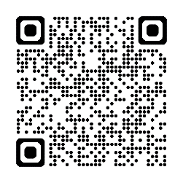 Watch this video about the Blue Helmets and tick the words below that you hear or read in the video. Type on YouTube [Who Are United Nations Peacekeepers?](https://www.youtube.com/watch?v=vREHxW3RtvI) or scan the QR code. 🡪

Staff Officer  conflict  security  engineer

peacekeeper  peace agreement  monitor

**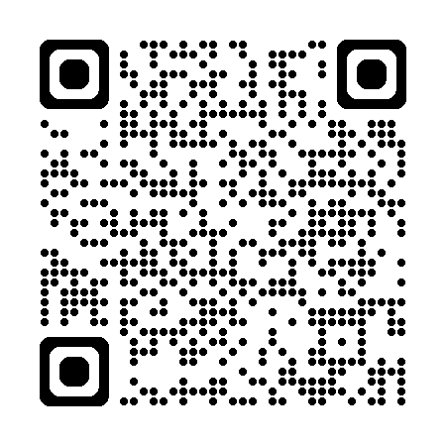**

## For more [practise](https://quizlet.com/1013440184/edit) with the words you’ve learned here, scan the QR code for a set of flashcards. You can do some more study on the vocab in this lesson on your own with these. 🡪

## This lesson links with: Lesson - A day in the life of a UN Peacekeeping Officer – Reading

Lesson - Women in Blue Berets - Peacekeeping in South Sudan – Listening

© Commonwealth of Australia 2025  
This work is copyright. Apart from any use as permitted under the Copyright Act 1968 (Cth),   
no part may be reproduced by any process without prior written permission from the Department of Defence.