**A**

student

**Military English**

Vocabulary Builder: Countries and Flags – East Asia

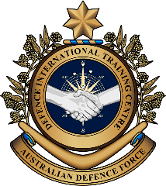

**Overview:**  
This sheet lists vocabulary of countries and their flags, nationalities, and languages in East Asia.

**In this vocabulary builder, you will:**

* learn and use vocabulary related to the countries in this region.

1. Do you know where each country of East Asia is? Write the word on the line, then check your answers with a partner.

South Korea Japan China North Korea Mongolia

b. ______________________________

a. ______________________________

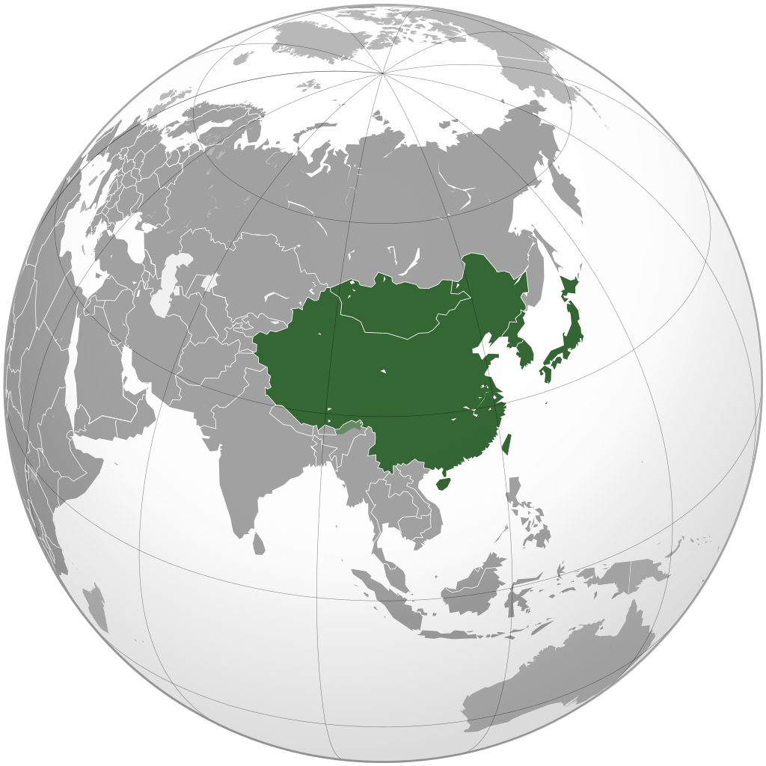

c. ______________________________

d. ______________________________

e. ______________________________

1. Discuss these questions with a partner.

Have you visited any of these East Asian countries?

No?

Which country would you like to visit the most? Why?

Did you like it? Why?

Yes?

Did you go on holiday or work?

Did you like it? Why?

1. Work in pairs. Are the flags and countries correct? If they are not, write the correct country next to each flag. If they are, put a tick ( ✓ ) on the line. Look at the example.

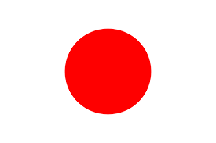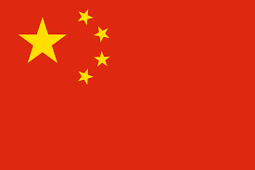

**China**

**Mongolia**

**South Korea**

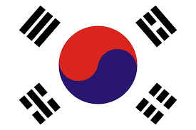

c. ____________________

b. ______________________

Japan

a. ______________________

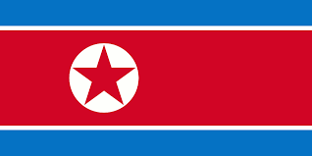

**South Korea**

**North Korea**

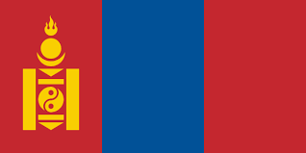

d. ___________________________

d. ____________________________

1. Practise the pronunciation of these countries. Listen and repeat.
2. Use the words in the boxes to fill in the sentence about the language of each country. Then check with a partner.

Australia

English

For example: In _________________, the official language is _______________.

1. In **J**___________________, the official language is ____________________.
2. In **N**____________________, the official language is ___________________.
3. In ___________________, the official language is **Mandarin**.
4. In ___________________, the official language is **M**___________________.
5. In ____________________, the official language is **K**___________________.
6. With a partner, write the nationalities* of the countries in East Asia.

* The nationalities below end in: ___ese, ___an

a. South/North Korea - ______________________

c. China - _________________________________

b. Japan - _____________________________

d. Mongolia - __________________________

\***nationality** (n) – the country a person belongs to e.g. the nationality of Australia is Australian.

1. Practise the pronunciation of the nationalities and languages of East Asia. Listen and repeat.
2. Work in pairs. Use only the words from this lesson to answer this quiz.

* Read the questions below to your partner. Student A and B have different questions.
* If they answer correctly, put a tick in the table below.
* If they answer incorrectly, read them the correct answer.
* Now, it’s your partner’s turn to ask you questions.
* At the end, the students with more ticks is the winner.

STUDENT A

|  |  |  |
| --- | --- | --- |
| **Read these questions.** | **Read these answers if your partner’s answer are not correct.** | **Tick (✓) the correct answers.** |
| What is the largest country in East Asia? | China |  |
| In which country is Mt Fuji? | Japan |  |
| Which two countries were one country in the past? | North Korea and South Korea |  |
| Which country is not near the ocean? | Mongolia |  |
| In English, you can call one Korean person ‘a Korean’. Can you say: ‘a Chinese?’ | No. (You have to say ‘a Chinese person’). |  |
| Where did the first noodles in the world come from? | China |  |
| Where are horses very important? | Mongolia |  |
|  | Write here how many points your partner scored 🡪 |  |

* 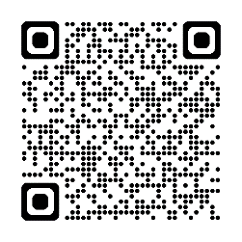Test your knowledge of the flags. Type into YouTube [East Asia Flag Quiz](https://www.youtube.com/watch?v=_DQXLaeoszU) or scan the QR code to the right 🡪
* 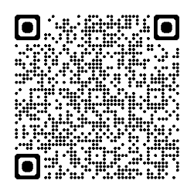For more practice with the words you’ve learned here, scan the QR code for a set of flashcards.

You can do some more study on the vocab in this lesson on your own with these. 🡪

* This Vocabulary Builder links with 🡪 Vocabulary Builder – Countries and Flags – Oceania Part A & Part B, South East Asia, South Asia.

© Commonwealth of Australia 2025  
This work is copyright. Apart from any use as permitted under the Copyright Act 1968 (Cth),   
no part may be reproduced by any process without prior written permission from the Department of Defence.

student

**B**

**Military English**

Vocabulary Builder: Countries and Flags – East Asia



**Overview:**  
This sheet lists vocabulary of countries and their flags, nationalities, and languages in East Asia.

**In this vocabulary builder, you will:**

* learn and use vocabulary related to the countries in this region.

1. Do you know where each country of East Asia is? Write the word on the line, then check your answers with a partner.

South Korea Japan China North Korea Mongolia

b. ______________________________

a. ______________________________



c. ______________________________

d. ______________________________

e. ______________________________

1. Discuss these questions with a partner.

Have you visited any of these East Asian countries?

No?

Which country would you like to visit the most? Why?

Did you like it? Why?

Yes?

Did you go on holiday or work?

Did you like it? Why?

1. Work in pairs. Are the flags and countries correct? If they are not, write the correct country next to each flag. If they are, put a tick ( ✓ ) on the line. Look at the example.



**China**

**Mongolia**

**South Korea**



c. ____________________

b. ______________________

Japan

a. ______________________



**South Korea**

**North Korea**



d. ___________________________

d. ____________________________

1. Practise the pronunciation of these countries. Listen and repeat.
2. Use the words in the boxes to fill in the sentence about the language of each country. Then check with a partner.

Australia

English

For example: In _________________, the official language is _______________.

1. In **J**___________________, the official language is ____________________.
2. In **N**____________________, the official language is ___________________.
3. In ___________________, the official language is **Mandarin**.
4. In ___________________, the official language is **M**___________________.
5. In ____________________, the official language is **K**___________________.
6. With a partner, write the nationalities* of the countries in East Asia.

* The nationalities below end in: ___ese, ___an

a. South/North Korea - ______________________

c. China - _________________________________

b. Japan - _____________________________

d. Mongolia - __________________________

\***nationality** (n) – the country a person belongs to e.g. the nationality of Australia is Australian.

1. Practise the pronunciation of the nationalities and languages of East Asia. Listen and repeat.
2. Work in pairs. Use only the words from this lesson to answer this quiz.

* Read the questions below to your partner. Student A and B have different questions.
* If they answer correctly, put a tick in the table below.
* If they answer incorrectly, read them the correct answer.
* Now, it’s your partner’s turn to ask you questions.
* At the end, the students with more ticks is the winner.

STUDENT B

|  |  |  |
| --- | --- | --- |
| **Read these questions.** | **Read these answers if your partner’s answer are not correct.** | **Tick (✓) the correct answers.** |
| What is the nationality of K-pop bands? | South Korean |  |
| If you’re born in China, you are ___________. | Chinese *(not China)* |  |
| What is the only country with a different word for the language and nationality? | China |  |
| What language do people from Mongolia speak? | Mongolian |  |
| Which country is next to South Korea and China? | North Korea |  |
| Where is sushi from? | Japan |  |
| Which 2 countries speak the same language? | North Korea and South Korea |  |
|  | Write here how many points your partner scored 🡪 |  |

* Test your knowledge of the flags. Type into YouTube [East Asia Flag Quiz](https://www.youtube.com/watch?v=_DQXLaeoszU) or scan the QR code to the right 🡪



* For more practice with the words you’ve learned here, scan the QR code for a set of flashcards. You can do some more study on the vocab in this lesson on your own with these. 🡪
* This Vocabulary Builder links with 🡪 Vocabulary Builder – Countries and Flags – Oceania Part A & Part B, South East Asia, South Asia.

© Commonwealth of Australia 2025  
This work is copyright. Apart from any use as permitted under the Copyright Act 1968 (Cth),   
no part may be reproduced by any process without prior written permission from the Department of Defence.