**Military English**

Vocabulary Builder: Countries and Flags – South Asia

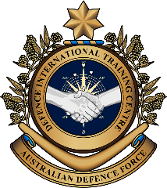

**Overview:**  
This sheet lists vocabulary of countries, their flags, nationalities, and languages in South Asia.

**In this vocabulary builder, you will:**

* learn and use vocabulary related to South Asian countries.

1. Work in groups of four. Have a conversation about the countries below. Use the questions to help you.

Afghanistan Bangladesh Bhutan India Iran

Maldives Nepal Pakistan Sri Lanka

Which countries have you visited? Did you go on holiday or work?

What did you do there? Did you like it? Why?

1. Work in pairs. Unscramble the letters to form the names of countries in South Asia.

|  |  |
| --- | --- |
| \\d85userdata.dpe.protected.mil.au\ma\marcos.pougy\Downloads\Flag_of_India.svg.png  India   1. n/I/a/i/d: \_\_\_\_\_\_\_\_\_\_\_\_\_\_\_\_\_\_\_\_\_\_\_\_\_ | \\d85userdata.dpe.protected.mil.au\ma\marcos.pougy\Downloads\Flag_of_Bhutan.svg.png   1. h/u/B/a/n/t: \_\_\_\_\_\_\_\_\_\_\_\_\_\_\_\_\_\_\_\_\_\_\_\_\_ |
| 1. l/s/a/B/d/n/h/g/e/a: \_\_\_\_\_\_\_\_\_\_\_\_\_\_\_\_\_\_\_\_\_\_ | 1. g/A/h/f/a/s/i/t/n/a/n: \_\_\_\_\_\_\_\_\_\_\_\_\_\_\_\_\_ |
| 1. n/I/a/r: \_\_\_\_\_\_\_\_\_\_\_\_\_\_\_\_\_\_\_\_\_\_\_\_\_\_\_\_\_\_\_ | 1. l/a/M/v/i/d/e/s: \_\_\_\_\_\_\_\_\_\_\_\_\_\_\_\_\_\_\_\_\_\_ |
| 1. k/n/P/a/i/s/t/a: \_\_\_\_\_\_\_\_\_\_\_\_\_\_\_\_\_\_\_\_\_\_\_ | 1. S/a/r/i/L/n/a/k: \_\_\_\_\_\_\_\_\_\_\_\_\_\_\_\_\_\_\_\_\_\_ |
| 1. l/a/N/e/p: \_\_\_\_\_\_\_\_\_\_\_\_\_\_\_\_\_\_\_\_\_\_\_\_\_\_\_\_ |  |

****

1. Practise the pronunciation of these countries. Listen and repeat.
2. Guess the nationalities. Look at these countries and languages and write the correct nationality in the space. Look at the example.

Afghan Bangladeshi Bhutanese Indian

Iranian ~~Maldivian~~ Nepali Pakistani Sri Lankan

|  |  |  |
| --- | --- | --- |
| **Country** | **Nationality** | **Language** |
| 1. Maldives | \_\_\_\_\_\_\_\_\_\_\_\_\_\_\_\_\_\_\_\_\_\_\_\_  Maldivian | Dhivehi |
| 1. Afghanistan | \_\_\_\_\_\_\_\_\_\_\_\_\_\_\_\_\_\_\_\_\_\_\_\_ | Pashto; Dari |
| 1. Nepal | \_\_\_\_\_\_\_\_\_\_\_\_\_\_\_\_\_\_\_\_\_\_\_\_ | Nepali |
| 1. Bhutan | \_\_\_\_\_\_\_\_\_\_\_\_\_\_\_\_\_\_\_\_\_\_\_\_ | Dzongkha |
| 1. India | \_\_\_\_\_\_\_\_\_\_\_\_\_\_\_\_\_\_\_\_\_\_\_\_ | Hindi; English |
| 1. Iran | \_\_\_\_\_\_\_\_\_\_\_\_\_\_\_\_\_\_\_\_\_\_\_\_ | Persian |
| 1. Bangladesh | \_\_\_\_\_\_\_\_\_\_\_\_\_\_\_\_\_\_\_\_\_\_\_\_ | Bengali |
| 1. Pakistan | \_\_\_\_\_\_\_\_\_\_\_\_\_\_\_\_\_\_\_\_\_\_\_\_ | Urdu; English |
| 1. Sri Lanka | \_\_\_\_\_\_\_\_\_\_\_\_\_\_\_\_\_\_\_\_\_\_\_\_ | Sinhala; Tamil |

****

1. Practise the pronunciation of these nationalities and languages. Listen and repeat.
2. Let’s practise the vocabulary from this lesson. Do this speaking activity in groups of 3-4.

* 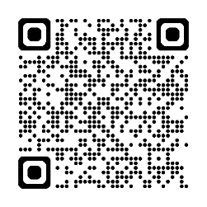You’ll need a dice, and counter (e.g. a coin) for each player. If you don’t have a dice, scan the QR code to the right.
* On the board on page four, put your counters on ‘Start’.
* Roll the dice to move your counters along the board.
* If you get a question, you must answer it correctly. If you don’t, go back the same number of squares.
* The winner is the first one to get to the ‘Finish’ square.

|  |  |  |  |  |  |  |
| --- | --- | --- | --- | --- | --- | --- |
| **START** | What languages do Pakistani people speak? | **Miss**  **A**  **Turn** | Which country has a lion on its flag? | What do we call people from Bhutan? | What colours are on the Indian flag? | **Go**  **Back**  **2 Spaces** |
| What languages do Afghan people speak? | What do we call people from the Maldives? | What colours are on the Nepali flag? | What colours are on the Bangladeshi flag | **Go**  **Back**  **2 Spaces** | What languages do Iranian people speak? | What language do Maldivian people speak? |
| Which country has a dragon on its flag? | What language do Sri Lankan people speak? | **Go**  **Forward**  **3 Spaces**  **☺** | What do we call people from Nepal? | What colours are on the Iranian flag? | What language do Indian people speak? | **FINISH** |

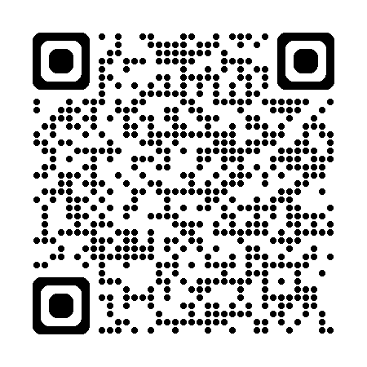

* Watch this video. Follow the instructions on the screen. Type into YouTube Guess the [flags](https://www.youtube.com/watch?v=dcI3Nsb6Z9w) – South Asia or scan the QR code.

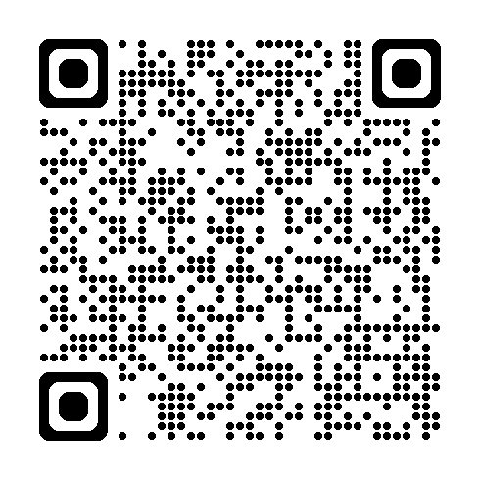

* For more practice with the words you’ve learned here, scan the QR code for a set of flashcards. You can do some more study on the vocab in this lesson on your own with these. 🡪
* This Vocabulary Builder links with 🡪 Countries and Flags – Southeast Asia

Countries and Flags – Oceania – Part A, B

Countries and Flags – East Asia

© Commonwealth of Australia 2025  
This work is copyright. Apart from any use as permitted under the Copyright Act 1968 (Cth),   
no part may be reproduced by any process without prior written permission from the Department of Defence.