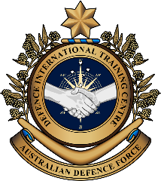
Military English
Lesson: Military Linguist - Reading

Overview:
This lesson is about the important role Military Linguists play.
In this lesson, you will:
- read and find general information in a text
- learn the meaning of new words
- use new words in a discussion
- practise interpreting skills in a dialogue.



Prepare for Reading
- Watch the video clip below and answer the questions with a partner.
Type “Learn another language” on YouTube (www.youtube.com/watch?v=1eknGauMhEw), or scan the QR Code.

- What language did the fish use?
- Why did the cat run away?
- Can learning another language save your life? Why?
- Why do some military personnel need to learn a foreign language? Tell your partner what you know about that job.

- Think about the role of an Australian army linguist and look at the activities listed below (a to f.). Tick the activities you think a military linguist would usually do.
- Ask people to speak in English.
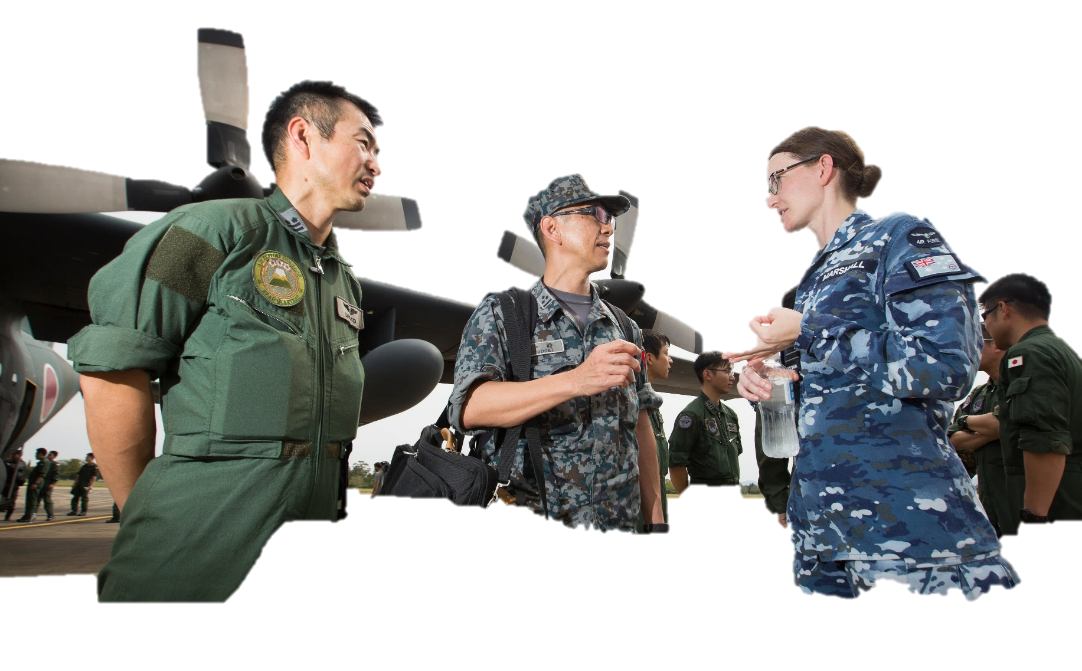
- Learn a foreign language.
- Translate documents from one language to another.
- Work with international defence force personnel.
- Communicate with military personnel from another country in their own language.
- Talk with local community leaders in a foreign country.

Reading
- Read the article below and underline the activities CPL James Rigg usually did. Check your answers with a partner/a group. Do not use a dictionary yet. You are going to learn the meaning of the words in bold in the next exercise.

Tip: When you read a text for the first time, you
- can try to read it quickly, to get an overall idea of the meaning of the whole text or of the topic of the whole text

- can try to complete the task that the teacher gives you but try not to worry about the words you don’t understand

- are usually looking for some key words or key ideas

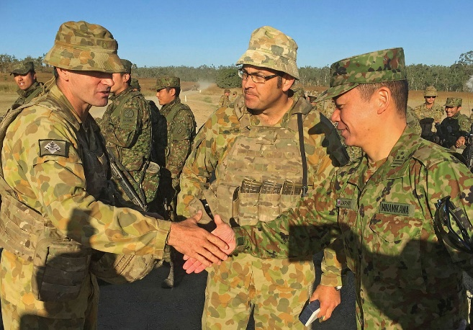
During Exercise Southern Jackaroo, Corporal James Rigg was one of six Military Linguists working with the Japan Ground Self-Defense* Force. He participated in every range movement and daily brief.

Japanese is a difficult language to learn. Corporal Rigg studied Japanese at the Australian Defence Force School of Languages for 12 months. He said 12 months was not enough for him to become confident. In the year after his language course, the Australian Defence Force (ADF) posted Corporal Rigg to Tokyo, Japan. Corporal Rigg said, “This was a great opportunity for some in-country language training and this made a big difference for my interpreting skill”.

According to Corporal Rigg, “It’s not only about being confident in a foreign language, a Defence Force Linguist also needs to know the culture of the country”. During Exercise Southern Jackaroo, Corporal Rigg explained some Japanese culture to his Australian colleagues, so they could interact with Japanese soldiers in a positive way. Corporal Rigg said the hardest part of this job was when he had to be the interpreter for a Japanese Officer who spoke really fast and with a different accent. “I really had to concentrate so I could understand what he said”.

Being an interpreter and translator is a very important job for the ADF’s mission to support peace and stability in the region. It helps Australia build relationships with other countries. Corporal Rigg explained why he loves this job: “As an Army Linguist, I travel a lot, meet new people, learn about other cultures, and be the point of contact between Japanese and Australian forces. This is a job I’m proud of”.

* Please note “Defense” is the American spelling. Japan uses American spelling for English words. Australia uses the British spelling: “Defence”.
- Answer the following questions with the information from the text:
- How many military linguists were in James’ team during Exercise Southern Jackaroo?
- How long did James Rigg learn Japanese at the Australian Defence Force School of Languages?
- Where did James start to feel better about his Japanese?
- Why was interpreting the Japanese Officer so challenging?
- What do interpreters help build?
- How does James feel about this job?

Learning Military Vocabulary
- The words in bold in the text are important military vocabulary that you should learn to use. Match the military words on the left to their definitions on the right on tables one and two. Look at the bolded example on table one.
Table 1
A Military Linguist helps people to communicate when they don’t speak the same language |  |  | - (n) moving troops, vehicles, or weapons systems across a training range or battlefield to a new place
range movements to relocate troops and equipment |  |  | b. (adj) feeling sure about what you can do and be successful
daily brief for planning an exercise |  |  | - (n) when a student joins a school in another country
a confident speaker | b |  | - (v) to send somebody to work or study in another place, or country
The ADF posted Corporal Rigg to Tokyo |  |  | - (n) an officer who uses language skills for the military. This includes translating words, interpreting what people are saying, or teaching others a foreign language. The main job is to help people in the military understand each other better when they speak different languages.
in-country training  (in-country language training) |  |  | - (n) a short talk or update that happens every day to give information about what's going on
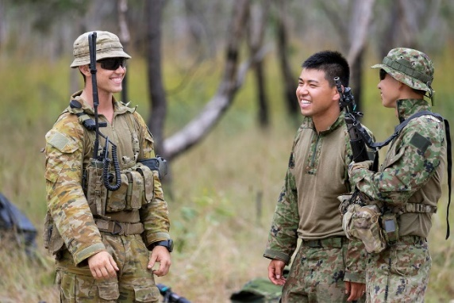
A Military Linguist from the Indonesian Army (centre) interprets a conversation between an Australian (left) and an Indonesian soldier (right) during Exercise Southern Jackaroo.
Table 2
interact (v) with foreign military forces |  |  | - (n) a person who you can speak to in an organisation when you need to talk about work or tasks
He speaks with an accent (n) |  |  | - (n) to make friends with someone by keeping in contact for a long time. This connection can bring benefits to all members.
Being and interpreter and translator (n) is a very important job |  |  | - (n) a situation where there is no war or conflict between countries. Countries in the region are friendly with each other
a mission (n) for supporting peace and stability |  |  | - (v) to talk with someone
peace and stability (n) in the region |  |  | - (n) someone who uses a foreign language to help someone talk to another person who does not speak the same language
to build relationships (n) with foreign countries |  |  | - (n) the way somebody pronounces words in their language or a foreign language. For example, American and Australian accents are quite different.
A point of contact (POC**) (n) for future communications |  |  | - (n) an important military role/job/task

** In the acronym “POC”, each letter must be pronounced “P. O. C.” (Pee Oh See); however, in the written form, you will most often see it written as “POC”.
- Now let’s practise saying the words from exercise 5. Listen and repeat.
- Try to use some of the words from exercise 5 correctly in the sentences below.
- The __________________ _________________ helped the soldiers understand and communicate in a foreign language.
- Practising ___________ ________________with other countries’ military forces during exercises is an important way of learning how to safely move troops and equipment in real combat situations.
- The Commanding Officer (CO) started the meeting with a ______________ ______________ to update all personnel on progress for the combined exercise.
- Australia wants to _________________ ________________ with countries in the Asia Pacific region to reduce conflict and maintain ________________ _______ __________________ in the region.
- Their French ________________ was so strong that sometimes it was difficult to understand what they said.
- The _____________________________ helped people who spoke different languages to understand each other at the UN meeting.
- If you have any questions about your application, your Administration Officer will be your ________ _____ ________________.
- If we want to learn how the ADF conducts operations in Australia, it is necessary to join some ______ ________________ _________________________during combined exercises.

Practice
- Discuss these questions with a partner:
- Does your defence force have interpreters? What kinds of things do you see them doing?
- What skills do you need to be one?
- Would you like being an interpreter? Why (not)?
Interpreting task (Consecutive Interpreting) – Role Play
- Read the instructions below and then practice your interpreting skills!
Situation: You are a military interpreter during a combined military exercise between your country and the Australian Defence Force (ADF). Your role is to interpret dialogue between your commander and the ADF commander. The ADF Commander is meeting your Commander for the first time in Australia. At the meeting they will talk about preparations and planning for the exercise.
Roles:
Student A: ADF Commander (speak English – use the transcript)
Student B: Your country’s Commander (speak your first language– use the transcript)
Student C: Interpreter (interpret dialogue between Person A and Person B – use your interpreting skills!)
Interpreting skills:
- Always translate dialogue using the ‘first person’ – for example: “I welcome you to Australia…” Not “He said he welcomes you to Australia…”. As the interpreter, you are the voice of the person speaking. You must use the ‘first person’ pronoun (I, my, me) in both languages in both directions of the conversation.
- If you did not catch the meaning of a word, do not pretend to know, or guess the meaning. Always ask for an explanation of the meaning from the person speaking. The person speaking will usually use different words to help you understand.
- When you ask for an explanation from a speaker, always politely tell the other speaker what you are doing. Always include the other speaker. Repeat the information back to the other speaker quickly and efficiently.
- Interpreters can take notes if they want – but not too many! You don’t want to distract the people from their conversation. A and B should be able to see the notes. You could keep the paper on the table if you have one.

Foreign country Commander: speaks foreign language only
Use the transcript to help you.

B
Interpreter: speaks English and foreign language
Don’t use the transcript. Listen and interpret.

C

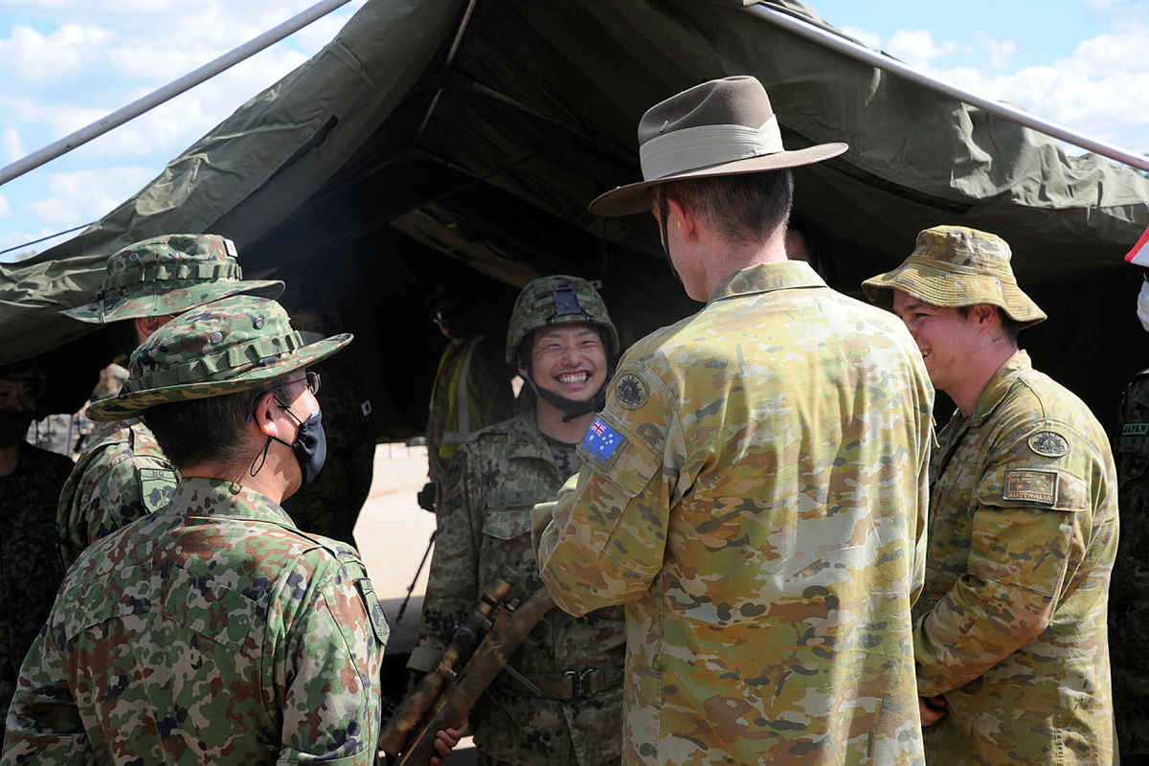

ADF Commander: speaks English only
Use the transcript
to help you.

A

B
A
C
English
Foreign language (your language)

Speaker | Transcript
A | Good afternoon. How are you?
B | Selamat siang Pak/Bu, saya baik-baik saja, terima kasih. Bagaimana kabar anda?
A | I’m fine too, thanks. Are you enjoying Australia?
B | Ya. Saya sangat senang ditempatkan di Australia dan dapat bekerja bersama-sama.
A | That’s good to hear. Well, let’s start with our daily brief.
B | Pertama-tama, bisakah Anda jelaskan apa yang akan kita diskusikan dalam pertemuan ini?
A | The aim is to discuss plans for both our forces during the exercise. Also, we can build relationships with officers from each country.
B | Ya, bagus sekali. Saya senang kita memiliki Penerjemah Militer bersama kita disini. Saya agak kesulitan memahami aksen Australia.
A | No worries, Ma’am/ Sir! Our interpreter from Headquarters can help us. This will also help us communicate during our range movements.
B | Jadi, di manakah daerah latihan dan pergerakan pasukannya?
A | At the defence training area in Queensland.
B | Berapa banyak negara yang akan terlibat dalam latihan ini?
A | There’ll be eight countries altogether, including your country.
B | Nampaknya ini akan menjadi seperti sebuah latihan besar.
A | Yes, it is. It’s a good chance for all countries’ armed forces to interact and train together.
B | Ya, ini adalah kesempatan bagus untuk pelatihan yang dilaksanakan di dalam negeri. Lantas, apa fokus misi pelatihannya?
A | That’s a good question. The main focus is on deploying military personnel and equipment for Humanitarian Assistance in a natural disaster.
B | Hmmmm, aku mengerti. Ini adalah sebuah upaya yang baik bagi semua negara untuk menjadi lebih percaya diri ketika bekerja sama dalam situasi yang sebenarnya.
A | Yes, that’s right. When there are real humanitarian disasters in our region, we hope to reduce the time for deploying military personnel and equipment.
B | Baiklah, terima kasih Pak/Bu. Itu saja pertanyaan saya untuk saat ini. Ini merupakan rapat harian yang bermanfaat.
A | No worries. I will be your Point of Contact for the exercise. Please feel free to contact me at any time. See you next time. Bye!

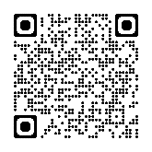
- Read this article about military linguist for more information: www.defence.gov.au/news-events/news/2022-12-22/linguists-vital-relationship-building
- Watch the video clip about being a military linguist for the Australian Defence Force. Type on YouTube How Australian Military Linguists Learn Languages Fast or scan the QR Code to the right.

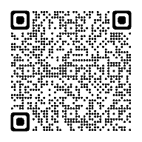
- For more practise with the words you’ve learned here, scan the QR code.

- This lesson links with Lesson – Military Exercises
Lesson – Humanitarian Aid

© Commonwealth of Australia 2025
This work is copyright. Apart from any use as permitted under the Copyright Act 1968 (Cth),
no part may be reproduced by any process without prior written permission from the Department

