# 

**Military English**

Lesson: On Patrol – NORFORCE: Eyes and Ears in the North – Reading

**Overview:**  
This lesson is about NORFORCE and how it conducts patrols in the northern and central regions of Australia.

**In this lesson, you will:**

* read a text for main ideas.
* find specific information in a text.
* learn the meaning of new words and practice using them.

## Prepare for Reading

1. NORFORCE are a special part of the Australian Armed Forces.
   1. What are they doing in the pictures?
   2. 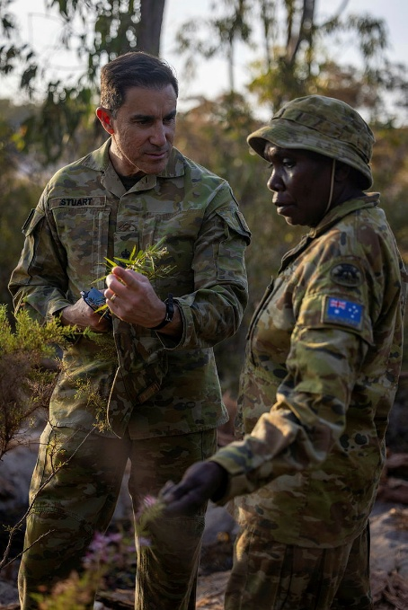What do you think NORFORCE does?
   3. 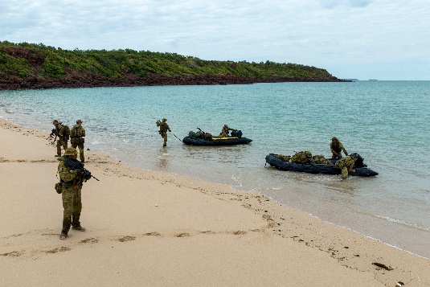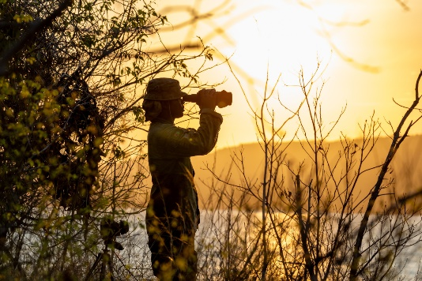What do you think makes this job special?

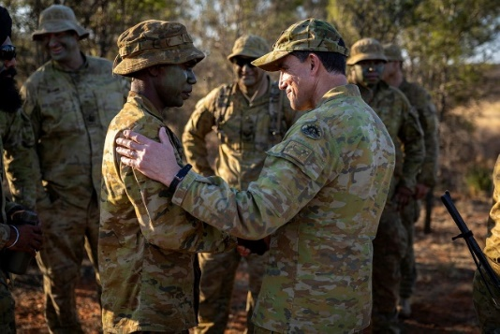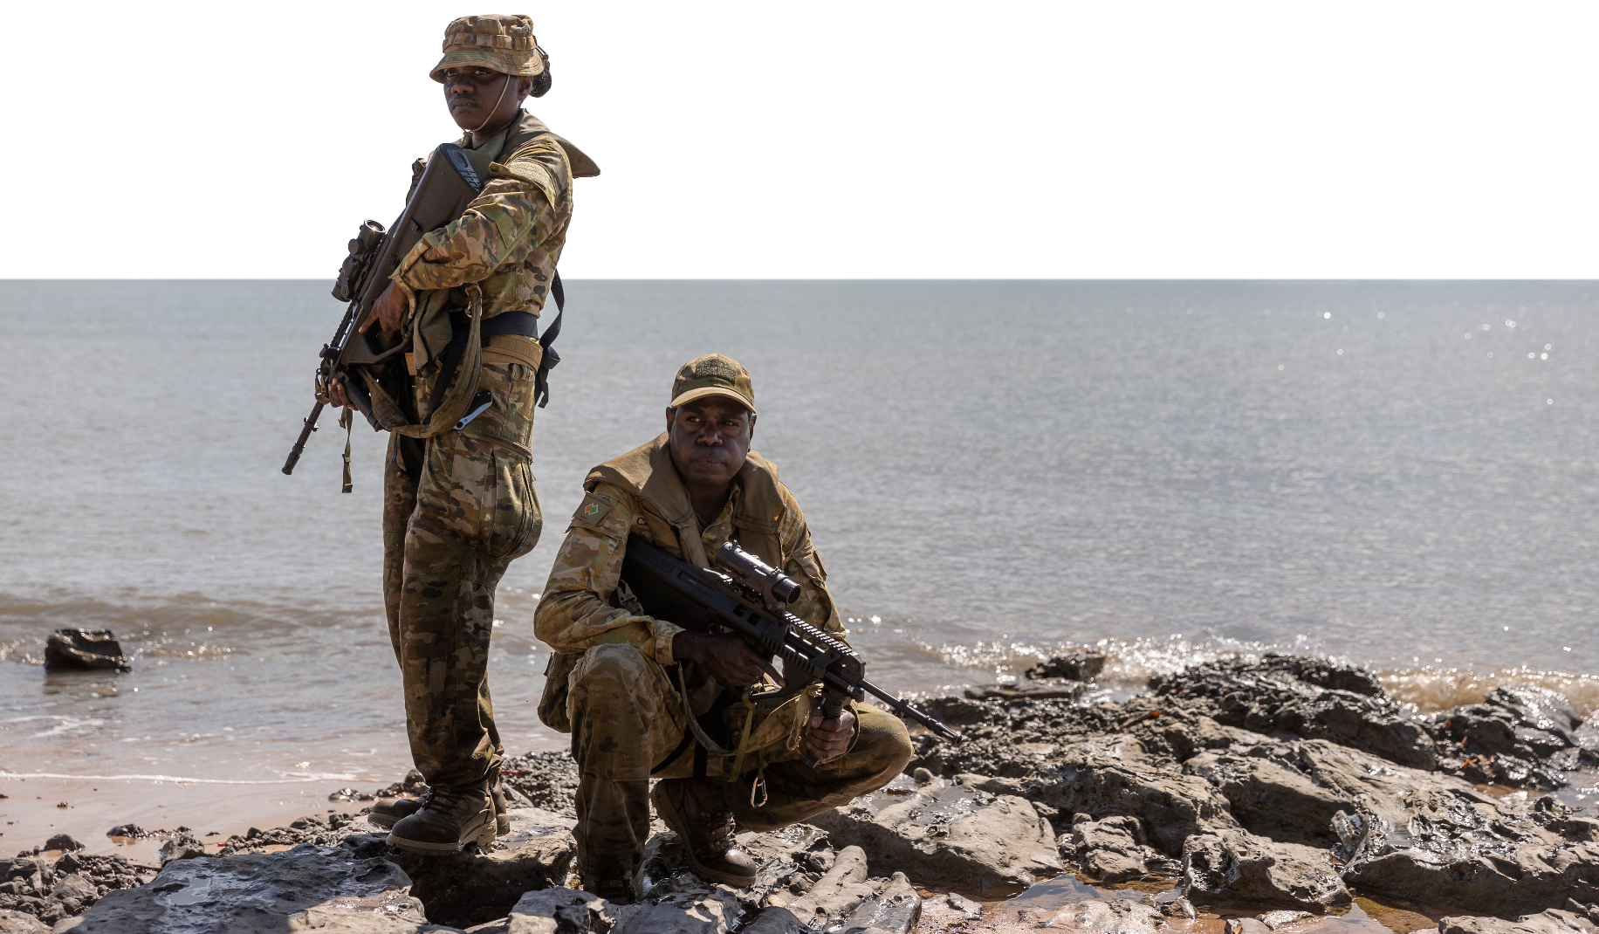

1. There are some words we need for today’s reading in the box. Match them with the pictures.

saltwater crocodiles // the bush // border // illegal fishing vessels //

F470 Zodiac // the Kimberleys // an Aboriginal woman // drugs

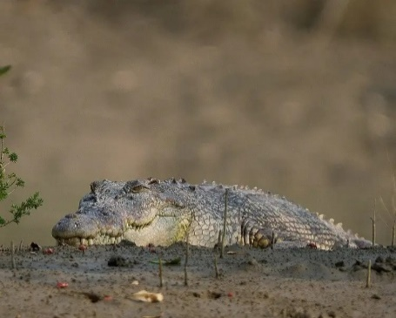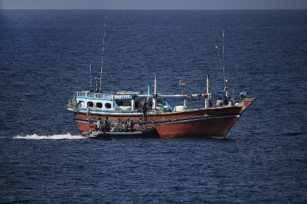

c. ___________________

b. ___________________

a. ___________________

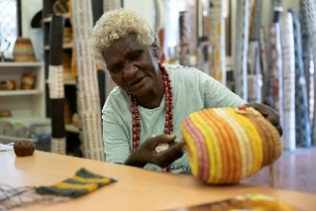

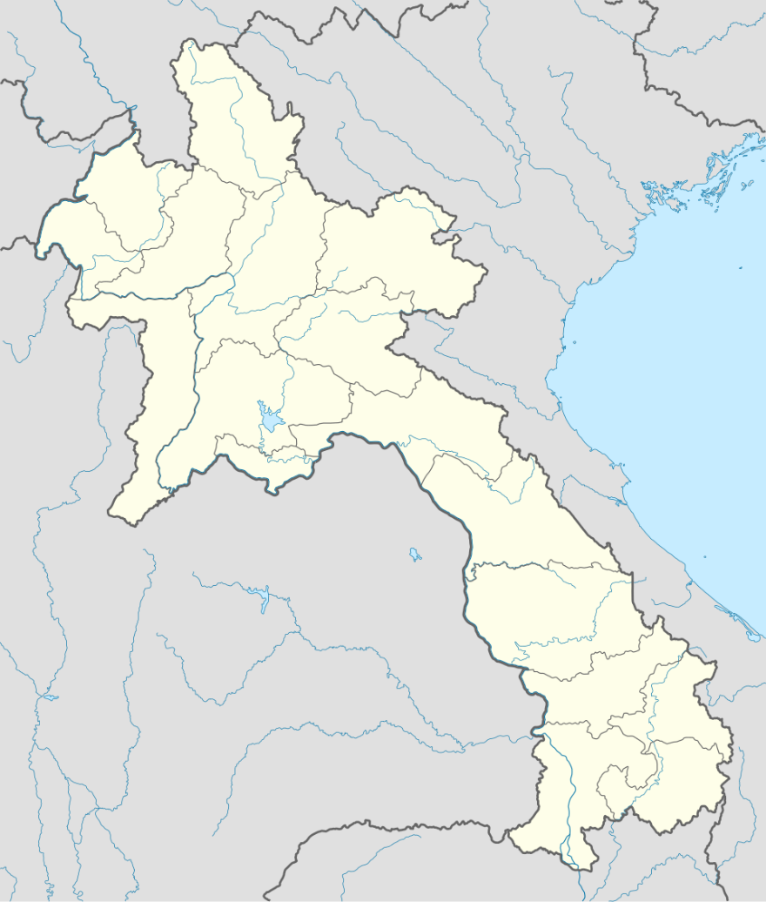

LAOS

VIETNAM

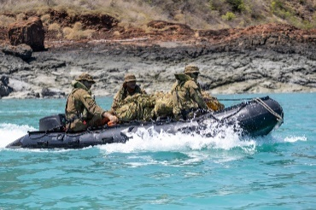

f. ___________________

e. ___________________

d. ___________________

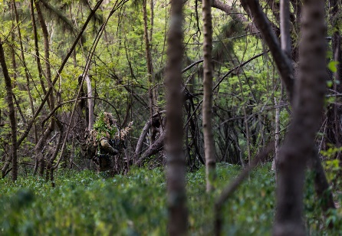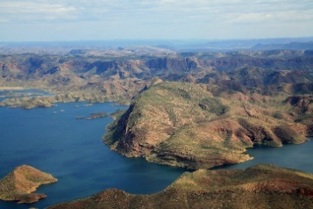

A wild natural area. This is also the Australian English word for ‘forest’.

This is in the north west region of Australia. It’s a beautiful place, with red rocks, rivers and water­falls. Few people live there.

g. ___________________

h. ___________________

1. Listen, check and repeat.
2. Discuss these questions with your partner to practise the new words.

a. Are there **crocodiles** in your country? Are they **saltwater crocodiles**?

b. Do you like going on training in **the bush**?

c. Why do you think the armed forces look for **illegal** **fishing vessels**?

d. Does your country share any **borders**? With what countries?

e. Do you know anything about **Aboriginals** in Australia?

f. Can you drive an **F470 Zodiac**?

g. Tourists love visiting **the Kimberleys**. Why do you think this is? Would you like to visit?

h. Does the army do anything to try to stop **drugs** in your country? What do they do?

## Reading

1. Read about NORFORCE. What do they do? Why are they special?

**NORFORCE: Protecting Australia's North**

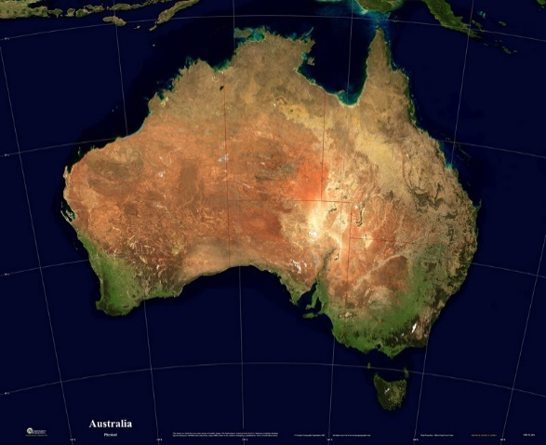Australia’s northern border is huge. Not many people live in this part of Australia. This means it is an attractive place for people trying to get drugs into Australia and for illegal fishing vessels. But they have NORFORCE to deal with if they try! NORFORCE **patrols** a huge area of 1.8 million square kilometres. It conducts **surveillance** and **reconnaissance** across the entire Northern Territory and Kimberly region of Western Australia. This is the largest area of operations for any military unit in the world. Its **mission** is to protect Australia’s Northern border and central area.

NORFORCE’s area of operation

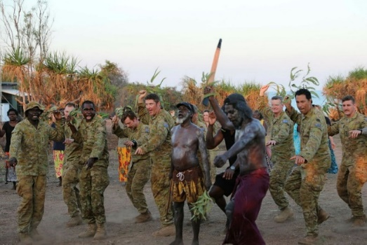

About 74% of people who live in this area are Aboriginals. Aboriginals have lived on their land for 65,000 years. They are the oldest living culture on earth. Many of the soldiers who work for NORFORCE were originally **civilians** from these local Aboriginal communities. They know the land very well – the rivers, the bush, and the animals. This knowledge is very helpful when they are doing their work.

*NORFORCE has deep links with the local Aboriginal communities.*

Their main job is to **gather intelligence**. This means they find information. For example, they look for anything unusual, often from **observation posts**. They also use boats like the F470 Zodiacs to patrol. They might see a boat where it should not be, or signs of people who shouldn’t be there. If they find something important, they **radio** their **HQ** to tell them. NORFORCE soldiers often work in small teams called **sections**. These sections go into the bush. They use their **fieldcraft** and **stealth** skills to **conceal** themselves, so people cannot see them easily.

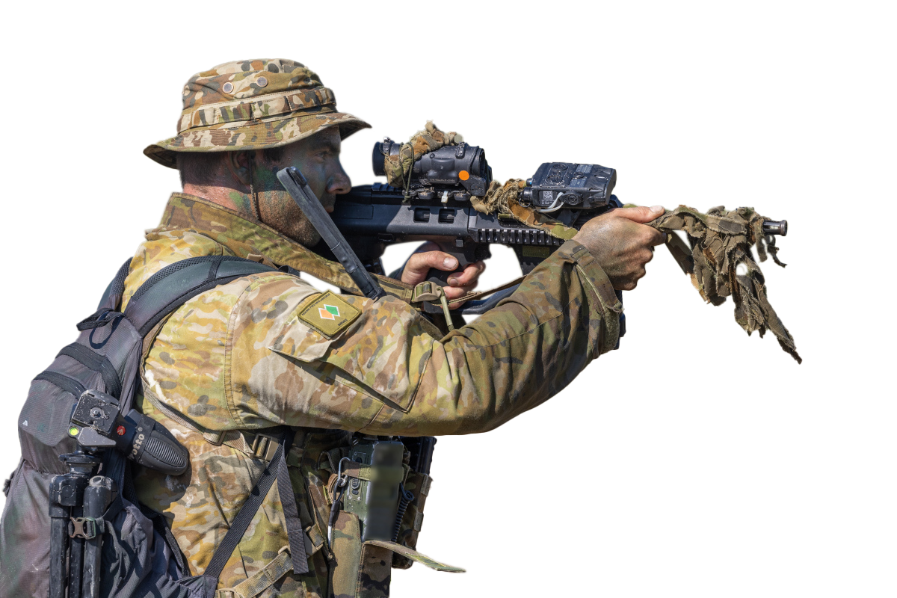They do not have to worry so much about an **ambush** from the enemy. But they do need to make sure they are not **ambushed** by salties! This is what Australians call the huge saltwater crocodiles that live in the north of Australia. They can grow bigger than the Zodiac boats!

NORFORCE is like the "eyes and ears" of northern Australia. In fact, they patrol 52% of the Australian mainland. They are a very special part of the Australian Defence Force.

*A NORFORCE soldier uses his rifle scope to scan the surrounding area during a patrol along the northern Kimberley region.*

1. Read the text again and decide if the following statements are true or false.
2. There is a big population in the North of Australia. TRUE // FALSE
3. NORFORCE is the largest military force in the world. TRUE // FALSE
4. Around three quarters of people living in the NORFORCE area are Aboriginal. TRUE // FALSE
5. Aboriginals have a long history with the land where NORFORCE work. TRUE // FALSE
6. Sometimes, NORFORCE patrol by boat. TRUE // FALSE
7. Salties are small, but quite dangerous. TRUE // FALSE
8. NORFORCE patrols more than half of Australia. TRUE // FALSE

**Tip: When you see a new word in English, you can:**

* find out how to say the word with an online dictionary
* practise using the word in your speaking.

1. Look at the words in **bold** in the reading. We will match them to their definitions next. First, look at them in the sentences and talk to your friends. Do you know any of them? Have you ever heard or read these words before? What part of speech are the words? What do you guess they mean?

**Learning military vocabulary**

1. The words in **bold** are important military vocabulary that you should learn. Match them to their definitions on the right. Look at the example and write the answers in the middle column.

|  |  |  |  |
| --- | --- | --- | --- |
| Table 1 |  |  |  |
| NORFORCE **patrols** a huge area | **f** |  | 1. Preview image for asset(n) watching things like planes, land, or water closely; soldiers can use their eyes, ears, or special equipment |
| It conducts **surveillance** and reconnaissance |  |  | 1. (n) a special job or task that soldiers are sent to do |
| It conducts surveillance and **reconnaissance** |  |  | 1. (vp) to secretly collect important information about an enemy or a dangerous situation |
| Its **mission** is to protect |  |  | 1. Preview image for asset(n) places where soldiers stay to watch an area carefully; they use them to look for enemies or important things |
| **civilians** from these local Aboriginal communities |  |  | 1. (n) people who are not in the army or other military groups; they are not members of the Defence Forces |
| job is to **gather intelligence** |  |  | 1. **(v) to move around an area regularly to watch or guard it** |
| often from **observation posts** |  |  | 1. (n) when soldiers or drones go to an area to find out information about an enemy or a place |

|  |  |  |  |
| --- | --- | --- | --- |
| Table 2 |  |  |  |
| they **radio** their HQ |  |  | 1. (n) a way of moving or doing something very quietly and secretly so that no one sees or hears you. |
| they radiotheir **HQ** |  |  | 1. Preview image for asset(v) to hide something or someone so that they cannot be seen or found. |
| soldiers work in **sections** |  |  | 1. Preview image for asset(v) to speak to someone using a special communication device, usually to send important messages or information. |
| They use their **fieldcraft** |  |  | 1. (n) ‘headquarters’. It is the main office or place where the leaders of an army or group work and make plans. |
| **stealth** skills to conceal |  |  | 1. (n) small groups of soldiers, usually 6 to 10 people, who work together as a team in the army. |
| to **conceal** themselves |  |  | 1. (v) to be attacked by surprise by an enemy who was hidden. |
| **ambushed** by salties |  |  | 1. (n) the set of skills a soldier uses to hide, move, and survive in a natural environment. |

1. Listen and check.

1. Now practise saying the words. Listen and repeat.

## Practice

1. Complete the questions with new words from the box.

patrol // ambushed // mission // section // conceal // radio // stealth

1. What would you do if a saltie _____________________ you?
2. How do you ______________________ yourself when you are on patrol?
3. Can you describe your last ________________? Were you successful?
4. Do you prefer to work in a __________________ or as a bigger group?
5. How can soldiers move with ________________ when they are on patrol?
6. When was the last time you had to ________________ HQ?
7. What skills are most important for a soldier to have when they are on ________________?
8. Ask and answer the questions above with a partner to practise new words.
9. Role play. Imagine you are part of a working group discussing how to keep your country’s borders safe. Discuss ideas with your group. Try to use as many words as you can from today’s lesson. You should discuss:

* the main problems at the borders
* how the armed forces in your country can help.

Something the   
armed forces can do to help is …

The main   
problems are…

One thing I would like to add is…

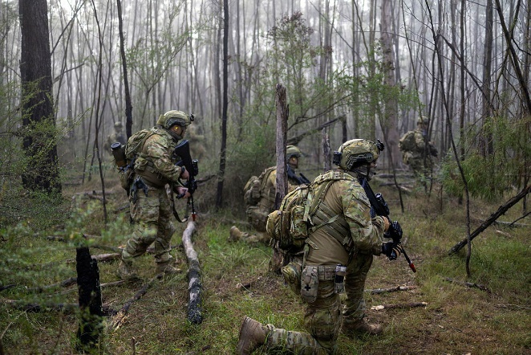

*Patrolling borders is an important way to keep a country safe.*

We should also think about…



* Watch this video about the NORFORCE Kimberly squadron and the work they do. Type “[**ADF Patrolling through adversity**](https://www.youtube.com/watch?v=BYxYEEJyFMA)**”** on YouTube or scan the QR code 🡪

Circle the things you see.

a Zodiac boat // illegal fishing vessels // soldiers on patrol //

something that has been concealed // an observation post // a saltwater crocodile



* For more [practice](https://quizlet.com/au/1054622707/lesson-on-patrol-norforce-eyes-and-ears-in-the-north-reading-flash-cards/) with the words you’ve learned here, scan the QR code. 🡪
* This lesson links with 🡪 Lesson: On Patrol – Listening

© Commonwealth of Australia 2025  
This work is copyright. Apart from any use as permitted under the Copyright Act 1968 (Cth),   
no part may be reproduced by any process without prior written permission from the Department of Defence.