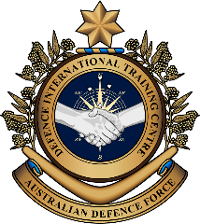

**Military English**

Lesson: Life of a UN Peacekeeping Medic – Part D – Deployment to Afghanistan – Listening

**Overview:** This is the fourth of four lessons that will teach vocabulary related to being a ‘Medic’ and Army nurse during United Nations (UN) Peacekeeping missions.

**In this lesson, you will:**

* practise listening while taking notes
* practise listening for details and ignoring distractors in multiple choice questions
* learn the meaning of, and practise, new vocabulary and expressions.

## Prepare for Listening

1. Look at the pictures of UN peacekeeping forces working together. Discuss the questions with a partner.

What would be fun about working with people from other countries?

What would be **rewarding** about this work?

What would be **challenging**?

What problems can people experience when they are working with people from other countries?

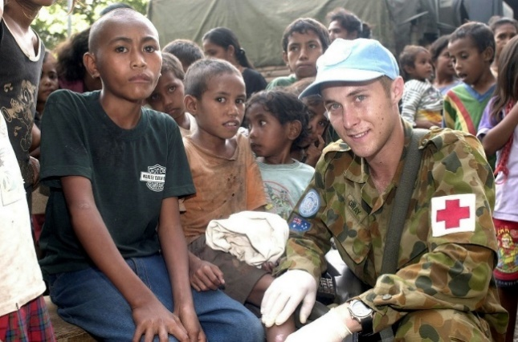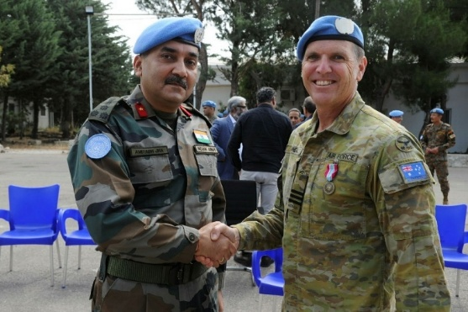

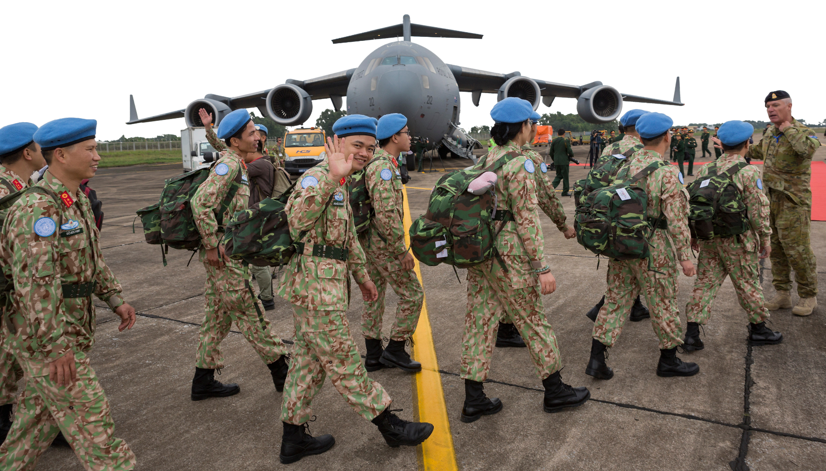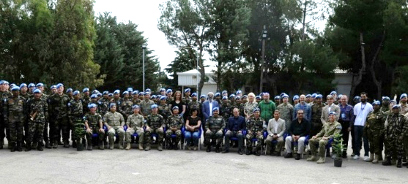

1. Here are some words we need for today’s listening. Match them with the pictures and definitions.

embedded // casualty incident // choppers // coalition forces // civilian contractor //

delegate // wound // prioritise // surgery

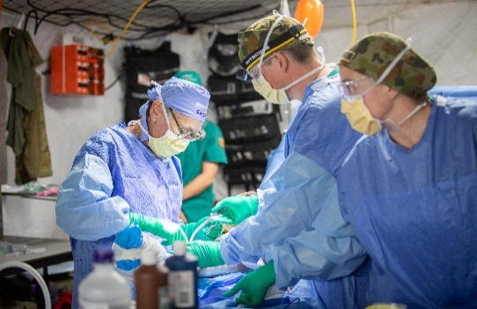

c. \_\_\_\_\_\_\_\_\_\_\_\_\_\_\_

b. \_\_\_\_\_\_\_\_\_\_\_\_\_\_\_

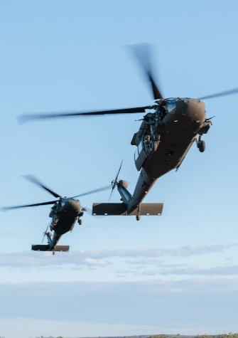

(adj) to be placed or inte­grated into a specific group, organisation, or environment

a. \_\_\_\_\_\_\_\_\_\_\_\_\_\_\_\_\_\_\_

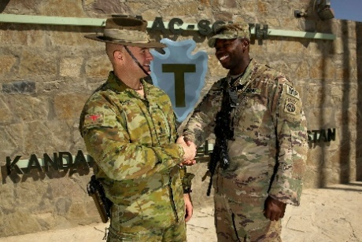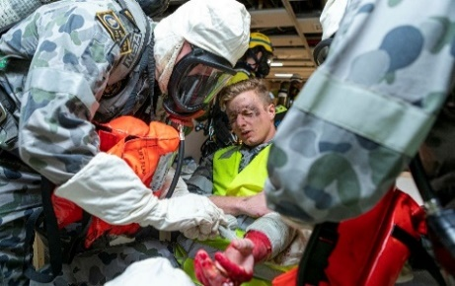

(n) an event where one or more people are injured or killed

f. \_\_\_\_\_\_\_\_\_\_\_\_\_\_\_\_\_\_\_\_\_\_\_\_\_

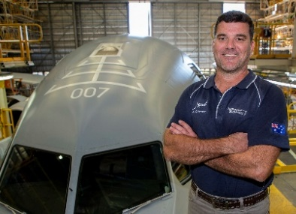

d. \_\_\_\_\_\_\_\_\_\_\_\_\_\_\_

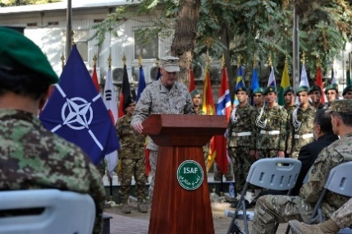

e. \_\_\_\_\_\_\_\_\_\_\_\_\_\_\_\_\_\_\_

(v) to give someone else some of your work or res-ponsibilities

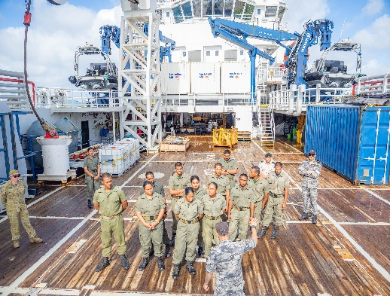

i. \_\_\_\_\_\_\_\_\_\_\_\_\_\_\_\_\_\_\_

g. \_\_\_\_\_\_\_\_\_\_\_\_\_\_\_\_\_\_\_

(v) to decide what to do first

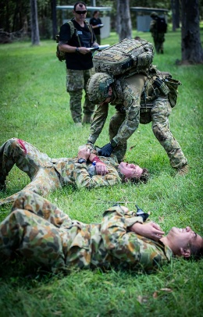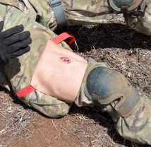

h. \_\_\_\_\_\_\_\_\_\_\_\_\_\_\_\_\_

1. Listen, check and repeat.
2. Practise the new words. Discuss the questions with a partner.

Why is it important for leaders to **delegate**?

What challenges are there doing **surgery** in a war zone?

How many of the members of the **coalition** in the war in Afghanistan can you name?

What are some of the ways soldiers can become **wounded** in a battle?

What jobs do **civilian contractors** do?

How do medics **prioritise** who gets medical attention first in **casualty incidents**?

What sorts of **choppers** do you use in your armed forces?

Which country would you like to have a chance to be **embedded** with?

1. Why is it important to take notes? Talk to your friend about times taking notes is important in your work.

## A black background with a black square AI-generated content may be incorrect. Listening

1. You will listen to an interview with an Australian Army nurse who served in a United Nations peacekeeping mission. Listen and take notes in the space provided. Compare what you understood with your partner.

\_\_\_\_\_\_\_\_\_\_\_\_\_\_\_\_\_\_\_\_\_\_\_\_\_\_\_\_\_\_\_\_\_\_\_\_\_\_\_\_\_\_\_\_\_\_\_\_\_\_\_\_\_\_\_\_\_\_\_\_\_\_\_\_\_\_\_\_\_\_\_\_\_\_\_\_\_\_\_

\_\_\_\_\_\_\_\_\_\_\_\_\_\_\_\_\_\_\_\_\_\_\_\_\_\_\_\_\_\_\_\_\_\_\_\_\_\_\_\_\_\_\_\_\_\_\_\_\_\_\_\_\_\_\_\_\_\_\_\_\_\_\_\_\_\_\_\_\_\_\_\_\_\_\_\_\_\_\_

\_\_\_\_\_\_\_\_\_\_\_\_\_\_\_\_\_\_\_\_\_\_\_\_\_\_\_\_\_\_\_\_\_\_\_\_\_\_\_\_\_\_\_\_\_\_\_\_\_\_\_\_\_\_\_\_\_\_\_\_\_\_\_\_\_\_\_\_\_\_\_\_\_\_\_\_\_\_\_

\_\_\_\_\_\_\_\_\_\_\_\_\_\_\_\_\_\_\_\_\_\_\_\_\_\_\_\_\_\_\_\_\_\_\_\_\_\_\_\_\_\_\_\_\_\_\_\_\_\_\_\_\_\_\_\_\_\_\_\_\_\_\_\_\_\_\_\_\_\_\_\_\_\_\_\_\_\_\_

\_\_\_\_\_\_\_\_\_\_\_\_\_\_\_\_\_\_\_\_\_\_\_\_\_\_\_\_\_\_\_\_\_\_\_\_\_\_\_\_\_\_\_\_\_\_\_\_\_\_\_\_\_\_\_\_\_\_\_\_\_\_\_\_\_\_\_\_\_\_\_\_\_\_\_\_\_\_\_

\_\_\_\_\_\_\_\_\_\_\_\_\_\_\_\_\_\_\_\_\_\_\_\_\_\_\_\_\_\_\_\_\_\_\_\_\_\_\_\_\_\_\_\_\_\_\_\_\_\_\_\_\_\_\_\_\_\_\_\_\_\_\_\_\_\_\_\_\_\_\_\_\_\_\_\_\_\_\_

\_\_\_\_\_\_\_\_\_\_\_\_\_\_\_\_\_\_\_\_\_\_\_\_\_\_\_\_\_\_\_\_\_\_\_\_\_\_\_\_\_\_\_\_\_\_\_\_\_\_\_\_\_\_\_\_\_\_\_\_\_\_\_\_\_\_\_\_\_\_\_\_\_\_\_\_\_\_\_

\_\_\_\_\_\_\_\_\_\_\_\_\_\_\_\_\_\_\_\_\_\_\_\_\_\_\_\_\_\_\_\_\_\_\_\_\_\_\_\_\_\_\_\_\_\_\_\_\_\_\_\_\_\_\_\_\_\_\_\_\_\_\_\_\_\_\_\_\_\_\_\_\_\_\_\_\_\_\_

\_\_\_\_\_\_\_\_\_\_\_\_\_\_\_\_\_\_\_\_\_\_\_\_\_\_\_\_\_\_\_\_\_\_\_\_\_\_\_\_\_\_\_\_\_\_\_\_\_\_\_\_\_\_\_\_\_\_\_\_\_\_\_\_\_\_\_\_\_\_\_\_\_\_\_\_\_\_\_

\_\_\_\_\_\_\_\_\_\_\_\_\_\_\_\_\_\_\_\_\_\_\_\_\_\_\_\_\_\_\_\_\_\_\_\_\_\_\_\_\_\_\_\_\_\_\_\_\_\_\_\_\_\_\_\_\_\_\_\_\_\_\_\_\_\_\_\_\_\_\_\_\_\_\_\_\_\_\_

\_\_\_\_\_\_\_\_\_\_\_\_\_\_\_\_\_\_\_\_\_\_\_\_\_\_\_\_\_\_\_\_\_\_\_\_\_\_\_\_\_\_\_\_\_\_\_\_\_\_\_\_\_\_\_\_\_\_\_\_\_\_\_\_\_\_\_\_\_\_\_\_\_\_\_\_\_\_\_

\_\_\_\_\_\_\_\_\_\_\_\_\_\_\_\_\_\_\_\_\_\_\_\_\_\_\_\_\_\_\_\_\_\_\_\_\_\_\_\_\_\_\_\_\_\_\_\_\_\_\_\_\_\_\_\_\_\_\_\_\_\_\_\_\_\_\_\_\_\_\_\_\_\_\_\_\_\_\_

\_\_\_\_\_\_\_\_\_\_\_\_\_\_\_\_\_\_\_\_\_\_\_\_\_\_\_\_\_\_\_\_\_\_\_\_\_\_\_\_\_\_\_\_\_\_\_\_\_\_\_\_\_\_\_\_\_\_\_\_\_\_\_\_\_\_\_\_\_\_\_\_\_\_\_\_\_\_\_

\_\_\_\_\_\_\_\_\_\_\_\_\_\_\_\_\_\_\_\_\_\_\_\_\_\_\_\_\_\_\_\_\_\_\_\_\_\_\_\_\_\_\_\_\_\_\_\_\_\_\_\_\_\_\_\_\_\_\_\_\_\_\_\_\_\_\_\_\_\_\_\_\_\_\_\_\_\_\_

\_\_\_\_\_\_\_\_\_\_\_\_\_\_\_\_\_\_\_\_\_\_\_\_\_\_\_\_\_\_\_\_\_\_\_\_\_\_\_\_\_\_\_\_\_\_\_\_\_\_\_\_\_\_\_\_\_\_\_\_\_\_\_\_\_\_\_\_\_\_\_\_\_\_\_\_\_\_\_

\_\_\_\_\_\_\_\_\_\_\_\_\_\_\_\_\_\_\_\_\_\_\_\_\_\_\_\_\_\_\_\_\_\_\_\_\_\_\_\_\_\_\_\_\_\_\_\_\_\_\_\_\_\_\_\_\_\_\_\_\_\_\_\_\_\_\_\_\_\_\_\_\_\_\_\_\_\_\_

\_\_\_\_\_\_\_\_\_\_\_\_\_\_\_\_\_\_\_\_\_\_\_\_\_\_\_\_\_\_\_\_\_\_\_\_\_\_\_\_\_\_\_\_\_\_\_\_\_\_\_\_\_\_\_\_\_\_\_\_\_\_\_\_\_\_\_\_\_\_\_\_\_\_\_\_\_\_\_

\_\_\_\_\_\_\_\_\_\_\_\_\_\_\_\_\_\_\_\_\_\_\_\_\_\_\_\_\_\_\_\_\_\_\_\_\_\_\_\_\_\_\_\_\_\_\_\_\_\_\_\_\_\_\_\_\_\_\_\_\_\_\_\_\_\_\_\_\_\_\_\_\_\_\_\_\_\_\_

\_\_\_\_\_\_\_\_\_\_\_\_\_\_\_\_\_\_\_\_\_\_\_\_\_\_\_\_\_\_\_\_\_\_\_\_\_\_\_\_\_\_\_\_\_\_\_\_\_\_\_\_\_\_\_\_\_\_\_\_\_\_\_\_\_\_\_\_\_\_\_\_\_\_\_\_\_\_\_

\_\_\_\_\_\_\_\_\_\_\_\_\_\_\_\_\_\_\_\_\_\_\_\_\_\_\_\_\_\_\_\_\_\_\_\_\_\_\_\_\_\_\_\_\_\_\_\_\_\_\_\_\_\_\_\_\_\_\_\_\_\_\_\_\_\_\_\_\_\_\_\_\_\_\_\_\_\_\_

\_\_\_\_\_\_\_\_\_\_\_\_\_\_\_\_\_\_\_\_\_\_\_\_\_\_\_\_\_\_\_\_\_\_\_\_\_\_\_\_\_\_\_\_\_\_\_\_\_\_\_\_\_\_\_\_\_\_\_\_\_\_\_\_\_\_\_\_\_\_\_\_\_\_\_\_\_\_\_

\_\_\_\_\_\_\_\_\_\_\_\_\_\_\_\_\_\_\_\_\_\_\_\_\_\_\_\_\_\_\_\_\_\_\_\_\_\_\_\_\_\_\_\_\_\_\_\_\_\_\_\_\_\_\_\_\_\_\_\_\_\_\_\_\_\_\_\_\_\_\_\_\_\_\_\_\_\_\_

1. Use your notes to select the best summary of what she says.

Warrant Officer Beth Andrews, a doctor in the American Army, was interviewed about her overseas deployments and role as a medic. She detailed her experiences coordinating patient evacuations in Timor Leste. She shared a story about a challenging casualty incident where she was unable to help save lives, highlighting the importance of international cooperation.

Warrant Officer Beth Andrews, a pilot in the Royal Australian Air Force, was interviewed about her overseas deployments and role as a medic. She detailed her experiences coordinating patient evacuations in Australia. She shared a story about a challenging casualty incident where she was crucial in saving lives, highlighting the importance of countries working independently.

Warrant Officer Beth Andrews, a nurse in the Australian Army, was interviewed about her overseas deployments and role as a medic. She detailed her experiences coordinating patient evacuations in Afghanistan. She shared a story about a challenging casualty incident where she was crucial in saving lives, highlighting the importance of international cooperation.

1. A black background with a black square

   AI-generated content may be incorrect. Listen again and select the correct option.

In Afghanistan, \_\_\_\_\_ medics were integrated with the American team in Kandahar.

20

52

11

What was most of her work about in Afghanistan?

Performing new surgeries

Patient evacuations

Operating on Afghan forces

Where did Australian forces go first if they were hurt in the war?

Bagram

Germany

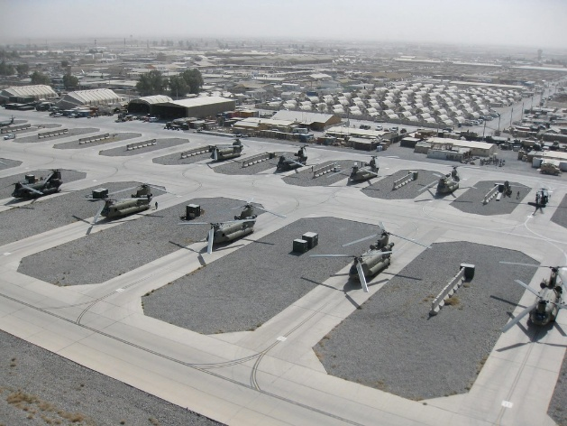Australia

Kandahar

How many people were working at a time in the joint operation centre?

80

24

82

What did she carry with her on the way to work?

A handgun

An assault riffle

All of the above

*Kandahar Air Field*

Why was she awarded a medal?

For her leadership in a major casualty evacuation

For requesting a fixed wing aircraft

For operating on coalition forces

1. Talk to your partner and reflect on today’s listening. What did you find easy to understand about today’s listening? What was more challenging? What do you want to improve for next time?

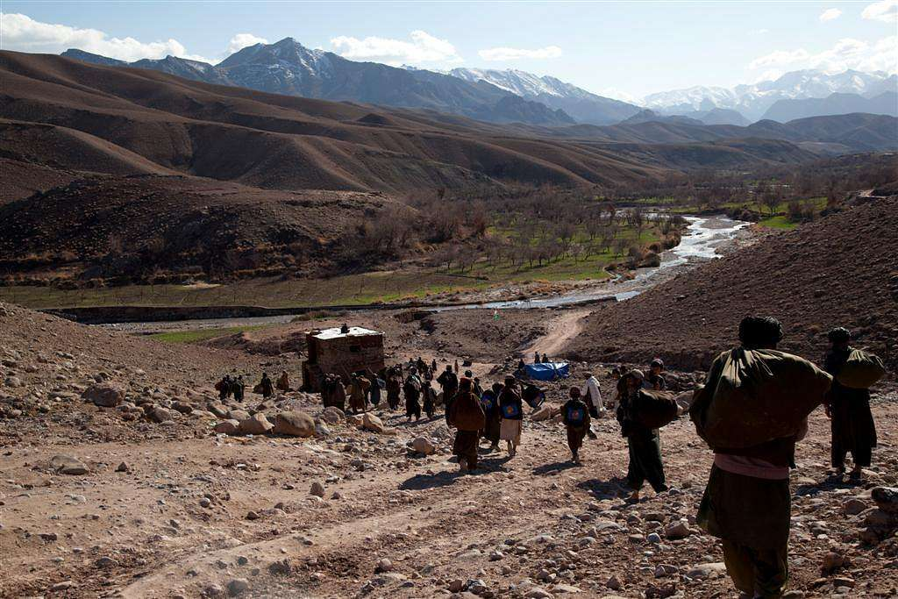

**Learning tip:**

**Reflection** is a great way of taking **responsibility** for and **control of** your learning. When you reflect on an activity or lesson, ask yourself what went well, what didn’t go well, and what you want to change for next time.

*Tirin Kut is in the middle of Afghanistan*

## Learning Military Vocabulary

1. The words listed in bold below are important vocabulary and expressions that you should learn to use. Match the vocabulary on the left with their definitions on the right. Look at the example.

|  |  |  |  |  |  |  |
| --- | --- | --- | --- | --- | --- | --- |
| Table 1 |  | |  |  | | |
| **Duty Officer** | | **c** | | |  | 1. (verb phrase) to send helicopters to a specific location or on a particular mission, often in response to an emergency or operational need e.g. a medical evacuation | |
| Patient **Evacuation** Coordination Cell | |  | | |  | 1. (n) a situation where too many people need help, and local emergency services can’t manage it alone; a bigger, organised response is needed | |
| **critical casualty events** | |  | | |  | 1. **(n) an officer who is responsible for managing operations after regular working hours; responsibilities include acting as a point of contact, handling emergencies and making key decisions** | |
| we would **dispatch choppers** out to pick up the casualties | |  | | |  | 1. Several soldiers in uniform on a stretcher     Description automatically generated(n) the organised removal  of people from a dangerous area to a safer location | |
| delegate **field hospitals** | |  | | |  | 1. \\d85userdata.dpe.protected.mil.au\ma\marcos.pougy\Downloads\20240518adf8547344_0265.jpg(n) places patients can get medical care e.g. a small first aid station, a large field hospital | |
| **treatment facilities** | |  | | |  | 1. \\d85userdata.dpe.protected.mil.au\ma\marcos.pougy\Downloads\VK0096-4.jpg(n) a temporary medical centre near the battlefield where injured soldiers get life-saving care before being moved to a bigger hospital | |

*Source: UN - John Isaac*

|  |  |  |  |
| --- | --- | --- | --- |
| Table 2 |  |  |  |
| available resources like **field operating theatres** |  |  | 1. (adj) feeling tense, anxious, or nervous, often due to emotional stress or anticipation of a threat, particularly as a result of fear, or a sense of uncertainty |
| **repatriated** back to Australia |  |  | 1. (n) a unit or team responsible for planning, coordinating and managing specific tasks or missions, often in real-time |
| sitting in the **opscell**, we could hear… |  |  | 1. (n) mobile or temporary medical units in conflict zones or disaster areas where doctors do urgent operations to save lives; these are usually inside field hospitals |
| I was always **on edge** working there |  |  | 1. (v) to send a person to their home country, often after an illness/injury, or emergency/crisis situations |
| when **outside the wire**, we would |  |  | 1. (n) resources or items that a military owns or controls that can be used to achieve specific objectives e.g. equipment, property, vehicles, personnel or financial resources |
| what **assets** were needed |  |  | 1. (n) various tools, supplies, personnel and facilities to provide healthcare and medical treatment |
| including required **medical resources** |  |  | 1. (phrase) not being in the secured or protected perimeter of a military base, camp, or compound in a conflict or hostile area; there is a higher risk of encountering enemy forces, ambushes or other threats in this area |

1. Now let’s practise saying the words. Listen and repeat.

**Learning tip:**

Using a transcript after a listening can be a great self-study tool. You can use it to notice **pronunciation features**, to reflect on **vocabulary**, and to understand why you might have missed some answers.

1. Complete the transcript with vocabulary words from the table.

## A black background with a black square AI-generated content may be incorrect.Practice and reflection

1. Listen to the interview and check your answers.

A: Last week you told us about your deployment to Timor Leste for a UN Peacekeeping Mission. After this, did you deploy overseas again?

B: Yes, after Timor Leste, I was next sent to Afghanistan in November 2011. I was one of 52 medics embedded with the Americans in the international headquarters in Kandahar. I was a Duty Officer in the Patient 1.\_\_\_\_\_\_\_\_\_\_\_\_\_\_\_\_\_\_\_\_\_\_\_\_\_\_\_\_ Coordination Cell.

A: What were your responsibilities in Kandahar?

B: My role was collecting casualties across a huge area, about the size of New South Wales, so we had a number of evacuation platforms situated across that area. When critical 2.\_\_\_\_\_\_\_\_\_\_\_\_\_\_\_\_\_\_\_\_\_\_\_\_\_\_ events occurred, we would dispatch choppers out to pick up the casualties and delegate field hospitals and 3.\_\_\_\_\_\_\_\_\_\_\_\_\_\_\_\_\_\_\_\_\_\_\_\_ facilities where those choppers could deliver casualties, depending on how badly the soldiers were injured and available resources like 4.\_\_\_\_\_\_\_\_\_\_\_\_\_\_\_\_\_\_\_\_\_\_\_\_ operating theatres and doctors.

A: Did you treat both coalition forces and Afghan forces?

B: If they were Afghan forces, we would bring them back to Kandahar to their own military hospitals. If they were Australian, or coalition forces, then casualties would be brought back to our facility in Kandahar first for immediate treatment, then sent off to Bagram and then onto Germany, prior to being 5.\_\_\_\_\_\_\_\_\_\_\_\_\_\_\_\_\_ (repatriated) back to Australia.

A: What was it like working with coalition forces at your field hospital?

B: I was located on an Air Base with approximately 30,000 people. It was a very busy place with numerous 6.\_\_\_\_\_\_\_\_\_\_\_\_\_\_\_\_\_\_\_\_\_\_\_\_ forces and other civilian contractors who were there to provide various logistics and other support services. I was attached to the United States 82nd Airborne Infantry Division. It was an interesting experience being embedded with the Americans. Within the joint operations centre there were also Americans, Italians, French, Canadians, Spanish and British – with approximately 80 people on shift at any one time, 24 hours per day. We were 500 metres from the airfield – so sitting in the 7.\_\_\_\_\_\_\_\_\_\_\_\_\_ we could hear jets taking off and landing every day – I found it very exciting.

Living and working on the base there was constant noise of military aircraft and troop movements. This was a very tense atmosphere. I was always 8.\_\_\_\_\_\_\_\_\_\_\_\_\_\_\_\_\_\_ working there, especially when walking to and from work. When at work we only carried pistols, but when outside the wire, we carried pistols and F88 Steyrs. The F88 Steyr was the ADF’s standard assault rifle and they had a full load of ammunition for protection purposes.

A: Are there any particular memories from Afghanistan that you would like to share?

B: As I was 9.\_\_\_\_\_\_\_\_\_\_\_\_\_\_\_\_\_\_\_\_\_ with a coalition force, I felt like I was always having to prove myself – prove that I was as good as my training. One casualty incident stands out in my memory, and I was awarded a medal for my response. There were 14 casualties north of our ‘AO’ – or area of operations – about 30 to 40 minutes’ chopper flight from Tirin Kut. As the 10.\_\_\_\_\_\_\_\_\_\_\_\_\_\_\_\_\_\_\_\_\_ could only carry four casualties at a time, we used two choppers to transport the injured personnel, which meant leaving six of the injured soldiers behind. We initially took the casualties to two separate facilities in Tirin Kut, which were run by a mixture of American and Australian army personnel. The problem was that both these facilities didn’t normally maintain direct communications and we didn’t know the nature of the injuries and how to categorize the patients, except that there were gunshot and grenade related wounds. So managing treatment for the injured soldiers was very uncertain and challenging for prioritising surgery and necessary treatment.

In this incident, I was responsible for managing the whole response, including advising the shift director who was an American Major, on what to do, what 11.\_\_\_\_\_\_\_\_\_\_\_\_\_\_\_\_\_ were needed for patient transport, and required medical resources. This also included requests for fixed-wing aircraft from other AOs in the south west of Afghanistan to assist with picking up casualties and bringing them back to Kandahar. Overall, our efforts required a lot of problem solving and learning how to operate together between coalition forces.

We learned a lot of lessons that night. It was the first time we had worked together, and our cooperation proved to be successful for saving the lives of all 14 casualties.

**Speaking**

1. Spend some time making notes on these questions. Think about how you can use words from this lesson to help them stick in your brain. Then discuss them with a partner.

What would some of the challenges of working in an international environment like this be?

What new things can you learn working in an international environment like this?

What sorts of qualities do you need to be successful in this situation?

How can people working in these tense environments do about feeling on edge so much?

What are the challenges of being a Medic in a warzone?

How would you feel ‘outside the wire’?

1. In a group discuss the challenges faced by military medics on UN peacekeeping missions.

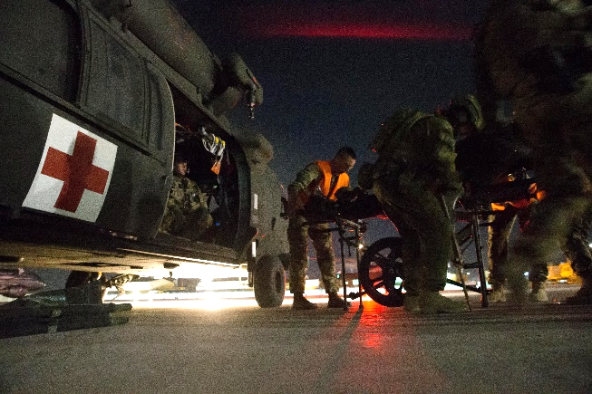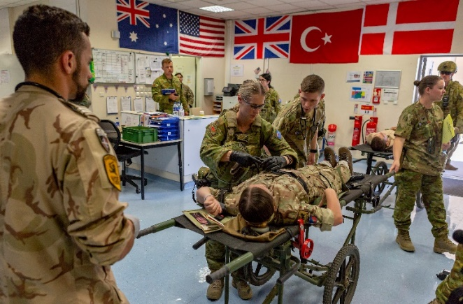

*An ADF medic during training at a treatment facility in Afghanistan.*

*An Australian medical team assists in an aero medical evacuation in Afghanistan.*

* A qr code with black dots

  AI-generated content may be incorrect.\\d85userdata.dpe.protected.mil.au\ma\marcos.pougy\Downloads\camera icon.png It is not only Medics who can help casualties. Watch the video titled “[Field Medical Assistants Course (FMAC) enhances the capabilities of UN peacekeepers](https://www.youtube.com/watch?v=vbVGZXXNVYY)” or scan the QR code 🡪

Answer the questions as you watch:

What can Sergeant Danquah do now that he couldn’t do before?

Where on their body was Sergeant Suryanto’s friend injured?

What is the most common cause of death on the battlefield?

Why does Corporal Adeniyi believe everyone should do the course?

According to Milena, when is the critical stage?

How does Colonel Imran describe the attitude of his students?

## For more practice with the words you’ve learned from this lesson, scan the QR code.

## This lesson links with: Lesson: The Life of a Peacekeeping Medic – parts A, B and C – Listening

Vocabulary Builder: Parts of a First Aid Kit – Basic and Combat

© Commonwealth of Australia 2025  
This work is copyright. Apart from any use as permitted under the Copyright Act 1968 (Cth), no part may be reproduced by any process without prior written permission from the Department of Defence.