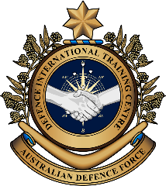
Military English

Lesson: A job in the Air Force – Loadmaster – Reading

Overview:
This lesson is about an important job in the armed forces – A Loadmaster

In this lesson, you will:
- read a text for main ideas
- find specific information in a text
- learn the meaning of new words
- practise talking about being a Loadmaster.

Prepare for Reading
- Look at the photos of Loadmasters doing their job.
        - What do they have to do?
qualities (n) – the character or personality of someone e.g. funny, smart, good at writing
              - What qualities do you think a Loadmaster needs to have?
              - Is this an important job? Why/not?

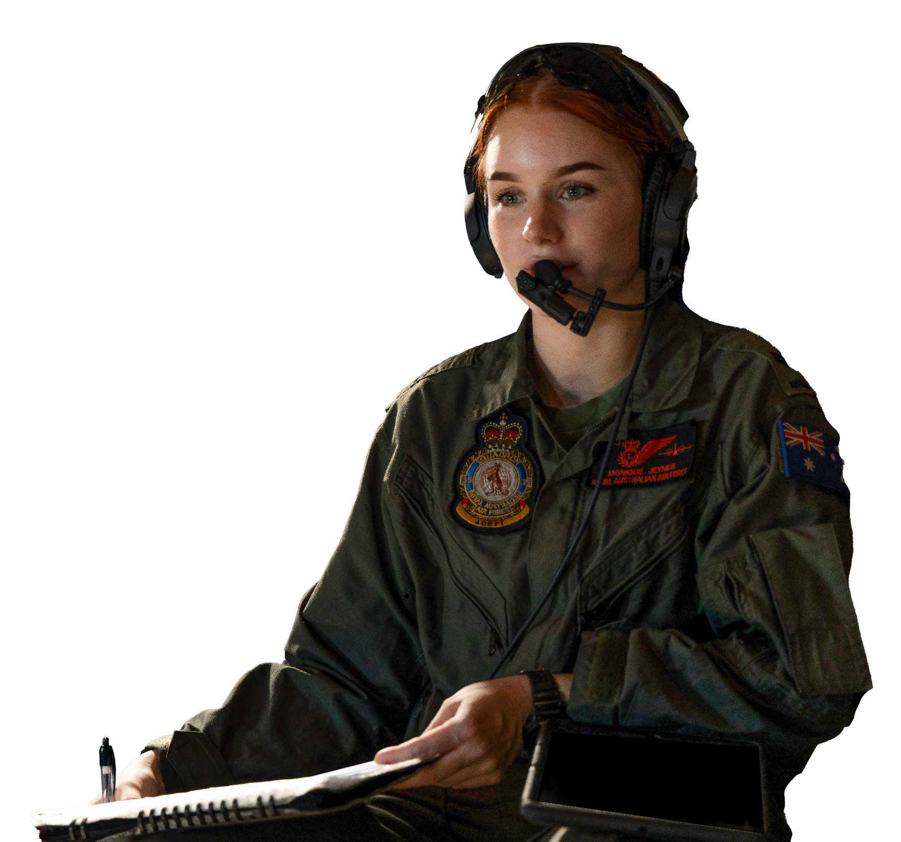
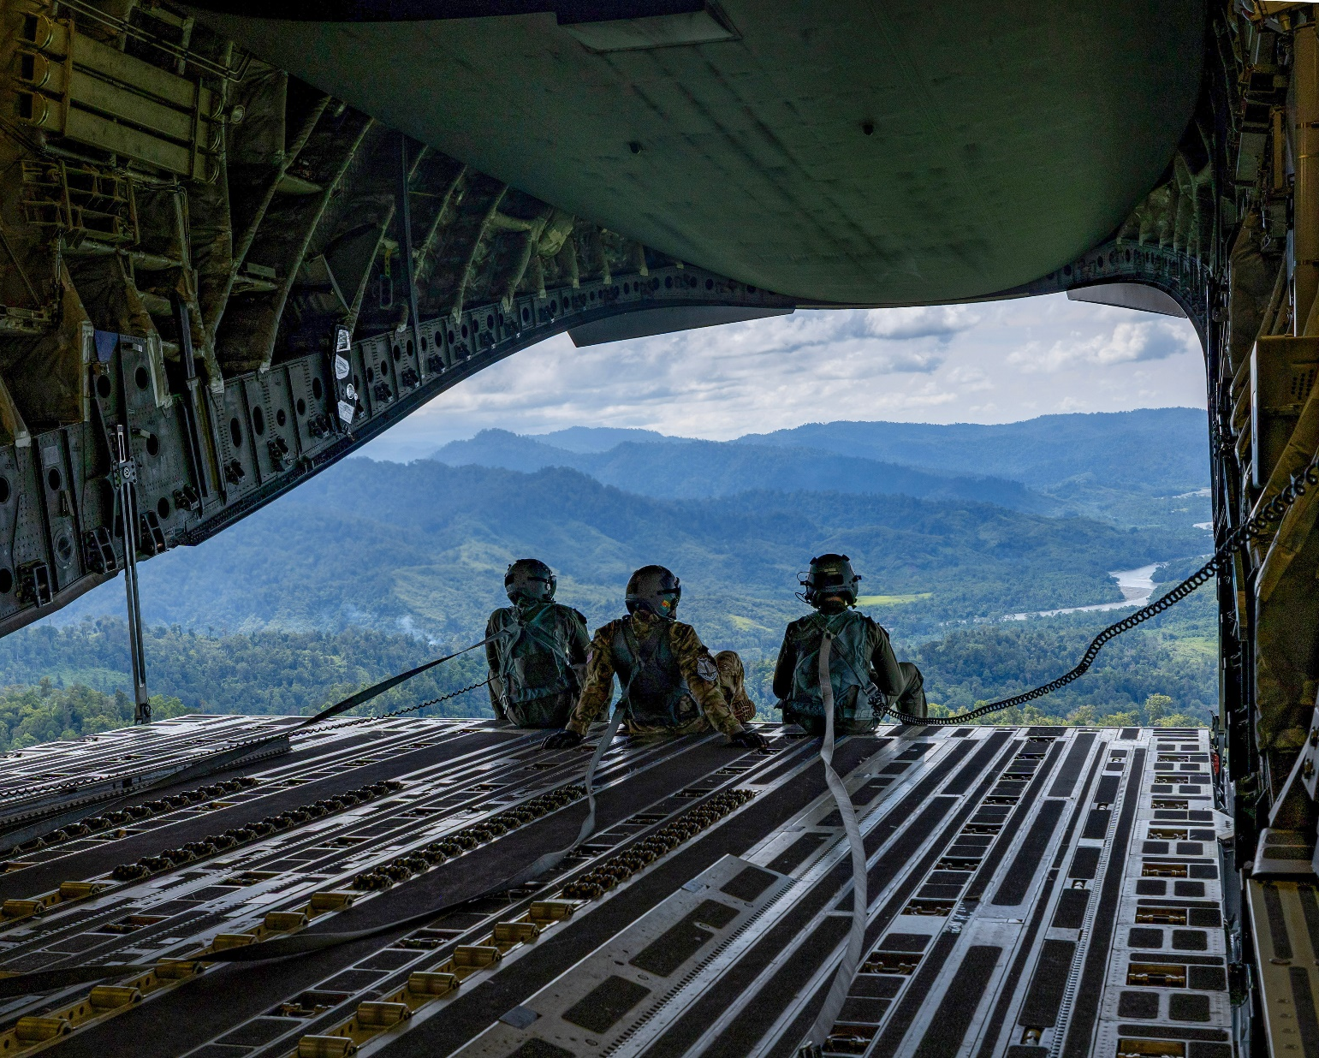
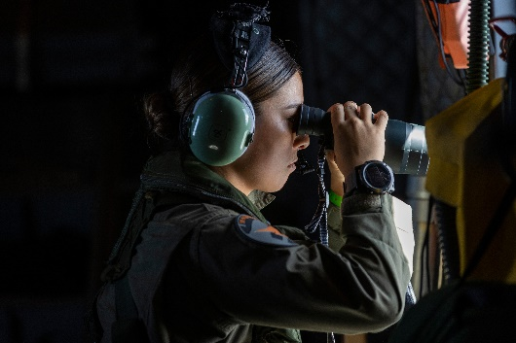
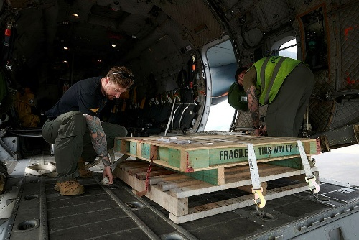
- Here are some words we need for today’s reading. Match them with the pictures.
a forklift // troops // C130 Hercules // calculate // balance // a pallet //
// calm // landing // C17 Globemaster // take off

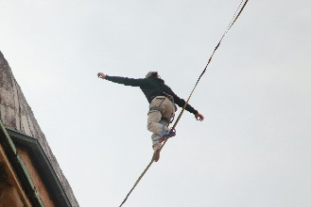
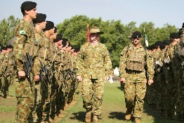
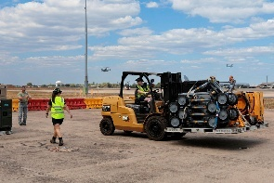
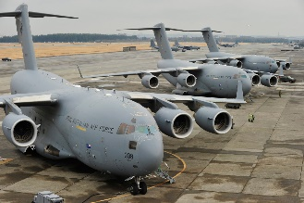

d. __________________
c. __________________
b. __________________
a. __________________

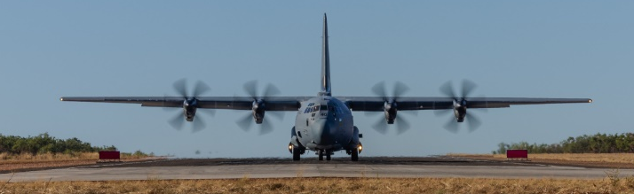
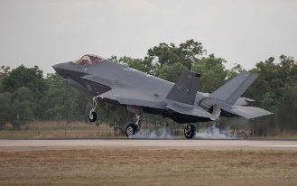
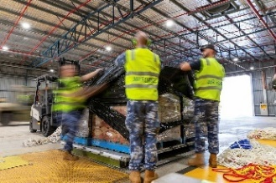
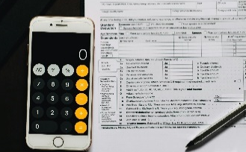


g. __________________
f. __________________
e. __________________

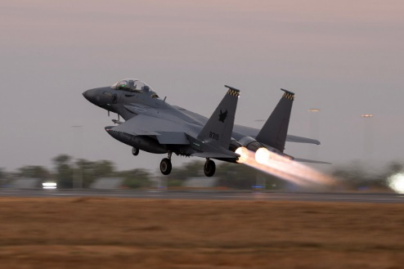
h. __________________

i. __________________
j. __________________


- Listen, check and repeat.

Reading
- Read and listen to an article about Loadmasters. Check your ideas from exercise one.
A Job in the Air Force - Loadmaster
People always think about pilots flying the planes when they think about the air force, but there are lots of jobs in the Air Force. One that not everyone knows about is called a Loadmaster, but in the ADF, everyone calls them ‘loadies’. Loadies often work on large aircraft, like C-17 Globemaster or
C-130 Hercules planes.
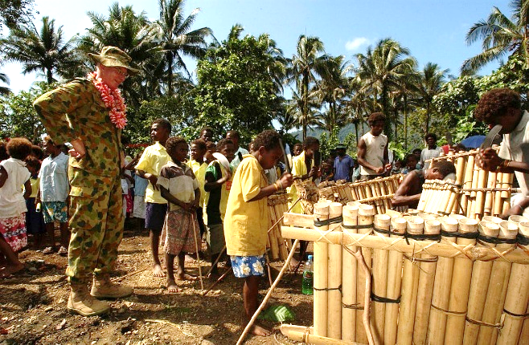
Their main job is to load and unload cargo. Cargo can be many things: army vehicles, weapons, food, water, or even other soldiers. They also often load forward deployment equipment to arrive before everyone else does. This is the equipment that the rest of the troops will need when they arrive at the deployed location. For example, they might load humanitarian aid and disaster relief (HADR) supplies to help people in war or when there has been a natural disaster.
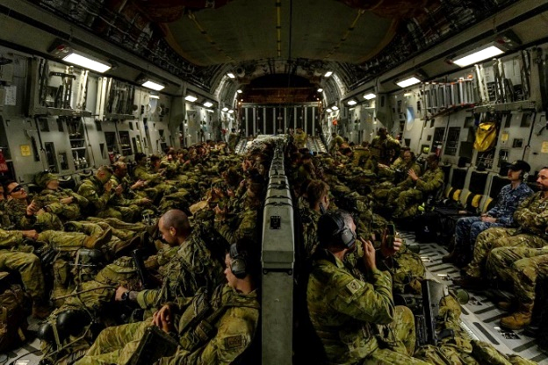
The Loadmaster must make sure the cargo is loaded onto the plane safely and correctly. This means that Loadies have to be good at maths. They need to calculate the distribution of the load in the aircraft for take-off, landings and flying. They also make sure the cargo is
tied down very well, so it does not move during the flight. They often use pallets to load equipment with a forklift. They then use cargo straps and netting to secure the load.
During a flight, the Loadmaster is also important for the safety of the aircraft and the people on board. They check the plane's weight and balance. If the plane is not balanced correctly, it can be dangerous to fly. They also airdrop people or supplies from the aircraft. This means pushing things out of the plane while it is flying.
A Loadmaster’s job is not always easy! They might arrive at a location to find the palettes are not ready, or the forklift is too small. Many things could go wrong. Loadmasters have to stay calm, work quickly, and pay attention to detail so that the plane can leave on time safely.
Loadmasters work closely with the pilots and other crew members. They are a team and need to trust one another. Their job can take them to many different places around the world, supporting soldiers on the ground or helping in emergencies. When people think about jobs in the air force, they often think about pilots, but loadies are just as important for a safe and successful flight.

- Read the article again. Complete the sentences with one word from the text.
- Usually, people think of _______________________ when they think of air force careers.
- Loadies have to get _________________________ on and off the planes.
- Good loadies have strong ____________ skills to help them calculate the load.
- When the plane is in the air, loadies help make sure the plane and ____________ on board are safe.
- During an airdrop, loadies __________________ supplies out of the plane.
- It is important that everyone in the ______________________ trusts each other.

- Look at the words in bold in the reading. We will match them to their definitions next. First, look at them in the sentences and talk to your friends. Do you know any of them? Have you ever heard or read these words before?
Tip: When you see a new word in English, you can
- ask a classmate
- use an English-English dictionary
- use the sentence to help you guess the meaning.
What part of speech are the words? What do you guess they mean?

Learning military vocabulary
- The words in bold are important military vocabulary that you should learn. Match them to their definitions on the right. Look at the example and write the answers in the middle column.
Table 1
pilots flying the planes | g |  | - (n) flat, strong platforms, usually made of wood or metal, that cargo is put on so it can be moved easily with special machines
job is to load and unload cargo |  |  | - (n) how the weight of the cargo is spread out inside the plane; it needs to be even so the plane can fly safely
Cargo can be many things |  |  | - (n) things like food, water, medicine, and tents that are sent to help people after a big problem, like a flood or an earthquake
forward deployment equipment to arrive before everyone else |  |  | - (v) to put things onto and to take things off a vehicle, like a plane or a truck
humanitarian aid and disaster relief (HADR) supplies to help |  |  | - (n) military gear and supplies that are sent ahead to a place where soldiers might need them soon, usually far from their main base
calculate the distribution of the load |  |  | 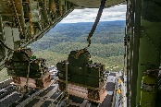  - (n) the goods or items that are carried by a vehicle, like a plane or a ship – also called the load
use pallets to load equipment |  |  | 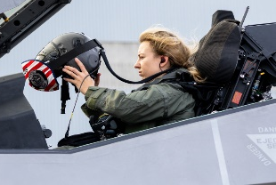  - (n) people who fly aircraft, like planes or helicopters
Table 2
use cargo straps |  |  | 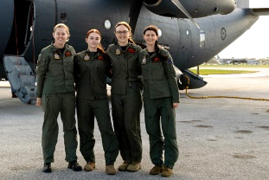  - (n) all the people who work together on a plane or a ship
netting to secure the load. |  |  | - (verb phrase) to notice and care about all the small parts of something, making sure everything is correct and exact
rigging to secure the load. |  |  | - (n) being protected from danger or harm; the Loadmaster's job includes making sure everyone and everything on the plane is safe
the safety of the aircraft |  |  | 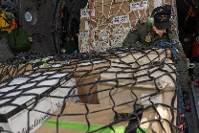  - (n) strong material like a net, used to hold cargo or other items in place, especially on pallets, to stop them from moving
airdrop people or supplies |  |  | 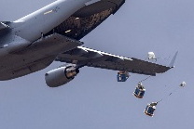  - (v) to drop supplies or people from an aircraft while it is flying
and pay attention to detail |  |  | - (verb phrase) to make sure that the cargo on a plane or vehicle is tied down and held firmly in place so it cannot move during travel
and other crew members |  |  | 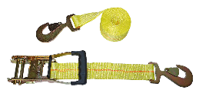  - (n) strong belts or ties used to hold cargo firmly  in place inside a plane or vehicle so it does  not move during travel
- Listen and check your answers.
- Now let’s practise saying the words. Listen and repeat.

Practice
- Complete the advertisement for a Loadmaster with words from the box.
crew // load // unload // detail // airdrop // cargo //
secure the load // HADR supplies // safety // Loadmaster

Are you ready for an exciting and responsible job? Become a ^{1.}___________________ in the Air Force! You will ^{2.}_________________ and ^{3.}_________________ important ^{4.}___________________ like vehicles and supplies onto large aircraft. Your job is to ^{5.}________________________________ and ensure the ^{6.}__________________ of the plane and crew. You will also help with ^{7.}____________________ missions, delivering important ^{8.}________________________________ or equipment worldwide. Work as part of an important ^{9.}___________________, travelling to many places. If you are careful and pay attention to ^{10.}______________________, this is the job for you!
DEFENCE FORCE CAREERS

- Talk to your partner. Is this a good advertisement for a Loadmaster? Why/not?

Speaking
- Take the quiz with a partner. When you are both finished, check your answers on the next page.
Are You Ready to Be a Loadmaster?
1. When you pack a bag for a trip, you usually:  - Just throw everything in quickly.  - Think carefully about how to fit everything in.  - Ask someone else to pack it for you.  2. Imagine you are moving a heavy box. Do you:  - Push it as hard as you can.  - Think about the best way to lift and move it safely.  - Ask someone stronger.  3. If you are working on a team project, do you prefer to:  - Work alone.  - Work closely with others to get the job done.  - Let others do most of the work. | 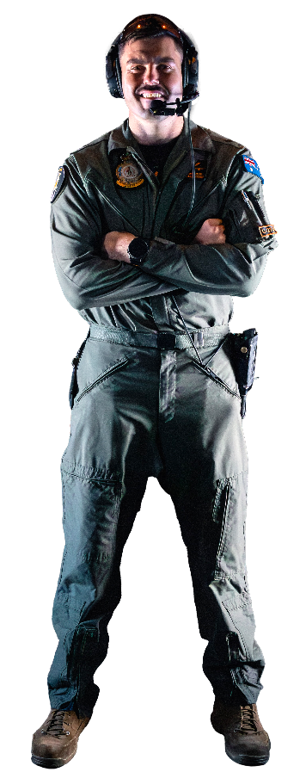  4. When you see a small mistake,  do you usually:  - Not worry too much.  - Notice it and try to fix it.  - Hope someone else sees it.  5. Do you like to travel to  many different places?  - No, I prefer to stay in one  place.  - Yes, I love seeing new  places!  - It’s okay.
- Talk to your partner. Do you agree with the results? What would you like about being a Loadmaster? What Loadmaster qualities do you have? Try to use the vocabulary from today’s lesson in your discussion.
I am good at …
I think I would enjoy…
A quality I have is …


- Watch this video about Loadmasters. Type “Air Load Team in the Middle East Region” on YouTube or scan the QR code

As you listen circle the words you see and hear from today’s lesson.
netting HADR loading forklift cargo pilots C17

C130 Hercules aircraft airdrops pallets troops calculating

Is there any other military vocab in the video that you want to learn?


- For more practice with the words you’ve learned here, scan the QR code.

- This lesson links with Lesson – Disaster relief - Reading
Lesson – Disaster Relief - Listening
Lesson – Humanitarian Aid - Reading
Lesson – Search and Rescue Operations - Reading
Vocabulary Builder – Types of Military Aircraft – Fixed Wing

Quiz answers
Mostly B answers: You might be a great Loadmaster! You are careful, like teamwork, and pay attention to detail – all important for this job.
Mostly A or C answers: Maybe a Loadmaster job is not the best fit for you, but there are many other interesting jobs in the Air Force!

© Commonwealth of Australia 2025
This work is copyright. Apart from any use as permitted under the Copyright Act 1968 (Cth),
no part may be reproduced by any process without prior written permission from the Department of Defence.

