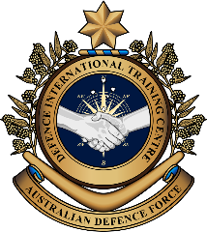
Military English
Vocabulary Builder – Symbology for UN Peacekeeping

Overview:
This worksheet lists vocabulary for identifying UN Peacekeeping symbols.
In this Vocabulary Builder you will:
- learn vocabulary to describe UN Peacekeeping symbols.

- Add a vowel or y to the words below.
Do you know what the symbol MP means? MP = M__ l __ t __ r __ P__ l __ c __
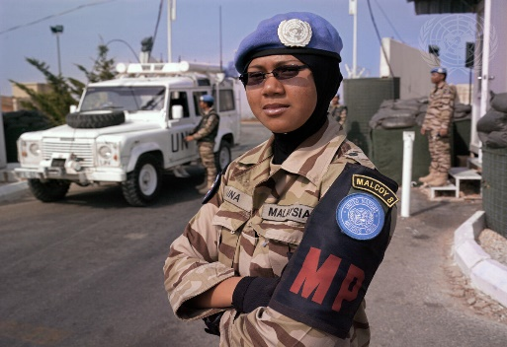
UN photo by Pasqual Gorriz


How about the symbol CKP?
CKP = ch __ c k p__ __ n t

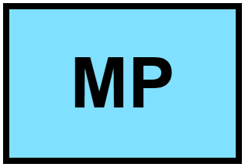
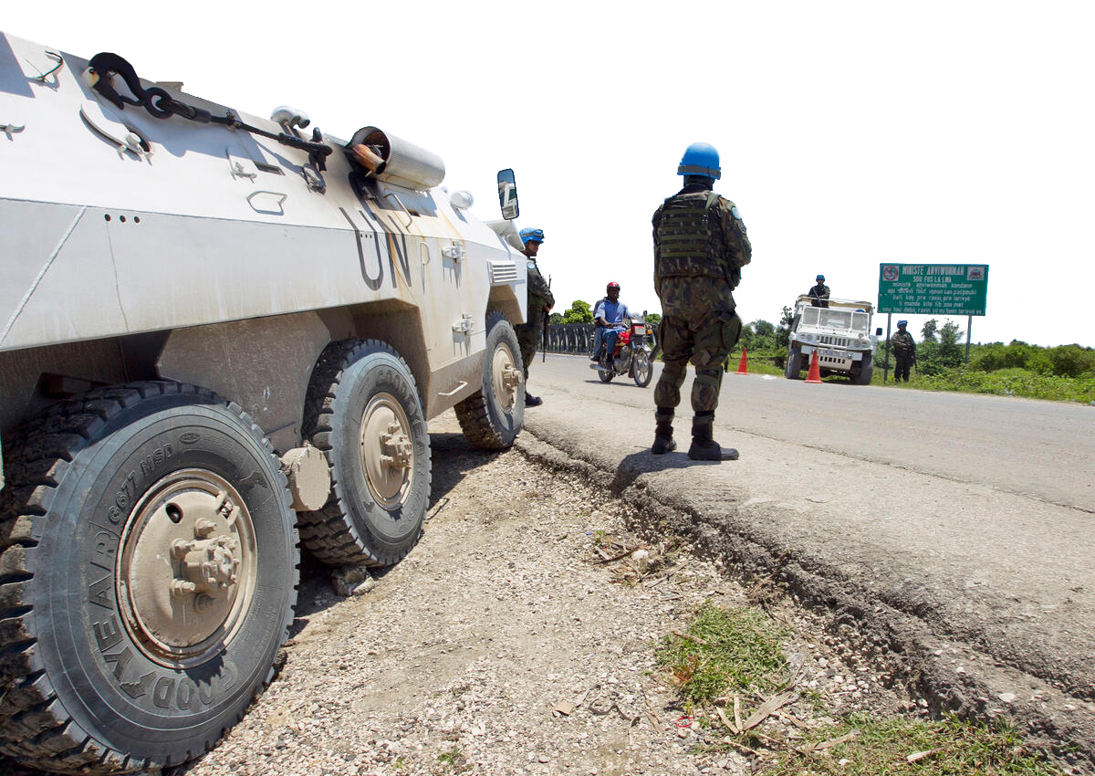
Did you know?
UN symbols are always light blue.

UN photo by Logan Abassi
- Label the symbols for people and places. Use the words in the box below.
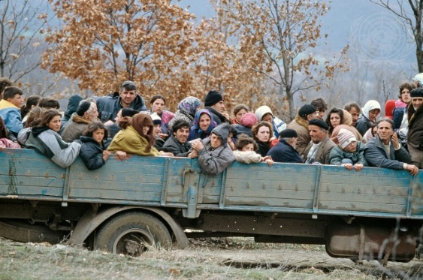
a. _____________________

a. _____________________
UN photo by R LeMoyne



refugees // UN base // school // bridge // train station //
refugee camp // hospital


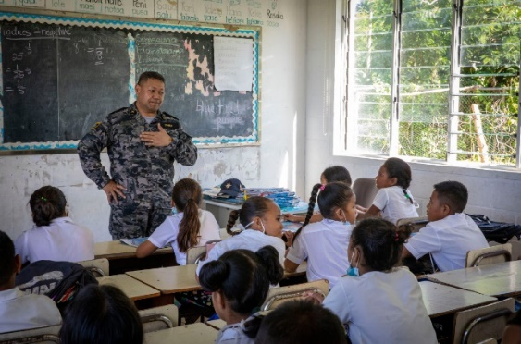
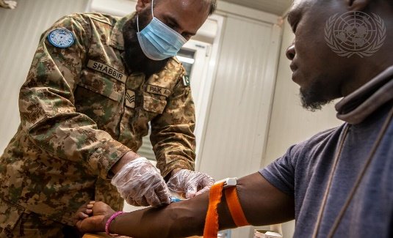
b. _____________________

d. _____________________
c. _____________________

c. _____________________
UN photo by Harandane Dicko

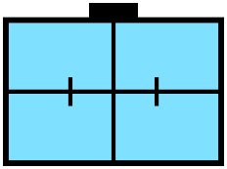


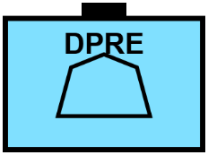
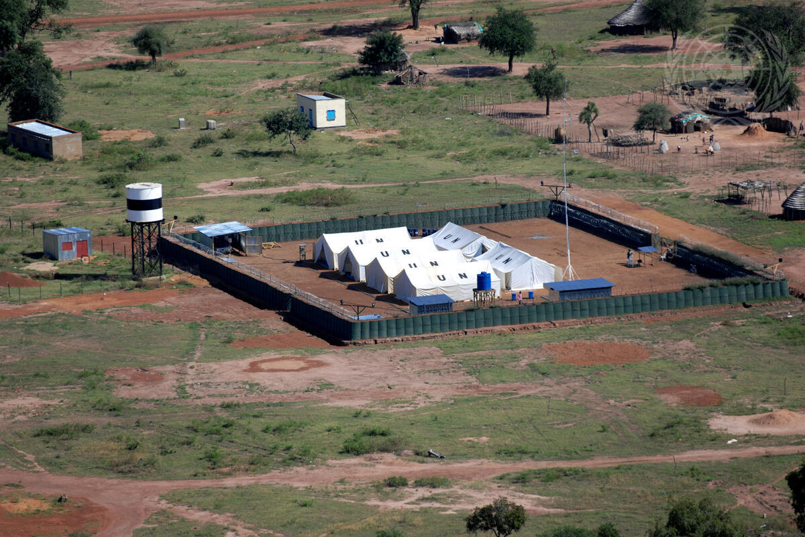
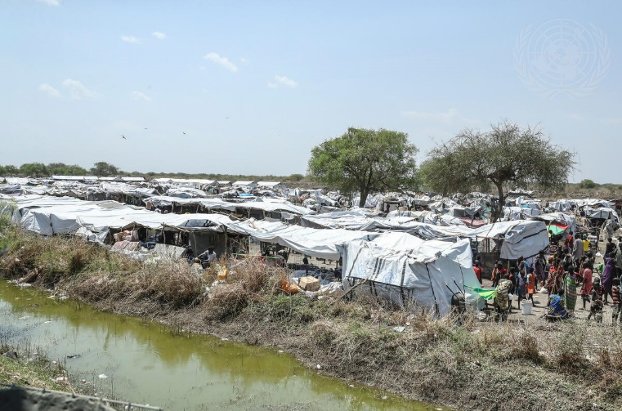
d. _____________________

a. _____________________

e. _____________________
e. _____________________

minefield // bridge // fence // roadblock
f. _____________________
UN photo by John Isaac

UN photo by Tim McKulka
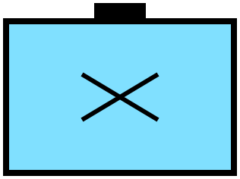

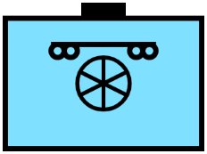
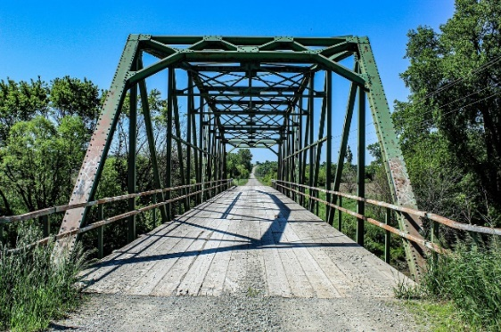
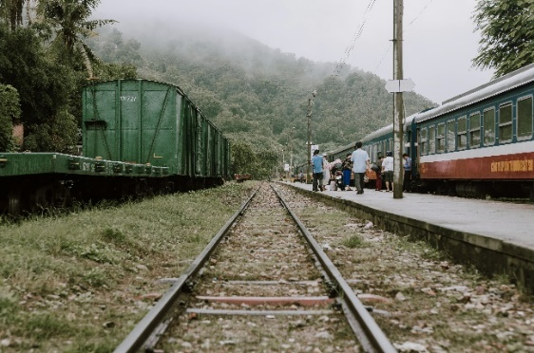
g. _____________________

b. _____________________
f. _____________________

a. _____________________

e. _____________________

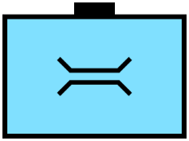

- Label the symbols for obstacles. Use the words in the box below.
minefield // fence // roadblock

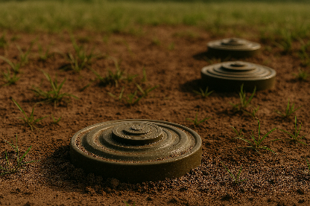
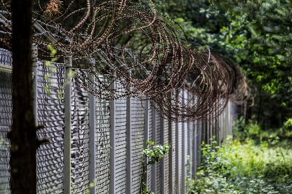
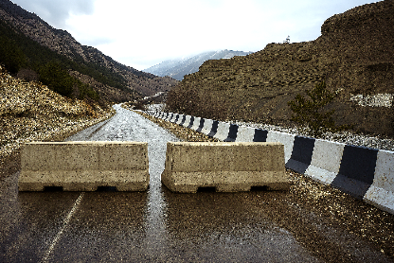


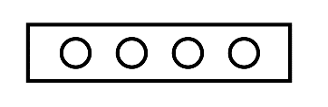

a. ___________________ b. ___________________ c. ___________________

- Vocabulary for giving directions and commands. Write the commands in the box in spaces a-d.
turn right // go straight // go over (a bridge) // turn left // turn around

a. _______________ b. _______________ c. _______________

d. _______________ e. _______________


- Let’s practise saying the words for symbols used by the UN and directions. Pay attention to the stressed syllables/words e.g. refugee. Listen and repeat.

- Now, work with a partner. Look at the map. Follow the red arrows to find to the refugees. Complete the sentences with the correct word for each symbol. Look at examples a. and b. Some words are repeated.
UN base

- Start at the .
refugee camp
- Go straight to the .
- Turn right at the .
- Go straight to the .
- Turn left at the .
- Turn right at the .
- Go straight to the .
- Turn left at the .
- Turn left at the .
- Turn right at the .
- Go straight to the .
- Go over the .
- Go straight and you’ll find the .

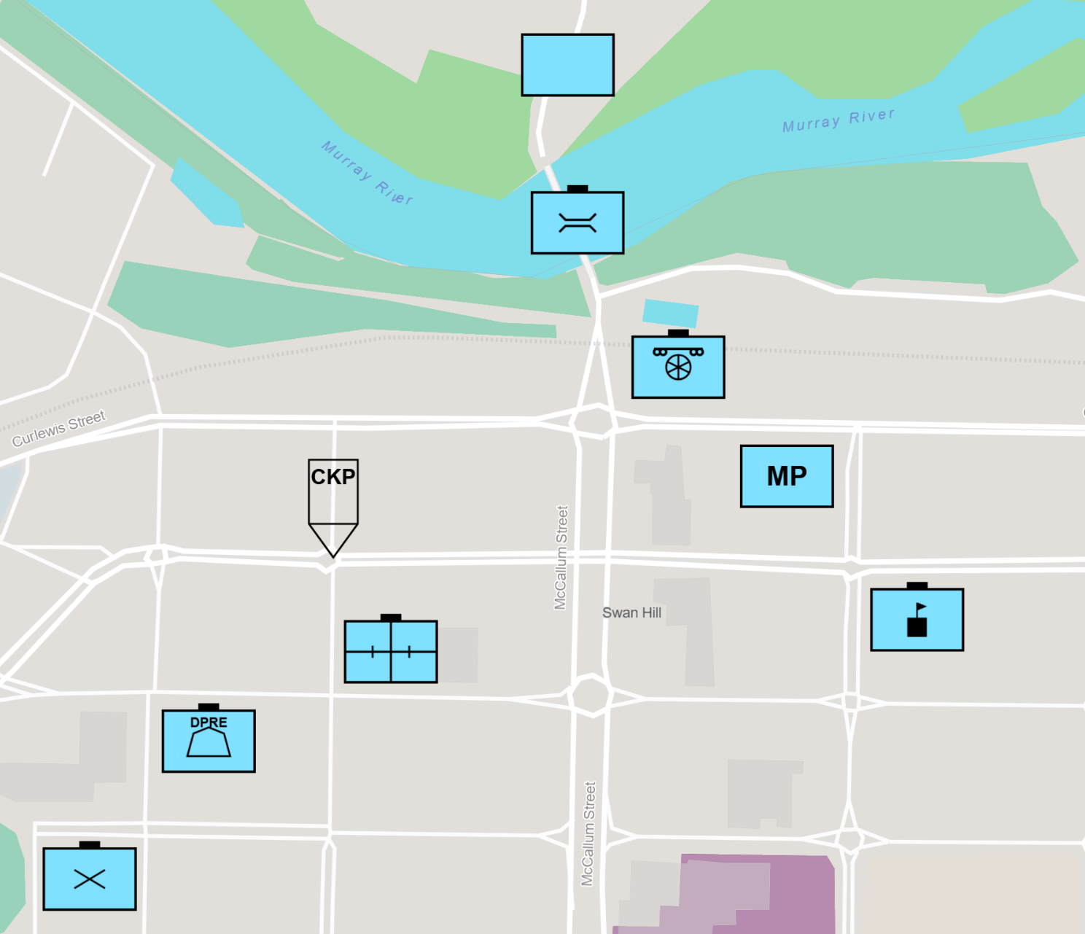
Start here

b.
c.
d.
f.
g.
a.
e.
h.
i.
j.
k.
l.
m.

XXXXXXXXXXXXXX

XXXXXXXXXXXXXX

- Listen, check and repeat.
- Pair work. Student A, stay on this page. Student B, turn to page 6.
Giving commands – part 1 – map for Student A only
Work with a partner. You are in a truck to rescue refugees.
You are Student A. Your partner is Student B, the driver. Give directions to your partner. Your partner must follow the directions carefully, or he/she will hit a fence, a roadblock, or a Minefield!
- Look again at the list of commands in exercises 4 and 6.
- Remember, for a straight arrow , use the words “Go straight to the...”

- For this or , use the words “Turn left at the (place)” or “Turn right at (the place)”.
- When the driver sees a bridge , tell the driver to “Go over the bridge”.
- When you have finished giving 10 commands, check your partner’s map. Did he/she go the right way?
- With the same partner, now do part 2. Turn to page 7.
Rescue the refugees!! Part 1 – Student A
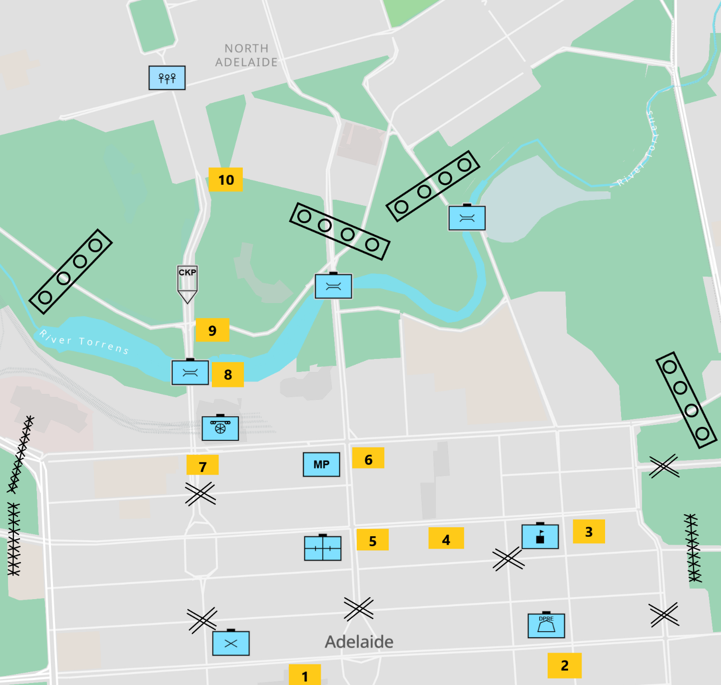
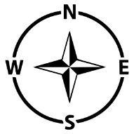
Start here

End here

Giving commands – part 1 – map for Student B only
Work with a partner. You’re the driver of a truck to rescue refugees.
You are Student B. Your partner is Student A. He/she will give you directions. You must follow the directions carefully, or you will hit a fence, a roadblock, or a Minefield!
- Put your pencil at the start and wait for the first command.
- You will hear 10 commands. When you have finished, look at your partner’s map.
- Did you go the right way? Did you hit a minefield?
- With the same partner, now do part 2. Turn to page 8.

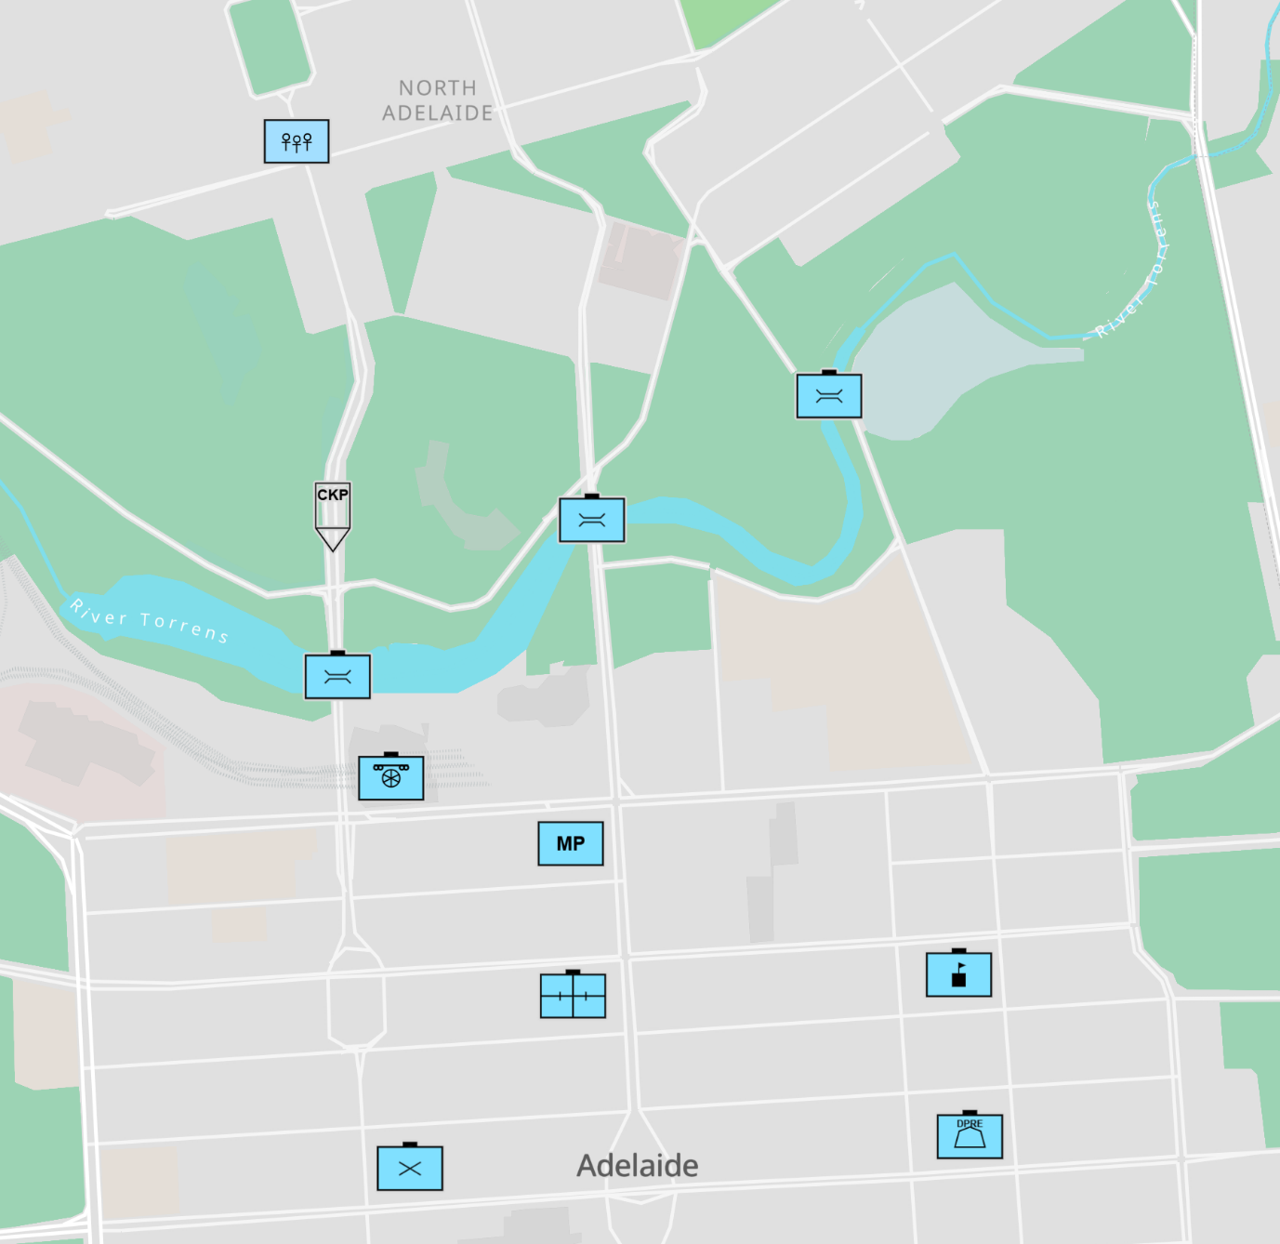
Rescue the refugees!! Part 1 – Student B
Start here

Giving commands – part 2 – map for Student A only
Swap roles. Now you are the driver of the truck to rescue more refugees.
Your partner will give you directions. You must follow the directions carefully, or you will hit a fence, a roadblock, or a Minefield!
- Put your pencil on the symbol for UN Base and wait for the first command.
- You will hear 10 commands. When you have finished, look at your partner’s map.
- Did you go the right way? Did you hit a minefield?
Rescue the refugees!! Part 2 – Student A
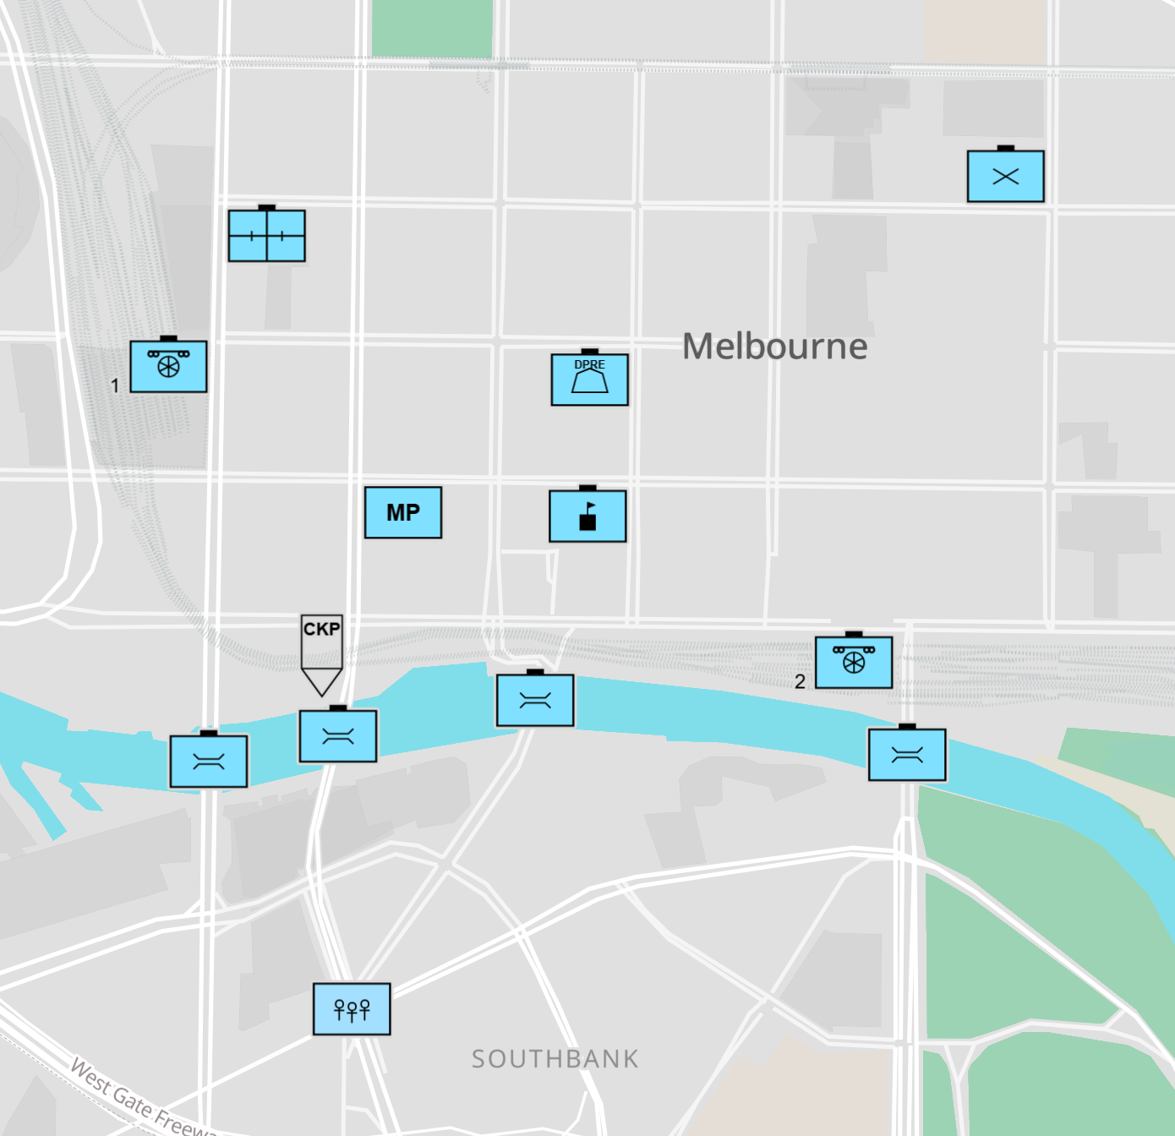

Start here

Giving commands – part 2 – map for Student B only
Swap roles. Now your partner is the truck driver. Give directions to the truck driver to rescue more refugees.
Your partner must follow the directions carefully, or he/she will hit a fence, a roadblock, or a Minefield!
- Look again at the list of commands from exercises 4 and 5. Remember, for a straight arrow , use the words “Go straight to the...”
- For this or , use the words “Turn left at the (place)” or “Turn right at (the place)”.
- When the driver sees a bridge , tell the driver to “Go over the bridge”.
- When you have finished giving 10 commands, check your partner’s map.
- Did he/she go the right way?
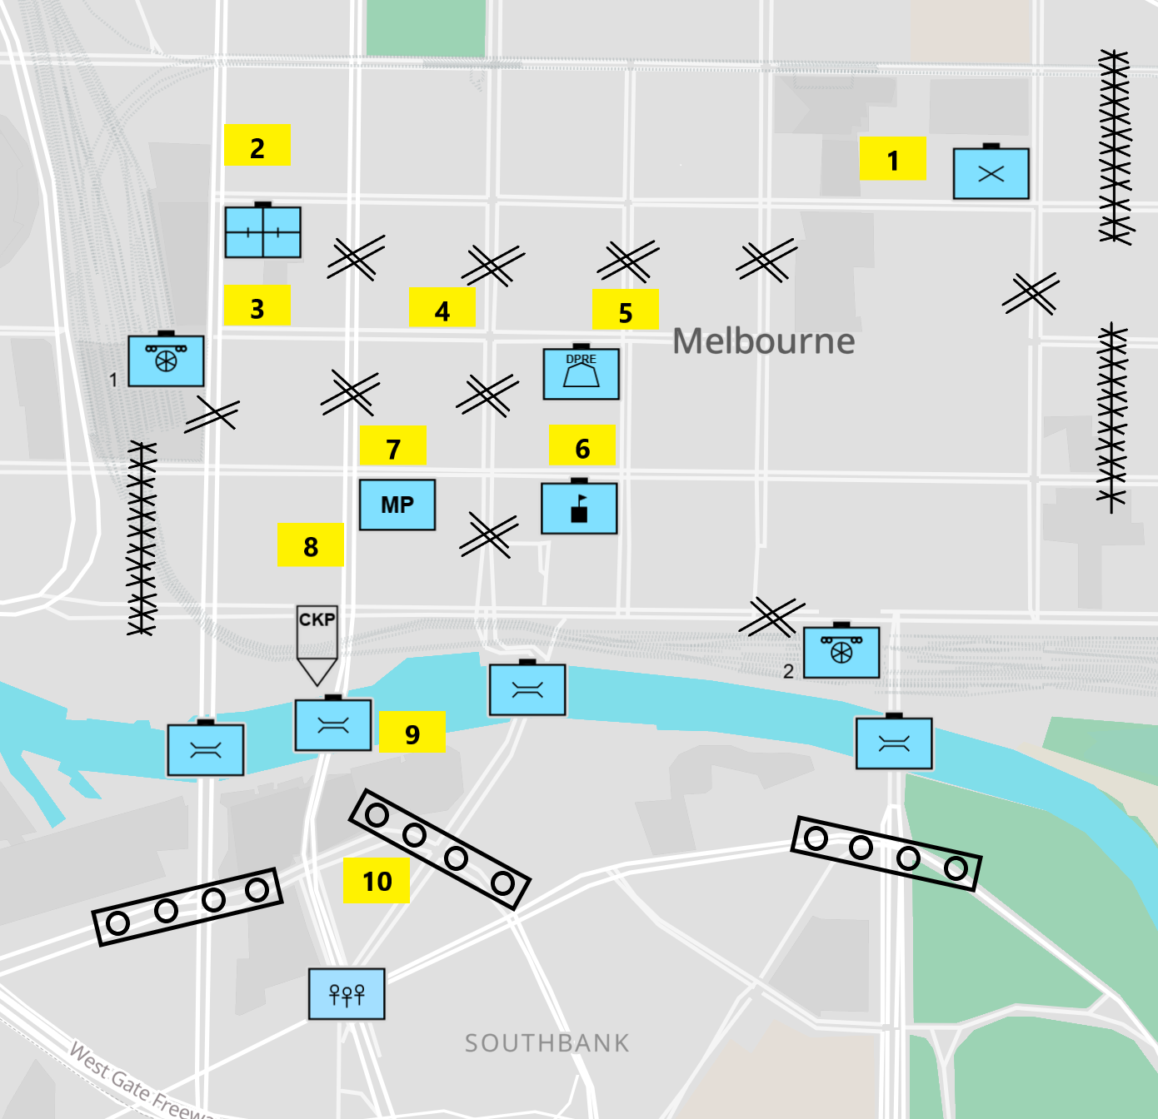
All maps created with Battle Staff Tools, spatialillusions.com, 2025. Map data from OpenStreetMap.
Rescue the refugees!! Part 2 – Student B
Start here

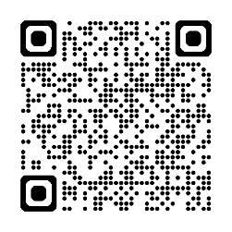
- Watch this YouTube video. Learn more symbols! Draw and write the names of the symbols that were not included in this lesson. Type on YouTube Military Graphics and Symbology (basic unit icons) or scan the QR Code to the right.

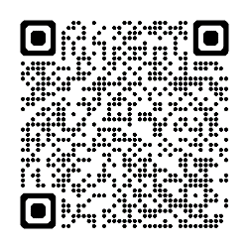
- For more practice with the words you’ve learned here, scan the QR code for a set of flashcards. You can do some more study on the vocab in this lesson on your own with these.

- This Vocabulary Builder links with Lesson: A Day in the Life of a UN Peacekeeping Officer (Reading)
Lesson: Life of a UN Peacekeeping Medic – Parts A-D (Listening)
Vocabulary Builder: Symbology for the Army

© Commonwealth of Australia 2025
This work is copyright. Apart from any use as permitted under the Copyright Act 1968 (Cth),
no part may be reproduced by any process without prior written permission from the Department of Defence.

