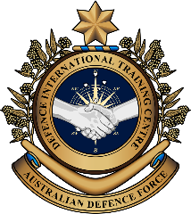
Military English

Lesson: Combined Air Force Exercises – Exercise Elangaroo – Reading

Overview:
This lesson is about “Exercise Elangaroo 24” and the long and special friendship between the Malaysian and Australian Defence forces.

In this lesson, you will
- read a text for main ideas
- find specific information in a text
- learn the meaning of new words and practise using them.

Prepare for Reading
- Look at some pictures of “Exercise Elangaroo 24”. Make guesses with your partner.

- Who did the exercise?
- Where was the exercise?
- What did they learn?
- Did they like the training?

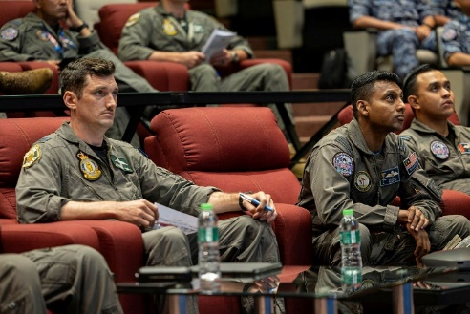
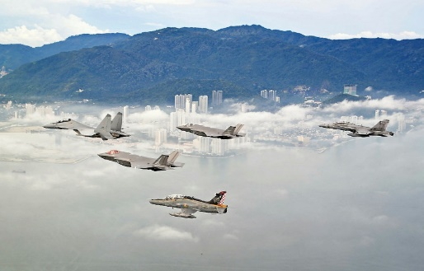
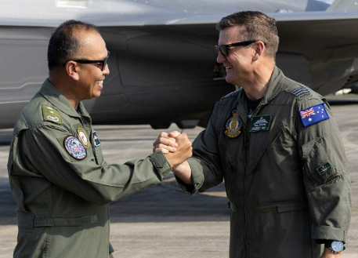

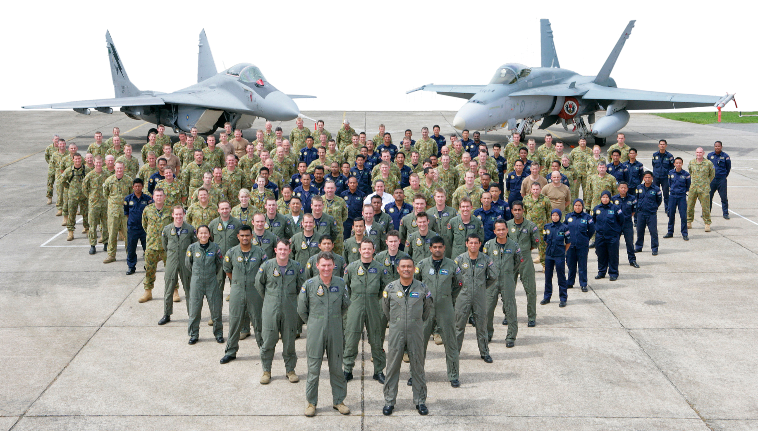

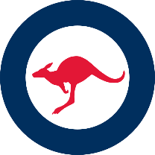


- There are some words we need for today’s reading in the box. Match them with the pictures.
Indo-Pacific region // aviators // destroy // target //
air combat // support // tsunami // maintenance personnel

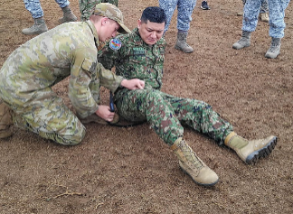
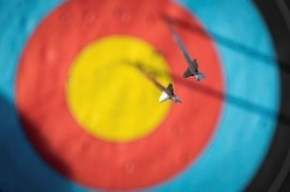
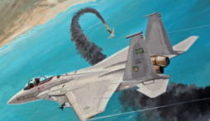

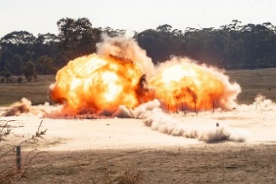

d. ________________
c. ________________
b. ________________
a. ________________

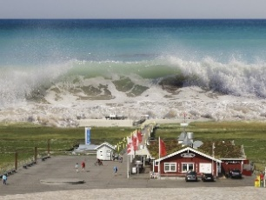
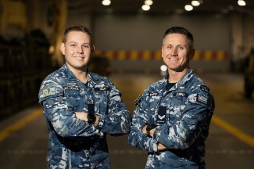
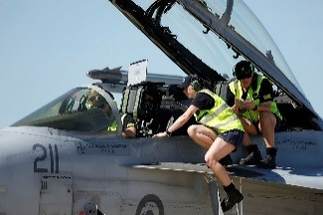


h. ________________
g. ________________
f. ________________
e. ________________


- Listen, check and repeat.

Reading
- Read, listen and check your guesses from exercise one.
“Exercise Elangaroo 24” was a great time to meet old friends and new. It was a combined exercise between the Australian and Malaysian air forces. The exercise was to improve interoperability, which means the countries’ militaries working better together.
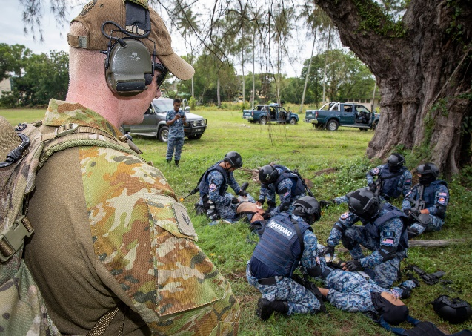
In the skies over Malaysia, Royal Australian Air Force (RAAF) F-35A Lightning IIs flew air combat training missions with Royal Malaysian Air Force (RMAF) F/A-18D Hornets and SU-30MKM Flankers. These aerial drills helped the two air forces learn from each other’s strengths. On the ground, maintenance personnel did their own training. Everyone also participated in activities to learn to work as one big team.
Six F-35As and about 140 RAAF aviators deployed for the exercise. Exercise Elangaroo 24 saw RAAF aviators working from RMAF Base Butterworth in Malaysia and Paya Lebar Air Base in Singapore. The F-35As took off from Paya Lebar Air Base, refueled mid-mission and then landed at RMAF Base Butterworth. When air combat power is spread out over more than one base, it is called ‘Agile Combat Employment’. Agile Combat Employment makes operations more likely to be successful. This is because it is harder for the enemy to target and destroy aircraft.
Corporal Stuart Jacobs from No. 2 Security Forces Squadron, watches a demonstration of tactical combat casualty care by the RMAF Security Squadron, Unit 214 Skuadron Handau during Exercise Elangaroo 22.
The Australian Defence Force has a long relationship with the Malaysian Armed Forces. In fact, the No. 77 Squadron (SQN) was based there for 11 years in the 50s and 60s. In the 70s, the Australian Army had an infantry company to support the Malaysian government. The company was called “Rifle Company Butterworth” and they were based at RMAF Base Butterworth. The base was given to the Malaysian Air Force in 1988, but the Australian Army still do jungle warfare training there. They also do combined training with the Malaysian Army. In 2004, the Indian Ocean tsunami hit Indonesia. Australia and Malaysia worked together to help people in Aceh, Indonesia. They used Butterworth again as a base for this disaster relief operation.
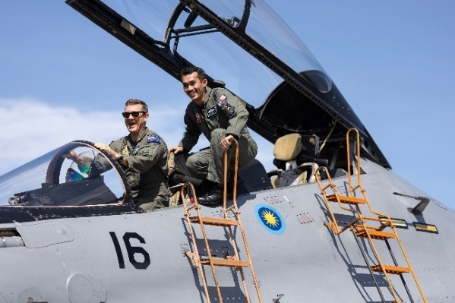
The Commanding Officer of No. 77 SQN is Wing Commander Paul Simmons. He says that Malaysia is one of Australia’s most important regional partners. It is important that the two defence forces can work well together to help keep the Indo-Pacific region safe.
Exercise Elangaroo 24 gave everyone the chance to share knowledge, ideas and experience. “We have enjoyed working, learning and flying together. Through this exercise we have continued to build the strong relationship between Australia and Malaysia,” Wing Commander Simmons said. “Every minute on this exercise has brought us closer together.”
LTCOL Fairul of the RMAF (right) shows WGCDR Simmons (RAAF) the cockpit of an RMAF Su-30MKM during Exercise Elangaroo 24.

- Complete the sentences with 1-3 words from the text.
- The aim of “Exercise Elangaroo” was to help build _______________________ between the Australian and Malaysian air forces.
- Together, the air forces did teamwork __________________.
- Agile Combat Employment makes it more difficult for the enemy to ___________ and ____________ planes.
- The Australian Army still does ______________________________ at RMAF Base Butterworth with the Malaysian army.
- The friendship between Malaysia and Australia is important to keep the _______________________ secure.
- Exercise Elangaroo ’24 helped Australia and Malaysia to make their ___________________ stronger.

- Look at the words in bold in the reading. We will match them to their definitions next. First, look at them in the sentences and talk to your partners. What part of speech are the words? What do you guess they mean?
Tip: When you see a new word in English,
you can
- ask a classmate
- use an English-English dictionary
- use the sentence to help you guess the meaning.

Learning military vocabulary
- The words in bold are important military vocabulary that you should learn. Match them to their definitions on the right. Look at the example and write the answers in the middle column.
Table 1
a combined* exercise between the Australian and Malaysian airforces | f |  | - (n) when different groups, like the armies of different countries, can work together easily and well; it means their equipment, their ways of doing things, and their communication systems can connect and understand each other
improve interoperability |  |  | - (n) practice activities done by pilots in the air; they practise flying in different ways and doing different things with their aircraft; this helps them to become better and safer pilots
F-35A Lightning IIs flew air combat training missions |  |  | - (n) planned activities or missions that the military does; these can be for training, helping people after a disaster, or for fighting if there is a war
These aerial drills helped the two airforces learn |  |  | - (n) a military unit that usually has about 100-250 soldiers
it is called ‘Agile Combat Employment’ |  |  | - (n) a way for an air force to move quickly and use small groups of people and equipment at different places; this makes it harder for enemies to attack them because they are not all in one place
makes operations more likely to be successful |  |  | - (n) exercises or operations with two or more nations’ armed forces
an infantry company to support |  |  | - (n) practice flights where pilots learn how to fight other aircraft in the sky; they pretend there is an enemy and practise different ways to attack and defend

Table 2
Everyone also participated in activities |  |  | - (n) when soldiers learn how to fight, move and stay safe in the jungle
the Australian Army still do jungle warfare training |  |  | - (n) very similar to a joint exercise, but more focused on skills building
do combined training with |  |  | - (n) countries in the same area or part of the world that work together
this disaster relief operation |  |  | - (v) to be doing an activity together with other people
Australia’s most important regional partners |  |  | 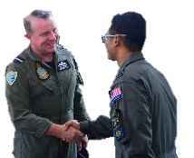  - (verb phrase) to create connections and become friendly with other people or groups or to get closer and trust each other more
to build on the long-standing defence relationship |  |  | - (n) help that is given to people after a very bad event like a flood, earthquake, or bushfire; this help can include things like food, water, shelter (a place to stay), and medical care
* “Combined” is correct, but you will probably hear a lot of Australians say “joint”.
- Listen and check.
- Now let’s practise saying the words. Listen and repeat.

Practice
- Using new words. Complete the questions with new words from the box.
interoperability // build relationships // combined training //
disaster relief // participated // regional partners

- What is the best way to _______________________________at work?
- Is __________________________ good between the navy, army and air force in your country? How could this be improved?
- Which countries are your country’s most important ________________________?
- What sort of _______________________________ would you like to join? With who? Why?
- What was the last training you ____________________________ in?
- What ____________________________ do you think the people of Aceh needed after the tsunami?

- Ask and answer the questions with a partner to practise new words.

- Role play. Work in groups of 3-4. Imagine you are planning a combined training exercise between your country and an important regional partner. Use the questions to guide your discussion.

  - Who will you do the combined training exercise with?
  - How will you build relationships between the groups?
  - What skills will you improve?
  - What exercises will you do?
  - How will you know if the combined training is successful?

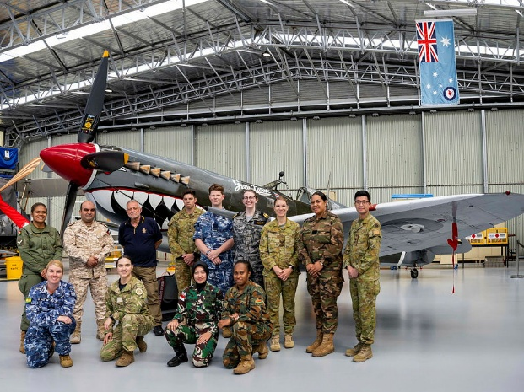
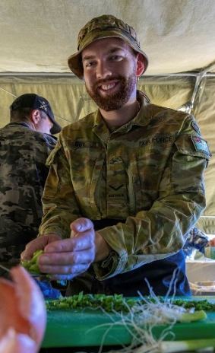
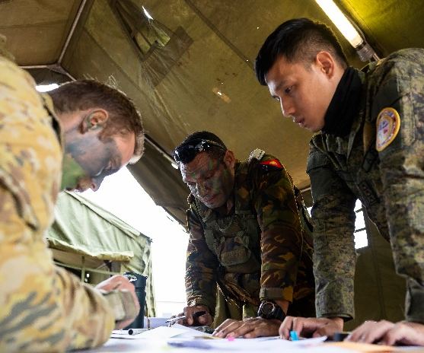


- Watch this video about Exercise Elangaroo 22. Type “Exercise Elangaroo 22 Endex” on YouTube or scan the QR code
After you listen, be ready to discuss:
- Who was in the training?
- What did they deepen*?
- What are they more ready for?
- Would you like to do the same training?
* deepen (v) – make stronger


- For more practice with the words you’ve learned here, scan the QR code.

- This lesson links with Lesson – Joint Military Exercises – Listening
Lesson – Military Exercises – Reading
Lesson – Combined Air Force Exercises – Exercise Pitch Black - Listening
Vocabulary Builder – Types of Military Aircraft – Fixed Wing

© Commonwealth of Australia 2025
This work is copyright. Apart from any use as permitted under the Copyright Act 1968 (Cth),
no part may be reproduced by any process without prior written permission from the Department of Defence.

