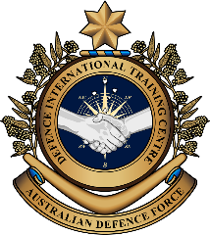
Military English
Vocabulary Builder: Countries and Flags – Southeast Asia

Overview:
This sheet lists vocabulary of countries and their flags, nationalities, and languages in Southeast Asia.
In this vocabulary builder, you will:
- learn and use vocabulary related to the countries in this region.

- Work in groups of four. Have a conversation about the countries below. Use the questions to help you.
Brunei Cambodia Indonesia Laos Malaysia
Myanmar Philippines Singapore Thailand Timor-Leste Vietnam
Which countries have you visited? Did you go on holiday or work?
What did you do there? Did you like it? Why?

- In your group of four, look at the flags and match the countries in the box below to the flag. Continue on the next page.
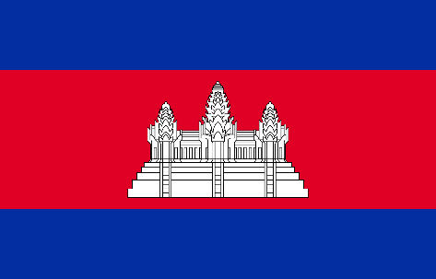
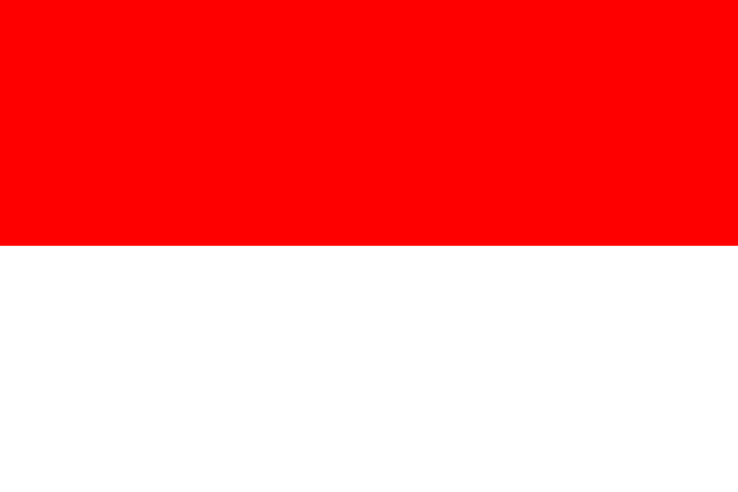
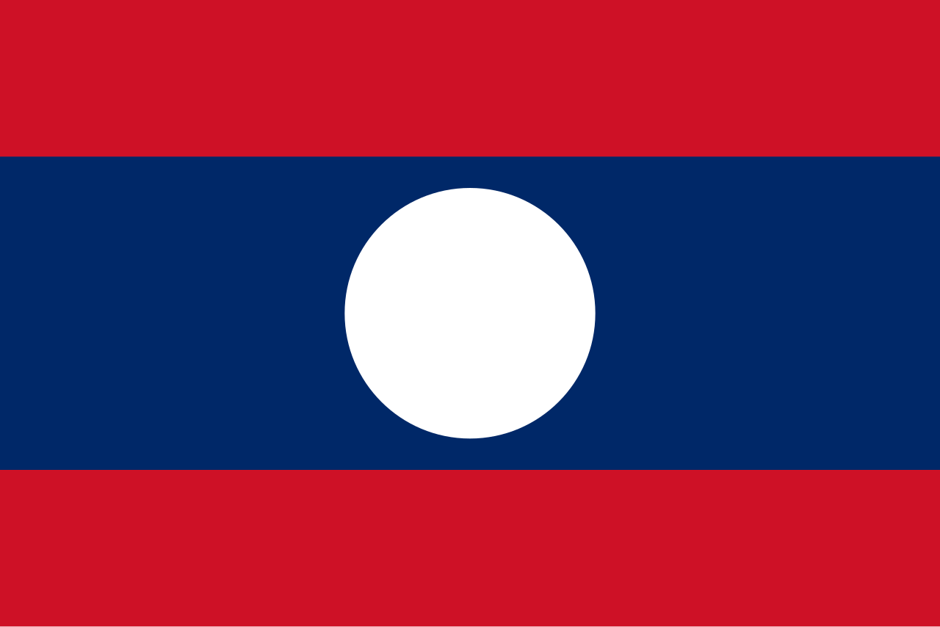

c. _______________________

b. _______________________

a. _______________________

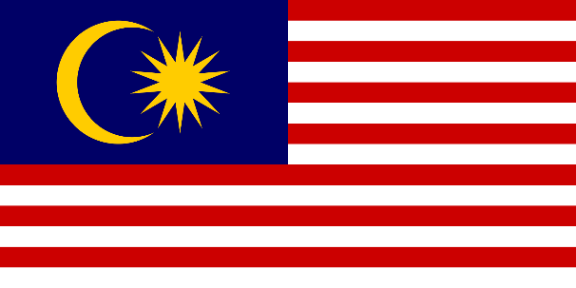
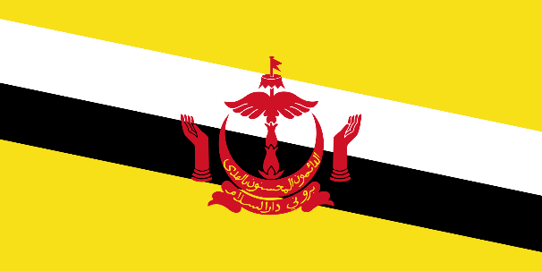

e. _______________________

d. _______________________

Brunei // Cambodia // Indonesia // Laos // Malaysia

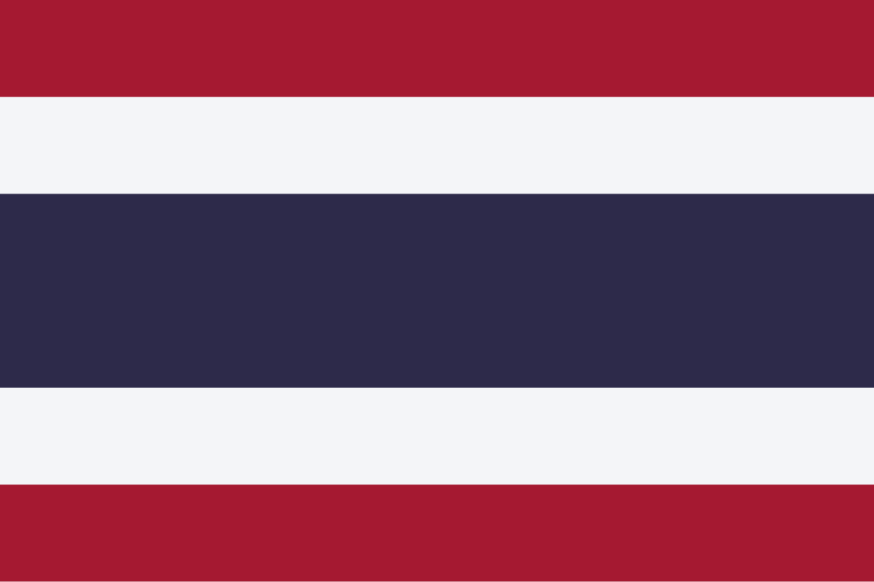
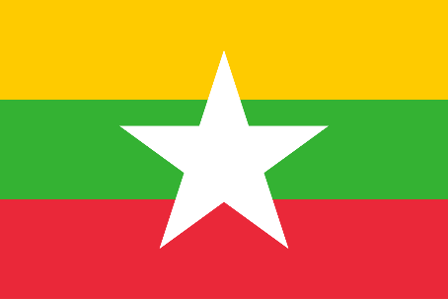
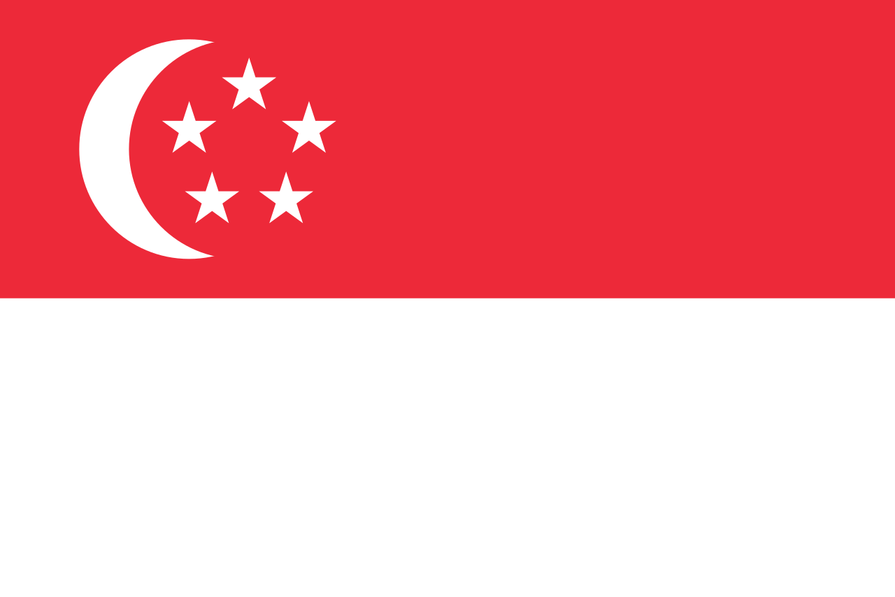

h. _______________________
g. _______________________

f. _______________________

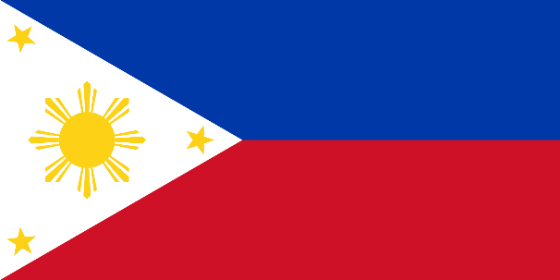
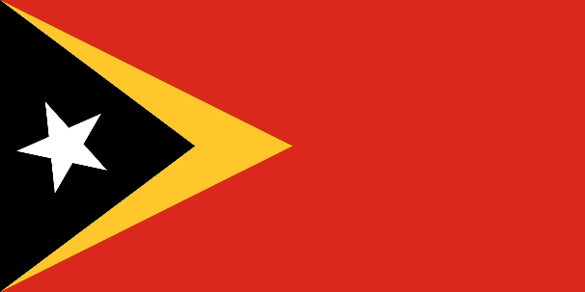

j. _______________________

i. _______________________

k. _______________________

Myanmar // Philippines // Singapore // Thailand // Timor-Leste // Vietnam


- Practise the pronunciation of these countries. Listen and repeat.

- The nationality describes the citizens of a country. Work in pairs, look at the number of missing letters below and then choose which of the endings will complete the spelling of the nationality -n, -o, -ai, -an,
-ian or -ese. Look at the example for Brunei.

Country |  | Nationality |  | Country |  | Nationality
Brunei |  | Brunei a n |  | Myanmar |  | Burm__ __ __
Cambodia |  | Cambodia__ |  | Philippines |  | Filipin__
Indonesia |  | Indonesia__ |  | Singapore |  | Singapore__ __
Laos |  | La__ |  | Thailand |  | Th__ __
Malaysia |  | Malays__ __ __ |  | Timor-Leste |  | East Timor__ __ __
 |  |  |  | Vietnam |  | Vietnam__ __ __
- Practise the pronunciation of these nationalities. Listen and repeat.

- The word for nationality is also used to describe objects of the country such as the flag, the food etc.
e.g. The Bruneian flag has four colours.
- Work in pairs to complete the sentences below (nationalities, numbers and colours). See example a.
- When you’re finished, check your answers with another partner. Decide who’s Student A and who’s B.
- Student A reads the first sentence to student B. Check if the answers are the same.
- Student B reads the next sentence to student A. Check if the answers are the same. Repeat.

- The Bruneian flag has four colours; they are yellow, red, black, and white.
- The Cambodia__ flag has ________ colours; they are _______________, _______________, _______________ and _______________.
- The Indonesia__ flag has _________ colours; they are _______________, and _______________.
- The La___ flag has ___________ colours; they are ___________, ___________, and ___________.
- The Malaysia___ flag has __________ colours; they are _______________, _______________, _______________, and _______________.
- The Burm_____ flag has __________ colours; they are _______________, _______________, _______________, and _______________.
- The Filipin__ flag has __________ colours; they are _______________, _______________, _______________, and _______________.
- The Singapore____ flag has _________ colours; they are _______________, and ________________.
- The Th____ flag has _____________ colours; they are _______________, _______________, and _______________.
- The East Timor_____ flag has __________ colours; they are _______________, _______________, _______________, and _______________.
- The Vietnam____ flag has ________ colours; they are _______________, and _______________.

- Every country has one or more official languages. Read the table below.
- Write the number of syllables for each official language in the column on the right. Look at the example.
- How many countries have the same word for their nationality and their official language? ____

Country |  | Official language/s |  | Number of syllables
Brunei |  | Malay |  | _2_
Cambodia |  | Khmer |  | ___
Indonesia |  | Indonesian |  | ___
Laos |  | Lao |  | ___
Malaysia |  | Malay |  | ___
Myanmar |  | Burmese |  | ___
Philippines |  | Filipino, English |  | ___, ___
Singapore |  | English, Malay, Mandarin, Tamil |  | ___, ___, ___,
Thailand |  | Thai |  | ___
Timor-Leste |  | Portuguese, Tetum |  | ___, ___
Vietnam |  | Vietnamese |  | ___

- Practise the pronunciation of these languages. Listen and repeat. Look at the underlining in the words in exercise seven to check which syllable is stressed.

- Work with a partner. Complete the crossword. Decide who’s student A and who’s student B. Student A, stay on this page, Student B, turn to page six.
STUDENT A
- Take it in turns: read the clues on this page to student B, then student B reads you their clues.
- Complete each word when student B reads you the clues.
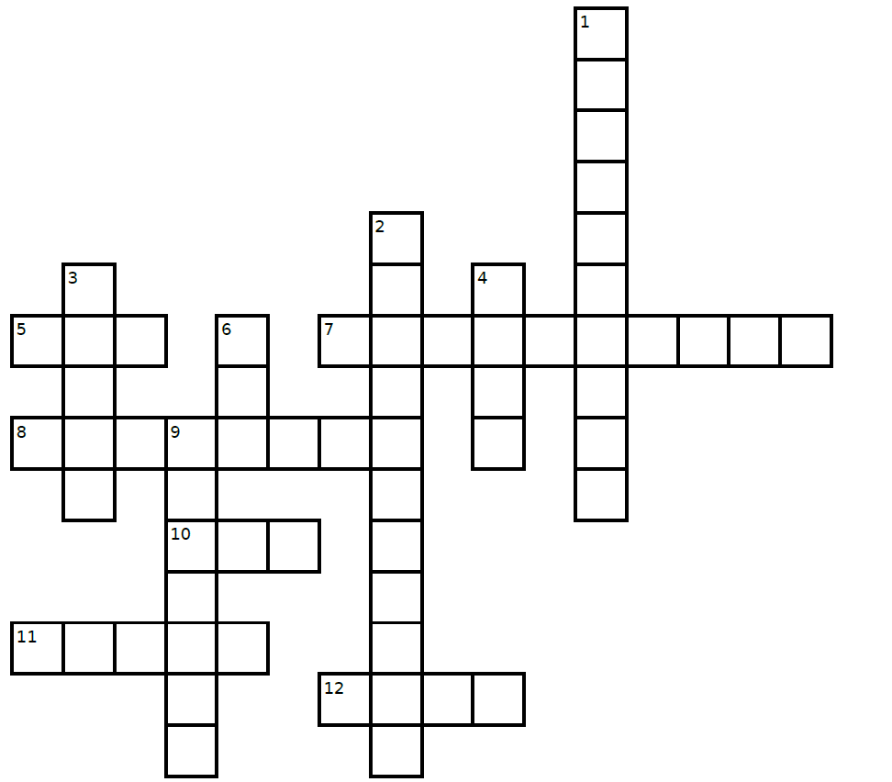
- Don’t show student B this page. Speak clearly and slowly so your partner can understand you.
INDONESIAN
F

U
R
M
A
L
A
Y
B
U
R
M

S
E
THREE
LAOS
- Ask for help if you can’t complete a word e.g., ‘I don’t know, can you please help me?’
- If your partner needs help completing their word, give them a letter (or two) from the word.

Read these clues to Student B

Across
7. a flag with two colours and no pictures
11. the number of countries with Malay as an official language
12. Lao is the official language of which country?
Down
3. the official language of Brunei
4. the number of official languages of Singapore
9. the nationality of a citizen from Myanmar

STUDENT B
- Take it in turns: read the clues on this page to student A, then student A reads you their clues.
- Complete each word when student A reads you the clues.
- Don’t show student A this page. Speak clearly and slowly so your partner can understand you.
- Ask for help if you can’t complete a word e.g., ‘I don’t know, can you please help me?’
- If your partner needs help completing their word, give them a letter (or two) from the word.
T
I
M
O
R
L
E
S
T
E
T
W

S
I
N
G

P
O
R
E
A
N
CAMBODIA
RED
LAO

Read these clues to Student A
Across
5. the nationality of a citizen from Laos
8. Khmer is the official language of which country?
10. the most common colour of all 11 flags

Down
1. a country in Southeast Asia with Portuguese
as an official language
2. a flag which has 5 stars and a moon
6. the number of countries in South East Asia with
English as one of their official languages

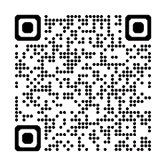
- Test your knowledge of the flags, nationalities and official languages. Type on YouTube Guess the Flag Southeast Asia or scan the QR code to the right.

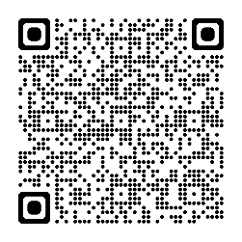
- For more practice with the words you’ve learned here, scan the QR code for a set of flashcards. You can do some more study on the vocab in this lesson on your own
with these.

- This Vocabulary Builder links with Vocabulary Builder – Countries and Flags – Oceania Parts A, B
Vocabulary Builder – Countries and Flags – East Asia
Vocabulary Builder – Countries and Flags – South Asia

© Commonwealth of Australia 2025
This work is copyright. Apart from any use as permitted under the Copyright Act 1968 (Cth),
no part may be reproduced by any process without prior written permission from the Department of Defence.

