
Military English
Lesson: Radio Communications (RATEL) – Radio Checks – [listening]

Overview:
This lesson covers vocabulary needed to conduct a radio check.
In this lesson, you will
- listen to a training session and learn the meaning of new words
- practise listening skills
- use new words in conversations.

Prepare for Listening
- Look at some pictures from today’s listening. Work in a small group and discuss the questions.
              - Do you have to use a radio at work?
              - Do you ever speak on the radio in English?
              - What is easy about it? What is harder?
              - Have you ever had any training about being on the radio? What did you learn about?

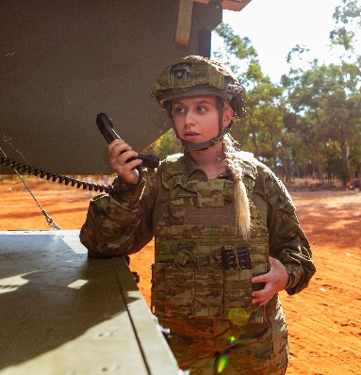
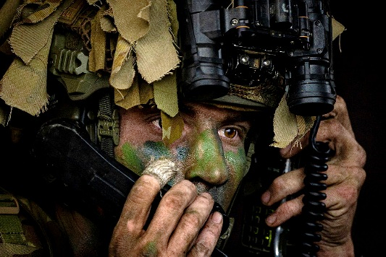
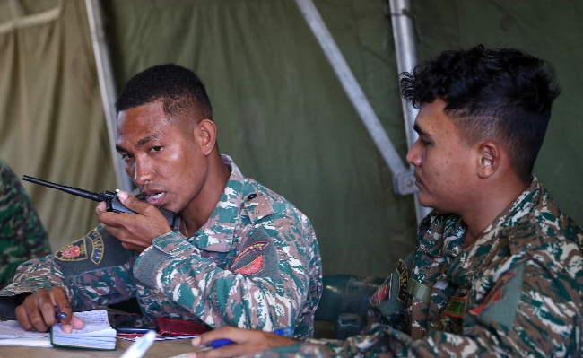

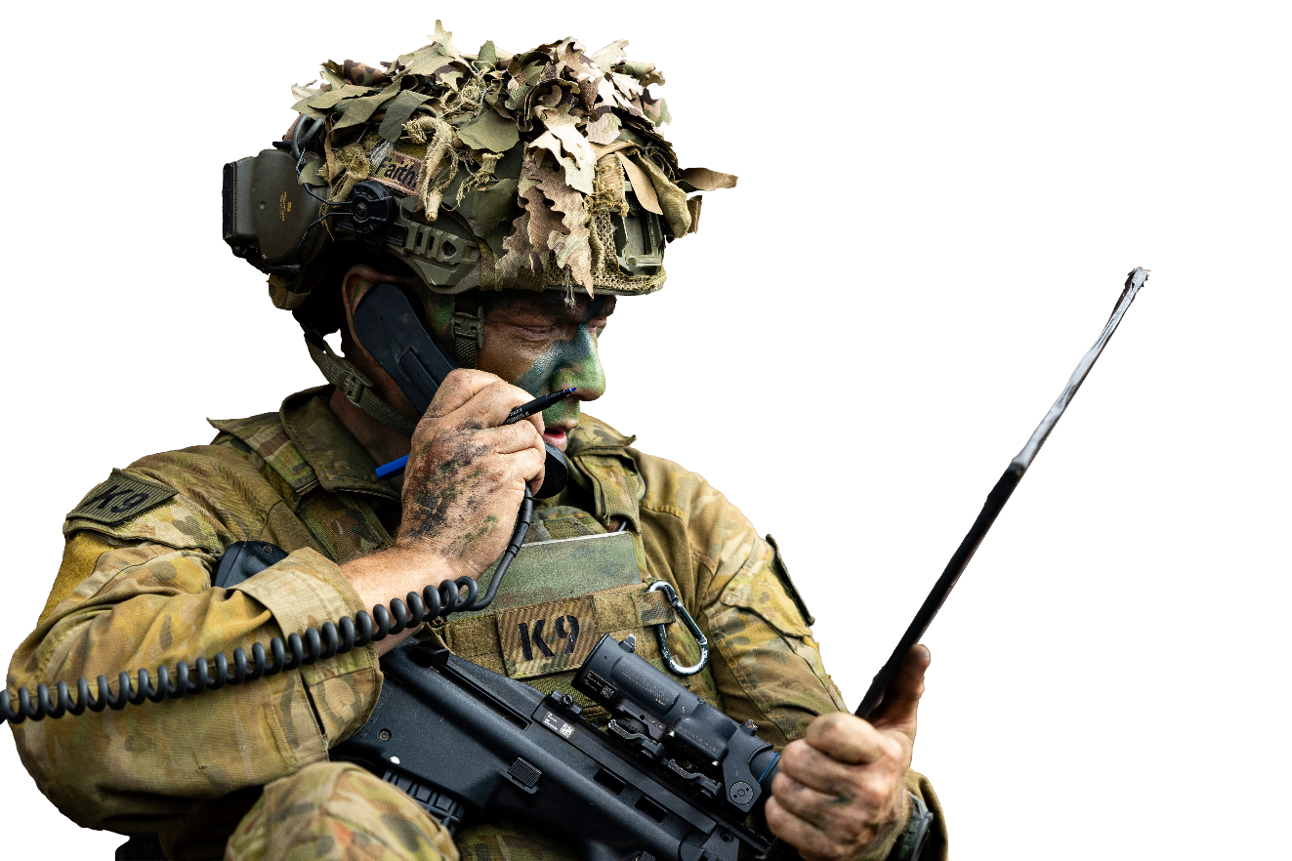

Listening

- Listen to the instructor. What is the main idea of the training? Circle the correct answer.
How to keep your radios clean and safe.
How to know that the radio is working.
How to be polite on the radio.

- Listen again and circle the correct answers.
1. Soldiers do radio checks to
- make sure everyone understands the message.
- tell the others when a soldier is hurt.
- fix broken radios.
- make sure the batteries are charged.
2. Circle one of the first things you do in a radio check.
- Say ‘loud and clear’.
- Make sure everyone is quiet.
- Turn your radio on to the correct channel.
- Ask if the call signs are correct.

3. Which phrase is ‘Lima Charlie’?
- Long and clear.
- Loud and Clear.
- Lost and Clear.
- Love and Clear.
4. RATEL (radio communication) in the Australian Defence Force is
- always done in the same way.
- not done in the same way.
- decided by the Commanding Officer.
- done through a phone.
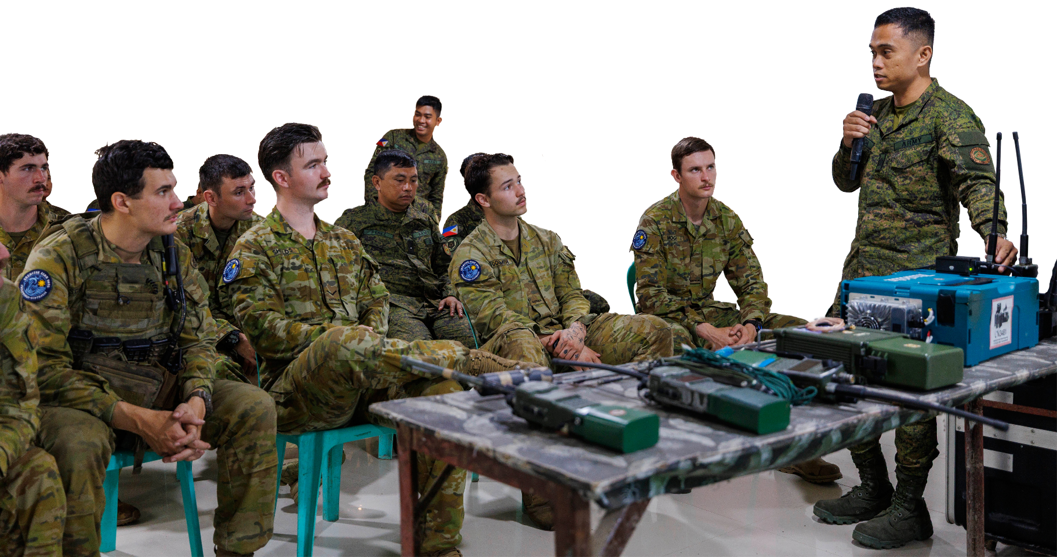

Learning Military Vocabulary
- The words in bold in the text are important military vocabulary that you should learn to use. Match the military words on the left to their definitions on the right on tables one to three. Look at the example.

Table one
radio checks |  |  | - this is the end of the exchange
transmissions |  |  | - I have finished speaking – your turn
channel |  |  | - I hear you
call signs |  |  | - (n) what radio users do to make sure their transmissions are strong and clear
this is | h |  | - (n) a name or number given to a person or a unit to identify them on the radio e.g. "Romeo 2" or "Charlie 1”
over |  |  | - (n) the messages sent over the radio
roger |  |  | - (n) a frequency that a group of people use to talk to each other on a radio – similar to a phone line for your team
out |  |  | - I am ______

Table two
loud and clear |  |  | - radio communications; talking on the radio
broken but readable |  |  | - I can hear you with no problems
nothing heard |  |  | - the radio isn’t working – we should try something different
broken and unreadable |  |  | - I can understand you, but it is not very clear
improve your means |  |  | - maybe you can hear me, but I can’t hear you
switch to alternative |  |  | - do something to make the signal better like moving the antenna or moving to a new place
RATEL |  |  | - I can hear you but the sound is bad and I can’t understand you
- Listen and check.
- Now let’s practise saying the words. Listen and repeat.
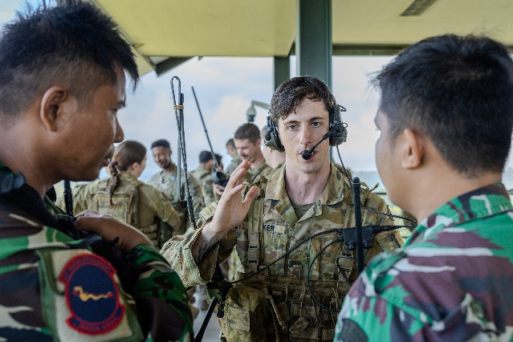
An Australian Army Bombardier conducts radio checks with Indonesian Armed Forces (TNI), during Exercise Super Garuda Shield 2025.
Practice
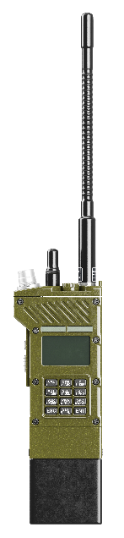
- Complete these radio conversations with the new words from exercise four.
>> Conversation 1 <<
C12, this is C11. Radio Check. ________________.
C11, _________________ C12, loud and clear. ________________.
C12 this is C11. Roger. ______________.
>> Conversation 2 <<
40, all __________________. Radio check. Over.
41, loud and clear. Over.
42, ……….
43, loud and clear. Over.
40. 41, 43, out to you. 42, radio check. Over.
42, broken ______________________. Over.
40, 42, roger. 40, ________________.

>> Conversation 3 <<
40, 41. ____________________________. Over.
……….
40 this is 41. Radio check. Over.
……….
40 this is 41. _________________________. Out.

>> Conversation 4 <<
40 this is 42C. Radio check. Over.
42C this is 40. You are _________________________, Switch to ______________________. Over.
40 this is 42C. Roger. Out.
…some time later…
40 this is 42C. Radio check. Over.
42C this is 40. ___________________________. Over.
40 this is 42C. Loud and clear. Out.

>> Conversation 5 <<
40 this is 42C. Radio check. Over.
42C this is 40. You are _______________________________________, say words twice. Over.
40 this is 42C, 40 this is 42C. Radio check. ____________________. Over.
42C this is 40. You are broken and unreadable. ________________________________________. Over.
40 this is 42C. ____________________. Out.
- Listen and check.

- Practise the conversations with your partners.

- Practise radio checks with a partner. Your teacher will give you a card that tells you how you can hear your partner on the radio e.g. well, not well, not at all. Take turns being the caller. Be ready to perform your radio check for the class!

Example one:
One-one, this is one-zero, loud
and clear, over.
One-zero, this is one-one,
radio check, over.
One-zero, this is one-one,
roger, out.

Example two:
Four-one alfa, roger. Out.
One-three alfa, this is four-one alfa, radio check, over.

Four-one alfa, this is one-three alfa, broken but readable, over.

- Listen to your partners perform their radio check. Make notes. Whose radios are working?

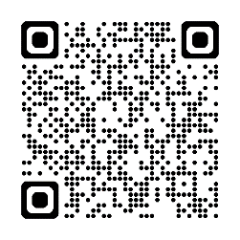
- You will watch a video of the Australian Defence Force (ADF) helping the Vanuatu police with RATEL training. Type on YouTube ADF Radio Operators train Vanuatu Police or scan the QR code.
Watch the video and decide if these statements are true or false. Also make a note of any other RATEL vocabulary you want to learn.
- They are learning about one type of radio system.
- They only learn in the classroom.
- This is the first time they are doing this kind of training.
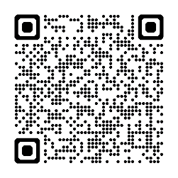
- The Vanuatu police think the training will be important for a long time.
- For more practice with the words you’ve learned here, scan the QR code for a set of Quizlet flashcards. You can do some more study on the vocab in this lesson on your own with these.

- This lesson links with: Lesson – Radio Communications (RATEL) [listening]
Vocabulary Builder – Phonetic Alphabet
© Commonwealth of Australia 2025
This work is copyright. Apart from any use as permitted under the Copyright Act 1968 (Cth), no part may be reproduced by any process without prior written permission from the Department of Defence.

