
Military English
Lesson: What’s in my Ratpack? [listening]

Overview:
In this lesson you will practise vocabulary related to ration packs – or ratpacks.

In this lesson, you will:
- practise listening for gist and specific information
- practise talking about ratpacks.

Prepare for Listening
- Look at the picture of an Australian soldier and his ratpack. Discuss the questions with your partners.
a. When do soldiers use ratpacks?
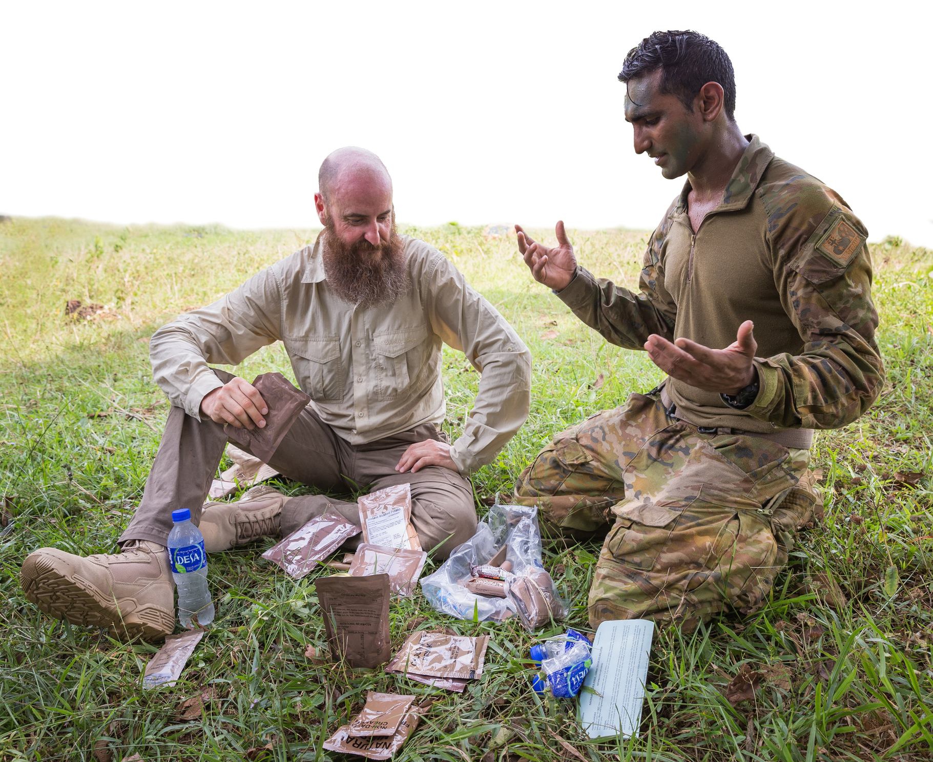
b. What do you think is in Australian Defence Force (ADF) ratpacks?

- These are words we will need for the listening. Look at the pictures and match as many as you can with words from the box.
dessert // to boil // a packet // to heat // meals // to be issued // beef // a cuppa // a mate

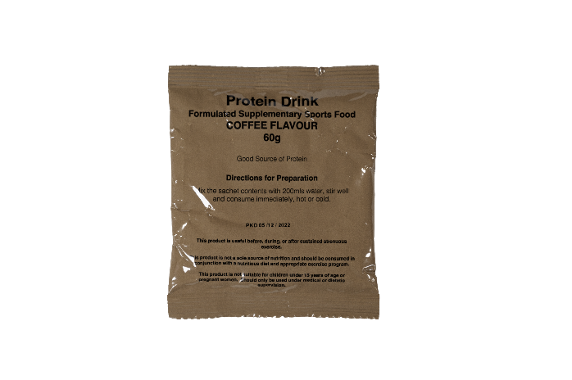
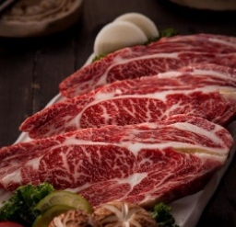
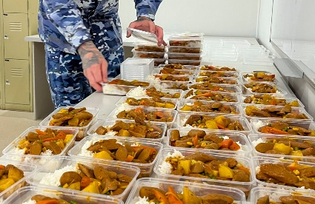

a. __________________
b. ________________
c. ________________


d. ________________
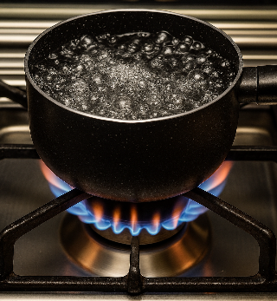
e. __________________
f. __________________
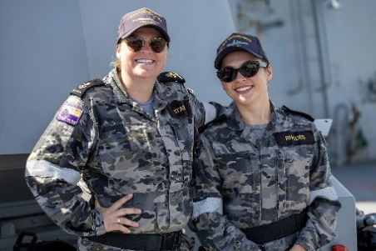
g. _________________

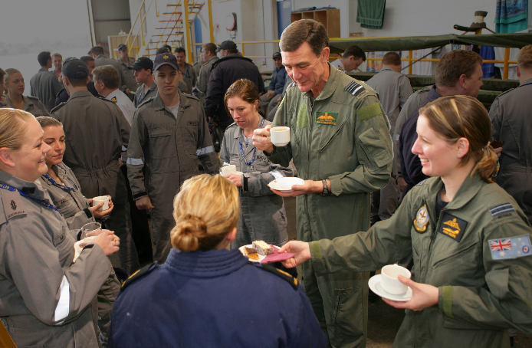
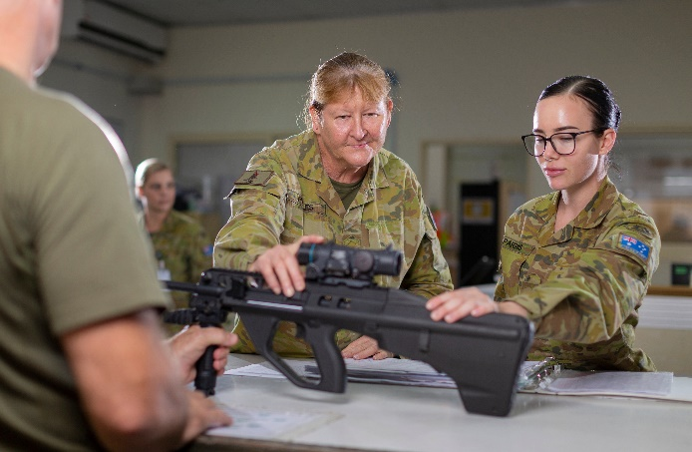

i. ____________________
h. ____________________


- Listen, check, and repeat.
- Discuss these questions with your partner to practise the new words.
a. What dessert would you like to find in your ratpack?
b. What is your favourite meal? Breakfast, lunch or dinner?
c. What foods come in packets?
d. How many cuppas do you have a day?
e. Do you prefer beef or chicken in a ratpack?
f. Who is your best mate at work?

Listening
- You will hear Tim talk about an ADF ratpack. What does he think of it?
  - It’s the best thing he has ever eaten.
  - He thinks it is good.
  - He hates it.
- Listening for details. Complete the sentences with one word or number from the listening. The first one has been done for you as an example.
Major
- Olivia is a __________________ in the Australian Army.
- Olivia likes ratpack letter ______________ the most.
- Soldiers do not open the _____________________________ to heat up the MRE.
- The other meals in the CR1P are soup and _____________________________ Italiano.
- The CR1P also has some _____________________________ like cheese and biscuits.
- Normally, Olivia just eats the MREs _____________________________.
- Tim gives the meal a score of ______________ out of 10.
- Tim asks for a cup of ______________________ to drink.
- The ratpack was made ______________ years ago.

Learning Military Vocabulary
- The words in bold are important military vocabulary that you should learn. Match them to their definitions on the right. Look at the example and write the answers in the middle column.
Table 1
CR1P pack G | e |  | - (n) army slang for a ration pack; food that soldiers take out field
the most popular ratpacks |  |  | 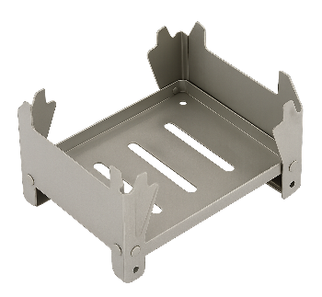  - (n) a small, light cooker that uses hexamine to heat food or water; it's easy for soldiers to carry
every soldier is issued one |  |  | 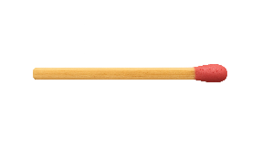  - (n) small sticks with a tip  that lights up and makes fire
This is a hexamine stove |  |  | 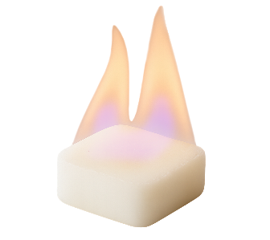  - (n) a small block that you can burn;  it makes fire to heat or cook food
use this hexamine tablet |  |  | 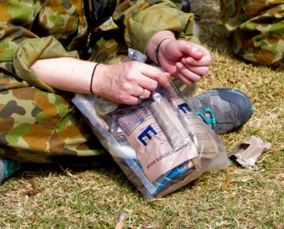  e. (n) this stands for Combat Ration 1 Person; this is the food a soldier has for one day out field
these matches |  |  | 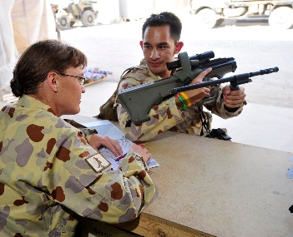  - (v) is given to someone e.g. military personnel are issued a uniform, and some are issued weapons

Table 2
I have my MRE here |  |  |   - (n) soft paper you use to clean yourself after going to the toilet
I have my canteen cup |  |  | 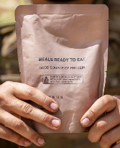  - (n) this stands for ‘Meal, Ready-to-Eat’; it's a packet of food that soldiers can eat when out field; they don’t need to cook it
of course, vegemite |  |  | 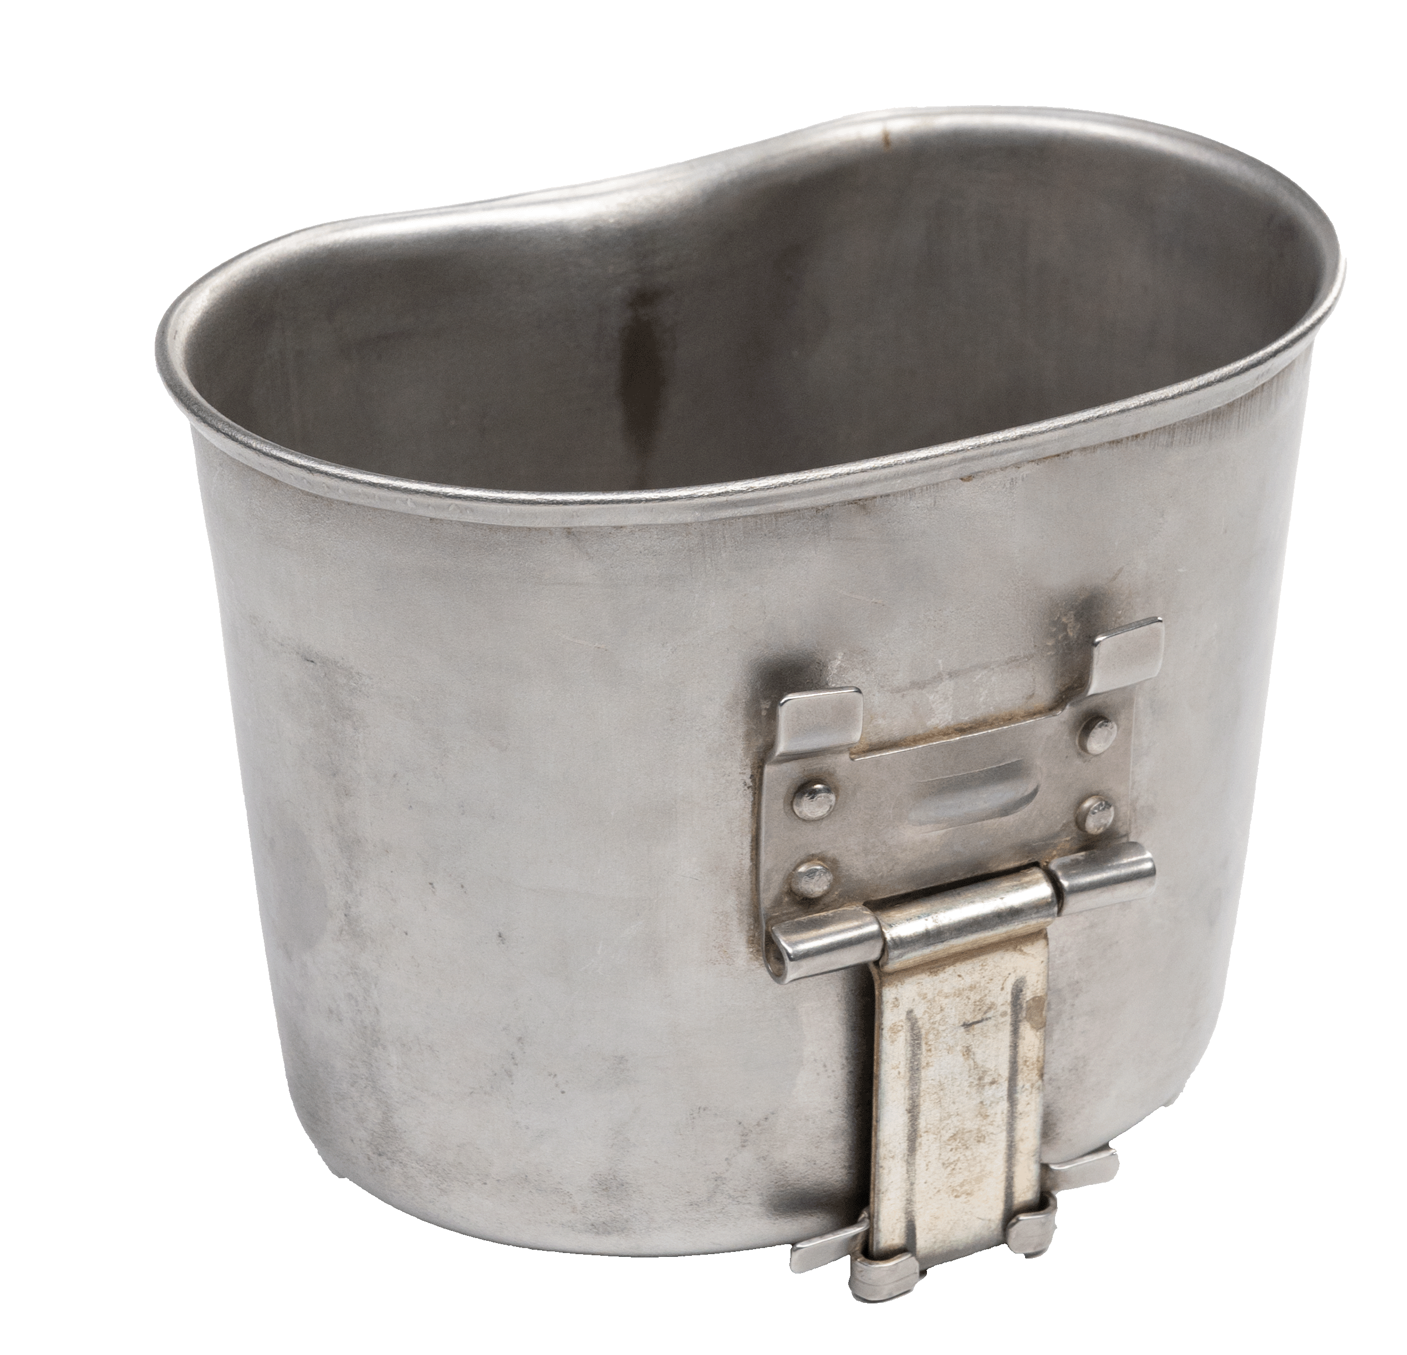  - (n) a small metal cup that soldiers use for drinking or heating water and food; it fits around their water bottle
Have some toilet paper |  |  | - (n) a drink that helps your muscles after exercise
isotonic drink |  |  | 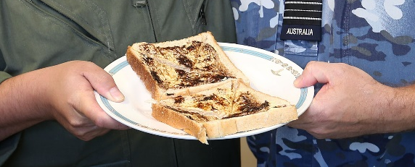  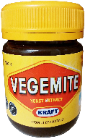  - (n) a salty, brown food Australians  often eat on biscuits or  bread
a protein drink |  |  | - (n) a drink that helps your body get water, sugar, and salts quickly when you exercise
- Listen and check.
- Now let’s practise saying the words. Listen and repeat.

Practice
- Complete the questions with one of the new words from the box.
canteen cups // hexamine stove // issued //
protein drinks // isotonic drinks // MRE

- What __________________________ are popular in your country? How often do you drink them?
- Do you ever drink _________________________ after you go to the gym? Do they help?
- Were you _____________________ with any gear when you joined the defence force? What things?
- Do canteens in your country come with _______________________? Are they useful?
- Have you ever cooked with a ______________________________________? Was it easy?
- What food from your country would work well in an __________________ packet?

- Discuss these questions with your partner to practise the new words.

- Speaking. Stand up and walk around the room.
- Try to find a different person for each of the lines below.
- When you find one, ask them a follow-up question e.g. Why?; Which one?...
- Then write their names next to the sentence and find another partner.
Find someone who…

…uses matches.
…drinks isotonic drinks.
…has eaten a ratpack recently.
…has tried an ADF ratpack.
…drinks protein drinks.

…has heated water with a hexamine stove.
…has tried vegemite – and liked it!
…has lost some issued gear.
…ate something out of a packet this week.
…would eat an MRE cold.

Have you ever heated water with
a hexamine stove?
Where were you?


Watch a video about an Irish ration pack. How many words from today’s lesson can you see? Would you prefer to try an Australian ration pack or an Irish ration pack? Type on YouTube Irish Defence Forces Ration Pack or scan the QR code.



For more practice with the words you’ve learned here, scan the QR code for a set of Quizlet flashcards. You can do some more study on the vocab in this lesson on your own with these.

This lesson links with: Vocabulary Builder – What’s in Your Webbing?
Vocabulary Builder – Parts of a Ratpack

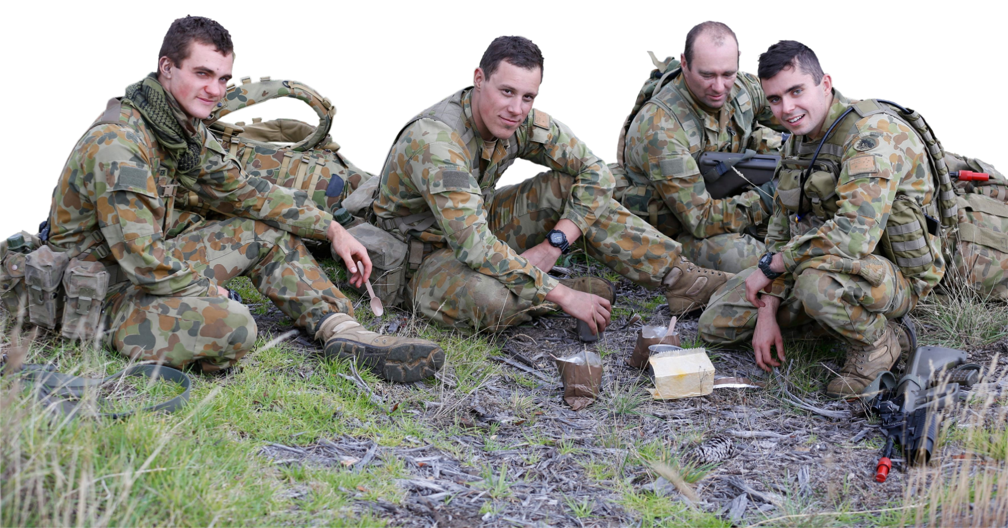
© Commonwealth of Australia 2025
This work is copyright. Apart from any use as permitted under the Copyright Act 1968 (Cth),
no part may be reproduced by any process without prior written permission from the Department of Defence.

Four Australian Army Privates eat their MREs.

