
Military English
Vocabulary Builder – Parts of a Ratpack

Overview:
This worksheet lists vocabulary related to ration packs (ratpacks).
In this lesson, you will:
- learn vocabulary for ration packs
- practise using the vocabulary
- use the vocabulary in speaking activities.

- Look at the pictures around the page and talk to your partners.
a. What can you see in the picture?
b. Why do you think this is happening?
c. What do the pictures make you want to know?
I see…
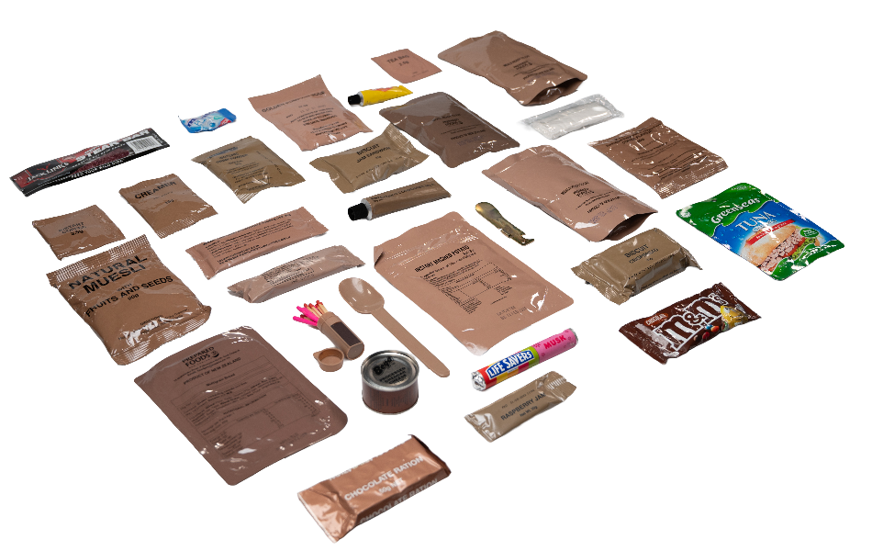
I think…
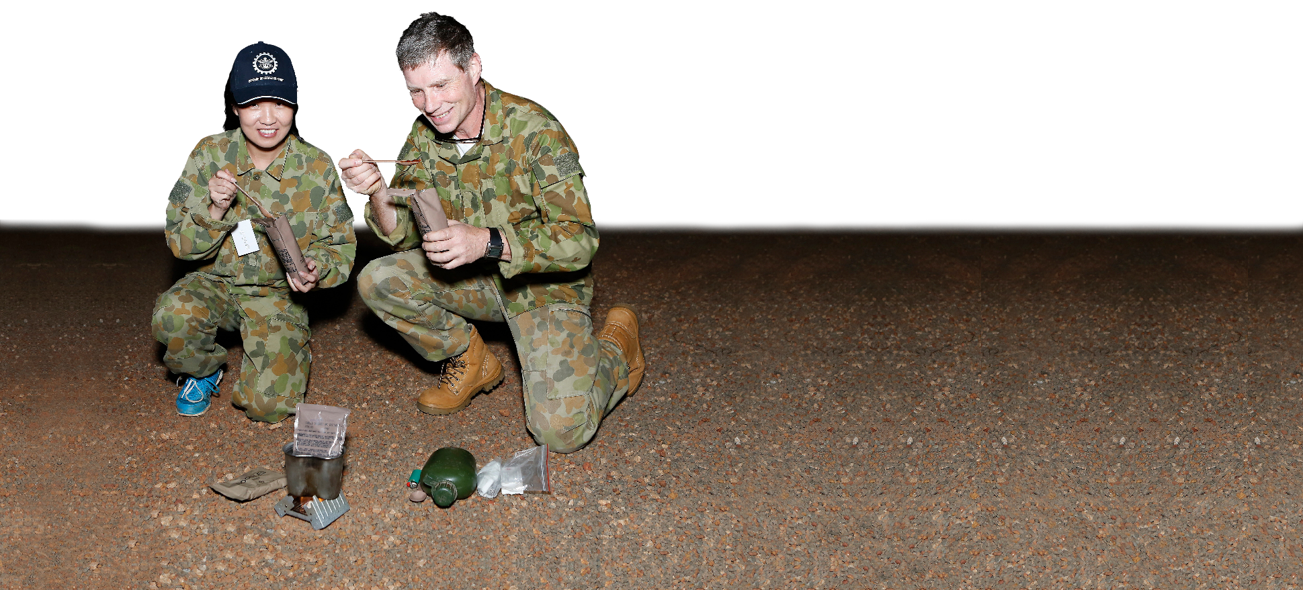
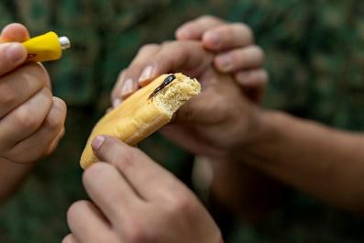
I want to know…
- Look at the picture and discuss with a partner. Do you think it is enough food for 24 hours? Why?
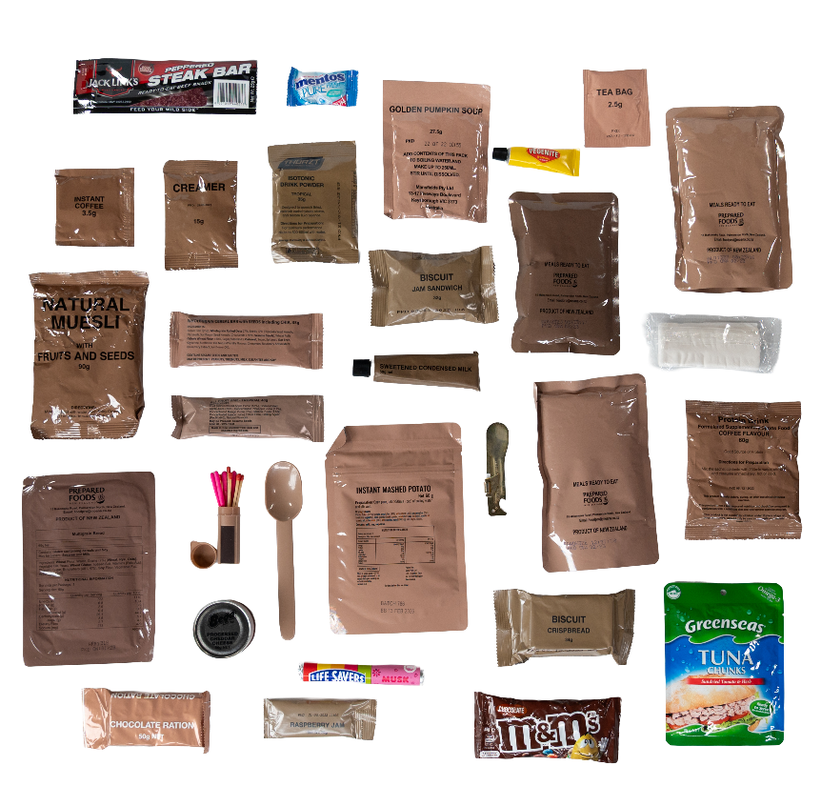
The Australian Army has different types of ratpacks. This is the Combat Ration One Person (CR1P). It’s for one soldier on a one-day combat mission.

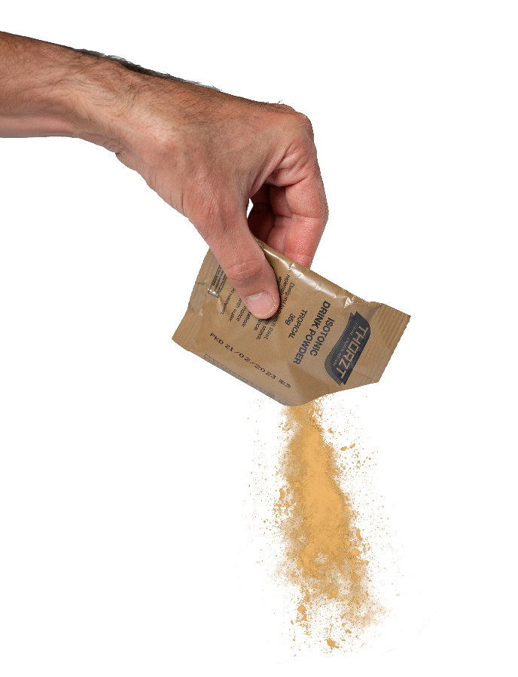
- Match the vocabulary to the pictures. Continues on the next page.
MRE // CR1P // snacks // isotonic drink powder
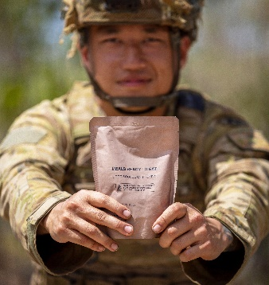
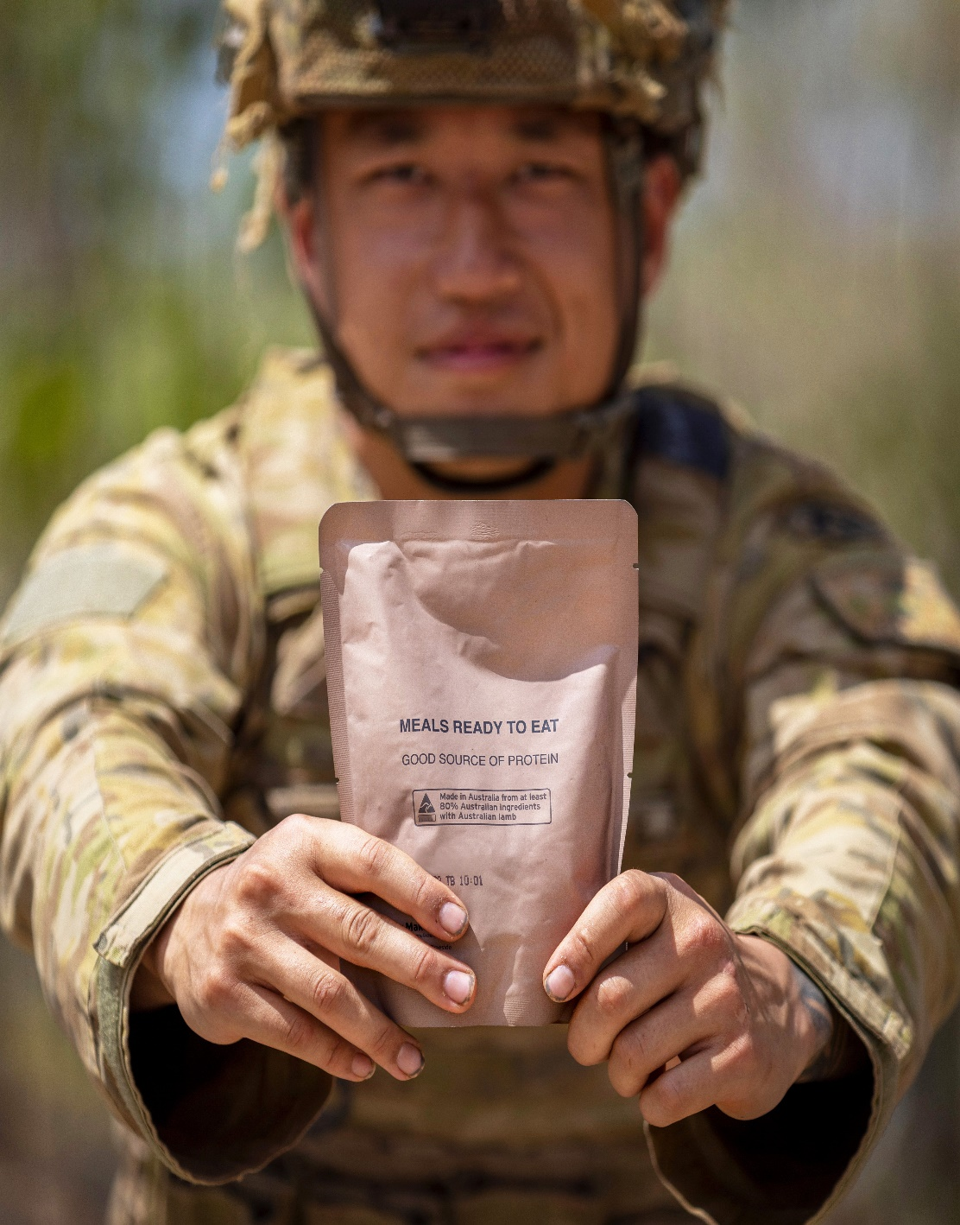
a. __________________
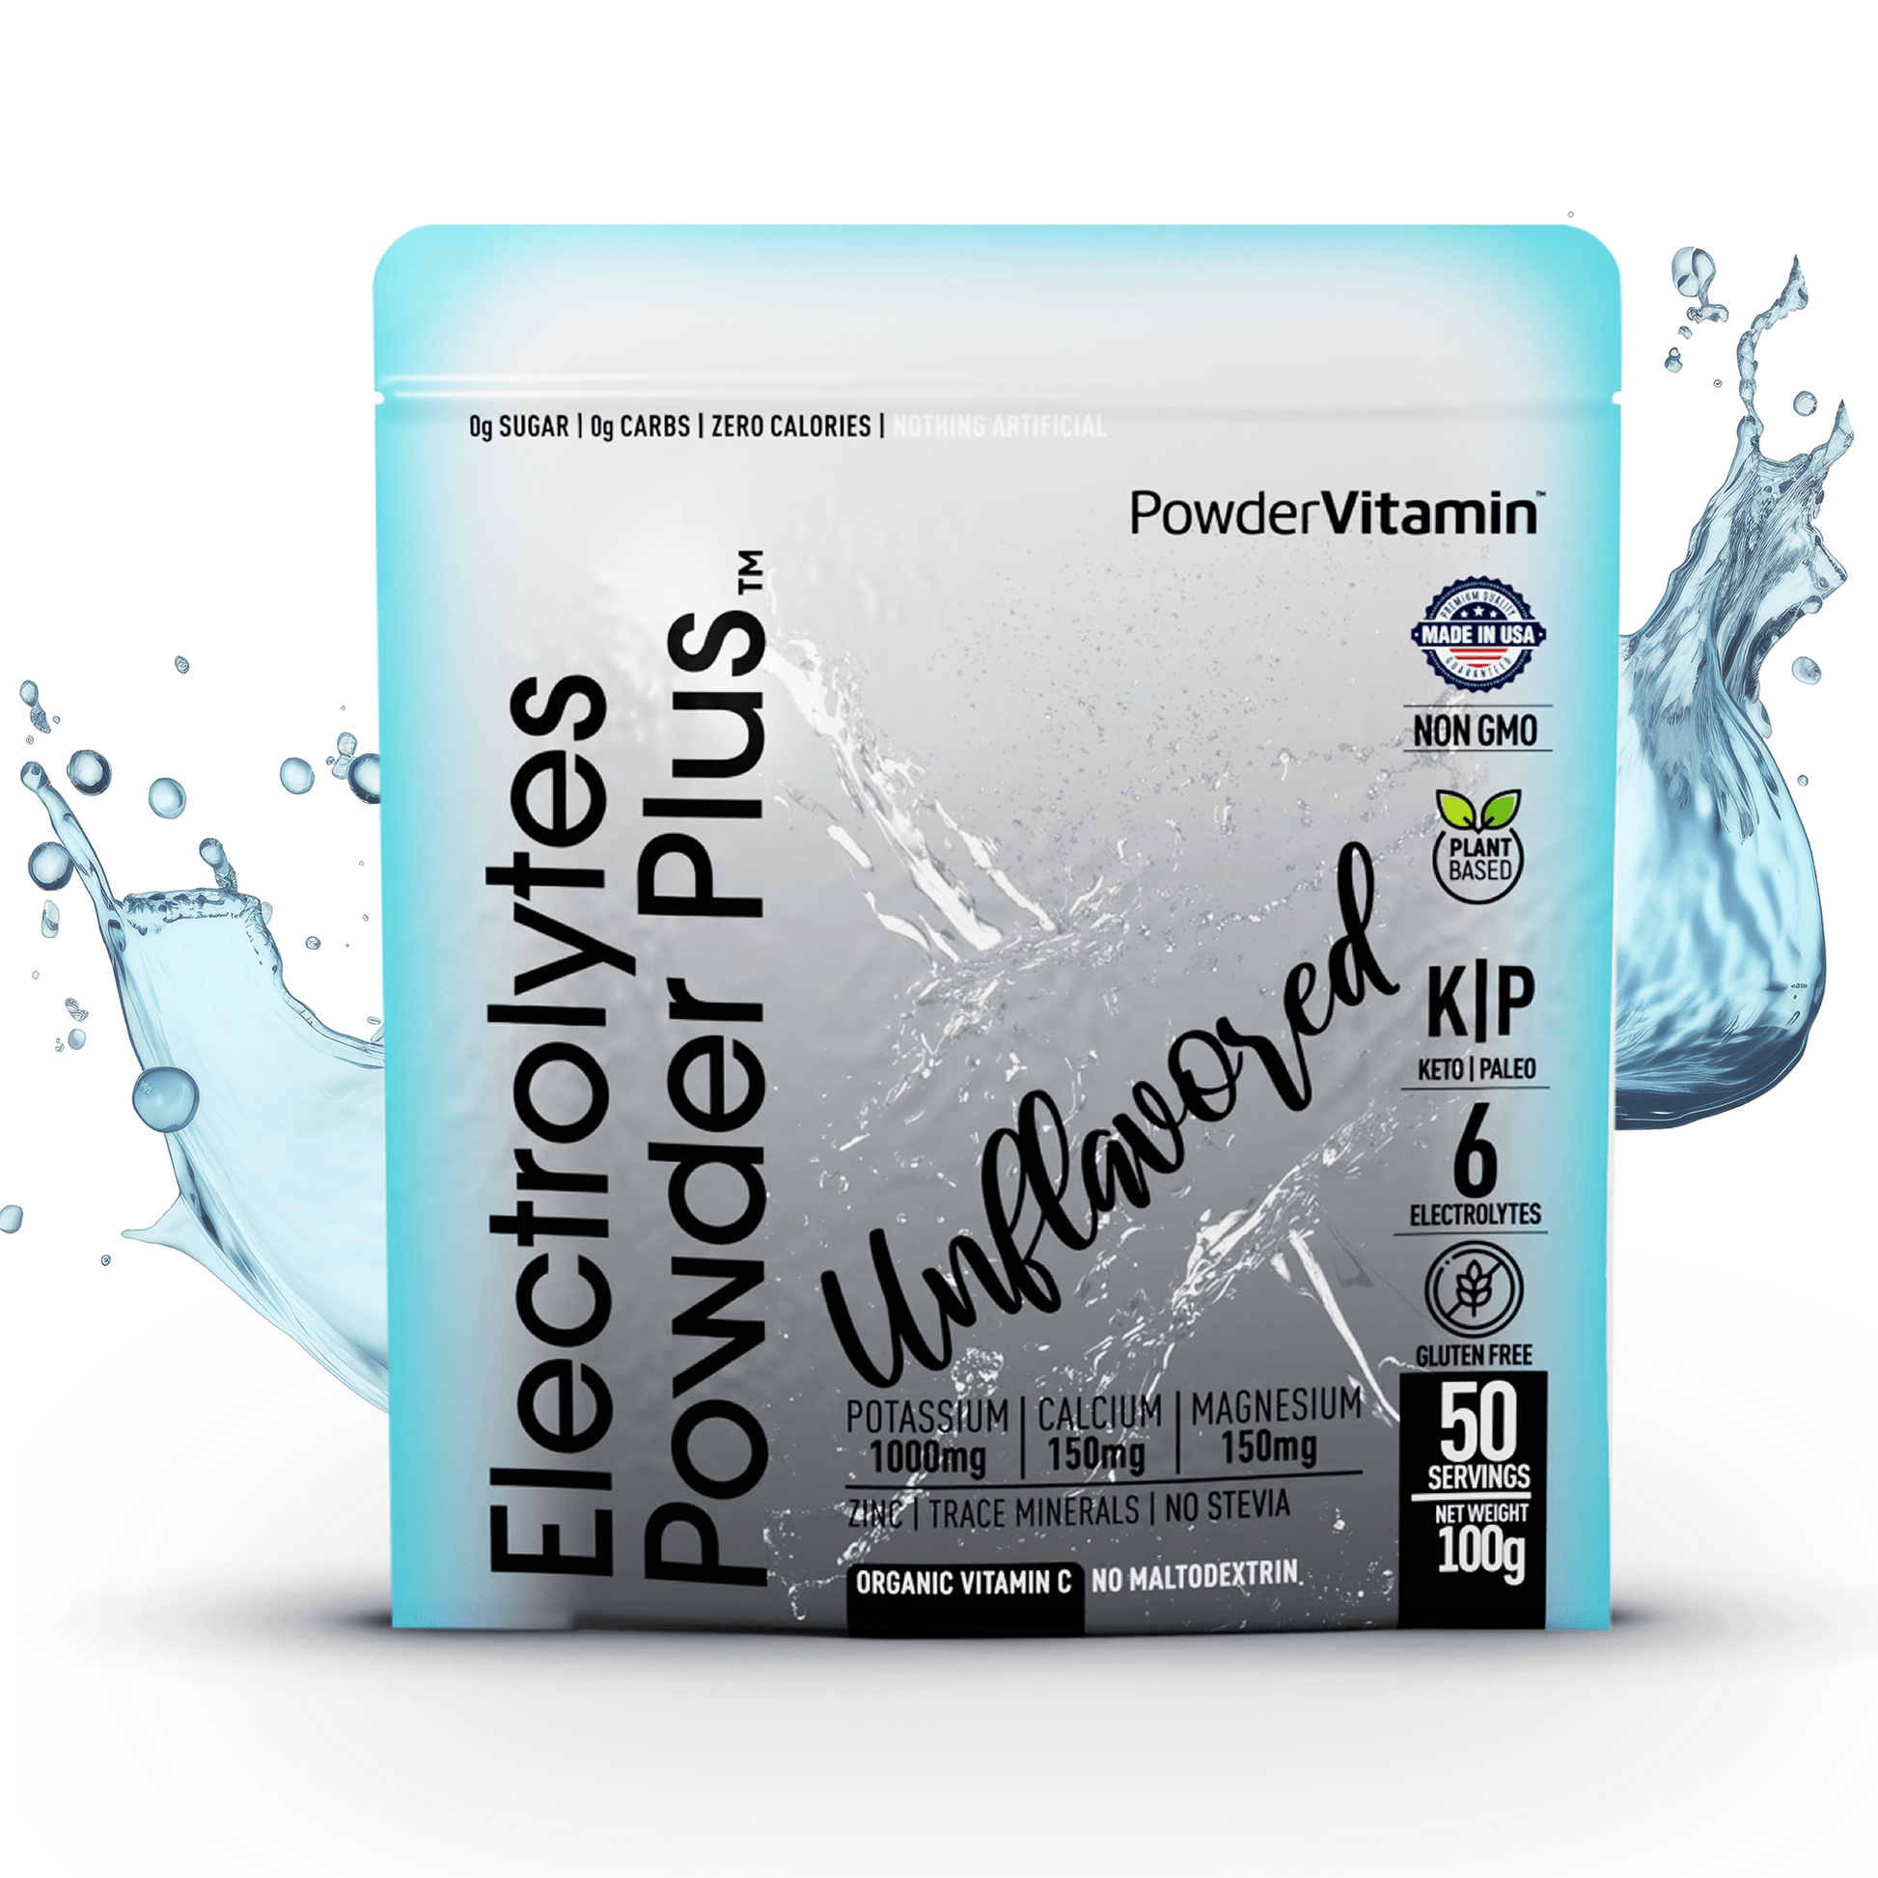

b. __________________

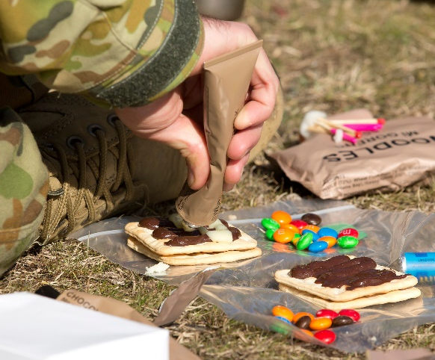
c. __________________

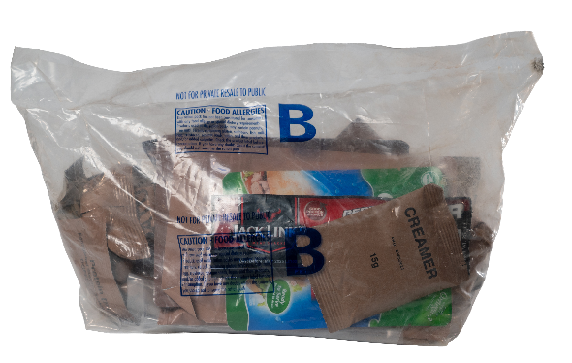

d. __________________
hexamine stove // hexamine tablet // canteen cup // FRED
protein drink powder // matches // toilet paper // vegemite

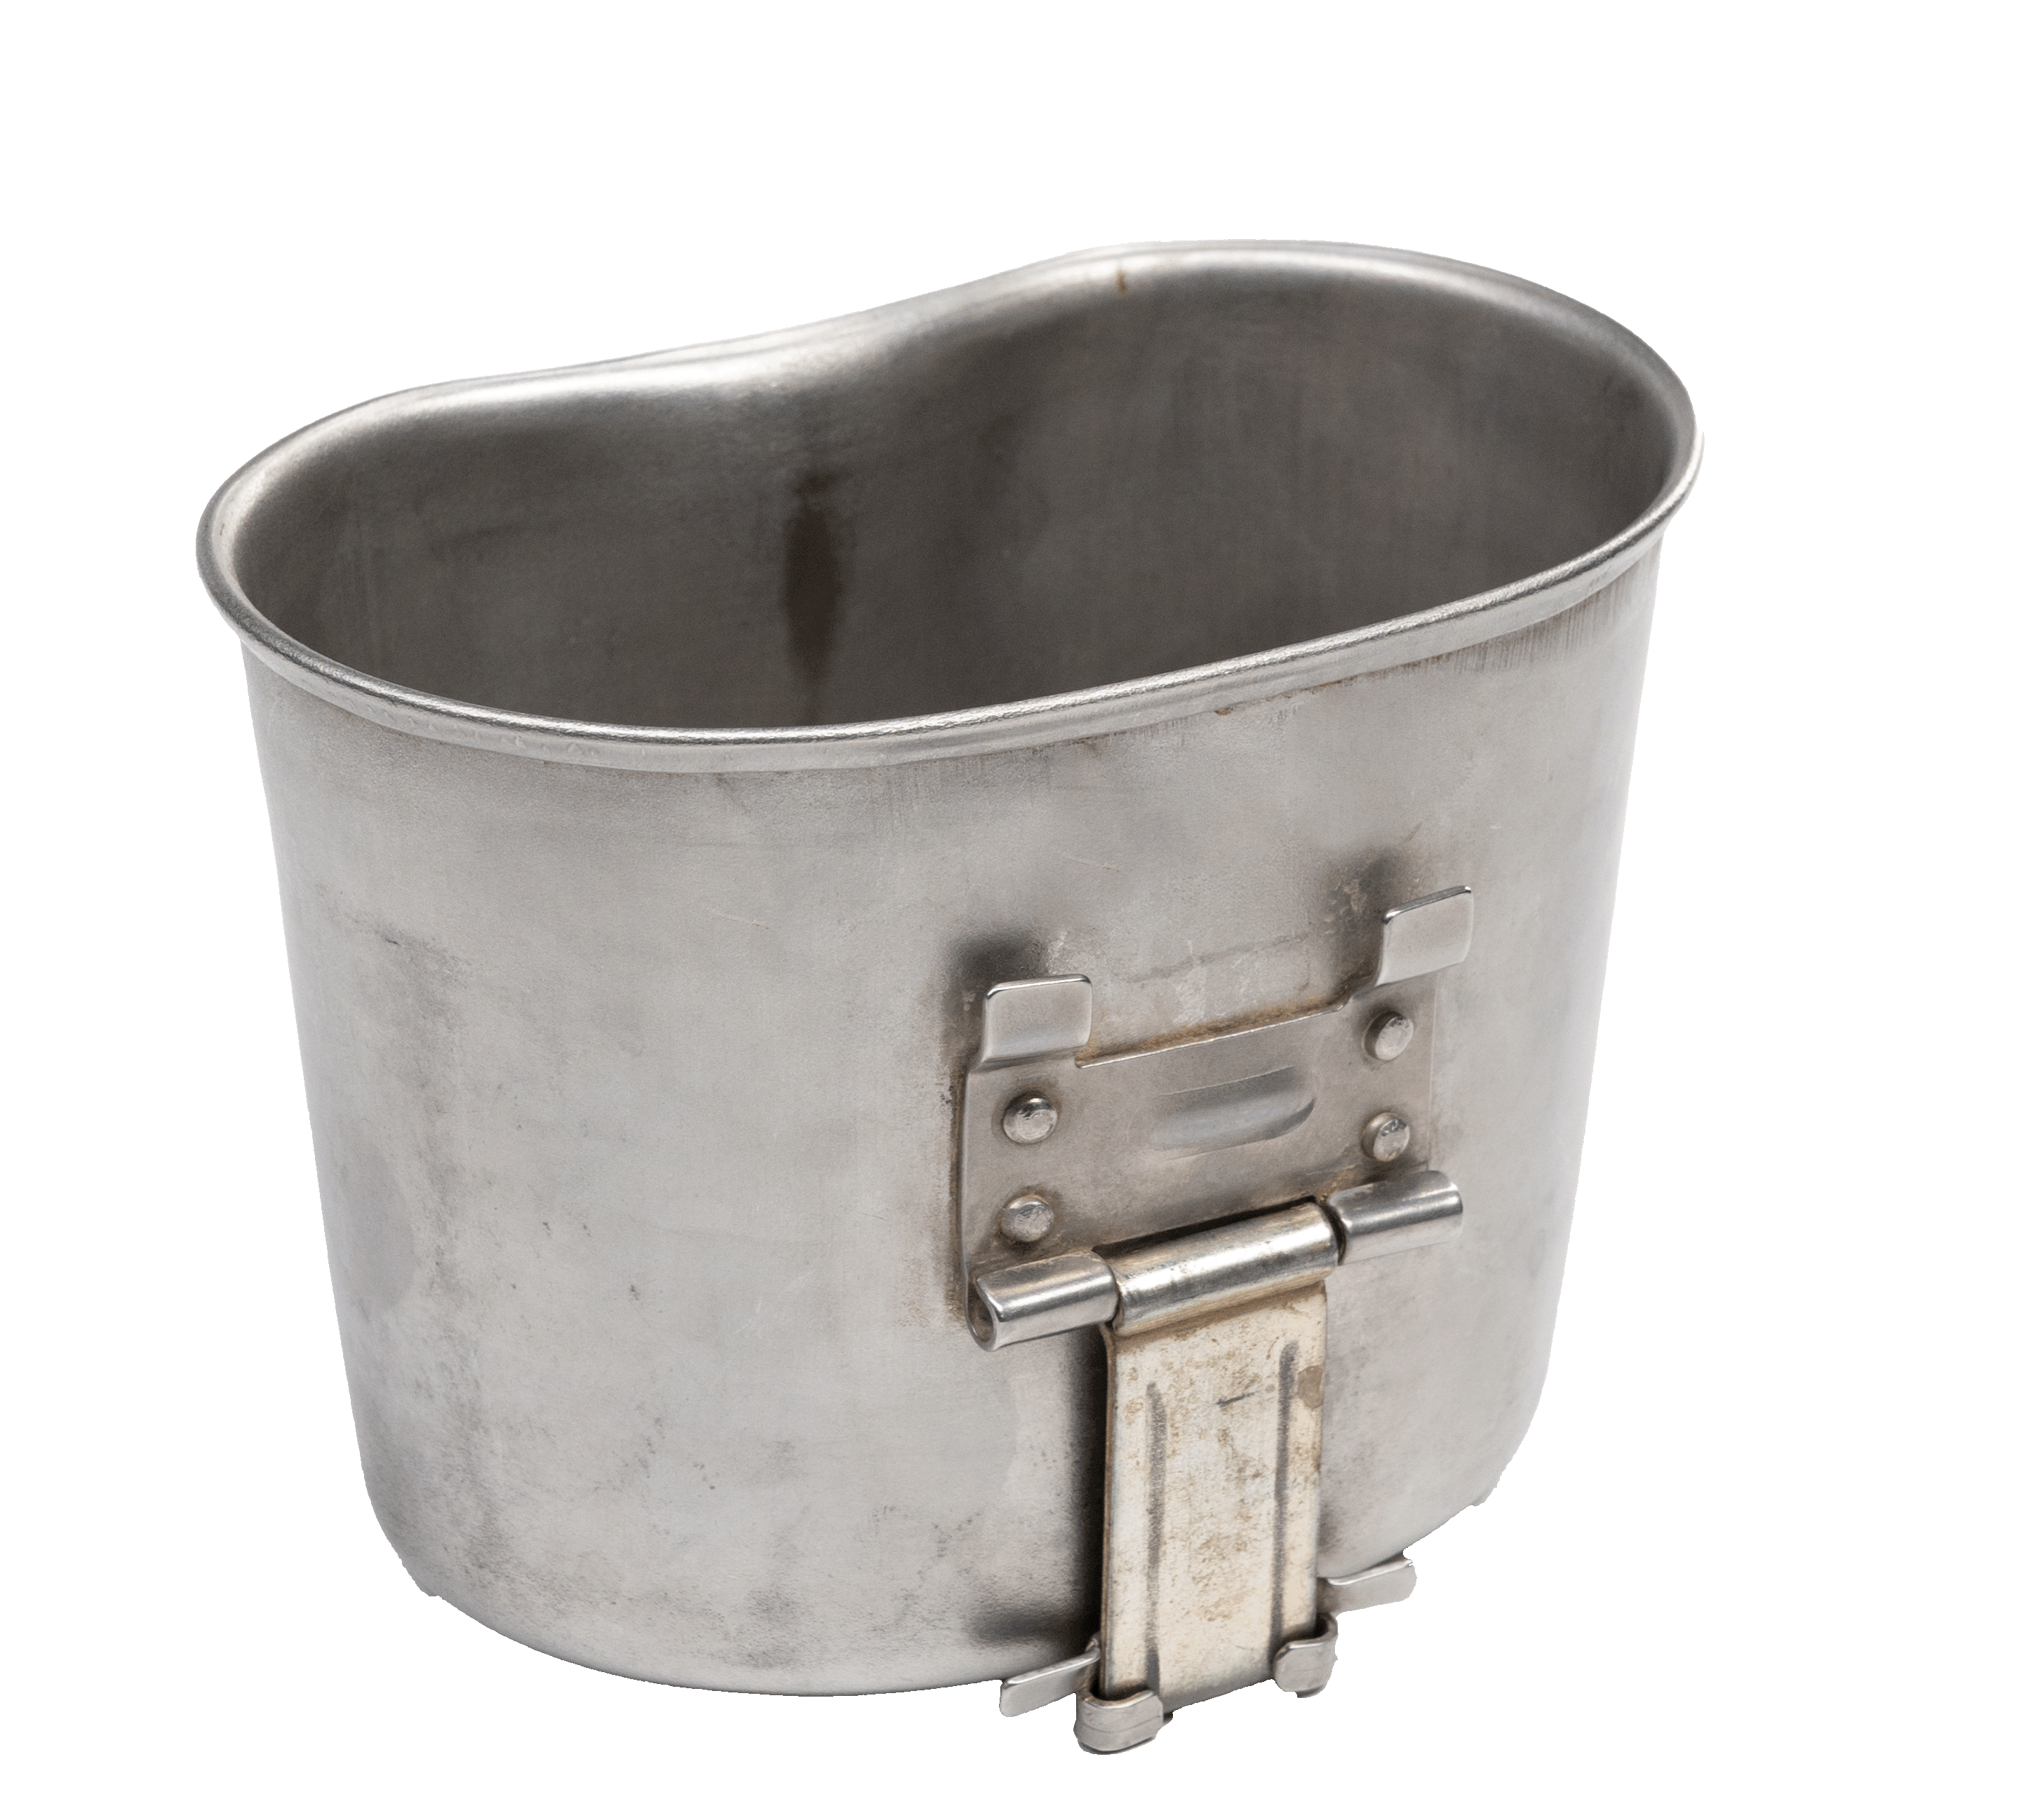
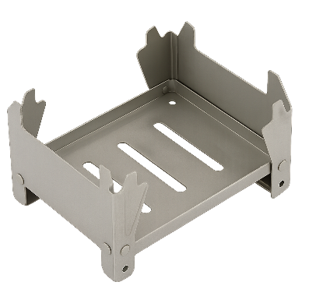


g. __________________
f. __________________
e. __________________

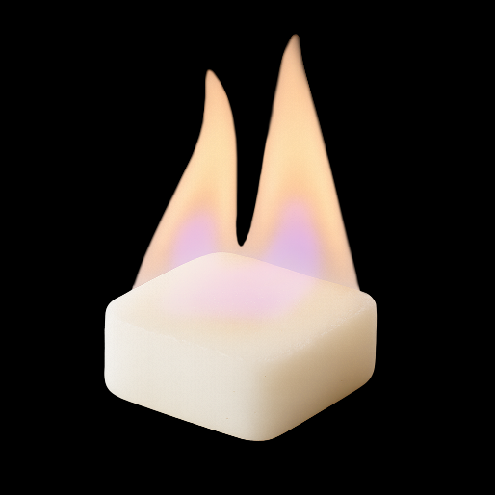
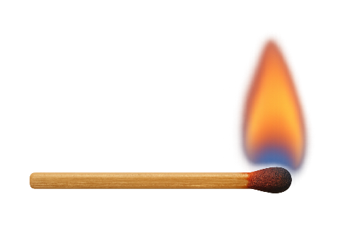
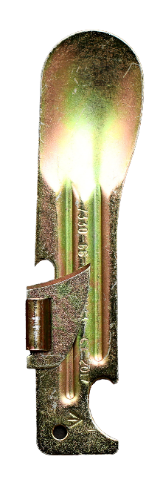

i. __________________
h. __________________

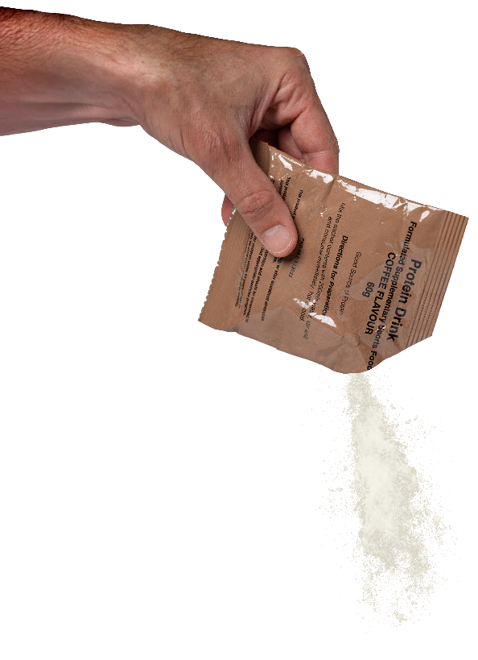
j. __________________
k. __________________

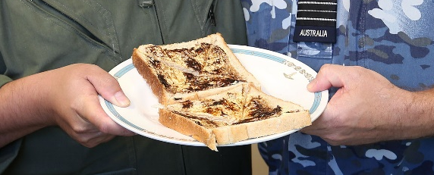

l. __________________


- Listen and check.
An officer from the British and Canadian military have a look through an Australian Combat Ration One Man (CR1M) ration pack.
- Now let’s practise saying the words. Listen and repeat.

- Work with your partner and answer this quiz. How many can you guess?
- This is a little tool that can act like a can opener and a spoon. ___________________
- These are used to light the hexamine tablet. ______________________
- You can eat and drink out of this. ___________________________
- You put the canteen cup and hexamine tablets on it to make your food hot. ___________________
- ‘Meal, Ready-to-Eat’ in a brown bag. There are 2-3 of these in a CR1P. ___________
- This drink is good for when you’re exercising and losing a lot of water. _________________________
- This is a salty, black spread* that Australians love. ________________________
- Little food you have between meals. _______________________
* spread – something you put on bread or toast eg butter, jam.

- Work in groups of 3-4. Design your dream CR1P ratpack. Use as many words from today as you can in your discussion.
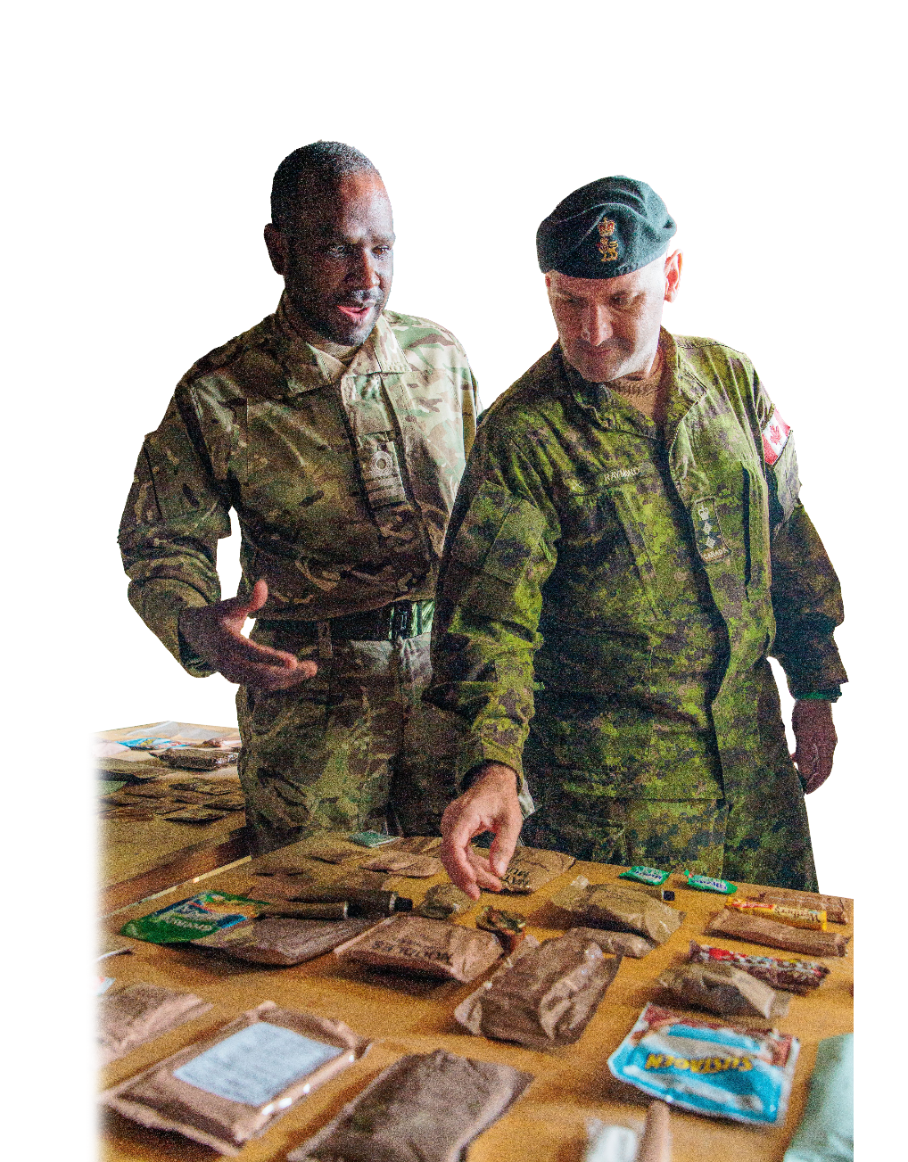
How about _________ for the breakfast MRE?
I think ______ is a good snack.

I’m not sure about ______

__________ for the dinner MRE is a good idea.
- Present your dream ratpack to your class.
Vote as a class for the winner!


- Scan the QR code and watch the video Australian Army Ration Pack (MRE) CR1M Menu A”.
- Write down the items you hear/see.
- Check your answers with a partner. Who has more correct items?
- What would you like to eat in the pack?


- For more practice with the words you’ve learned here, scan the QR code for a set of flashcards. You can do some more study on the vocab in this lesson on your own with these.
© Commonwealth of Australia 2025
This work is copyright. Apart from any use as permitted under the Copyright Act 1968 (Cth),
no part may be reproduced by any process without prior written permission from the Department of Defence.

This material links with: Lesson – What’s in my Ratpack? [listening]
Lesson – What’s in your Webbing? [listening]
Vocabulary Builder – What’s in Your Webbing?

