
Military English
Vocabulary Builder – Parts of a Pistol

Overview:
This worksheet presents vocabulary related to the parts of a semi-automatic pistol.
In this lesson, you will:
- learn vocabulary for the parts of a pistol
- practise using the vocabulary.

- This is the new pistol used by the Australian Defence Force (ADF). Look at the image and discuss the questions with a partner.
- Which pistol does the defence force of your country use?
- Compare this one below, to the one you use in your defence force. How similar or different is it?
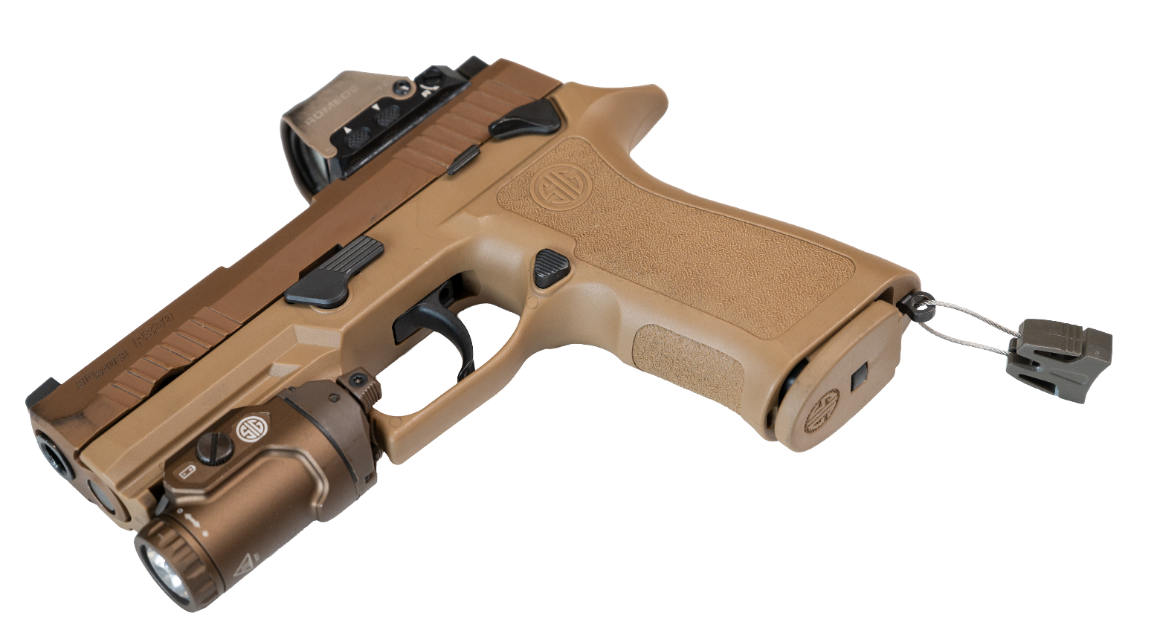
- Why is it important to learn the English words for the parts of a handgun?

Specifications:
- model: Force SIG Sauer P320 XCarry Pro
- weapon type: semi-automatic pistol
- sight: optical (reflex)
- calibre: 9mm
- magazine capacity: 17 rounds*
*round = bullet

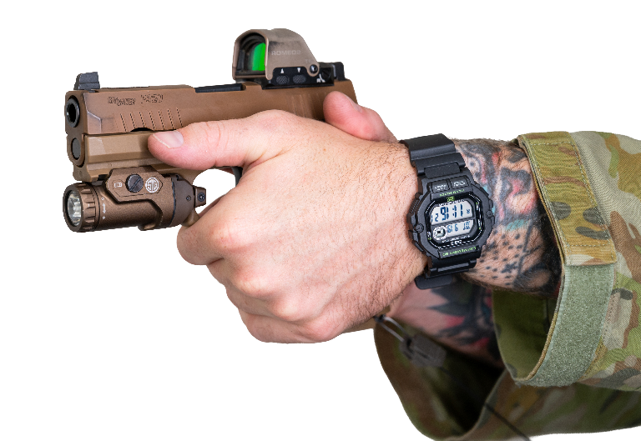

- Write the words in the correct line below. Look at the example. Continues on the next page.
sights // magazine release // trigger // torch // trigger guard // takedown lever

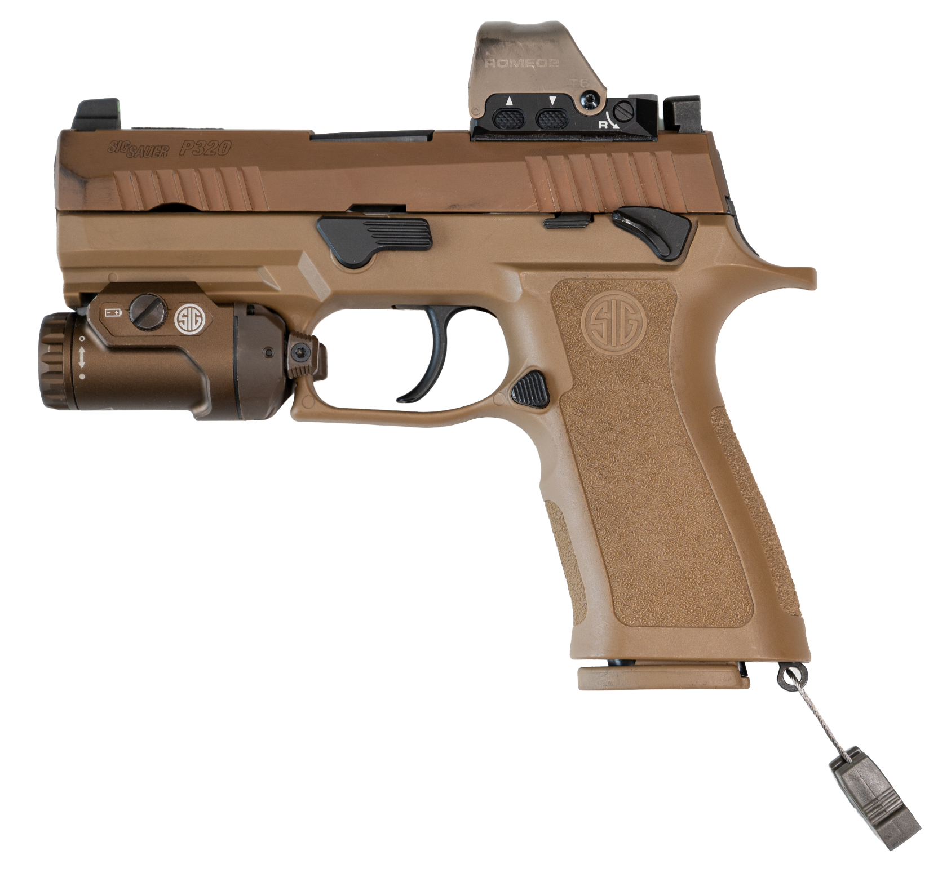
a.

a.

b.

f.
e.
d.
c.

sights

a. _____________________________________ | b. _____________________________________
c. _____________________________________ | d. _____________________________________
e. _____________________________________ | f. _____________________________________
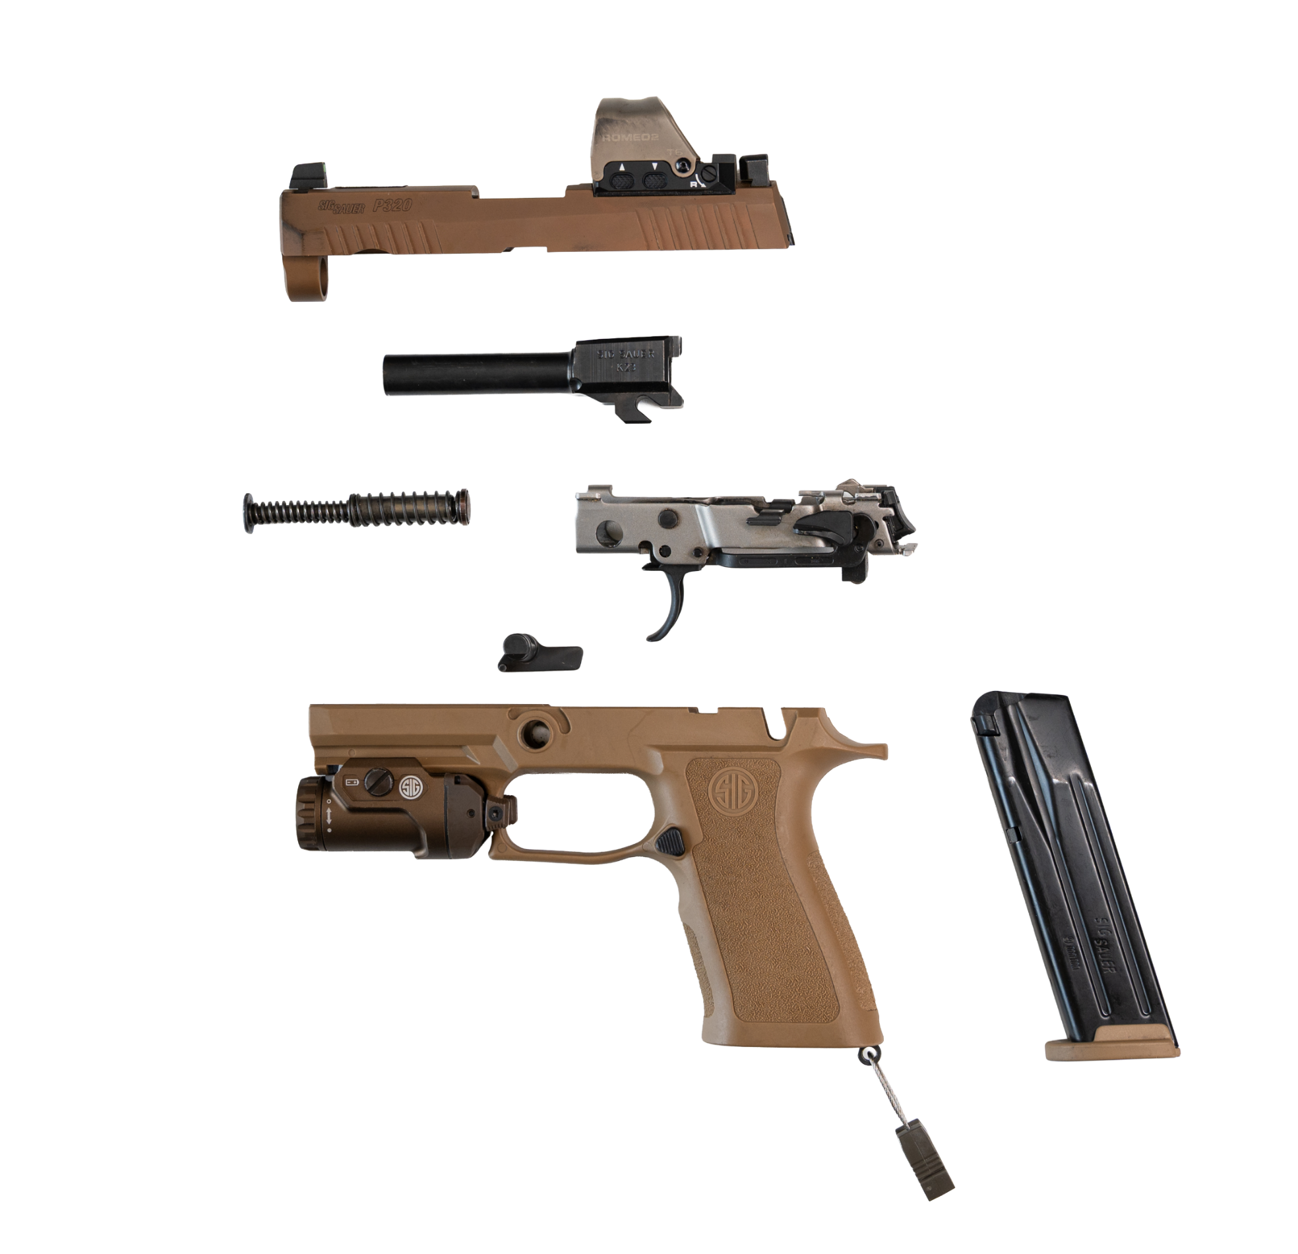
h.
g.
i.
hammer // safety // magazine // barrel // slide // grip // muzzle

j.
k.

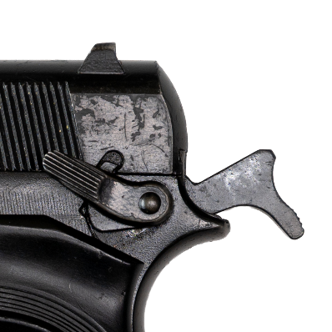
m.
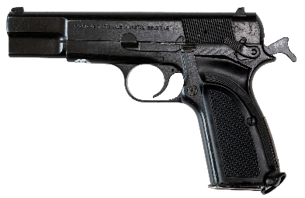
l.

g. _____________________________________ | h. _____________________________________
i. _____________________________________ | j. _____________________________________
k. _____________________________________ | l. _____________________________________
m. _____________________________________


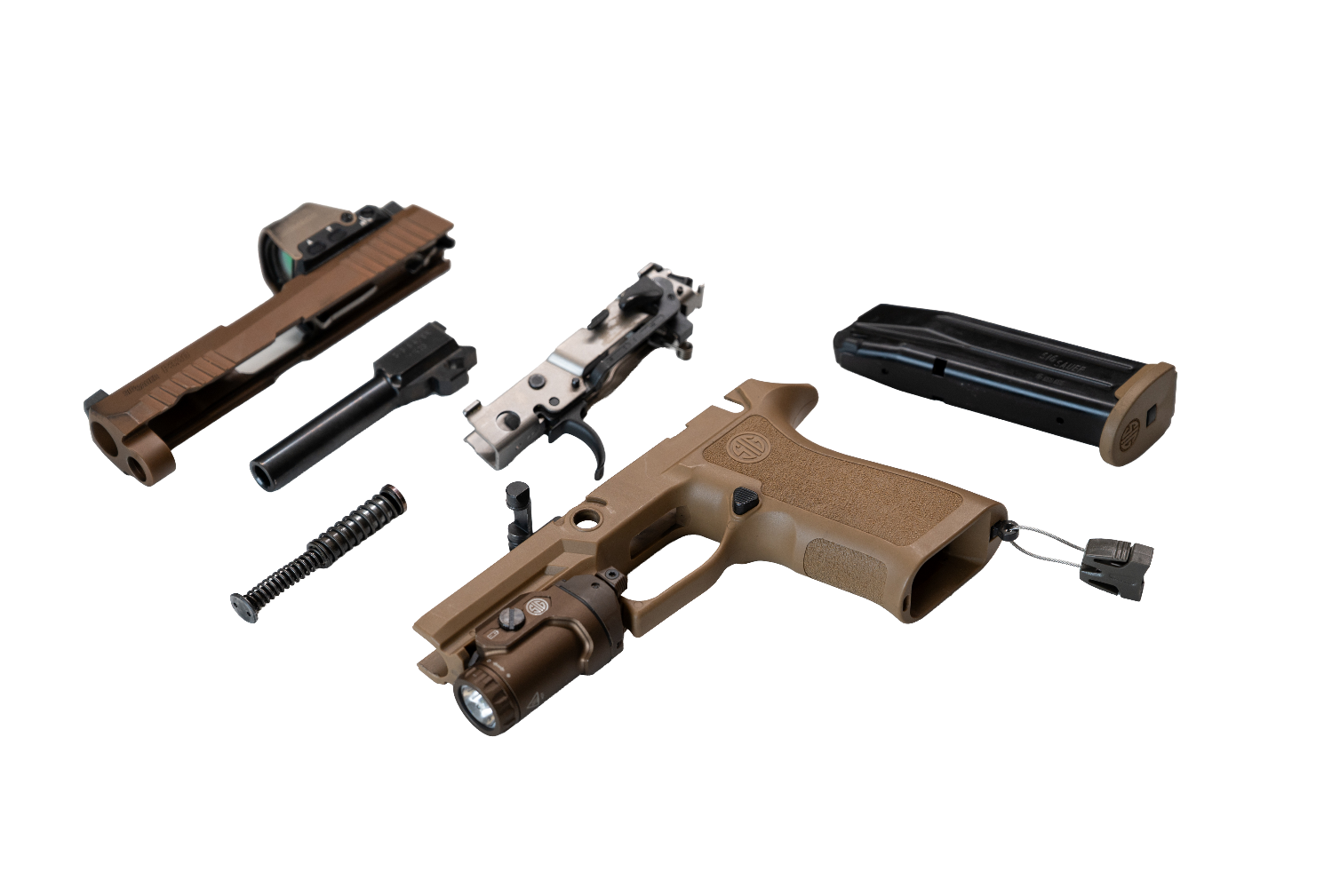
- Listen and check.
- Now let’s practise saying the words. Listen and repeat.

- Speaking. Work with a partner. Play a question and answer game. Your teacher will give you a handout for this task.

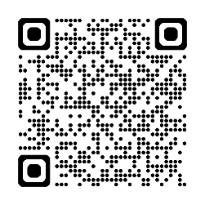
- Scan the QR code and watch the video ‘How a Handgun Works: Parts of a Semi-Automatic’. Write down the parts that were not included in this lesson.

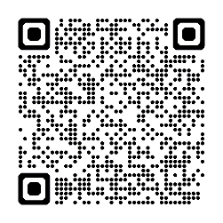
- For more practice with the words you’ve learned here, scan the QR code for a set of
flashcards. You can do some more study on the vocab in this lesson on your own with these.

- This material links with: Lesson – At a Firing Range [listening]
Lesson – Marksmanship Principles [reading]
Vocabulary Builder – Parts of an Assault Rifle

© Commonwealth of Australia 2025
This work is copyright. Apart from any use as permitted under the Copyright Act 1968 (Cth),
no part may be reproduced by any process without prior written permission from the Department of Defence.

