
Military English
Vocabulary Builder – Parts of an Aircraft Movement Area

Overview:
This worksheet lists vocabulary for parts of an Aircraft Movement Area.
In this vocabulary builder, you will:
- learn and use vocabulary related to Aircraft Movement Area.

- Use the words in the box below to label the parts of an aircraft movement area. Continues on the next page.
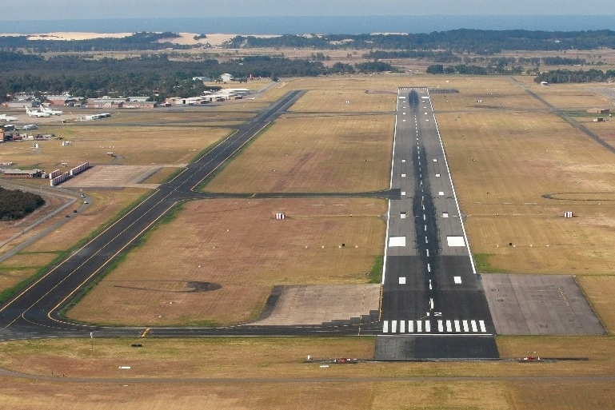
Aircraft Movement Area – the part of an airfield* where aircraft move. It includes the places where they take off, land, taxi, and park.
* airfield – the area on land used by aircraft

b. __________________
a. __________________

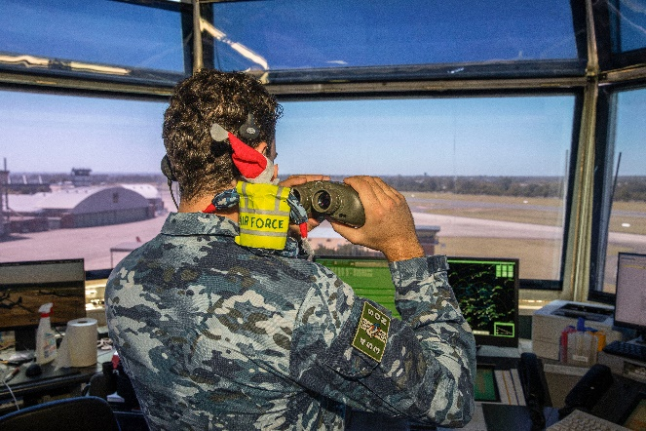
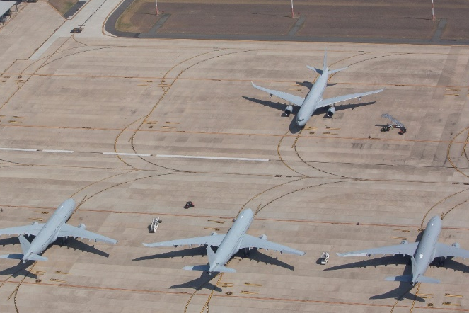

d. ____________________________
c. ____________________________

control tower // apron // taxiway // runway

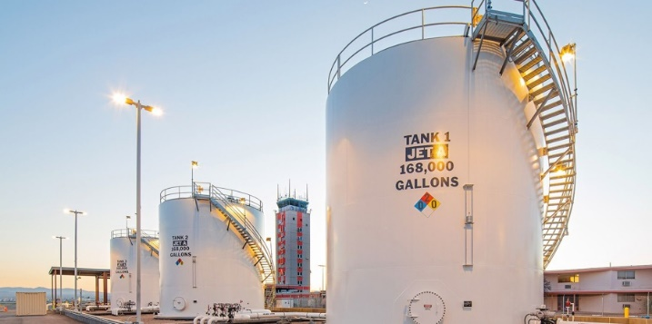
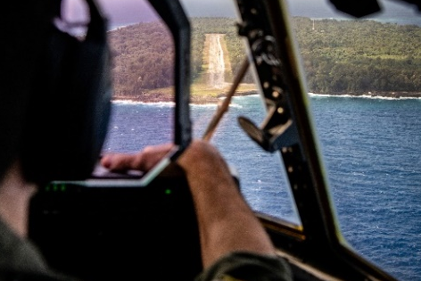
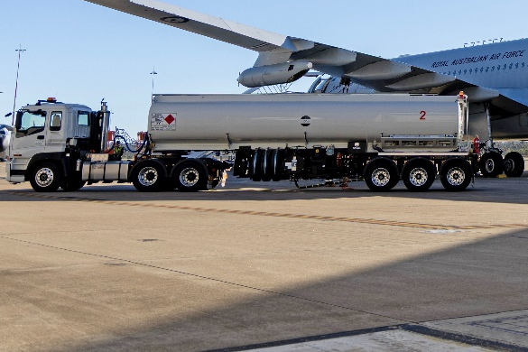
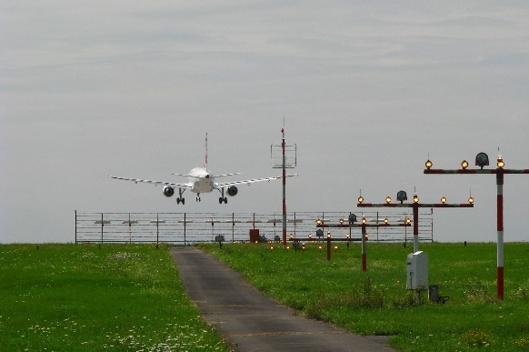
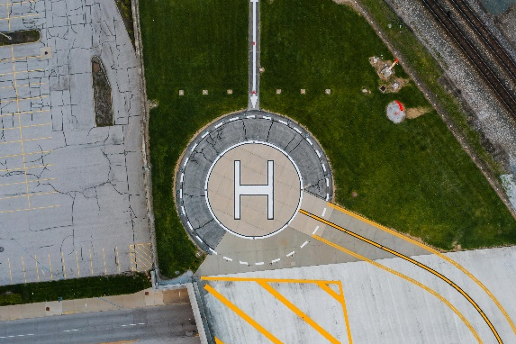
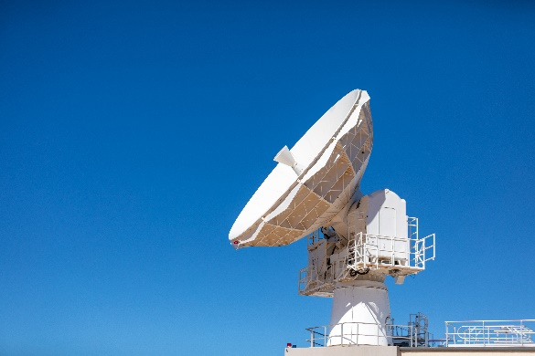
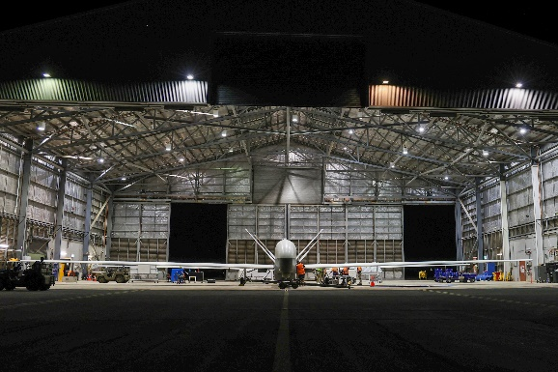
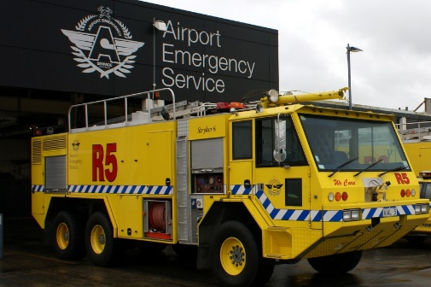
l. ____________________________
k. ____________________________
j. ____________________________
i. ____________________________
h. ____________________________
g. ____________________________
f. ____________________________
e. ____________________________
ILS (Instrument Landing System) antenna // radar // fuel truck // helipad //
emergency vehicles // hangar // fuel farm // airstrip


- Listen and check your answers.

- Now let’s practise saying the words in this worksheet. Listen and repeat.

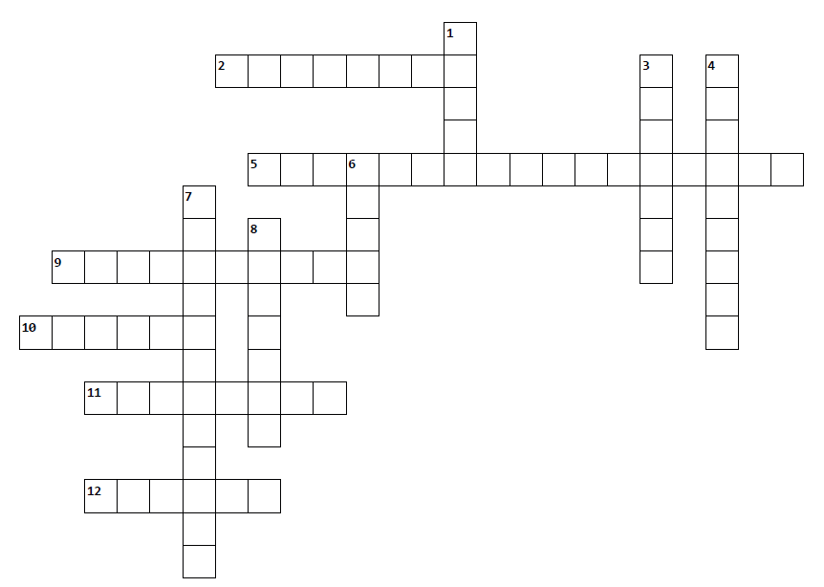
- Read the clues to solve the puzzle. Use the words from exercise one.

Across |  | Down
2. simple, long, flat area where aircraft can take off and land, often with no control tower and little support (sometimes in the middle of a forest!)  5. fire trucks, ambulances, police vehicles, etc; they’re used when there’s a problem  9. equipment near the runway that helps pilots land safely  10. a large building where aircraft are kept  11. a place where fuel is kept  12. aircraft use this to take off and land |  | 1. the area where aircraft park, pick up passengers or cargo, refuel, etc  3. an area where aircraft move to and from the runway  4. a big vehicle that carries fuel to the aircraft  6. a system that helps people see aircraft in the air and on the ground  7. the tall building that controls aircraft movement  8. a landing and take-off area for helicopters only

- Use the words in the box to fill in the gaps in the text below. Look at the example.
taxiway // hangar // runway // fuel farm // emergency vehicles // apron

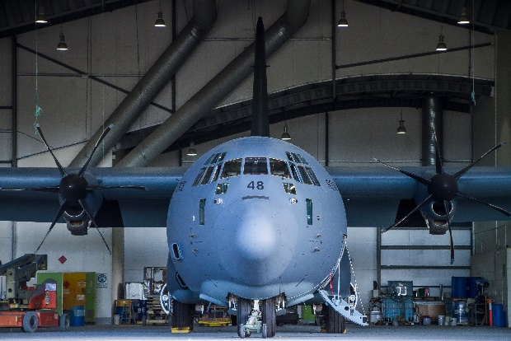
I t’s a busy morning at RAAF Base Richmond, New South Wales, Australia. The C‑130J Hercules is parked inside the ^{1.}_____________________, where technicians check the aircraft.
hangar
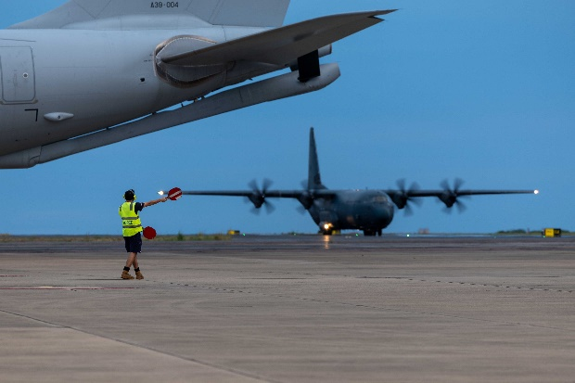
After the checks, the aircraft is moved to the ^{2.}_____________________ for refuelling. Fuel trucks arrive from the ^{3.} _____________________ to refuel the C‑130J. Nearby, ^{4.} ___________________________ are always ready if there is a problem like a fire or an accident.
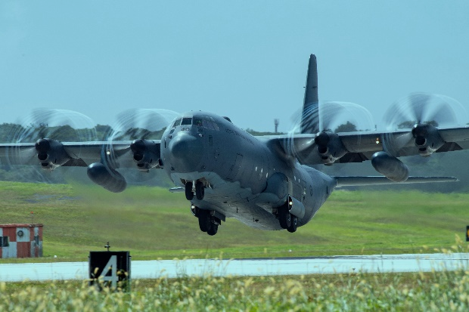
The control tower gives instructions to the pilots. The Hercules then moves slowly along the ^{5.} ____________ in preparation for take off. Finally, it lines up on the
^{6.} __________________________ and receives one final instruction from the control tower: 212, you’re cleared for take off!

- Listen and check your answers.

In the Royal Australian Air Force, the C-130 Hercules is also known as ‘Herc’ /hɜːk/.
This informal word is usually only used in speaking, not in writing.
DID YOU
KNOW
?

- Discuss the following questions with a partner.
- Which items in exercise one have you seen in real life?
- Have you ever worked in an aircraft movement area? If yes, what were your jobs? If no, what job would you like to do?
- Why is teamwork between people from different parts of the movement area important?



For more practice with the words you’ve learned here, scan the QR code for a set of flashcards. You can do some more study on the vocab in this lesson on your own with these.

- This Vocabulary Builder links with Lesson – A Job in the Air Force – Loadmasters [reading]
Vocabulary Builder – Parts of an Aircraft
Vocabulary Builder – Parts of a Helicopter
© Commonwealth of Australia 2026
This work is copyright. Apart from any use as permitted under the Copyright Act 1968 (Cth),
no part may be reproduced by any process without prior written permission from the Department of Defence.

