
Military English
Lesson: Combined Air Force Exercises – Exercise Pitch Black [listening]

Overview:
This lesson presents vocabulary related to combined air force training.
In this lesson, you will:
- practise listening for gist and specific information
- learn and practise new vocabulary and expressions about combined air force training.

Prepare for Listening
- In pairs, discuss:
- What do you see in the pictures?
- What was the best training event you have ever been on?
- Have you ever travelled anywhere for training? How did it make you feel?
- How can training with people from different countries help people learn?
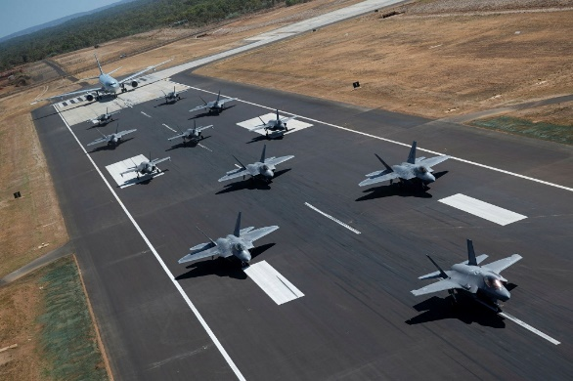
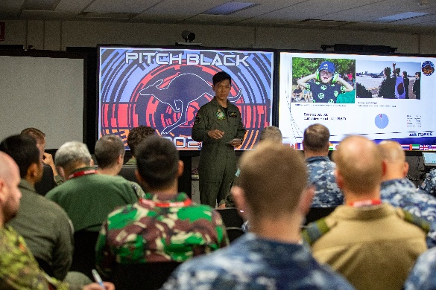

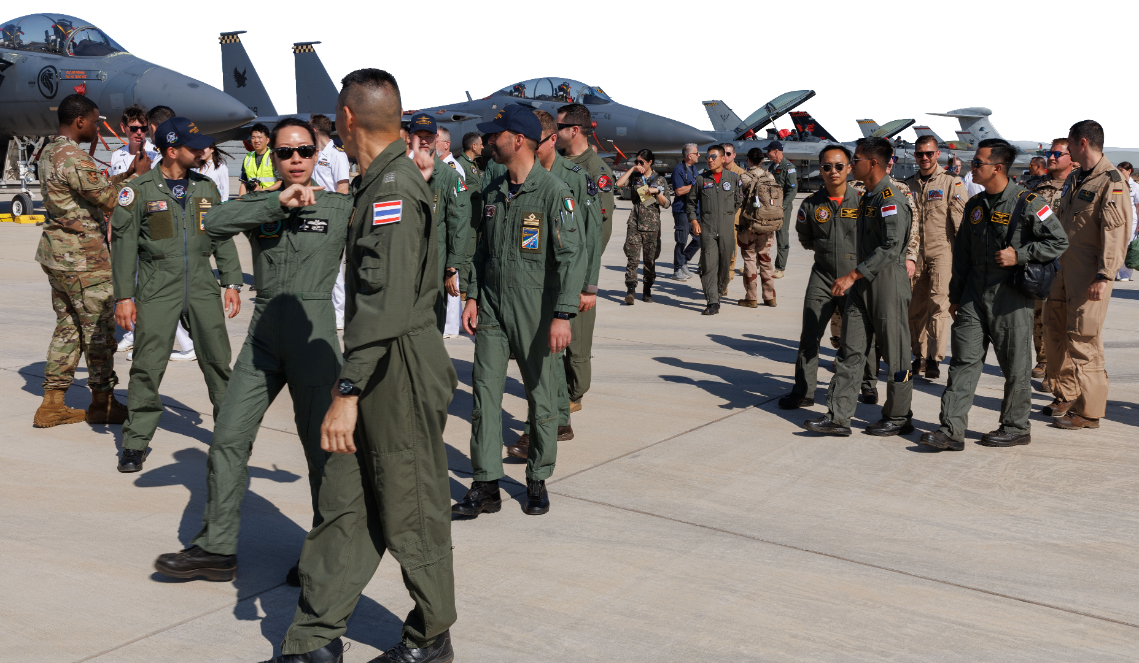

- In the box there are some words we need for today’s listening. Match them with the pictures.
a hostage // aircraft // a region // a square kilometre // parking // an airbase //
a landslide // a PAC-750 light transport // a recruitment tent

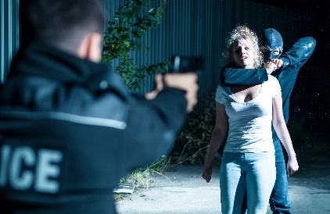
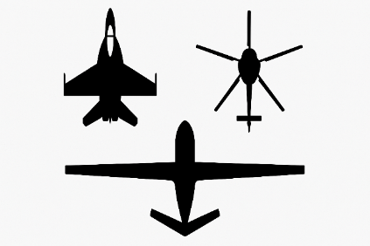

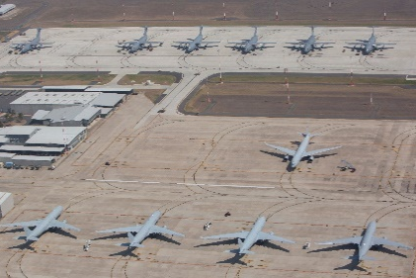
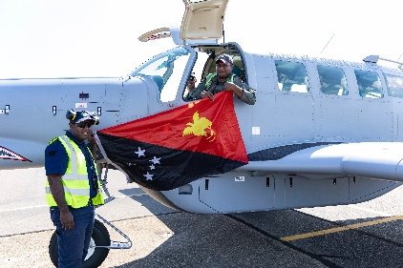
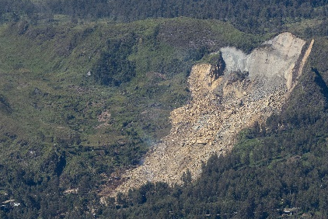
a. _____________________
f. _____________________
b. _____________________
c. _____________________
1km
1km
e. _____________________
d. _____________________

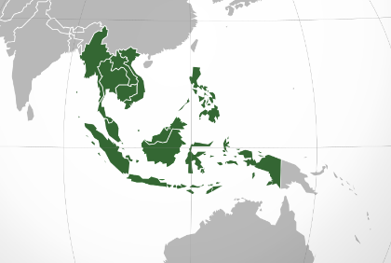
by Keepscases

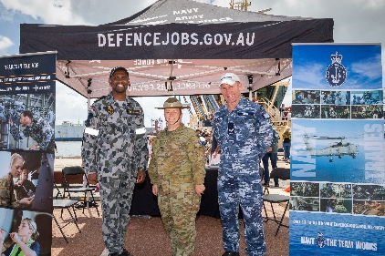

i. _____________________
h. _____________________
g. _____________________


- Listen and check your answers.

- Discuss these questions with your partner to practice the new words.
- Are there ever landslides in your country? Do the armed forces help when there is a landslide?
- Have you ever seen a recruitment tent for your armed forces? Where was it?
- Does your country have a PAC750? What do you think these planes are used for?
- Can you name 5 countries in your region?
- Would you like to do training to help hostages? What do you think you’d would learn?
- How many airbases are there in your country?
- Look at some pictures from Exercise Pitch Black. What can you see in the pictures? Where is Exercise Pitch Black? What happens at Exercise Pitch Black? What do you want to know about Exercise Pitch Black?
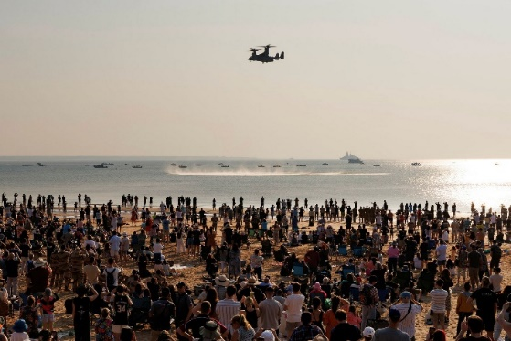
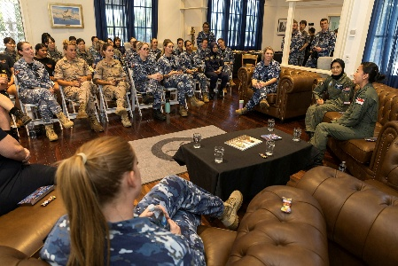

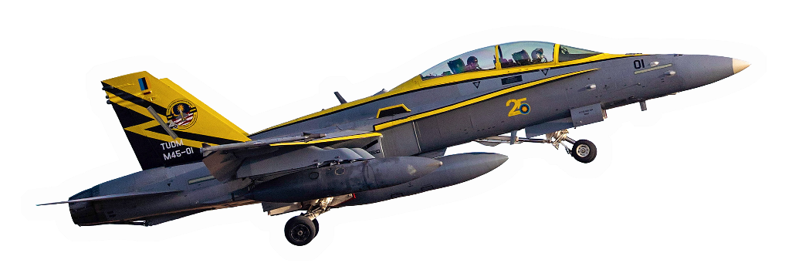

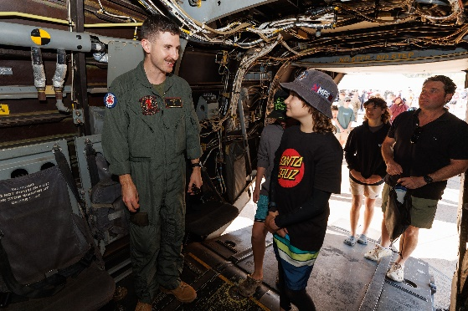
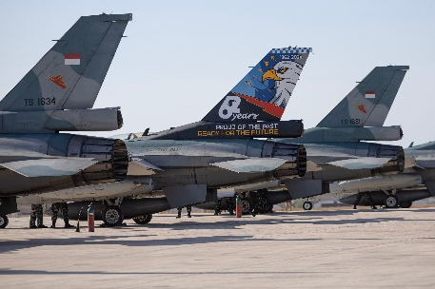

Listening
- Look at the main ideas below. What order do you think you will hear them in? Listen, and number the main ideas 1-6. The first one has been done as an example.
____ How ordinary people can enjoy Exercise Pitch Black
Listening Tip! – guessing skills
When you guess answers to questions, it helps you:
- get ready to listen
- understand all the questions.

____ The size of Exercise Pitch Black
____ See you next time?
1
____ Training missions at Exercise Pitch Black
____ International visitors
____ Why Exercise Pitch Black takes place
- Listen for detail. Answer the questions with a number and no more than two words that you hear.
20 hostages
  - How many hostages are in the training scenario? _____________________
  - How big is the training area? __________________
  - How long has the event been taking place? ________________________
  - How long does it take to get to Darwin from RAAF Base Amberley? ____________________
  - How many missions were conducted during Exercise Pitch Black 2024? _______________________
  - How many countries joined in in 2024? ____________________
  - How many people joined in in 2024? ______________________

Learning Military Vocabulary
- The words listed in bold below are important vocabulary and expressions that you should learn to use. Match the vocabulary on the left with their definitions on the right. Look at the example.
Table 1
need to extract them | e |  | 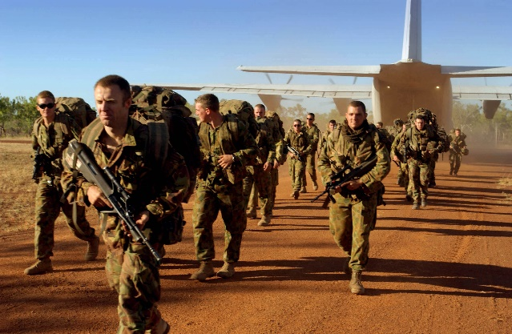  - (n) military personnel who are fighting on land; not in the air or on the sea
support ground troops like soldiers |  |  | - (n) a planned practice event where military from different countries work together to improve their skills
go through training scenarios |  |  | - (n) people who are taking part in an activity or event
the biggest combined training exercise in the region |  |  | - (n) practice situations that help military personnel learn and improve their skills for real events
participants get put into teams |  |  | 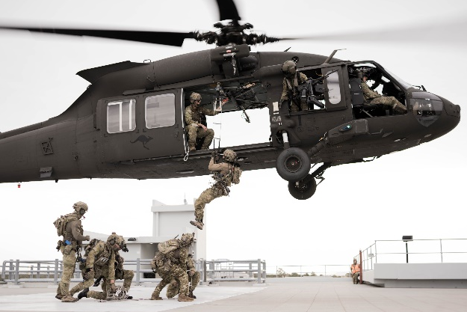  e. (v) to quickly and safely remove someone or something from a dangerous place
This ability to work well together develops interoperability |  |  | - (n) the ability of different military groups or countries to work together easily and share information

Table 2
to build relationships with regional partners |  |  | 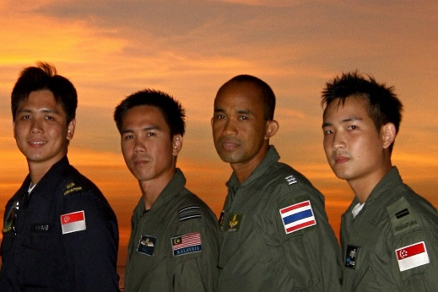  g. (n) countries in the same part of the world that work together
to build relationships with regional partners |  |  | 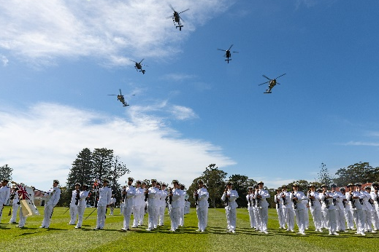  h. (n) when one or more aircraft fly low over a place during a special event
up to 100 aircraft on a mission |  |  | 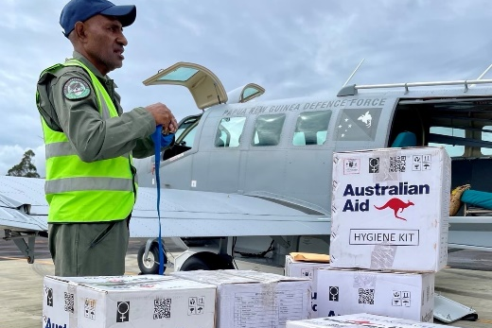  i. (n) help given to people after a very bad event like a flood, earthquake or tsunami
a disaster relief mission |  |  | 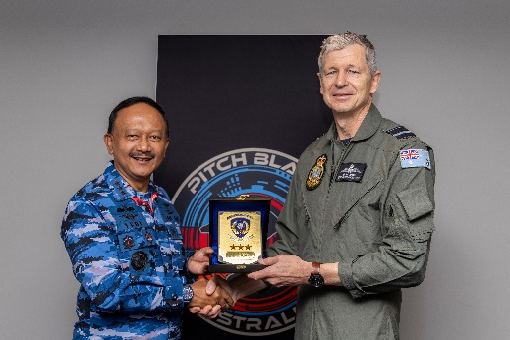  j. (vp) to create good connections and understanding between people or groups, often by working together
‘fly past’ is held on Mindil Beach |  |  | k. (n) practice activities that pilots do in the sky with their aircraft to improve their skills
this includes aerial drills |  |  | l. (n) an important job or task that a military group is given to do
- Listen and check.
- Now, let’s practise saying the words. Listen and repeat. Look at where the stress is underlined.
- Complete the questions below with a word from the box. There are two words you do not need. Then, ask and answer the questions with your partner about you.
combined training exercise // build relationships // interoperability // fly past // regional partners // training scenarios // participant // mission

  - What things help different armed forces have better ________________________?
  - Why do civilians like to go and watch a _______________________? Have you ever seen one?
  - Who are some of your country’s __________________________?
  - How do you _________________________ at work?
  - What _______________________________ help air force personnel prepare for real situations?
  - Would you like to be a ____________________________ in the next Exercise Pitch Black? Why/not?

Practice
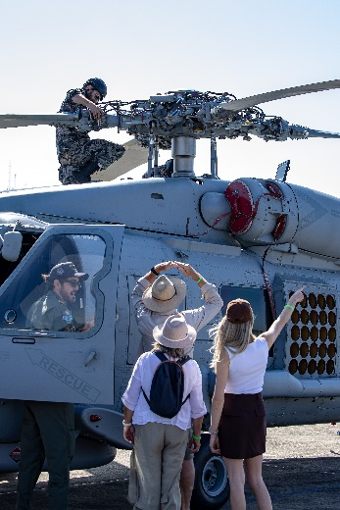
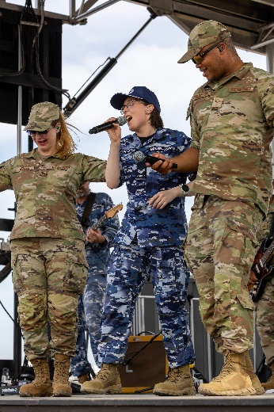
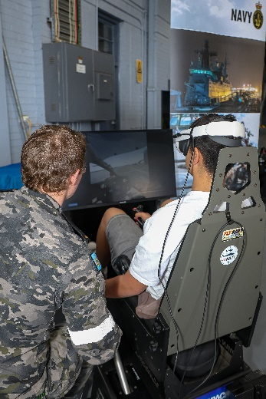
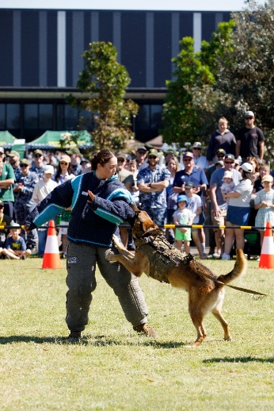
- Speaking. You and your colleagues are planning an open day for your base. The open day will let civilians know what life is like working on your base. Maybe some will want to join! Work in groups of 2-3. Discuss what activities you will put on. What will visitors be able to see and do? Share some ideas with the class.

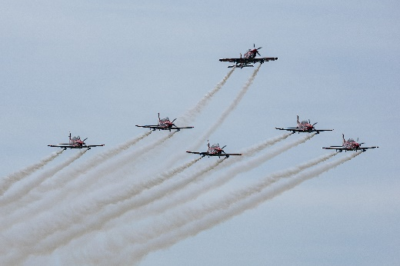

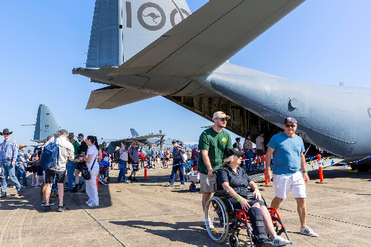
- Speaking. You are working at the recruitment tent. Someone wants to know what it is like to work for the armed forces in your unit. Take it in turns with your group asking and answering questions. Use the questions below to help you think of other questions.
What’s the best thing
about your job?
Do you have to work with foreign personnel?
Tell me about some of the training you do.
How many hours do you work a day?
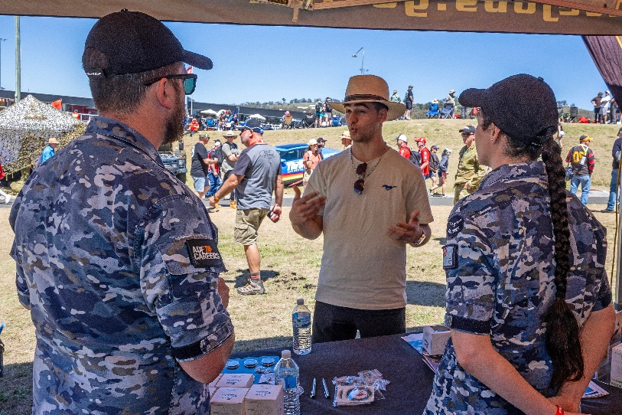



Watch a video about Pitch Black 2018. Type in YouTube Exercise Pitch Black 18 Open Day at RAAF Base Darwin or scan the QR code.
What events can you see? Would you add any other event to this Open Day at RAAF Base Darwin?



For more practice with the words you’ve learned here, scan the QR code for a set of Quizlet flashcards. You can do some more study on the vocab in this lesson on your own with these.

This lesson links with Lesson - Combined Air Force Exercises - Exercise Elangaroo [reading]

Lesson – A Job in the Air Force – Loadmaster [reading]
Vocabulary Builder – Parts of an Aircraft Movement Area
© Commonwealth of Australia 2026
This work is copyright. Apart from any use as permitted under the Copyright Act 1968 (Cth),
no part may be reproduced by any process without prior written permission from the Department of Defence.

