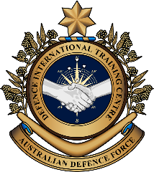
Military English

Lesson: A Job in the Military - Defence Attaché - Defence and the Media [reading]

Overview:
This lesson presents reading practice on the topic of bilateral agreements.
In this lesson, you will:
- read a press release for main ideas and details
- learn the meaning of new words and practice using them
- think about and practise public relations skills.

Prepare for Reading
- Discuss these questions with a partner.
- What defence co-operation agreements exist between your country and others? Do the public know about them? Why/not? (If you have no idea, do some online research now).
- What is the purpose of these agreements? What do countries get by signing up to these agreements?
- In the future, which country do you think your country should sign agreements with? Why?
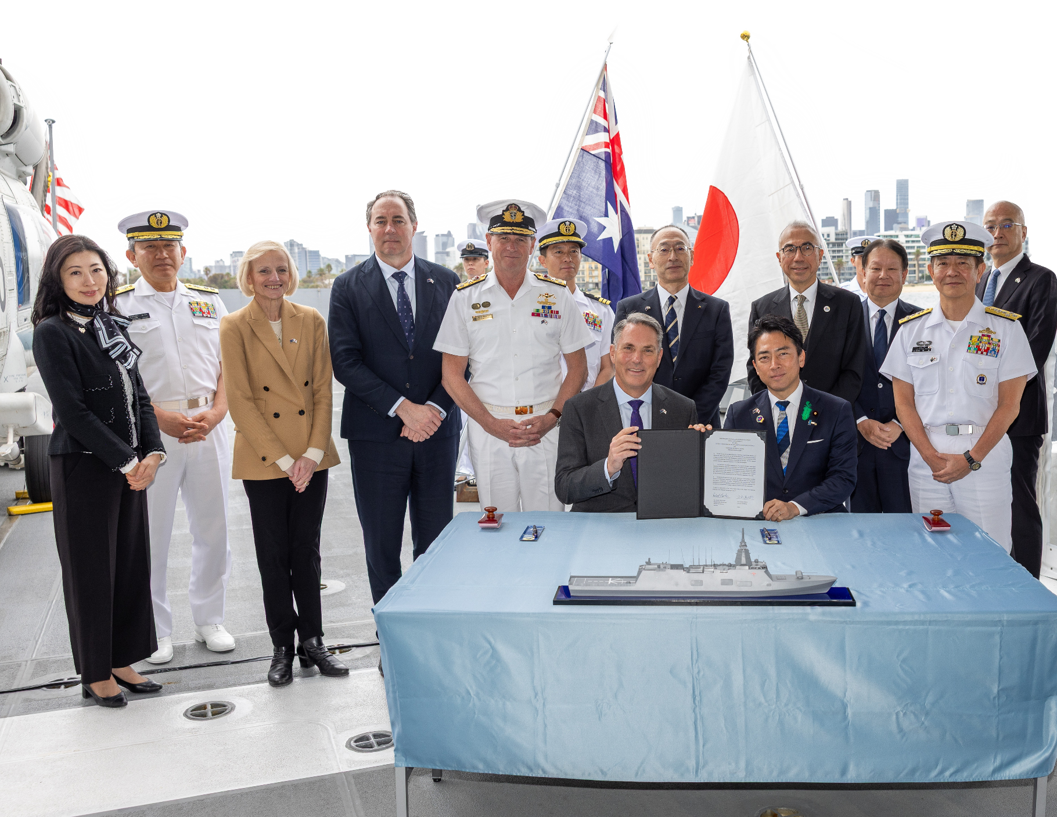
- Indonesian President Prabowo has said “A thousand friends are too few, one enemy is too many.” What did he mean? How does this relate to the work of a Defence Attaché (or DA for short)?

Deputy Prime Minister and Minister for Defence, the Hon Richard Marles MP, with the Minister of Defense of Japan Koizumi Shinjiro, after signing the statement of intent, with delegations from Australia and Japan in Melbourne, Australia.
- There are some words we need for today’s reading in the box. Match them with the pictures.

evolution // procure // maritime routes // defence industry //
middle powers // Indo-Pacific region // prosperous // dominate



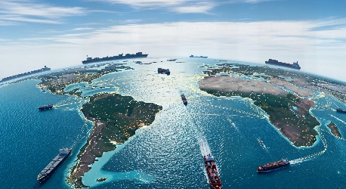
good economic conditions and quality of life
to have power or control over something or someone
sea paths used by ships to travel and transport goods

c. _____________________
a. _____________________
b. _____________________

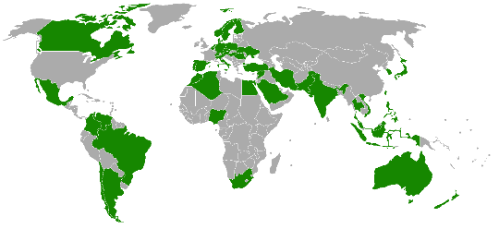
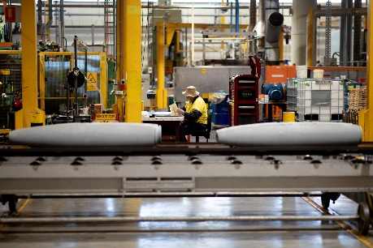
e. ___________________________
countries that have important influence
in international affairs
by NerdyNSK
production of goods used by a defence
force e.g. weapons and vehicles

d. ___________________________


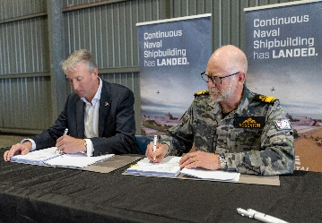

f. _____________________
the region around the Indian and Pacific Oceans
the process of buying equipment and after care
g. _____________________
h. _____________________
a gradual improvement
over time


- Listen, check and repeat.

- Discuss these questions with your partner to practise the new words.
- Which middle power countries does your defence force have important relationships with?
- Which maritime routes are important to your country? Why?
- What defence industry does your country have?
- What does your country procure from other countries for defence? Do you tell the public about this spending? Why/not?
- How has your military evolved over the last 30 years?
- How can governments make their countries prosperous? How can the military help?
- Which countries in the Indo-Pacific region does your country have a good relationship with?
- What are some of the ways that countries can dominate one another in terms of defence? What is the issue if one country becomes too dominant?

Reading
- Read and listen to the press release about the signing of a bilateral agreement. Who is the agreement between? What does the agreement try to achieve?
- Australia and Japan have agreed to next steps to enhance defence and security cooperation between the two nations. This is to support a shared ambition for a peaceful, stable and prosperous region. A Joint Statement on Enhanced Defence and Security Cooperation has just been issued. “Australia and Japan share a strong commitment to regional stability, and at a time of global uncertainty, strengthening our longstanding defence cooperation is more important than ever” Australian Minister of Defence, Richard Marles, said.
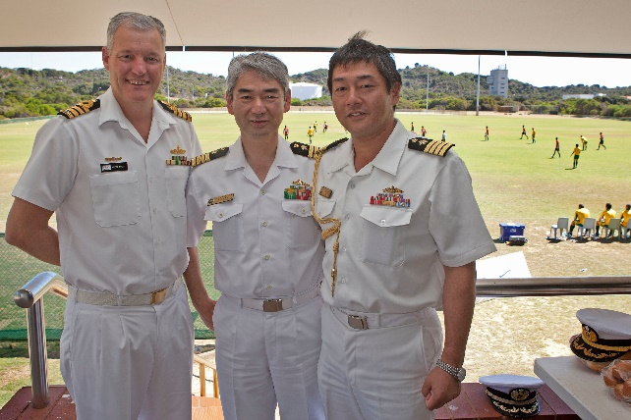
- This marks a natural evolution of already close cooperation between Japan and Australia. It builds on decades of engagement including the 2022 Australia-Japan Joint Declaration on Security Cooperation, the 2023 Australia-Japan Reciprocal Access Agreement (RAA)
and the establishment of the Framework
for Strategic Defence Cooperation (FSDC).
It focuses on strengthening capability, deepening integration and bolstering interoperability between Australia
and Japan.
A Japanese DA to Australia (on the right) engages with the Royal Australian Navy during a soccer match between Australian and Japanese navy personnel.
- Some of the key priorities of the joint statement include increased information sharing; co-development, co-production and co-sustainment of defence capabilities. Some of the activities the countries will do together are advanced weapons testing, enhanced training and exercises; joint maintenance and sustainment of assets, and closer collaboration to secure supply chains and critical maritime routes.
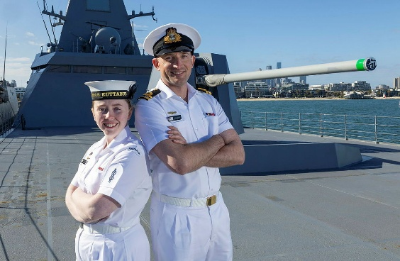
- The joint statement also shows a shared commitment to deepening cooperation in key areas, including defence industry.
This follows Australia’s decision to procure upgraded Mogami class frigates from
Japan for Australia’s general purpose frigate program.
- Australian Foreign Affairs Minister, Penny Wong, stated, “In these uncertain times,
middle powers must keep working together
for a free and open Indo-Pacific, and a world where no country dominates and no
country is dominated.”
Royal Australian Navy personnel
on a Mogami Class frigate.

- Write the paragraph letter next to the idea that it is mentioned in. You may use any letter more than once.
Reading tip:
When matching paragraphs to ideas, don’t look for key words, but for the main ideas in the paragraph. Read (skim) the paragraphs, then the ideas. Run your eyes back over the paragraphs to find a match. Good luck!
Idea | Paragraph
A new and important document
standing as one against unwelcome influence
some of the ways the two countries want to learn together in the future
previous agreements
changes to a relationship that are ‘natural’
a strategy for countries in the region
Australia buying equipment from another country

- Read the text again, then complete this summary choosing no more than three words from the text in each space. The words must be copied exactly.
Australia and Japan have agreed to strengthen ¹ __________________________ cooperation, formalised in a new ² _____________________________________ aimed at promoting regional peace, stability, and prosperity.
Reading tip:
In this task, you MUST follow the instructions to use between one to three words – you CANNOT insert four. Your one, two or three words must be grammatically correct in this new sentence. This type of task follows the order of the text, so you know which part of the text to read. Read the questions, and underline key words. Skim, then scan to find the correct one, two or three words to fill the gap.
This builds on longstanding Australia–Japan defence ties, expanding recent agreements to further strengthen capabilities, deepen integration, and improve
³ ________________________________ between the two countries.
Key priorities include boosting ⁴ _______________________________________, jointly developing and sustaining defence capabilities, expanding testing, training and exercises, and collaborating more closely on
⁵ _______________________________________ and critical maritime security.
The Joint Statement also focuses on commitment to closer defence
⁶ ___________________ cooperation, highlighted by Australia’s decision to acquire upgraded Mogami-class ⁷ ___________________________.
Penny Wong said that due to global uncertainty, middle powers should cooperate to support a free and open Indo-Pacific and prevent any country being ⁸ _______________________________________.

- Talk to a partner. Why are press releases important? What do they try to achieve? Does your defence force issue press releases? What do they include? What do they leave out?
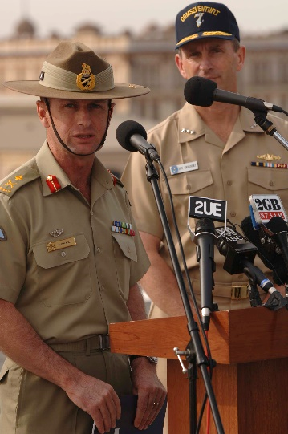
A press release is an official statement issued to the media or public – delivered either in writing or orally – to announce news or provide information.

On the left, two senior officers from the Australian Army and US Navy issue a joint press release on the Opening Ceremony of Exercise Talisman Sabre 2005.

- Look at the words in bold in the reading. We will match them to their definitions next. First, look at them in the sentences and talk to your partners.
- Do you know any of them?
- Have you ever heard or read these words before?
- What part of speech are the words?
- What do you guess they mean?
Learning Military Vocabulary
- The words in bold are important military vocabulary that you should learn. Match them to their definitions on the right. Look at the example and write the answers in the middle column.
Table 1
a prosperous region |  |  | - (n) the ability of different systems, organisations, or forces to work together effectively e.g. the navy working well with the air force or the Australian Defence Force working well with Japan
a Joint Statement | c |  | - (n) the process of bringing different parts together so that they work effectively
close co-operation |  |  | - (n) something that someone, for example a politician, writes or says officially
it focuses on deepening integration |  |  | - (n) the process of working together towards the same goal (usually a positive meaning)
it focuses on bolstering interoperability |  |  | - (n) a large area of a country or the world (that has particular features e.g. a lot of mountains)
Table 2
increased information sharing |  |  | - (n) the abilities, skills, or resources needed to do something well
defence capabilities |  |  | - (n) the act of working with another person, group or organisation (often in war time) to achieve something; can have both negative and positive meaning
sustainment of assets |  |  | - (n) something of value owned by a company or organisation
closer collaboration |  |  | - (n) a promise or a strong willingness to support or do something
shared commitment |  |  | - (n) the exchange of knowledge, data, or intelligence between people, organisations or countries
- Listen and check.
- Now practise saying the words. Listen and repeat. Look at where the stress is underlined in words that have more than one syllable.

Practice
- Complete the questions with new words from the box. You may have to change the word form. Look at the example. Then, ask and answer the questions with your partner about you.

capability // integration // statement // interoperability // cooperation //
collaboration // commitment // information sharing // region // assets

integrate
- How do you think DAs _________________ themselves into new cultures and social situations when they post overseas?
- Why is it important for defence ministers to release a joint _____________________ after meetings?
- What are the main security challenges in your _____________________?
- What are the benefits and risks of a country selling – or donating – older military _______________, such as tanks and aircraft, to another country?
- Does your country ______________ ____________________ with neighbours? What information do you keep secret?
- What is one __________________ you have that many other people don’t? e.g. speaking a language
- What are the advantages and disadvantages of cybersecurity _______________________ between nations? What are the advantages of working alone?
- How can a country show its ___________________________ to regional peace and security?
- Why is the _______________________ of land, air and naval power important in military operations? What are some challenges of working closely and well together in your country?
- When is it important to ___________________________ with allied militaries? When is it important to say no?

- Looking at language – collocations. In the text in this lesson, there were adjectives as collocations for most of the nouns you have learned. Can you remember any of the collocations? Write down as many as you can. Then, check your ideas against the reading. The first one has been done for you.
Did you know learning vocabulary in ‘chunks’ can help you to sound more fluent and help people understand you more easily?
These websites will help you build your collocations in essays and professional communication.
Scan here:

Or here:

collocating adjective for the | noun
stable | region
 | statement
 | cooperation
 | information sharing
 | capabilities
 | collaboration
 | commitment



- Preparing to speak. Imagine you are the DA for your country in Australia (or another country) and have been tasked with giving a short oral briefing to the media on an upcoming bilateral exercise.
- First watch this video with an ADF representative giving a briefing about Exercise Talisman Sabre to the media in Australia: Type on YouTube Australian and US join forces for largest defence exercise | Sunrise or scan the QR code
As you watch, answer the following questions:
- Who is in the exercise? ____________________________
- Where will the exercise take place? ____________________________
- What does the exercise want to achieve? ____________________________
- What does the Brigadier not comment on? ____________________________

- Now plan your briefing. Make notes on:
- the exercise name
- where the exercise will take place
- why the exercise is important to both countries
- a VIP who might open/close the exercise.
Tell your partner about your ideas.
  - Try to use words from this lesson.
  - Do they think it is a good idea for a bilateral exercise?

- Speaking. Work with another partner. Take turns delivering your short oral briefings. Which same words from this lesson did you both use?


- For more practice with the words you’ve learned here, scan the QR code.

- This lesson links with Coming soon!

Adapted from: https://www.minister.defence.gov.au/media-releases/2026-05-04/enhanced-defence-security-cooperation-japan Accessed 10 May 2026

© Commonwealth of Australia 2026
This work is copyright. Apart from any use as permitted under the Copyright Act 1968 (Cth),
no part may be reproduced by any process without prior written permission from the Department of Defence.

