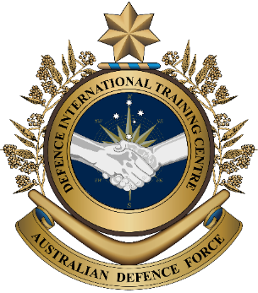
Military English

Lesson: Humanitarian Assistance and Disaster Response (HADR) – Operation Tonga Assist 2022 [listening]

Overview:
This lesson practises vocabulary about how militaries can help neighbours after a natural disaster.
In this lesson, you will:
- practise listening for gist and specific information
- learn and practise new vocabulary and expressions about HADR.

Prepare for Listening
- Look at some pictures from today’s listening. Discuss with a partner:
- What natural disaster can you see?
- What other words in English you can see?
- Guess what today’s listening is about.
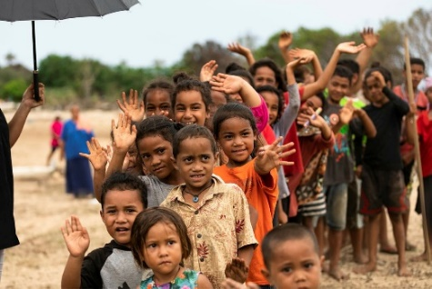

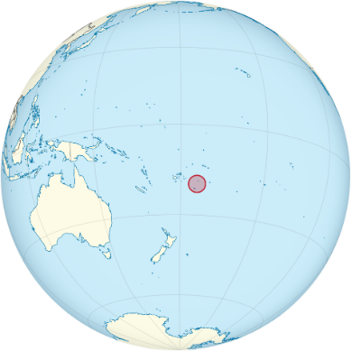

map by TUBS

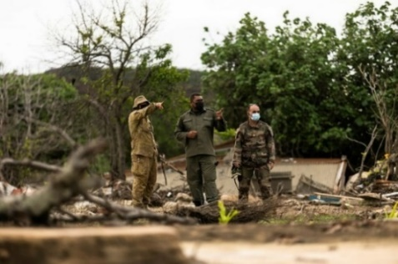
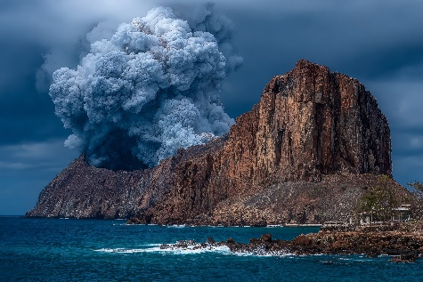

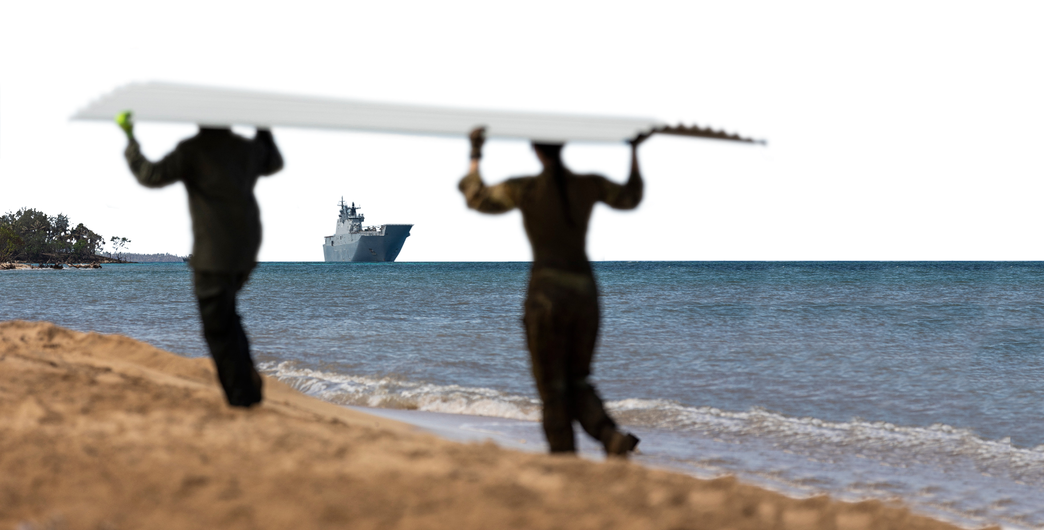

- These are words we will need for the listening. Look at the pictures and match as many as you can with words from the box. The first one has been done for you.
ash // a cable // an explosion // a runway // a tsunami // a volcano // a challenge

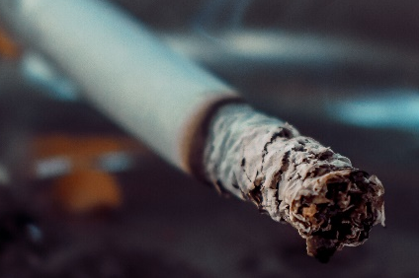
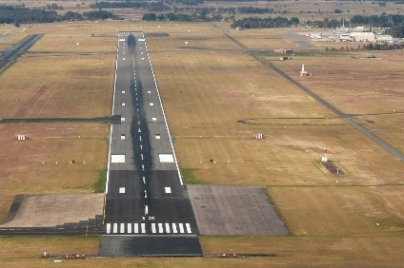
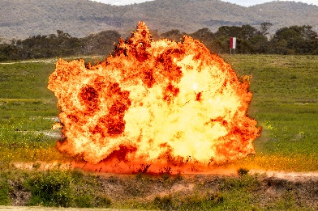
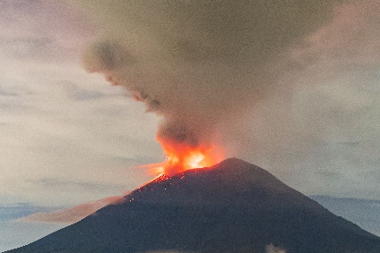
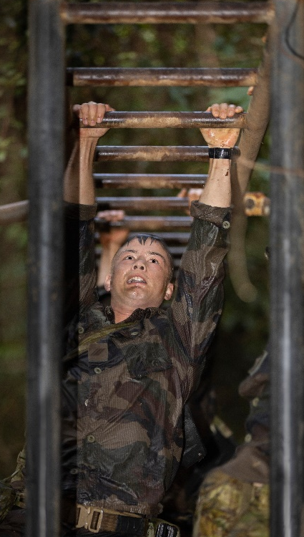
c. ____________________
f. ____________________
g. ____________________
d. ____________________
a. ____________________
b. ____________________
e. ____________________

ash

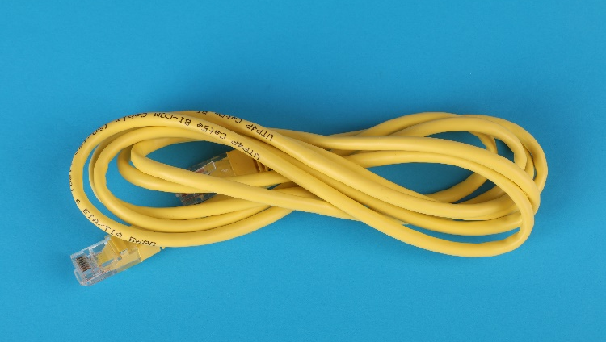

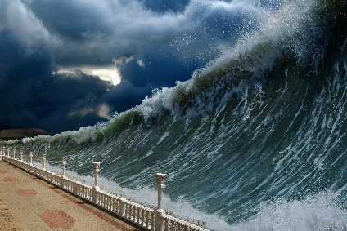


- Listen and check.

- Ask and answer questions with your partners to practise the new words.

What problems do you think ash from a volcano causes?
- What problems can there be for runways after a volcano?
- What problems might there be with housing after a tsunami?
- Why are internet cables important to a country?
- How many things can you name that explode?
- What are some of the challenges after a volcano or tsunami?

Listening
- Listen and check your guesses from exercise 1b – What is today’s listening about?
- Listen again and fill the gap with up to three words or numbers. Look at the example.
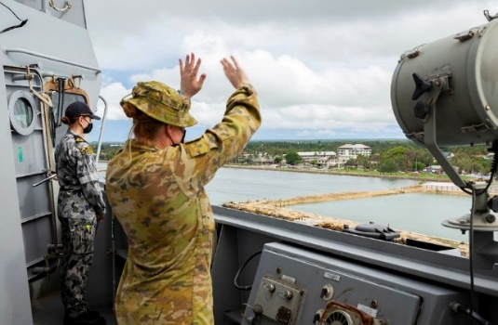
- The Hunga Tonga Hunga Ha’apai volcano erupted on the 14th ________________, 2022.
January
- The explosion was heard almost 10,000 kilometres away in _____________________.
- The ___________________________ was damaged in the explosion, so communication was difficult.
HMAS Canberra arrives in Nuku'alofa,
the capital of Tonga, in support
of Operation Tonga Assist 2022.
- People in Tonga had to get _____________ off the runway.
- HMAS Adelaide carried over _________ pallets of supplies.
- None the houses on _______________________ were left after the tsunami.
- Australia worked with personnel from New Caledonia and ________ on clean up and reconstruction.

Learning Military Vocabulary
- The words listed in bold below are important vocabulary and expressions that you should learn to use. Match the vocabulary on the left with their definitions on the right. Look at the example.
Table 1
the disaster relief effort | e |  | 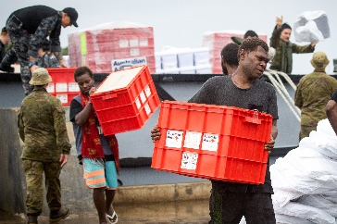  - (noun phrase) sending help, like food, water, or medicine, to people who need it, often after a disaster
a challenging HADR operation |  |  | - (n) all the necessary items like food, water, medicine, and blankets that people need, especially after a disaster
challenges delivering aid as well |  |  | 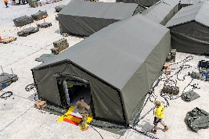  - (noun phrase) tools and materials to quickly build a place to stay (for example a tent) for soldiers or people in need
250 pallets of supplies |  |  | - (noun phrase) HADR stands for Humanitarian and Disaster Relief; this means actions to help people, like giving food or medicine, after a disaster
250 pallets of supplies |  |  | - (noun phrase) when people work together to help others after a bad event like a flood or earthquake
shelter kits |  |  | 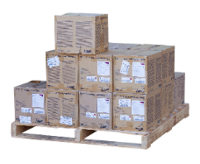  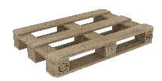  - (n) a flat object used to hold and move heavy things like boxes; it is usually made of wood
Table 2
bedding |  |  | 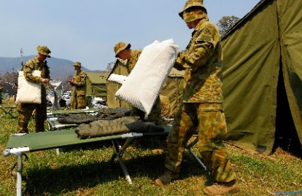  - (n) things needed to make it comfortable for sleeping such as beds, sheets, blankets, and pillows
water purification tablets |  |  | - (n) the basic things a country or city needs to work, like roads, bridges, electricity, and water systems
a lot of damage |  |  | 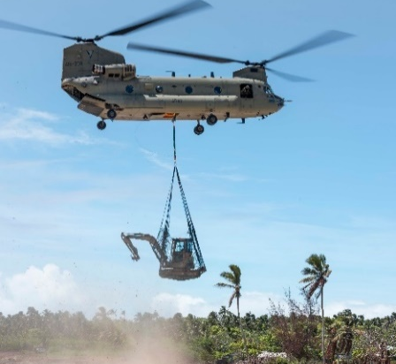  - (n) tools, machines,  or special items needed  to do a job or activity
housing and infrastructure |  |  | 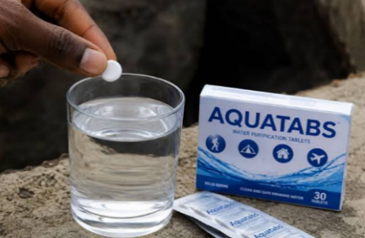  - (n) small pills you add to dirty water to make it safe to drink
every single house was destroyed |  |  | 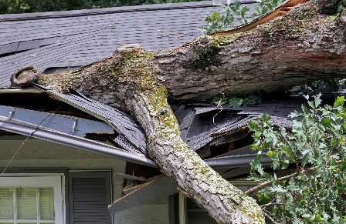  - (n) when something breaks, but it can usually be fixed
we sent equipment |  |  | 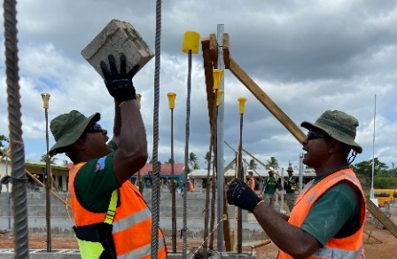  - (n) the process of building things like homes, roads, and bridges again after they have been damaged or destroyed, often by a disaster
supplies for reconstruction |  |  | 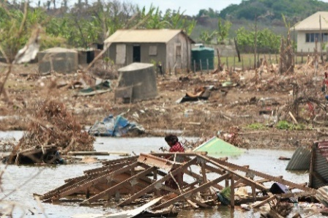  - (v) something is broken so badly that it cannot be used or fixed anymore
- Listen and check.
- Now, let’s practise saying the words. Listen and repeat. Look at where the stress is underlined in words that have more than one syllable.

Practice
- Complete the questions below with a word from the box. Then, ask and answer the questions with your partner about you.
deliver aid // disaster relief effort // equipment // supplies //
destroyed // infrastructure // operation // damage

- What _____________________ do you take with you when you go out field*?
- Would you like to help with a _________________________________________? Why/not?
- Apart from food, bedding and shelter, what else do people need
when their homes are ___________________________?
- What examples of ___________________________ have you used today?
- Tell your friend about the last ___________________ you went on. Were you successful? Why/not?
- What ___________________________ would soldiers need to clear roads after a disaster?
- Sometimes soldiers from different countries work together to ________________________. What is good about this?
- What was the last natural disaster that did _______________________ to housing in your country?
*out field – away from a military base; working or training outside

- Role play and mini presentation. Work in groups of 3-4. Imagine one of your neighbours has had a natural disaster. Your armed forces will help with the HADR efforts. Brainstorm some of the following:
- What is the natural disaster?
- What sort of supplies do you think people will need?
- What disaster relief will you give?
- What special training have you done to help you with this?

- Stand up and present your group’s ideas to other groups. Try to use words from this lesson. Answer any questions they have about your HADR operation. Who has the best plan?
The natural disaster we talked about is a _____ in ______.
Some ways we can help _______ are …
I wondered about …

Some supplies we think are useful are…
Some of the special training we have done is …

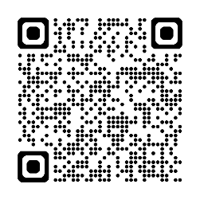
You will watch a video about the ADF deploying to Tonga. Type in YouTube “HMAS Adelaide completes recovery efforts in Tonga” or scan the QR code.
Circle the words from today’s lesson that you hear or see.
cable volcano pallets tsunami HADR
runway time of need equipment bedding shelter kits

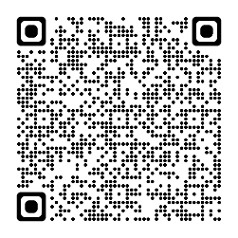

For more practice with the words you’ve learned here, scan the QR code for a set of Quizlet flashcards. You can do some more study on the vocab in this lesson on your own with these.

This lesson links with Vocabulary Builder – Natural Disasters
Lesson – Disaster Relief – Changing Climate; Changing Defence Force [reading]
Lesson – Disaster Relief [listening]
Lesson – Humanitarian Assistance and Disaster Response
(HADR) – Working Together After Disasters [Reading]

© Commonwealth of Australia 2026
This work is copyright. Apart from any use as permitted under the Copyright Act 1968 (Cth),
no part may be reproduced by any process without prior written permission from the Department of Defence.

