
Military English

Lesson: Recruit Training in the Australian Army - What I learnt at Kapooka [reading]

Overview:
This lesson is about daily routines for recruits.

In this lesson, you will
- read a text for main ideas
- find specific information in a text
- learn the meaning of new words and practice using them to talk about your training.

Prepare for Reading
- Look at some pictures of Australian Army recruits at Kapooka. Talk with your partner.
- What are the people doing in the pictures?
- Where are they?
- Why?
recruit (n) - a new soldier; they haven’t finished their training yet. All Australian army soldiers do their training at Kapooka, New South Wales.

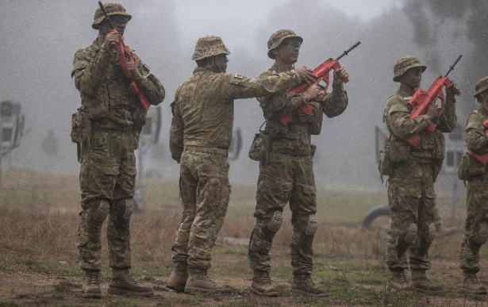

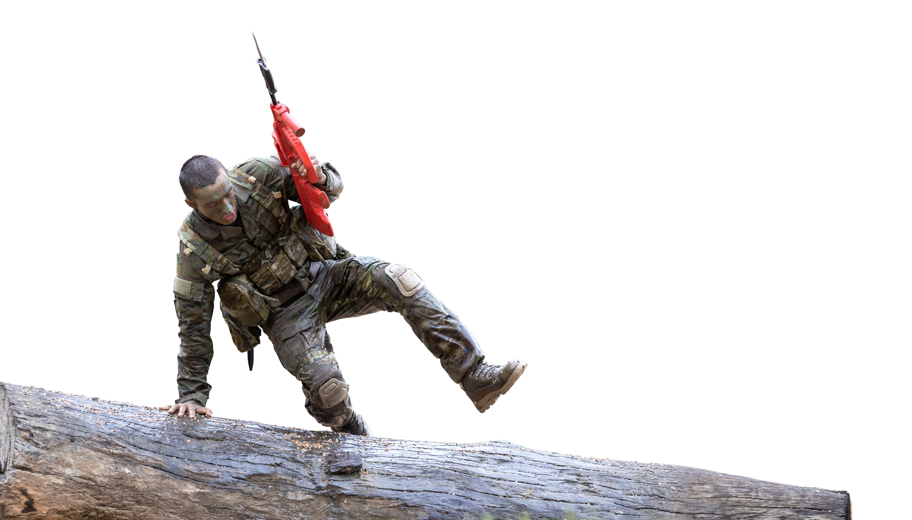

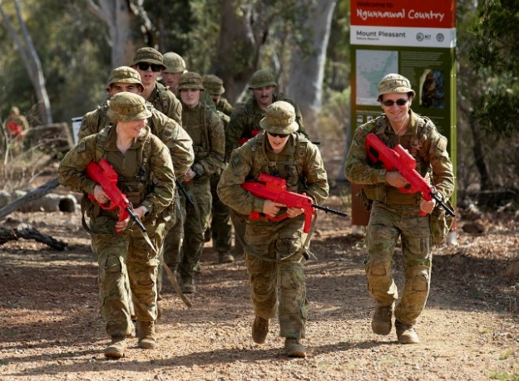

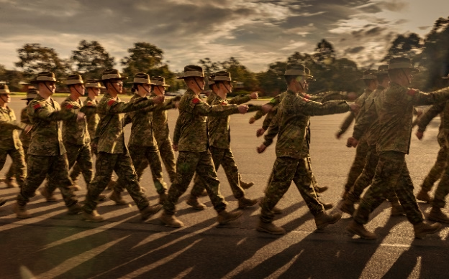

- There are some words we need for today’s reading in the box. Match them with the pictures. The first one has been done for you.
rank structure // bunks // mates // polish your boots // bodyweight exercises // bugle

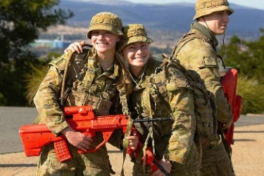
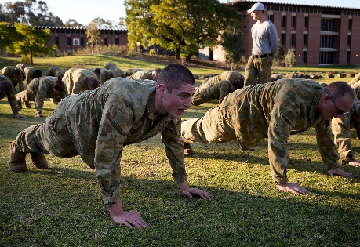
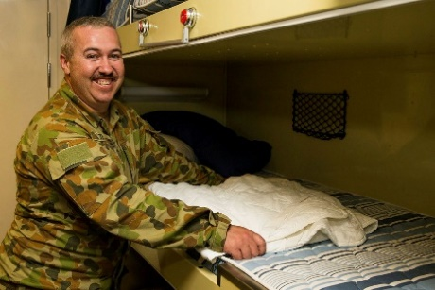

bunks
b. ________________________
c. ________________________
a. ________________________

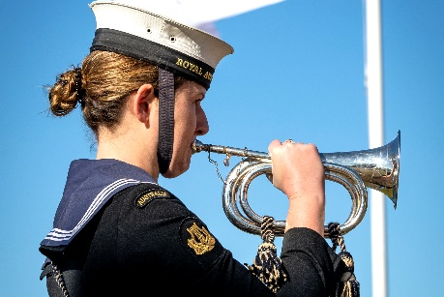
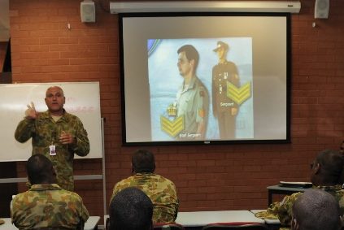
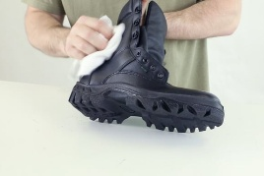

a. b. c. d. e. f.

f. ________________________
e. ________________________
d. ________________________

- Listen, check and repeat.

- Ask and answer questions with your friends to practice the new words.
- Bugles are an important part of the Australian Armed Forces.
Do you use bugles in your army? What for?
- What bodyweight exercises do you like doing? Are there any bodyweight exercises you don’t like?
- Do you think the army is a good place to make mates? Why/not?
- Who is above you in your rank structure? Below?
- Do you like sleeping in bunks? Why/not?
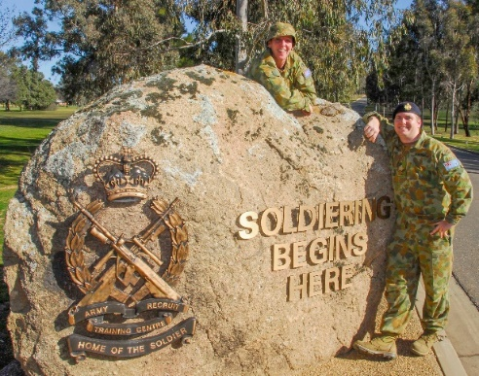
Two recruits at the entrance to the Army Recruit Training Centre.

Reading
- Read and listen to Australian Army recruit, Mia, talking about her training at Kapooka. How does she feel about her training?

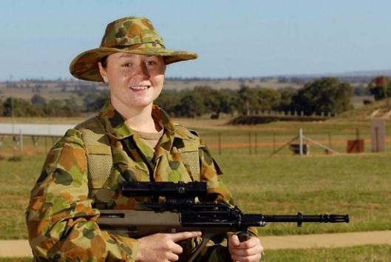
Kapooka changed my life. Like all army recruits, this is where I did my basic training. I learnt weapons handling, field craft, and got fit.
Kapooka days start early. I usually woke up at 0600. However, on mornings we had PT – that’s short for physical training – I got up at 0545. This was a challenge for me! At home, I used to get up as late as possible, but at Kapooka, we all got out of our bunks very early.
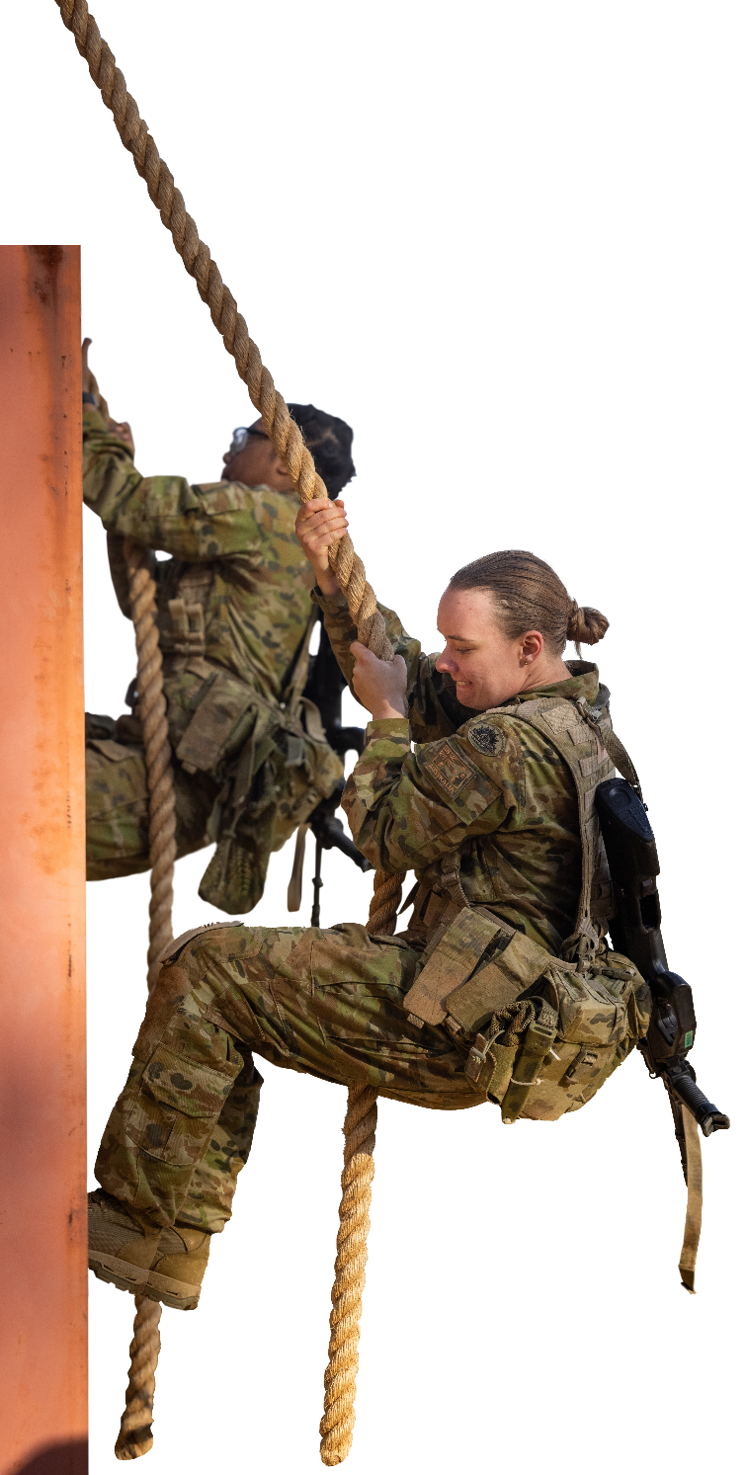
On days we got up at 0600, we got straight into our morning duties. We cleaned the barracks, and got ready for the day. On PT days, we worked out. This could be swimming, group runs, or bodyweight exercises like push ups, sit ups and star jumps. Then, we had breakfast in the mess at 0700 hours.
After breakfast, we had classes. There was lots to learn in the classroom. We learnt about rank structures – like who is in charge of who. I am the first in my family in the army, so I am not from a military background. This was hard for me to remember. I preferred the classes that were outside, like the obstacle course sessions. I loved climbing over and crawling under things! At somewhere between 1200 and 1400, we had lunch, and then more classes in the afternoon.
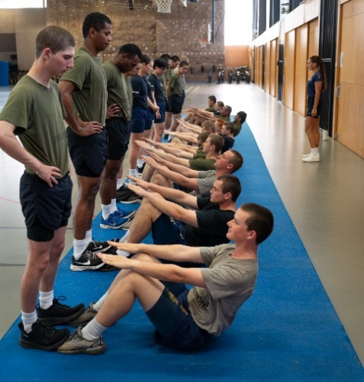
In the evenings, we returned to the barracks between 1700 and 1800. We had about an hour to grab a shower, polish our boots, clean our equipment and get things like laundry done. There was trouble if you went out looking messy in uniform! At 1900, we had dinner in the mess. Sometimes after this we had a briefing at around 1930 or 2000 about what to expect in the morning. After that, we had a little time to study before lights out at 2100 when we had to be silent. This was no problem for me! I always slept very well at Kapooka and never woke up until I heard the bugle for morning call.
I was very proud at the graduation. For me, Kapooka was a place where I made mates for life and fell in love with my career. I learnt a lot about myself at Kapooka. I learnt to work as part of a team, and to push myself. This is why Kapooka is called the ‘Home of the Soldier’.
- Read the statements and decide if they are true or false. Write T or F on the line. The first one has been done for you.
- __F__ Mia got out of bed every morning at 06:00.
- _____ At home, Mia liked to sleep in.
- _____ Bodyweight exercises are things such as running and swimming.
- _____ All the classes at Kapooka were outdoors.
- _____ Mia thought the classes about command structure were easy.
- _____ One of the things Mia learnt was to present herself well as a soldier.
- _____ Mia made lifelong friends at Kapooka.

- Have you done recruit training? What did you learn? What are your memories of this time?

- Look at the words in bold in the reading. We will match them to their definitions next. First, look at them in the sentences and talk to your friends. What part of speech are the words? What do you guess they mean?
Learning military vocabulary
- The words in bold are important military vocabulary that you should learn. Match them to their definitions on the right. Look at the example and write the answers in the middle column.
Table 1
all army recruits |  |  |  | - (n) when new soldiers learn the important things they need to know to be a soldier
I did my basic training |  |  |  | - (n) these are special skills soldiers learn for working outside, for example it teaches them how to hide and move quietly
I learnt weapons handling, field craft, and got fit. | f |  |  | 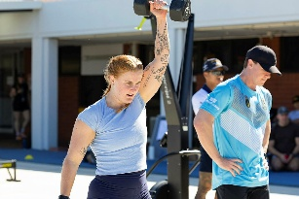  - (verb phrase) to become strong and healthy by doing physical exercises; soldiers need to do this to be ready for their job
I learnt weapons handling, field craft, and got fit. |  |  |  | - (n) this is a difficult task or problem that needs a lot of hard work; it can be something hard you need to do
I learnt weapons handling, field craft, and got fit. |  |  |  | 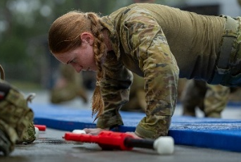  - (n) this stands for ‘Physical Training’; it is all the exercise recruits do to get fit
mornings we had PT |  |  |  | 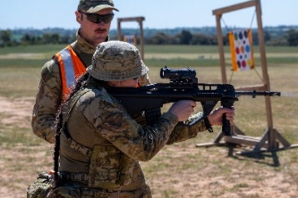  - (n) learning how to use weapons like a pistol or assault rifle safely; it includes knowing how to carry, load and fire them
This was a challenge for me |  |  |  | - (n) a person who has recently joined the military and is starting their training
Table 2
got out of our bunks very early |  |  |  |  | 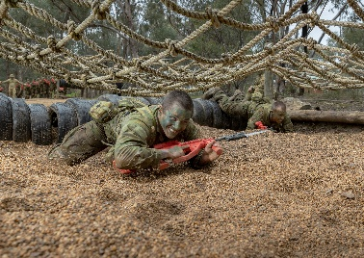  - (noun phrase) soldiers train here; it is a path with many different difficult things to climb over, crawl under, or jump across
got straight into our morning duties |  |  |  |  | 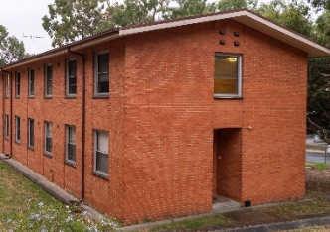  - (n) soldiers live here; it has many rooms for them to sleep and spend their time
We cleaned the barracks |  |  |  |  | - (n) when other people in your family have been in the military
to have breakfast in the mess |  |  |  |  | 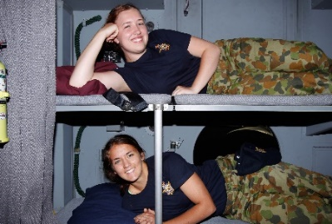  - (n) beds that are built one above the other in a room
from a military background |  |  |  |  | 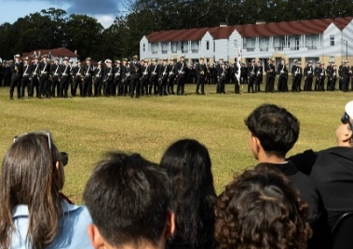  - (n) a special event at the end of training (or school); it means someone has finished their studies or military course successfully
the obstacle course |  |  |  |  | 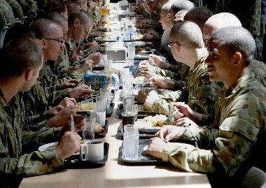  - (n) a big dining room where soldiers eat their meals; it's a place for them to get food and sit together
I was very proud at graduation |  |  |  |  | 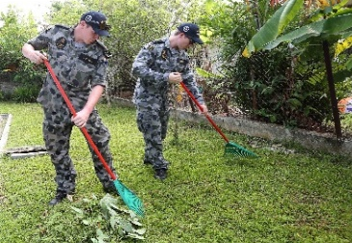  - (noun phrase) the jobs soldiers must do early each day; this includes cleaning their area or getting ready for the day's activities.
- Listen and check.
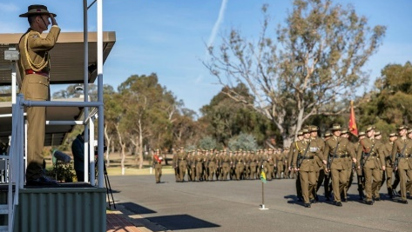
- Now, let’s practise saying the words. Listen and repeat. Look at where the stress is underlined in words that have more than one syllable.

Practice
- Complete the questions with new words from the box. The first one has been done for you.
army recruit // bunks // PT // mess // morning duties // military background // obstacle course
army recruit // bunks // PT // the mess // barracks // military background

bunks
- Are there _____________ in your barracks? What makes a person good to share a bunk with?
- Do you do enough _________? Are you as fit as you were when you joined the army?
- Do you like going around an ___________________________? Which parts do you like best?
- Do you come from a ___________________________? If so, who in your family served before you?
- Do you remember your first day as an ____________________? What did you do? How did you feel?
- Do you have to do ________________________? What things do you have to do?
- What is the best food that they serve in your _______________?

- Ask and answer the questions in exercise 12 with your partner about you.

- You are going to play a game of ‘Would you rather…?’. First, answer the questions about you. Circle your answers.
  - Would you rather work as part of a team OR work by yourself?
  - For PT, would you rather do swimming OR running?
  - Would you rather be from a military background OR not be from a military background?
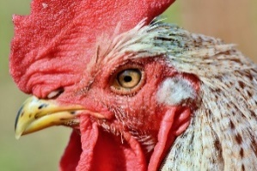
  - Would you rather eat in the mess OR eat by yourself?
  - Would you rather sleep in bunks OR by yourself?
  - Would you rather wake up to a bugle OR wake up to a rooster?
  - Would you rather learn something challenging OR learn something easy?
  - Would you rather go to a radio communications class OR go to weapons training class?
  - Would you rather do 100 sit ups OR do 100 push ups.
- Stand up and walk around the room. Find someone the same as you for each of the questions. Ask why they chose this. Did they have the same reasons as you? Try to talk to as many people as you can.


- Watch this video about Preparing for Kapooka on YouTube or scan the QR code.
After you listen, be ready to discuss:
- How did you prepare for your recruit training?
- What did you bring with you?


- For more practice with the words you’ve learned here, scan the QR code.

- This lesson links with Lesson – Recruit Training in the Australian Army [listening]
Lesson – Studying at DITC [listening]
Vocabulary Builder – At an obstacle course
© Commonwealth of Australia 2026
This work is copyright. Apart from any use as permitted under the Copyright Act 1968 (Cth),
no part may be reproduced by any process without prior written permission from the Department of Defence.

Vocabulary Builder – Military time

