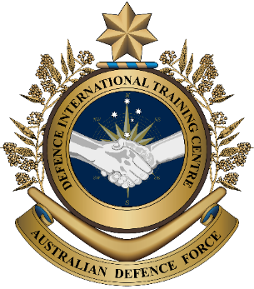
Overview:
This lesson describes what HADR operations are and presents vocabulary related to it.
In this lesson, you will:
- practise reading for gist and specific information
- learn and practise new vocabulary and expressions about HADR.
Military English

Lesson: Humanitarian Assistance and Disaster Response (HADR) – Working Together after Disasters [reading]

Prepare for Reading
- Look at the pictures of military personnel helping after disasters.
- How many disasters can you see in the pictures?
(n) something that causes a lot of harm or problems
- What are the personnel doing to help?
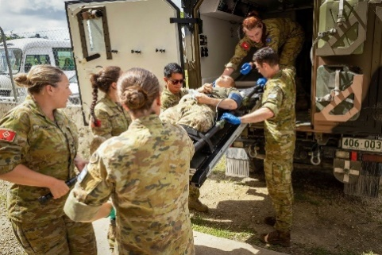
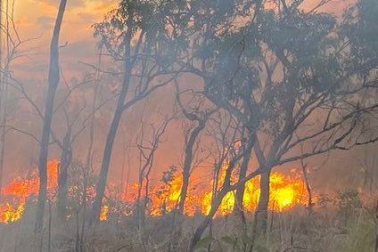
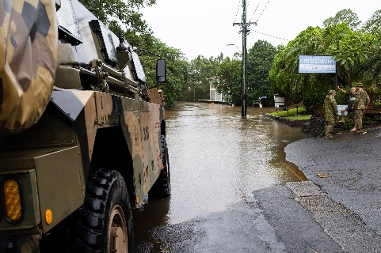

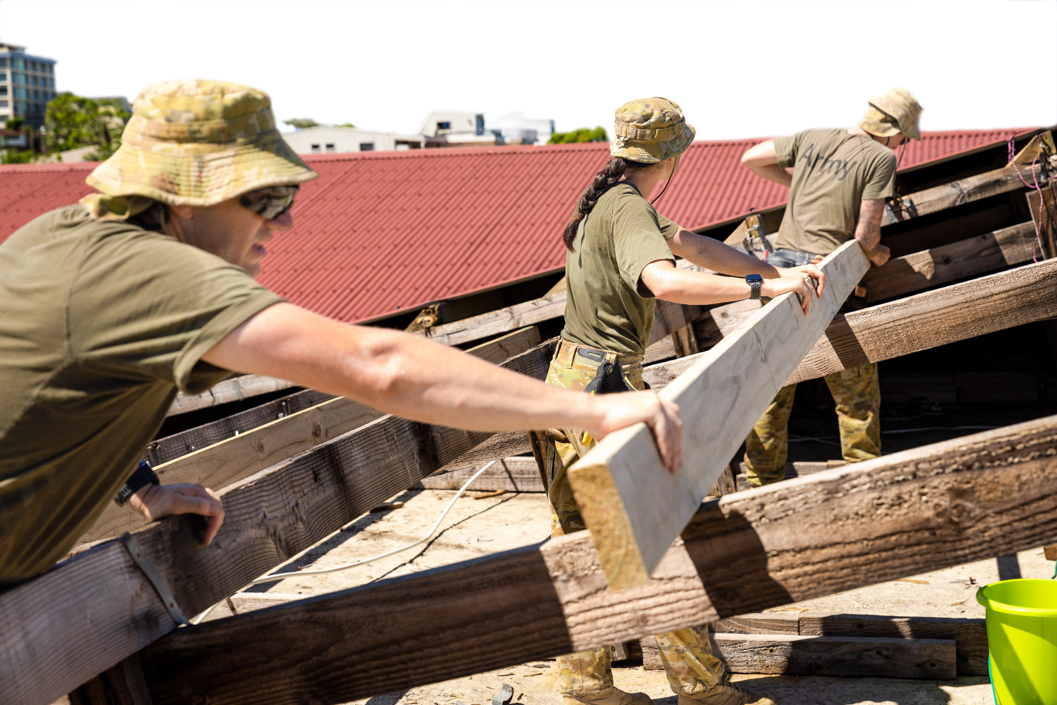

- Here are some words we need for today’s reading in the box. Match them with the pictures. The first one has been done for you.
damaged // destroyed // medical // stuck // clear roads // communities // climate change

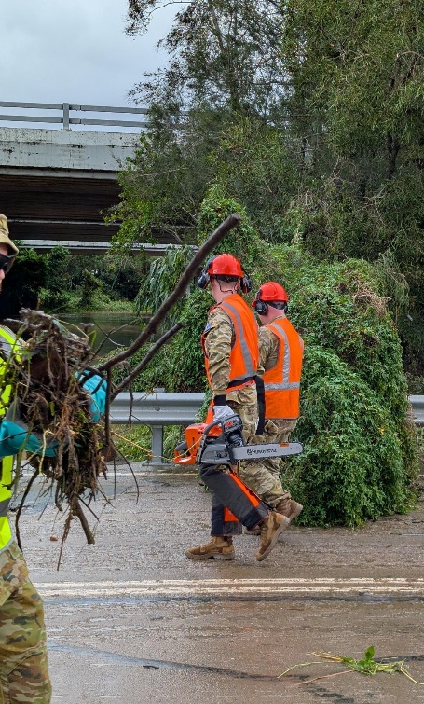
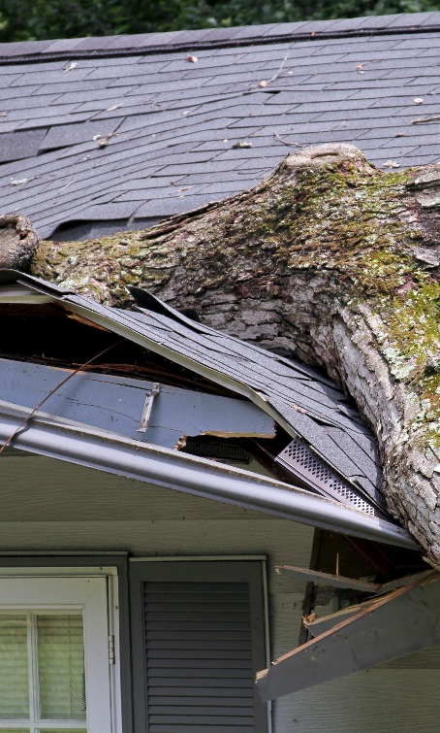
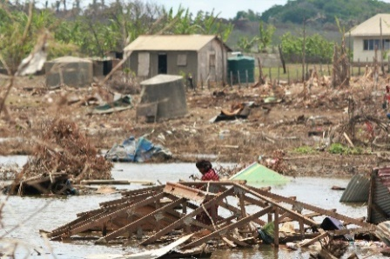

a. ____________________

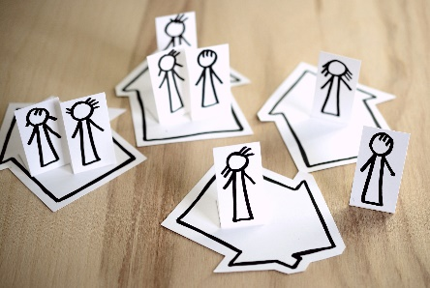

c. __damaged___
b. ____________________
d. ____________________


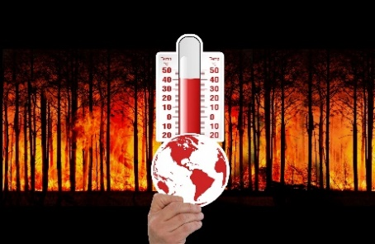
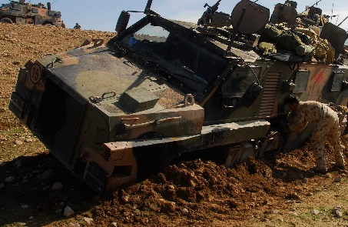

g. ____________________
f. ____________________
e. ____________________


- Listen and check.

- Discuss these questions with your partner to practise the new words.
- What causes climate change?
- What do you like most about living in your community?
- Do you have any medical training?
- What things might soldiers clear off the roads after a flood?
- What building can get damaged in a storm?
- How can people get stuck in a disaster?
- Listen and read. What type of text is this?
- An article explaining what HADR is.
- An essay giving the pros and cons of HADR.
- An article giving the readers opinion of HADR.

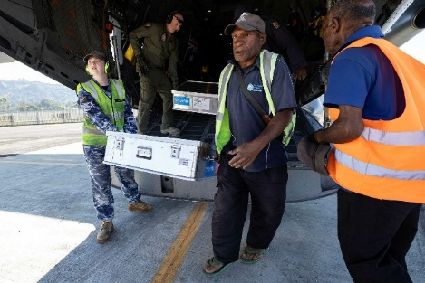
Humanitarian Assistance and Disaster Relief (HADR) is when countries send help to people after a war or natural disaster like an earthquake, a flood, or storm. For example, Australia might help when a problem is too big for the country that has the disaster to do everything themselves. The main goal of HADR is to save lives and help people quickly. The Australian Defence Force (ADF) often helps, especially when their neighbours are in trouble. The ADF is proud of this work. They often work with other defence forces to do this work. The ability to work together is called interoperability.
A member of the Royal Australian Air Force (RAAF) and a Papua New Guinea (PNG) local unload UNICEF aid from a RAAF C-27J Spartan at an airport in PNG.

First, special medical teams, military personnel, and supplies have to get to the affected areas where people need help. Just getting people and supplies to the disaster from Australia is a big job. The ADF uses large aircraft or ships. These planes and ships carry important disaster relief supplies such as clean water, food, medical supplies, and shelter. Aircraft are first to arrive and ships can take many days. However, ships can carry much more than aircraft can.

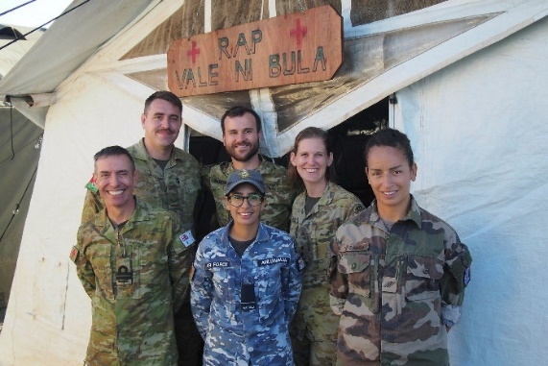
When they arrive, military personnel often help with search and rescue work. For example, they might look for people stuck in buildings or floods and help them get to safety. Often, homes are damaged or destroyed. This means people don’t have a place to stay and need shelter. They may also need food or clean water.

They also move big trees or broken houses to clear roads. They bring special equipment to help with this work. Military personnel can also help with reconstruction. For example, they help fix buildings like schools.
Members of the Primary health Care Team from the ADF and French Armed Forces in New Caledonia. They provided support after Tropical Cyclone Yasa hit Fiji in 2020.

HADR missions also help with preparedness. This means getting ready for future disasters. Countries share knowledge and do training together. This helps communities become stronger, which is called resilience. If a disaster happens again, people are more ready to face it.
Because of climate change, there are more HADR missions now than in the past. It also means that there will be many more disasters in the future. It is important that we all work together as climate change gets worse.
- Complete the sentences with 1-2 words from the text.
- Australia assists with HADR when the problem is too __big_____ for a country to deal with alone.
Tips for when you see a new word in English.
- Look for clues in examples.
- Good words to look for are ‘like’, ‘such as’, ‘for example’ and ‘for instance’.
- When ________________ experience natural disasters, Australia regularly helps.
- ____________ are faster than ships.
- Search and rescue work tries to help _____________ in trouble.
- Communities have better ______________ when they are stronger.
- There are more HADR missions nowadays because of ____________________________ .

- Look at the words in bold in the reading. We will match them to their definitions next. First, look at them in the sentences and talk to your friends. What part of speech are the words? What do you guess they mean?

Learning Military Vocabulary
- The words listed in bold below are important vocabulary and expressions that you should learn to use. Match the vocabulary on the left with their definitions on the right. Look at the example.
Table 1
Humanitarian Assistance and Disaster Relief (HADR) is when | f |  | 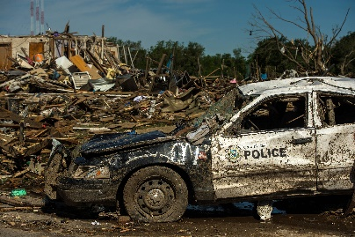  - (n) an event in nature that causes big problems for humans like a flood or a storm
natural disaster, like an earthquake, a flood, or storm |  |  | - (n) things that doctors and nurses need to help sick or hurt people
work together is called interoperability |  |  | - (n) the place that is having problems because of a disaster or a war
affected areas where people need |  |  | 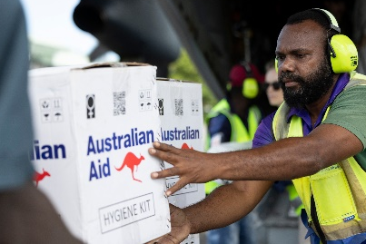  - (n) important things people need after a natural disaster to stay healthy and safe
disaster relief supplies such as clean water, food |  |  | 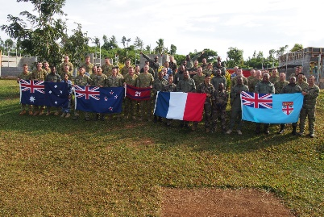  - (n) being able to work together e.g. armies from different countries
disaster relief supplies such as clean water, food, medical supplies, and shelter |  |  | - (n) helping countries after a natural disaster or a war
Table 2
search and rescue work |  |  | - (n) the ability of a community or system to deal with a disaster, recover from it, and learn to be stronger for the future
don’t have a place to stay and need shelter |  |  | - (n) special tools, machines, and other things that people use to do a particular job or activity e.g. chainsaws
special equipment to help with this work |  |  | 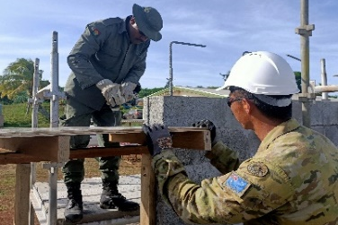  - (n) building something again after it has been broken or damaged
help with reconstruction |  |  | 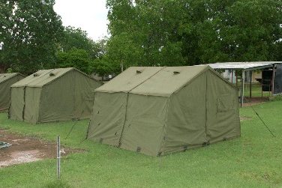  - (n) a place where you can sleep and be safe e.g. from the weather
preparedness |  |  | 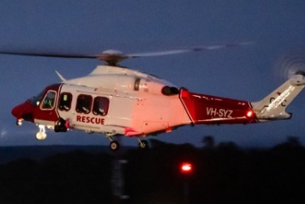  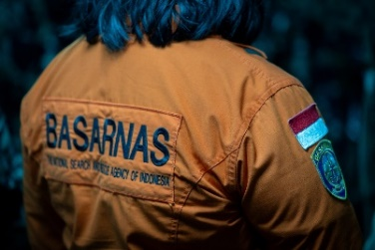  - (n) when special teams look for people who are lost or in danger to get them to safety
stronger, which is called resilience |  |  | - (n) the actions taken before a disaster to be ready for it, like making plans and gathering supplies
- Listen and check.
- Now, let’s practise saying the words. Listen and repeat. Look at where the stress is underlined in words that have more than one syllable.

- Complete the questions below with a word for the box. Then, ask and answer the questions with your partner about you. The first one has been done for you.
interoperability // natural disasters (2x) // medical supplies //
equipment // prepared // reconstruction

- What does your defence force need for better ___interoperability__ with neighbours?
- What ___________________ might doctors and nurses need after an earthquake?
- Bushfires and floods are common _______________ in Australia. What ______________ are common in your country?
- It is important for schools to work as soon as possible after a disaster. What other buildings do you think need ___________________ efforts after a disaster?
- What ___________________ do you think the ADF brings with them on HADR missions?
- Do you think your community is ___________________ for a natural disaster?

Practice
- You are on a working group thinking about your country’s preparedness and resilience for natural disasters. Discuss the following with your group. Try to use new words from today’s lesson.
- What natural disasters are common in your country
- How the disasters were dealt with in the past
- How your country can prepare now for future natural disasters
The most common natural disaster in our country is …
In the past, there have been problems with…

Another disaster we have is…
To be better prepared in the future, we could…

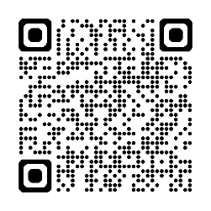

You will watch a video about Fiji and Australia HADR. Type in YouTube ADF deploy to Operation Fiji Assist in response to Tropical Cyclone Yasa or scan the QR code.
Think about these questions as you watch:
- How did Fiji help Australia?
- How did Australia help Fiji?
- Why is interoperability important?
- Why is it important to help neighbours?

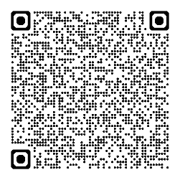
For more practice with the words you’ve learned here, scan the QR code for a set of Quizlet flashcards. You can do some more study on the vocab in this lesson on your own with these.

This lesson links with Lesson – Humanitarian Assistance and Disaster Response (HADR) – Operation
Tonga Assist 2022 [listening]
Vocabulary Builder – Natural Disasters
Lesson – Disaster Relief – Changing Climate; Changing Defence Force [reading]
Lesson – Disaster Relief –The Role of the Military in the
Climate Crisis [listening]
© Commonwealth of Australia 2026
This work is copyright. Apart from any use as permitted under the Copyright Act 1968 (Cth), no part may be reproduced by any process without prior written permission from the Department of Defence.

